April 1969

GUS PAYS OFF AN OLD DEBT

by Martin Bunn
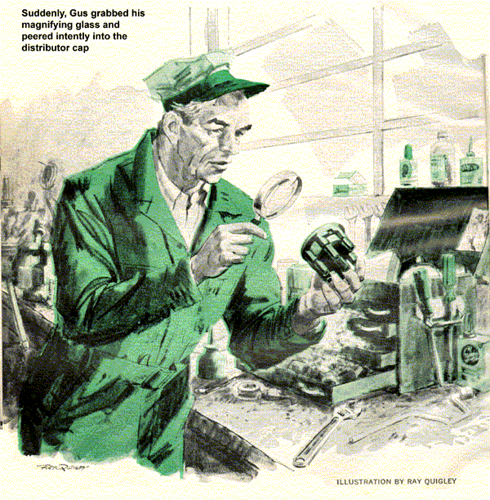
Gus Wilson, proprietor of the Model Garage, poked a forefinger at young Tommy Tibbet, one of his favorite customers. "If you want to coach the Central High track team," he said sternly, "you've got to fight for it."
Outside, the rain poured down and Gus recalled how it had rained for three weeks when he first opened up. And how Tommy's grandfather, Judge Tibbett, had rolled up in his Reo one soggy afternoon, surveyed the all but deserted premises and said, "Don't be discouraged, Gus. With a little luck, things will work out." After that the courthouse crowd had begun to bring in their cars.
Tommy, who had grown up around the garage, was the town's newest teacher of physical education. Now he wanted to move up the ladder. "But I'm licked before I start," he told Gus. "They've brought in this new man, Boggs, to head the department. He makes the assignments and he's a track coach himself."
"Have you told him how you've trained your boys?"
"We've got a date for tomorrow noon."
"Tell him how you've worked with them through junior high school and the town recreation program. Tell him that."
A 1967 Oldsmobile rolled to the front of the garage. "You tell him," Tommy said. "Here he is now."
A car door slammed and a burly, middle-aged man sloshed through the rain. "Hello Tom," he said, then offered his hand to Gus. "I'm Horatio Boggs. My radiator hose collapsed. I've got to get to Reedsville right away to make a dinner talk. Can I rent a car here?" Reedsville was across a range of hills and the road was treacherous.
"Why not change your hose?" asked Gus.
"No time. Besides, my bad luck runs in threes. Sure as fate, I'd have another breakdown in those hills."
Gus saw Tommy's Plymouth beyond the gas pump. The tank was full and the '64 car had been recently tuned.
Tommy saw it too. "You take my car, Mr. Boggs," he offered. "Gus can have your car ready in the morning."
"Pick it up on the way to school," Gus suggested.
You could see Boggs' mind working. This would save a half hour, click. He'd buy it, click! "You got a deal. Much obliged," he rumbled.
Tommy and Gus walked him out to the Plymouth and watched him head for the hills. Silently the two shook hands.
Gus replaced the faulty hose the next morning. When Tom walked in, Gus said, "I've got a hunch that today is your big day."
Almost at once they heard the awful noise. Tommy's Plymouth was limping in, one cylinder skipping each compression cycle. Horatio Boggs braked to a stop and jumped out. "Young man, your car's a lemon," he told Tom. Maybe your intentions were good but you wrecked my evening."
"But it was running smooth as butter," Tom exclaimed.
"Up in those hills, all at once, that cylinder cut out and stayed out. Drove me nuts!" Like I told you, my luck runs in threes. That's two in a row. Well I'll survive. Is my car ready?"
Gus said, "Sure, but I'd like to know what happened."
The big man shrugged. "She simply started to miss. Well, forget it." He leaped into his Olds and took off.
Gus could feel the pain of Tom's disappointment.
Stan Hicks, Gus's assistant, started the Plymouth, and its jarring rhythm filled the air. He turned to Tom. "Come on, I'll drive you to school and then try her on a hill."
Gus sighed, wishing he knew as much about the inside of a man's skull as he did about the inside of an engine.
That afternoon, a long-faced Tom Tibbett walked back toward the garage. Boggs had firmly rejected his application. Turning the corner, he was surprised to see Boggs himself standing in the door of the garage, his arms waving. Tom jogged the last block.
Boggs was shouting at Stan. "What kind of shop is this? I drive a car you've tuned and it turns into a clunker. I get a new hose and it collapses like a wet pretzel. And where's Gus Wilson?"
Gus's voice rose from the oil pit. Let's find out what's wrong, first. Then maybe we can call each other names."
"Okay, you find out if you can," Boggs agreed. "I've got to make a phone call. Somebody lend me a dime."
Gus lifted the hood of the Olds. The hose was plump but a little soft.
"What's he yelling about?" asked Stan. "It's like new."
"Maybe not," Gus said, unscrewing the radiator cap. A soundless whistle escaped from his lips as he examined it. "This is a 1968 cap. How come it's on a 1967 Olds?" He got a parts catalog.
"I was right. The 68 cap takes 2-1/2 pounds of vacuum to vent it; the 67 cap only a half pound. You get the right cap out of stock and put it on. And one of those spring-reinforced hoses, too.
"Can a cap make that much difference?" Tommy asked.
"Cooling systems operate under pressure. The higher the pressure, the hotter the coolant can get without boiling away. A hot engine develops more power. So radiators have caps with double seals to hold the pressure. Trouble is, they cool off slow. Take the cap off a hot radiator and it'll spray you and you lose your coolant."
"Caps look all the same to me."
Gus turned the removed cap over and squeezed it, compressing the spring. "Watch that spring. It holds the lower seal against the coolant's pressure.
The bottom of the cap had a dime size disk cut into it. He pulled it out and then let it snap back. That's the vacuum release. This '68 model takes 2-1/2 pounds of vacuum before it'll vent, five times as much as the one the year before."
"Where does this vacuum come from?" asked Tom.
"Hot coolant expands to fill the radiator system. Turn off the engine and the coolant contracts. The system is sealed, so the space left by contracting liquid has got to be a vacuum. In this case, it wasn't strong enough to pop the cap. Still, some vacuum did develop as the engine cooled and something had to give-it was the hose."
When the Olds was ready to roll, Gus remembered Tommy's problem. "Get that coaching job yet?"
"He turned me down."
Boggs came out of the office, his mood softened. "Sorry I popped off. Got too much to do. Never seem to catch up."
Gus said, "I guarantee no more radiator trouble."
Boggs looked at his watch, jumped into his car, and was gone.
Tom's Plymouth sat there shaking and vibrating. "Wonder if this clunker will take me to the school?" he asked.
Gus had a better idea. "Stan will drive you out in the pickup. I'm going over that ignition again. Could be that we missed something somewhere."
Gus reviewed the plugs, wires, compression, the works. With a bench magnifier, he inspected every plug for hairline cracks. Nothing. After making sure that all the high-tension lines were okay, he pulled them off the distributor and removed the cap to check its towers for leakage. He rubbed his finger and thumb together, then grabbed his magnifying glass and peered into the gap.
On the bottom, he saw a scattering of almost invisible metal flakes. His forefinger stroked the aluminum inserts. One of them might have retreated fractionally into the mount.
When Stan came back, Gus asked, "You know where Tommy got this distributor cap? It's not one of ours."
"I bought it off the Ace Supply station wagon when it was here. Something wrong with it?"
"I've been hearing about aluminum inserts. Let's try a different cap." The replacement cap had brass inserts. Gus snapped it into place, started the engine. It rolled over as smooth as a millrace.
"That's it! Aluminum is touchy stuff. When a spark jumps off it, it generates a gas containing nitrogen. In wet air, this turns into weak nitric acid. The acid forms a fungus that attacks the inserts. When the rotor spins and hits this flaky stuff, it turns into a grinding wheel. An insert wears away and you've got an instant miss." He slid behind the wheel. "You lock up, Stan. I'm going out to see Tommy's young athletes."
At the athletic field, muscular youths were swarming energetically over the track. Horatio Boggs was sitting in his car, watching, and working at a pile of papers on his lap. As Gus parked, Tom Tibbett and a quartet of cross-country runners passed nearby.
"Mr. Boggs, you still trying to catch up with your paperwork?" asked Gus.
"Some day, by golly, I'll do it." Boggs looked at the Plymouth. "The way she sounds now you found the trouble."
"The distributor was acting up."
Boggs lips tightened abruptly and he winced. "So's my ulcer."
Gus's indecision fled. A little meddling was called for. With an ulcer, a new department to run, too much paperwork, and a heavy coaching load, this man would soon be in deep trouble. For his own good, he needed to be told!
"Tell me something, Wilson. Are you superstitious?" Boggs asked in a voice tight with anxiety.
Gus made a knock-on-wood gesture. "Not in the least."
"I am. Things always happen to me in threes. First it was that hose... then the Plymouth. What next?"
Gus took the '68 radiator cap from his pocket. "How long have you been driving with this cap on your '67 car?"
"They sold it to me at a service station the other night after my old one blew off and rolled into the highway. A truck ran over it."
"It's what made your hose collapse. Don't you know you have to match a cap with the car it's made for?"
Boggs looked very tired. "Of course I knew - it slipped my mind."
"Sometimes we make our own hard luck," Gus said. "We try to do too much when there are young people around raring to carry some of the load."
The educator glanced at the papers heaped around him. Then his eyes roved the athletic field searching out Tom Tibbett. You could almost see his mind work. He was getting older; nature was warning him to ease up, click. Coaching would interfere with his real work, click.
He scrambled out of the car and trotted to the track, where he hailed a runner. "Hey you! Run over there and tell Coach Tibbett I want to see him," he demanded.
"Coach who?"
"Coach Tibbett. Go get him."
Waiting, Gus watched Tommy cross the field with that four-square walk that was so much like his grandfather's.
"A little something on a long-overdue account, Judge," he muttered.

END

