November 1968

GUS AND THE BACKWARD BATTERY

by Martin Bunn
Harry's foreign sedan was in A-1 shape -
except for the radio, clock, tach, gas gauge, and battery.
"Easy," said Gus.
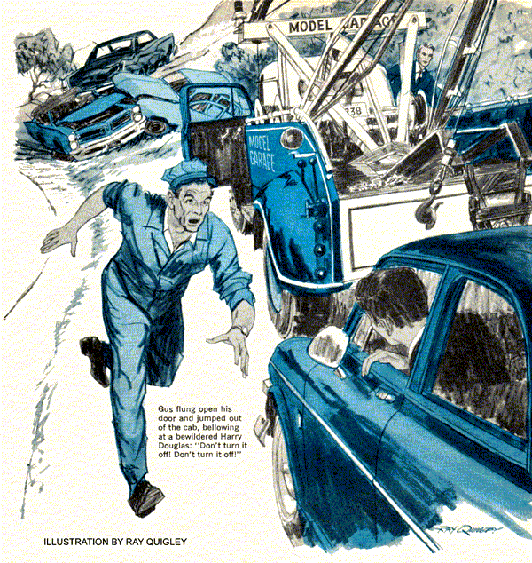
"It's obvious that I can't sell the Model Garage any more insurance today, Gus, so I'll take my tank of gas and go," said Harry Douglas, as he hoisted his lanky six-foot frame from the wooden bench opposite Gus Wilson's desk. "In case you change your mind..."
"I know where to reach you!" interrupted Gus, grinning. "In the past month you've sent me two letters and three postcards, all printed with your address and phone number."
Douglas grinned in return. "Guess that's what happens when the son of a good friend becomes the town's newest insurance agent."
Outside, a 1964 Volvo sedan stood idling next to the line of gas pumps. Stan Hicks, Gus's assistant, was busily polishing its windshield.
"Check the oil?" asked Stan.
"Not unless you can do it with the engine running," answered Douglas. "I doubt if it will start again if you switch it off. My wife left the headlights on last night. I had to use jumper cables and the battery in a neighbor's car to start up this morning."
Gus chuckled. "No problem. We'll give the battery a quick boost."
Douglas glanced at his watch. "No time now," he said. "Anyway, my last appointment this morning is several miles out on the main road. I'm meeting a claim adjuster to look over the scene of a three-car crack-up, and the drive there should help recharge the battery. I'll leave the engine idling while I make my next few calls."
He slid into the driver's seat, and an instant later popped his head out of the side window. "Hey, Stan, I asked you to fill it up."
"The tank is full," said Stan.
"You can't tell by the gas gauge," said Douglas. "The needle reads 'empty.'
Guess it's broken, too."
"Probably nothing serious," said Gus.
"A blown fuse, or maybe a short in the wiring from the tank sender unit."
Douglas looked glum. "This seems to be my day for car troubles. The radio wouldn't work this morning, along with the electronic tachometer and the clock. And now this fuel gauge. Gus, as soon as things stop breaking down, I'll bring the car in so you can fix the lot."
Douglas tromped on the accelerator, and wheeled the Volvo into the street before Gus could say anything, but Stan recognized the thoughtful expression on Gus's face.
"It bothers me too, boss," he said.
"Those accessories work off different fused circuits, so the trouble couldn't be single short or a blown fuse."
Gus spun around and dashed into the office, with Stan close behind. "Stan, we've got to find Harry before he gets to that last appointment this morning. I could kick myself for not thinking about everything sooner."
"I...I don't understand," Stan said.
"Unless we can stop him," said Gus, reaching for the phone, "there's a 50-50 chance that Harry will burn out the Volvo's generator and part of the wiring harness the instant he switches off the engine." But his call was fruitless.
What was left of the morning passed very slowly. Harry Douglas worked out of a one-man office, without a secretary, and his telephone answering service didn't have a list of his appointments for the day. Neither did his wife. Now Gus and Stan waited for the phone call they hoped wouldn't come: from Harry asking them to tow his car to the Model Garage.
It was a welcome distraction when a 1968 Dodge Charger pulled up in front of the office, with a familiar face behind the windshield.
"That's the fanciest police cruiser I ever saw," called Gus. "No wonder our taxes are up this year."
State Trooper Jerry Corcoran, dressed in off-duty civvies, climbed out of the front seat and winked slyly, "just between you and me, this car can outrun most of the cars in our fleet. It's a good thing I'm a law-abiding citizen on my days off."
Stan cocked his ear next to the hood.
"The idle sounds a bit rough today."
"That's exactly why I'm here. "The engine runs rough at all speeds, and it misfires a lot. I think the tune-up you did last week wore off."
"Impossible!" Stan sputtered.
"Improbable, Stan," said Gus, "but not impossible. Let's have a look."
A small metal box bolted to the left fender pan caught Gus's eye as he raised the hood. "I see you've installed a capacitor-discharge ignition system," he said. "Did the misfiring begin right after you installed the system?"
"Yes," Jerry admitted. "But it's only a coincidence..."
Without answering, Gus carefully loosened the distributor-locking clamp, and slowly rotated the distributor body to retard ignition timing slightly. Immediately, the rough idle smoothed out.
"Same old problem?" asked Stan, a triumphant smile on his face.
"Seems like it," answered Gus, and turned to Jerry," "It's what Stan and I call a 'short spark.'"
"I've heard of a short circuit," said Jerry, Looking baffled, 'but never..."
"Jerry!" Gus interrupted. "Talking of short circuits, you're the one man who can help me." Gus grabbed the startled trooper by the arm, and pulled him toward the tow truck.
"Jerry, this is important," he said. "Do you know the location of a recent three-car accident? On the highway?"
"Sure," Jerry said, "it's about eight miles north of town."
"Come on...you guide me out there," Gus said. "Stan will have your car fixed by the time we get back."
Jerry Corcoran bounced up and down in the passenger seat, occasionally giving Gus a direction. Finally, he said, "Since I'm along for the ride, would you please explain what a short spark is? I'm getting more curious by the minute."
"Well," Gus said, "as you know, a C-D system delivers high-voltage pulses to the ignition coil, which transforms them into 25,000-volt-plus pulses that fire the spark plugs. These pulses are uniform, no matter what the engine r.p.m.: That's why a C-D system improves starting and high-speed performance."
"So why the misfiring?" asked Jerry.
"Because the C-D system you installed, like many on the market produces a very-short-duration spark - it lasts a shorter period of time than the spark from a conventional ignition.
"Some high-performance engines - like your big V-8--balk at the short spark. It doesn't always ignite the mixture properly. When I retarded the timing a bit, back at the garage, it allowed the air/gas mixture to stabilize longer inside the cylinder, before the spark ignited it, insuring proper ignition."
"Do I have to take the system out?" asked Jerry. "Or is there another cure?"
"There is," replied Gus. "A very simple one. Stan will increase the gap of all eight spark plugs to about 0.045 inches. This lengthens spark duration, but..."
"There's a catch?" interrupted Jerry.
"Sort of," said Gus. "Increasing the gap also raises the voltage of the coil's output pulses above 25,000 volts. This ignition wiring can take, so Stan may also have to replace it with special extra-high-voltage cable."
"Fair enough," said Jerry. Then" "Hey, Gus the accident spot is just ahead on the right."
Gus scanned the scene. Three cars were jumbled at the side of the road, but no Volvo was in sight. As he pulled up, he glanced at the rear-view mirror - and jammed on his brakes. Harry Douglas' car was rolling to a stop just behind the tow truck.
Gus flung open his door and jumped out of the cab, bellowing at a bewildered Harry Douglas: "Don't turn it off! Don't turn it off! Keep it running!"
"Gus...what are you doing here?" Harry Douglas stammered.
"Trying to save you some money," Gus said as he reached into the car to pull the hood-release lever. "Whatever you do, don't touch the ignition key. I need some test gear from my truck. I'll be right back."
A quick voltmeter check proved that Gus's hunch was right: The battery was reverse-charged. Deftly he disconnected the terminal clamps, and breathed a sigh of relief.
"I'm sure glad you aren't on time for morning appointments," he said.
"I was here 15 minutes ago," said Douglas, "but while our adjuster was taking pictures of the scene, I went for a sandwich." He pointed to a heavy-set man down the road busily working with a camera.
"Now tell me how disconnecting the battery cables will save me money."
"This morning," Gus explained, "you hooked up the jumper cables backward - plus to minus and minus to plus. A mistake like that might have caused a partially discharged battery to explode - I've seen it happen - but your battery was totally dead, so nothing happened."
"But the car started okay," said Harry.
"Right," said Gus. "The starter motor is series-wound, so it will turn in the proper direction regardless of battery polarity. And the ignition system will work also.
"The generator is the trouble marker, though. The first surge of backward current through its field coils repolarized it, reversing its output voltage polarity. All morning you've been driving a positive-ground car. That's why your accessories designed for negative-ground operation, didn't work.
"Worse yet, the generator has been reverse-charging your battery. The battery has been reformed - in other words, its internal polarity has been switched. Its positive plates are now negative and its negative plates positive."
"Doesn't sound good for the battery," said Harry. "Is it ruined?"
“Fraid so," admitted Gus. "But that may not be the worst of it. Kill the ignition and we'll find out."
A continuity proved the point: The voltage regulator's cut-out relay contacts were frozen together.
"The sudden surge of repolarizing current through the generator welded the contacts," Gus explained. "They're supposed to open when the generator stops producing an output voltage. If they don't, the generator's armature windings become a direct short circuit to ground for the battery. If you had turned off the engine before I disconnected the battery cables there'd have been an enormous current flow - for just long enough to burn out the windings and the cables linking the battery and generator."
"Ouch!" said Harry. "I guess I owe you a vote of thanks, and a favor in return for this mission of mercy."
"Right," said Gus. "And you can pay your debt easily."
"How's that?"
"By passing the word around among your colleagues that I have all the insurance I'll need until 1999."
END

