June 1968

GUS MAKES A BET

WITH THE CHIEF MECHANIC

by Martin Bunn
One car ran fine - if you could start it;
the other stalled once every mile
but Gus's magic words fixed them both.
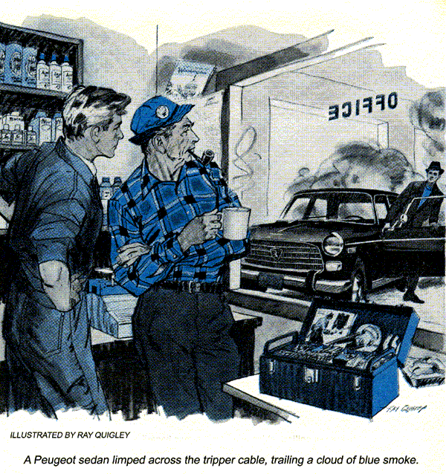
Gus Wilson wheeled his vintage Jeep to a stop in front of the Model Garage. It was almost midnight, but the shop lights were burning brightly, and the big overhead door was open. Through it, Gus could see a late-model hardtop parked next to the test-equipment rack, and Stan Hicks at the rear workbench, leafing through service notes.
"Why the midnight oil on Saturday night?" Gus asked his assistant.
Stan spun around. "Boss, you're back! Now we've got a chance to lick this…"
"Not we," Gus interrupted. "You're chief mechanic around here until Monday morning at eight o'clock sharp. That's when my vacation ends. I just stopped by to pick some extra fishing tackle."
Gus headed for the storeroom behind the office, with Stan tagging after him.
"Boss, have a heart. I've been working on this car since two this afternoon. I promised I'd have it fixed for the Allens to drive to the volunteer firemen's picnic tomorrow. But it's no use. I've tried everything - the car just won't start."
Gus scowled at his watch. "In exactly nine hours, I hope to be reclining in Paul Winter's 16-footer, in the middle of Wilderness Lake. It's a half-hour drive to the cabin, and I plan to get a good night's sleep. However..."
Stan's eyes lit up.
The firemen's picnic only comes once a year, so I'll listen to your tale of woe while I drink the cup of coffee you're about to pour for me."
In a moment, a mug of coffee was shoved into Gus's hand, and a note was waving in front of his face. "Here, read this," said Stan. "It was for you anyway."
Gus looked at the signature and muttered, "Poor Stan."
"Dear Mr. Wilson," he read aloud. "My new car won't start. But when I get it going, it runs fine. I think it needs a different key. Cordially, Daisy Allen."
"For your information," said Stan, "I found that note under the windshield wiper of the hardtop when I arrived this morning. And she's right. The car won't start. The starter spins the engine over okay, but it won't catch."
"And Daisy says the car runs fine…"
"It sure does," Stan answered, "if you push-start it. That's how she got it here this morning."
"What's that business about the key?"
"Jim Allen lost the original keys last week. Our Daisy thinks the duplicates don't work right.
But I checked out the key numbers in the book - the dupes are okay."
Gus propped his feet up and lit his pipe. "Cheer up, there are only two ..."
"Yeah, I know. In 999 out of a thousand cases when an engine won't start it's due to one of two reasons: no gas or no spark. Well, let me tell you something - Daisy Allen's car, like Daisy Allen herself, is that one in a thousand."
Gus opened his tackle box and began browsing through his lures. "You're assuming both gas and spark are okay?"
"Face it, Gus," Stan answered. "They have to be. After all, the car drove in under its own power. But I double-checked, anyway. I talked a customer into push-starting the just after lunch. The big V-8 runs as sweet as a Swiss watch, at any r.p.m. That proves there's plenty of gas and spark."
"Not necessarily…" Gus began.
The lecture was interrupted by a loud clang-clang. Stan and Gus watched as a trim Peugeot sedan limped across the tripper cable, trailing a cloud of blue smoke, and slid to a stop. A tall, angular man threw open the door and jumped out.
"Thank goodness I saw your lights. I never expected to find a garage open at this time of night."
"We aren't really open…" Stan started, but the stranger had already swung open a rear door and was rousing a child sleeping on the back seat. He turned toward Stan. "It's my daughter - she's had it. We've been driving for hours and still have 50 miles to go. The name's Bob Edwards. We're from downstate. What a time for a car to act up!"
Still groggy, the little girl slid out of the car.
Stan sighed. "She'll probably be more comfortable in the office." He shot a helpless glance at Gus, then turned to Edwards. "Okay, I'm the original soft touch. What seems to be wrong?"
"The car won't run unless the choke is pulled out."
Gus looked quizzically at the car, and then questioningly at Stan.
"The engine catches immediately when it's cold," Edwards continued, "but as soon as I push in the choke it starts coughing. It quits dead after a mile or two, unless I pull out the knob again."
"The choke is out now?" asked Stan.
"Yep; I think that's the cause of all this smoke."
"You're probably right. The air-gas mixture is much too rich for normal running, so raw gasoline is washing oil off the cylinder walls. That makes smoke. How long has your car been doing this?"
"For about two weeks," answered Edwards, "every hundred miles or so. But, until tonight the trouble always went away after a few stalls and restarts."
"Restarts?"
"Yes. I could always restart the engine after it died by yanking out the choke knob before I hit the starter."
"Sounds like the fuel system," said Stan, "but it couldn't be - that engine is obviously getting plenty of gas."
"Couldn't is a big word, Stan," said Gus, as he climbed into his Jeep.
"Gus, you're not running out on me now?" wailed Stan.
The wall clock read 12:15 as Gus turned the Jeep's ignition key. "Tell you what, Stan. I'll bet you half my catch tomorrow, against you cleaning the whole lot, that you'll fix both these cars tonight, and still be in bed before me - if you'll keep one fact in mind."
"What choice have I got?" asked Stan. "What are the magic words?"
"Just remember," said Gus, "that starting and running are two very different stages in an engine's operation - different pieces of machinery may be at work." He turned to Bob Edwards. "Since my assistant hasn't looked over your car yet, I'll tell you - your car has no choke."
Edwards jumped up. "Of course it has a choke. I'll show you the knob."
"Nope," Gus answered firmly. "Check the instruction manual and you'll see that it's a 'cold start control.' It acts like a choke, but it's a very different animal."
Gus popped the gearshift lever into first and looked back at Stan who was smiling for the first time that evening.
"Okay, boss," Stan shouted after him. "The bet is on!"
A massive fireworks display marked the end of each firemen's picnic, and Gus saw the first star shell explode over the lake as he was driving home on Sunday evening. He was in a happy mood. The weather had been perfect all day; but more important, the fish had been biting. When he reached the picnic area, he steered into the parking lot.
The park lights were turned off for the fireworks display, so Gus stepped carefully to avoid treading on the picnickers sitting on the grass. He heard a familiar voice behind him.
"Why, Mr. Wilson, you came to the picnic, after all. Mr. Hicks said you went fishing."
Gus turned around. "How are you, Mrs. Allen? I was fishing. I just dropped by to see the fireworks."
"Well, you certainly have a nice young man working for you - one bright enough to listen to suggestions."
"Pardon?" Gus said.
"Stan Hicks, I mean. My note said my car needed a new key, and here it is." The key chain she swirled on her finger carried a shiny new ignition key.
An exasperated voice next to her said: "Daisy, as I've been trying to explain all day, it wasn't the key."
Gus looked past Daisy to her husband. "Hello, Jim. How…"
"Don't ask, Gus," Jim Allen interrupted. "I don't intend to talk any more today about the goofy thing that happened to Daisy's car. Your assistant is sitting right down the road. Ask him."
Gus peered into the darkness. It took him a moment or two to spot Stan sprawled comfortably on the grass.
Gus lowered his length to the grass and slapped Stan on the back.
"Boss, you're back. Glad you made it. How was the fishing?"
"Great!" said Gus. "And I hear from Daisy Allen that you had a good day, too - or should I say early morning?"
"Yep," Stan said proudly, "I fixed both the Allen and Edwards cars in less time than it takes to tell about it."
"Really? I'd like to hear…"
"I'll bet you would. But you're still on vacation. Remember? Until eight tomorrow morning."
"Well, then I'll just have to guess."
A volley of rockets exploded with a shower of glowing streamers. Over the loud "ooh" that rose, Gus said, "The Peugeot is easy. I'd guess a clogged main carburetor jet. A speck of dirt probably bounced around in the orifice for the past two weeks, blocking the jet every once in a while, until yesterday when it lodged in a place permanently."
"That's right," Stan conceded. "Your hint about the car not having a choke steered me to the trouble. Instead of a butterfly valve to reduce air flow and enrich the mixture, the cold-start system in the carb is really an independent jet circuit - almost a second carburetor within a carburetor, designed to provide a very rich mixture for starting. Its jet could deliver gas even though the main jet was clogged. That's why the engine ran when the 'choke' knob was pulled out."
"And the fix?" Gus asked.
"That particular model has a main jet holder that unscrews from the outside. I just removed the jet, blew it out with compressed air, and popped it back in. It took about two minutes."
"One down, one to go," Gus said. "And Daisy Allen is waving a new ignition key around, so I'd bet you replaced the whole ignition-switch assembly."
"Right again, boss. But that was one of the weirdest ignition problems I've ever come across.
I assumed that because there was perfect spark when the engine was running, there had to be a perfect spark when the starter motor was turning. After you left, I tried the oldest ignition test there is. I disconnected one of the plug leads, held it close to the block, and turned the engine over. There wasn't any spark; the engine wouldn't have started if you cranked it all night."
"A bad switch?" asked Gus.
"It was the darnedest thing. The switch had a faulty contact. When the key was turned to the spring-loaded start position, the current to the ignition coil was cut off. So there was no spark when the starter motor was working. But when the key was released for driving, the ignition current came back on. Of course, by then the engine was turning too slow to start."
"Sounds like an hour job, hmm?"
"No, it only took about 15 minutes."
The fireworks had ended and the two men walked over to Gus's Jeep. "Hey," said Stan suddenly, "I won our bet, huh? Where's my fish?"
Gus grinned. He reached into the Jeep and pulled a string of bass. "Here they are," he said.
"Fish for dinner!" crowed Stan.
"Who says?" asked Gus. "You're a little mixed up, aren't you? I bet you would fix those cars in jig time, and you did." He handed the fish over. "They're all yours, Stan - to clean."
END

