January 1968

GUS GIVES THE TEACHER A LESSON

by Martin Bunn
It was a cold day at the shopping center and it grew chillier
when one driver accused another of backing into her
- but Gus soon warmed things up.
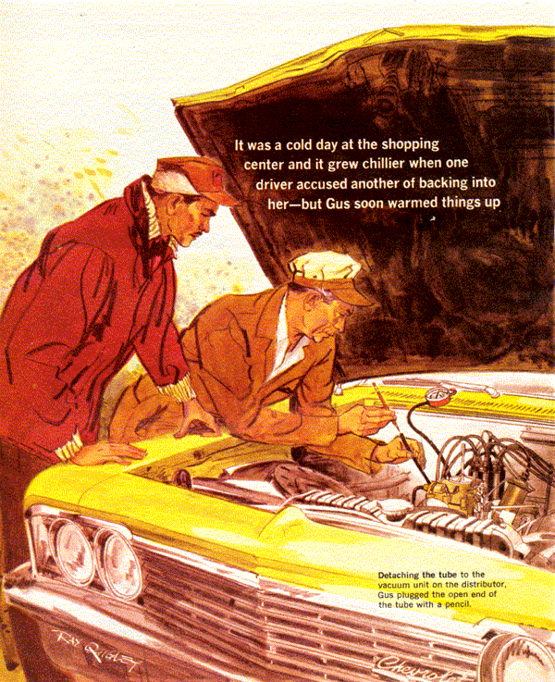
"There was this car that backed in front of mine," said the feminine voice on the phone.
"Suddenly its engine simply roared, there was an explosion, and something hit my car. My engine stalled. Now it sounds funny when I try to start it."
It sounded, thought Gus Wilson, like what his assistant Stan called a kooky complaint. But Miss Fredericks was a regular customer of the Model Garage. She had her '61 Olds tuned up only two weeks ago.
"Where are you?" he asked.
"Crestgrove Shopping Center," Miss Fredericks replied briskly. "North end, third row. I'll keep that other driver here until you check the damage."
She would, too, mused Gus, remembering the girl's firm jaw line, no-nonsense gray eyes, and fiery red hair.
But she was alone when Gus arrived, huddled in her car with the windows up against the cold. A 1966 Chevrolet was backed against the front bumper of the Olds. Gus saw no sign of grille damage.
"I'm so glad you're here," said Miss Fredericks when he came up. "If this man did damage to my engine, I can't afford to pay for his mistake on a physical-education teacher's salary."
"I don't understand how he could have hurt your engine. There was an explosion, you said."
"An awful bang, with the engine simply howling, it ran so fast," replied the girl.
A shadow made Gus aware of someone at his side. It was a tall young man, wearing a short heavy jacket and a hunter's cap.
"I'm back, Miss Fredericks," he said. "Have you established my culpability?"
"We've only begun," she retorted. "This is Mr. Wilson, who takes care of my car. This is Mr. Jeffries, of Buffalo."
Jeffries offered Gus his hand. "But I'm settling down here. Miss Fredericks can easily find me - to sue or whatever."
"Let's try the engine first," said Gus.
The girl turned the key. The starter spun effortlessly, as though the engine had lost all compression.
"That's enough," said Gus. On the back seat he had noticed three filled grocery bags. "You saw all this happen, Miss Fredericks?"
"No. I was moving a bag from the front seat to the back," she snapped. "Naturally, I was looking the other way. But I heard it and felt the shock."
Jeffries nodded. "A backfire, yes. And we did touch bumpers. But my engine was not racing."
The girl glared at him.
"How can you say that? I heard it."
"I wonder if I could talk to the lady alone?" asked Gus.
"Sure," answered Jeffries. He went forward to sit in his own car. Miss Fredericks looked at Gus, her chin out.
"Well, get in out of the cold," she suggested, sliding over on the seat.
Gratefully Gus did so, for the day was on the brisk side.
"First of all," he began, "your engine will start normally in about 10 minutes, with no help from me. Meanwhile, you can be grateful your drive selector was in neutral. Otherwise you'd have hit that man's car hard enough to get hurt, and maybe injure him, too. Or, with no car in front, you could have crashed through a storefront or into shoppers."
The girl stared at Gus in horrified amazement. "I wasn't even moving!"
"Luckily. When you turned to put that bag in back, your right foot flattened the gas pedal.
What you heard wasn't the other car's engine, but your own, racing wide open. Some drivers who've done that - to manhandle packages, grab the children, or help a rear passenger open a door - have wound up in a hospital or sent the other people there because they left the selector in drive or reverse."
"Oh, I never dreamt - I'm so sorry," breathed the girl, looking up in dismay.
"Now, about your engine," continued Gus. "It stalled at peak speed because in running wild it whipped the oil into a froth. The valves are raised by hydraulic lifters, a plunger in a small cylinder, with oil between the plunger and lifter body. Normally oil is incompressible, solid as steel. But the air-oil foam wasn't.
"When it reached the lifters, they could no longer raise the valves. No air-fuel was taken into the engine cylinders. There was nothing to compress or fire, so the engine quit. Just as well. If it had kept running, oil failure might have made it seize."
Miss Fredericks sat silent for a time.
"We'll try the engine in a minute," said Gus. "Want me to tell Mr. Jeffries you won't sue him after all?"
The girl smiled. "It was my goof, so it's my job to apologize."
Gus nodded, and turned the key. After spinning a few seconds, the engine regained the normal pulsation of compression. An instant later it fired.
Late that afternoon, Jeffries drove his Chevrolet into the Model Garage, cut the engine, and got out.
"You did me one good turn," he told Gus, "so I came to try for another."
"What might that be?" asked Gus.
A muscle on the young man's cheek twitched. "My engine began giving trouble this fall. It would start fine cold, but balk when warm. It also began missing at road speeds, running hot, and back-firing. First thing everybody thought of was ignition trouble. By now this is probably the best-ignitioned car on the road.
"It's been checked and checked. It's had new plugs twice, all new wiring, a new condenser, coil, points, rotor, and distributor head. Finally I was sold a complete new transistor-ignition unit. Nothing's made any difference. Listen."
Getting back in, Jeffries turned the key. It took four tries to start the engine, and then its idle was rough, with what Gus's ears identified as a lean-mixture surge. Jeffries jazzed the throttle.
The engine sputtered, backfired violently before settling to speed.
"I'd say it's carburetion, not ignition," remarked Gus as Jeffries shut off the engine.
"So they said in Syracuse, where I stopped last. Running too lean, they told me. They checked the carburetor-bowl level, put in a new fuel filter, tested the gas line and fuel pump, and looked for air leaks. But it still misses. Now for the good turn I need - could you fix it by tonight? I'll hang around and wait for it."
"Sounds sticky. I can't promise."
"Sure wish you could - it's important to me," muttered Jeffries. "My hunch is that new transistor system wasn't installed right. Do me a favor and check that first. After all they did in Syracuse only yesterday, it can't be carburetion."
Half an hour later Gus disconnected and put away his ohmmeter, timing light, voltmeter, and plug scope.
"Could be this is the best-ignitioned car on the road," he told Jeffries. "It checks out fine.
Timing's right, plugs good and correctly gapped, wiring in fine shape. No cracks or carbon streaks on the distributor cap or coil. The pickup coil in the distributor checks at 350 ohms and isn't grounded. Spark's good. So is the ignition-pulse amplifier.
"The distributor leads aren't reversed, which often causes a surge like a lean mixture, but worse. Same thing could be caused by an intermittent open in the pickup coil or its circuit."
The muscle in Jeffries' jaw twitched again. "Anything else you can try?"
"Yes," said Gus. "I'd like to see whether it's carburetion."
From a corner Gus rolled out a stand carrying instruments. With the engine running and an exhaust hose on the tail-pipe, he removed the air cleaner. Nothing changed until he partially covered the air-intake horn with a hand. The engine perceptibly picked up speed.
"It sure is running lean," he remarked. "Hear it speed up when I cut down the air to the mixture?"
Nodding, Jeffries nervously looked at his watch. Gus disconnected the windshield-wiper hose from its fitting on the intake manifold and hooked up a vacuum gauge in its place. It read about six inches of mercury below normal.
He inspected the throttle shaft. It wasn't worn enough to cause an air leak. Running a thread of oil along the carburetor and intake-manifold joints, Gus looked for it to be sucked in, so indicating an air leak. There was none.
"Thought you wanted to check the carburetor," remarked Jeffries.
"Carburetion," corrected Gus. "Which doesn't stop at the carburetor."
Detaching the tube to the vacuum-unit on the distributor, Gus plugged the open end of the tube with a pencil. The vacuum needle at once indicated 21 inches of mercury, fell as Gus accelerated the engine briefly, and returned to its high reading at idle.
Gus killed the engine. Whistling, he removed the vacuum unit. At a bench, he opened the casing - and stopped whistling.
"There it is," he said. "Where the diaphragm is crimped into the housing, it's cracked right along part of the edge. When cold, the diaphragm is stiff enough to keep the crack almost shut. But once warm, it's so limp the manifold vacuum pulls it away, opening the crack wide.
All the extra air made the engine run constantly lean, and caused the missing and backfiring, besides making it over-heat and start hard when warm."
"That bit of junk's what had me running to mechanics all these months?"
"It let in a lot of air," said Gus.
"I'm mighty glad you found it," said Jeffries, looking at his watch. "It's late. You got a new whatchamacallit in stock?"
"Wouldn't have busted this one apart if I hadn't," chuckled Gus. "We can have you on your way in 15 minutes."
Good as his word, Gus closed the hood on a smoothly idling, responsive engine.
"Want a road test?" he asked.
"Uh-no. I'm in a hurry. Forgot to tell you - I'm the new history teacher at the high school."
"Oh, yes. That's where Miss Fredericks teaches, isn't it?" asked Gus innocently.
"Sure. That's - " Jeffries hesitated.
"That's why you wanted a sweet-running car tonight," finished Gus. "But I don't think a balky engine would put her off."
Jeffries laughed. "Guess not. She's a strong-minded girl. But I didn't want to start off apologizing for driving a klunker - nor for being late on our very first date!"
END

