October 1967

GUS GIVES

A COUPLE OF POKER PLAYERS A HAND

by Martin Bunn
When one of Gus's poker pals
accused another of selling him a lemon,
Gus had to play his cards right to restore peace…

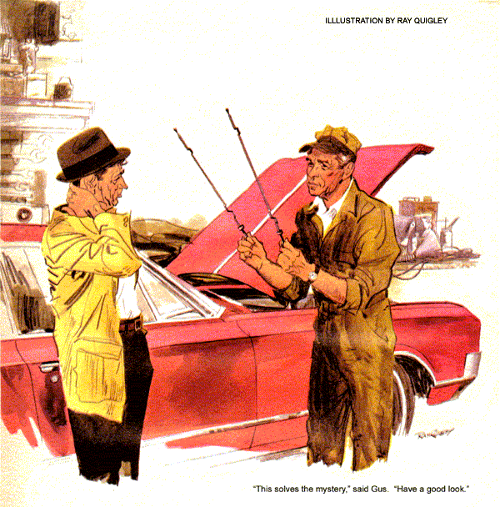
"I fold," muttered Pete Vancourt, throwing down his cards. "George is too lucky for me. I should have known."
"Meaning what, Pete?" demanded George Bell, pausing in the act of raking in the pot.
Vancourt's lantern jaw assumed a stubborn set. "Meaning you can take care of yourself, more ways than one."
Gus Wilson gathered up the cards. "At these stakes," he quipped, "George won't get rich, even if he is the big winner."
"Maybe Pete's soured on that car he bought from George," offered Sam White, the local used-car king, with heavy humor. "And if you fellows keep on selling cars to each other, I might just as well retire, too."
"What it is," put in Ed Hastings, "is that Pete's just jealous of the white Cadillac convertible George bought to replace - for his old age - the Olds he sold Pete."
Bell flushed, his plump red cheeks a bright contrast to his snowy hair.
"If you've got a beef about the car, Pete, come out with it," he said.
The Adam's apple in Vancourt's throat bobbed. "Well, I have. That slush-pot transmission's got no pep, and the engine's all smeared up as though sprayed with an oilcan. It was clean when you sold me the car, but the man at the Five Corners station where you buy gas told me it's always been greasy. He calls it the Oily Olds."
Bell nodded his white-thatched head.
"Sure. I've had the engine cleaned three times, last time a month ago. It always gets oily again, but it doesn't use any oil. Bet you haven't added any since you bought it."
"No," admitted Vancourt grudgingly. "But there must be something wrong and, one of these days, I'll be stuck with a big repair bill."
"Hey!" protested Gus, "Are we going to play poker, or chew on about cars?"
The cards fell and the game went on.
Gus showed no surprise when Pete Vancourt rolled into the Model Garage next day in a well-kept 1965 Oldsmobile. Pete's usually sardonic face was wearing a sheepish grin.
"You heard me blow off last night, Gus. Maybe I'm off base; maybe not. Either way, I want to know."
"George Bell isn't a fellow who'd unload a lemon on a friend," remarked Gus.
"I didn't think so, either. But he wanted that Caddy awfully bad, and he did clean up the engine before showing me the car. Something's sure spraying oil around. That can't be good, can it?"
"No," admitted Gus. "Gun the throttle a bit after I get around in back."
As the engine roared briefly, he watched the exhaust. It was normal.
"You notice any blue-gray smoke on the road, especially when coasting down the hill or on deceleration?" asked Gus.
"Can't say I do," answered Vancourt.
Gus signaled him to cut the engine, and opened the hood. The valve covers, manifolds, and air cleaner all showed an oily film, especially at the back of the engine, but there was not indication of oil coming from the filler cap, nor any oil-washed areas to suggest leakage from valve covers, fuel pump, or other visible joints.
Gus wiped a finger on the film and sniffed it, then pulled the dipstick. The engine oil was at the Full mark, with no trace of water or smell of gasoline in it. He unscrewed and inspected a spark plug, then replaced it.
"I don't think this oiliness is from the engine. It isn't burning oil, and there's no water or gas dilution in the crankcase to make up an oil loss."
Vancourt grunted. Gus had him restart the engine and run it for a minute at fast idle, the lever in Park. Then, the engine at normal idle, Gus pulled the transmission dipstick. It showed fluid near the Add mark. He smelled it, then stared at the dipstick.
"Well?" asked Vancourt impatiently.
Instead of answering, Gus walked across the shop to another Olds, in for a brake job. His assistant Stan looked up in surprise as Gus raised the hood.
Pulling the dipstick from the automatic transmission, Gus compared it with the one he held, and took it to Vancourt.
"This solves the mystery of your oily Olds," said Gus. "Have a good look."
"They're exactly alike, of course."
"Exactly. That's just the trouble, Pete. Your dipstick is the wrong one," said Gus.
"But they're both from Oldsmobiles."
"Yes, but this one is from a Jetaway transmission. Yours is from a Turbo HydraMatic. On the assembly line or later, somebody put a Jetaway dipstick in your car. The right one for your car is almost four inches longer.
"Using this wrong dipstick, when fluid is at the Full mark, it's really about three quarts over! So fluid blows out of the breather, all over the engine.
It also foams inside, making the torque converter inefficient. Once the excess is drained, you should get better performance."
"So I was off base," said Vancourt. "Poor George. You fix it, Gus, while I think up a painless apology."
"Come get it tonight," said Gus.
A horn sounding outside, next morning, brought Gus to the fuel pumps. A '67 Cadillac convertible, spotlessly white, stood there.
"Fill it up, Gus," said Bell from behind the wheel. "And add oil."
Gus checked. It took a quart of oil.
"I sure do thank you for straightening out that thing between Pete and me," said Bell as he paid up.
"Glad to help," said Gus. "This the car the boys were kidding you about?"
"It's a childhood dream," confessed Bell. "When I worked for Oliver Kipp, in his drugstore years ago, he had a white Willys Knight. Ever since, I've wanted a fine, big, white car like that. When I was about to retire last fall, it seemed farther away than ever.
"Then Jim Wheeler, our comptroller, was transferred to the coast and didn't want to drive out. He put this car up for sale. He hadn't expected the transfer so soon, and the engine was being overhauled at Garretson's when I bought it. I sold Pete my Olds to help pay for it, and my wife and I planned a country-wide tour - another dream."
"When are you going?" asked Gus.
Bell's voice got husky. "Looks as if we can't afford it, not in this car. It guzzles oil. We made a few short trips, and every time I get gas it takes a quart of oil - or more. My brother-in-law, who thinks I'm wacky at my age to enjoy a car like this, is having a ball saying 'I told you so."
"But worse, if we resell the car at a loss to get another, my pension won't stretch to cover any big tour, even the way we had it budgeted. Seems we'll have to settle for rocking chairs."
"Move over," ordered Gus. "We're going for a road test. Then we'll see."
Bell slid over. Behind the wheel, Gus headed for a highway. There he accelerated to 45, then suddenly let the throttle snap shut. Blue-gray smoke billowed from the exhaust. After speed had dropped to 15, Gus suddenly floored the gas. A big puff of smoke resulted.
"It's burning oil, all right," he reported, turning the big car around.
"Means a ring job, doesn't it?"
"Not necessarily. Oil can get into the combustion chambers through worn valve guides or, in some cars having oil passages in the block, past a damaged head gasket. You can get too much oil into the valve chambers - which will then get into the cylinders - because the return passages are clogged, or even because rocker shafts are in upside down.
"If there are external leaks, too, you lose oil two ways. Even one drop every 100 feet of car travel can mount up to a lot of oil. When bad rings or a clogged crankcase ventilator lets pressure build up in the crankcase, oil will come out at places you'd never suspect - places that would never leak otherwise."
Bell sighed. "If you think there's a prayer of curing this oil hog, Gus, let me out downtown and go to it."
"I thought," answered Gus with a grin, "that you'd never ask me."
By late afternoon, Gus was all but ready to admit himself stumped. A compression check showed the rings were sealing well. Though the car had considerable mileage on it, there were no external leaks. The valve guides had been fitted with seals. Oil-return passages in the valve chambers were clear, the PCV system showed equal signs of oil fouling, which ruled out a local internal leak. That would have affected chiefly the nearest cylinder.
Gus called the Garretson shop.
"Tell me, Dave," he asked the shop foreman, "do you remember what you did when you worked on Jim Wheeler's white Caddy?"
"Valve grind, valve seals, new rings, new fuel pump, complete tune-up."
A faint bell rang in Gus's memory.
"Those rings - did your man pick the right oversize, check the gap, and install them chamfer up?" he asked.
"You think we're shoemakers?" asked Dave Skelly in an injured tone. "Sure he did, but I'll check with him."
"Yep," reported Skelly in tones dripping with sarcasm. "He miked the bores, got the right gap, put the chamfers up."
"Sorry about that," said Gus. "I know you stand behind your work. This is a job you people are going to have to make good on."
Just about closing time, Bell walked into the Model Garage office. "Any luck with my car, Gus?"
"None of those troubles I told you applied," returned Gus with a grin. "It's the rings, after all."
"I was afraid of that," Bell said.
"Don't be. It won't cost you anything. Garretson's goofed. But they're fair, and they're going to make good. They put the rings on the pistons upside down, chamfers up, same as they are in 1966 Caddy engines.
"The '67 engines should have the chamfers down on the compression rings. All rings are marked, with a dot or a little o near one end. This has to be up in the groove, toward the top of the piston. But the mechanic, after installing a lot of rings in '66 engines, by force of habit put yours in the same way. So, instead of scraping oil back down into the crankcase, the rings pumped it up into the combustion chambers."
Bell's face crinkled into a grin. "If it works out, maybe I'll have the last word over that smart-aleck brother-in-law. And we'll have our trip."
Gus made out a bill for his work and handed it to Bell.
"Say, it seems to me I owe you for more than this," remarked Bell. "You not only settled Pete's hassle with me, but you're saving me a lot I'd spend on oil."
"That's okay," returned Gus. "I expect a bonus out of this pretty soon."
"What bonus? When?"
"A peaceful poker game," answered Gus, "come next Saturday night."
END

