May 1967

GUS AND THE CAR

THAT STOPPED ON SIGNAL

by Martin Bunn
Mrs. Fogarty's car seemed to be allergic to traffic lights.
It sometimes quit cold at the very first one on the way to town.
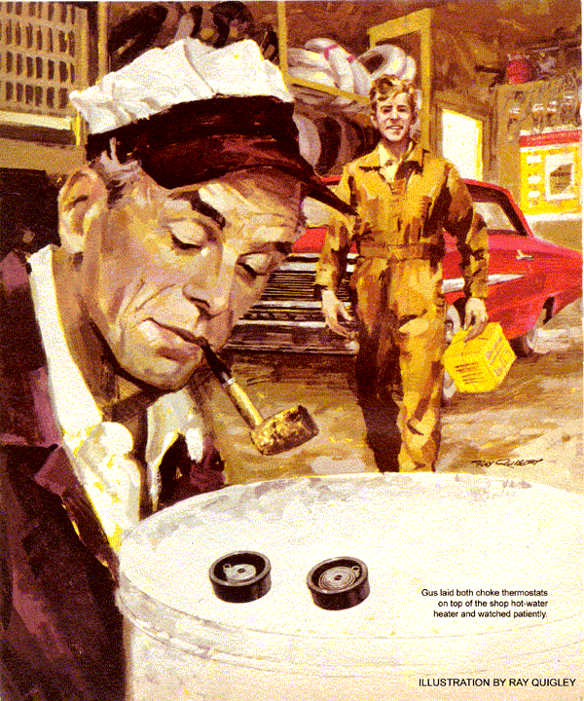
"Anything new since I left early yesterday, Stan?" asked Gus Wilson, putting on coveralls to begin a new day at the Model Garage.
"Perkins came for his car. Silas Barnstable stopped to beef about gas going up - though he'd bought it at the self-service station, not here. And a Mrs. Fogarty came in with a wild story. But I got her car out pretty fast," replied Gus's helper.
"What was the story?" asked Gus.
"She said her '62 automatic-drive Ford has been cold-stalling all winter, even after a carb overhaul. She thought it would be okay once the cold weather was over, but the engine was still quitting - only on a different timetable, now it's mild."
"It stalls on schedule?" demanded Gus.
"So she said. There are three traffic intersections between her house and town. In winter, any time she had to stop at the third light, the engine bucked and stalled. In this weather, it quits if she has to stop at the second light. On those real warm days we had, it would conk out at the first light. Some yarn, huh?"
Gus switched on the coffee pot.
"Did you find out why?" he asked.
"Aw, Boss, the whole thing's kookie. I checked everything. The automatic choke was at the right notch, fast idle worked fine, hot idle was on the button. The choke wasn't binding. The heat tube was new - I made sure it was clear and tight in the manifold. The heat-riser valve worked okay.
But the points were worn and the timing was two degrees retarded. I put in new points and retimed it. What else could I do about that wacky story of hers?"
"Driven the car - cold - through those three lights," said Gus with a grin.
"Huh! You know how weird women drivers can be. Now you take Daisy Allen - "
"You take her," interjected Gus, heading for his office. "She's driving in."
Mrs. Allen tootled in, driving a small Mercedes. She got out, a trim and pretty woman wearing an outrageous hat that looked like a spaceman's helmet surmounted by a seagull.
"Oh, Mr. Wilson," she chirped. "You've done such good work on my car that when my brother said he wanted some work done on his, I brought it right over."
Stan set her straight on names.
"Not that there's anything wrong with the car," she went on. "It's him - he drove up from Florida to visit me, and sprained his ankle right on our porch step. The doctor says he has to stay off it another 24 hours and he has to be back in Florida by Wednesday - it's terribly important to the government. So he thought if I dropped his car off, he could pick it up tomorrow morning."
"Yes, ma'am," said Stan. "You say there's nothing wrong with the car? What's it need - a lube job?"
"Oh no, it's the battery. He drove all night to get here, and it didn't charge up enough. I had to coast down to start the engine. So he wants you to put on a new water pump."
"A new what?" gasped Stan.
"Water pump. That's what he said."
"Because the battery won't stand up?"
"That's right," replied Daisy Allen. "You have to put water in the battery, don't you? Well, I suppose that has to go somewhere and do something, only it isn't, because the pump isn't working. And if you don't mind, I'll sit down until Mrs. Fogarty comes to pick me up."
Stan nodded numbly, feeling the need to sit down himself.
Before he recovered, Mrs. Fogarty drove in, giving him that steely glance a sergeant reserves for a recruit with two left feet. Her ramrod-stiff back and ringing voice bore out the resemblance.
"Young man," she declared, striding up to Stan, "you haven't done a thing for my car. It stalled at the second light."
"I - I guess I didn't find the trouble, ma'am," stammered Stan.
"No. What are you going to do about it?"
Gus emerged from under a hood.
"Morning, Mrs. Fogarty. Since you need a car, suppose you borrow mine and leave yours here and we'll have another try."
As the women left in Gus's coupe, Stan morosely kicked one of the Ford's tires.
"Park it outside in the shade," ordered Gus. "When it's cool, I'll test-drive it."
When Gus came back from lunch, Stan was at work on the Mercedes and the Ford's engine was cold. It started up immediately.
The day was springlike but cool. Gus headed for a clear road. On reaching it, he stopped. The engine kept going, still on fast idle. He drove a long block and stopped again. The engine never faltered. Again Gus started up and stopped.
As he did, the engine gulped for an instant and stalled. It restarted with no trouble. When he stopped a fourth time a block farther on, it kept ticking over, on slow idle now. He returned to the shop.
Before Gus could get out, Stan was at the car window.
"Gus, the radiator's full up and there's no sign of leaking at the pump. You think I should put a new one on that Mercedes?"
"How about the generator?"
"The battery's low, so I checked the generator and voltage regulator," declared Stan in an injured voice. "The fan belt was a bit slack. After I tightened it, generator output was just dandy. Do I put on a new pump or don't I?"
Lighting his pipe, Gus pondered.
"From what you just told me, I think we'd better. After we check out what I'm thinking, of course. Loosen the fan belt."
Stan went back to the Mercedes, while Gus parked the Ford in a work area. Then he went to the Mercedes, grasped the pump pulley and checked it for play.
"Looks as if Mrs. Allen was right," he declared. "We'll have to put on a new water pump if we want to keep that battery charged."
"Relax, Stan. I'm not nuts. The pump bearings are worn. On a Mercedes, the pump will keep working for a time anyway, but the fellow who owns this car slacked belt tension so that it wouldn't wear the bearings still faster.
"The trouble is, he didn't figure on the extra electrical load of a long all-night drive. Under these conditions, belt slippage was enough to cut down his charging rate - that loose belt couldn't pull the generator at full speed. Since he'll probably be driving at night again when he goes back, he figured he'd better get a new pump put on the car first."
Stan grinned weakly. "Makes sense, Gus, when you tell it."
Gus returned to Mrs. Fogarty's Ford. By now he felt pretty sure that the trouble was in the automatic choke, though, as Stan had said, it worked freely and was set at the right notch. Nevertheless, Gus pulled off the thermostat for a look inside. It was perfectly clean; the carburetor venturi was gleaming, too. Evidently both had been serviced not long before.
As Gus began to put the choke thermostat back on, something else registered. The bimetallic thermostat spring looked odd. It was not perfectly spiral, and one turn touched the next instead of clearing it.
From his parts stock, Gus selected a new choke thermostat of the same model. He took it out of its box. Its coil was a smooth spiral. Taking both the old and the new thermostats outdoors, he left them to reach the same temperature.
When they had done so, Gus laid both on top of the shop hot-water heater and watched patiently. As warmth expanded them, the old coil unwound much more quickly than the new one.
The shop door banged, and Stan bounded in, back from downtown with a new Mercedes pump. He looked curiously at the two unwinding thermostats.
"That's Mrs. Fogarty's trouble?"
"Sure. The old coil opens too fast," explained Gus. "That leans the mixture too soon for a cold engine. It also lets the fast-idle screw drop off its cam too early. So the engine stalls that much easier. All the car needs is a new choke thermostat."
"Want me to put it on, Boss?"
"Go ahead. I'll do the really rough part for you, if I have to."
"What tough part, Boss?"
"Explaining to Mrs. Fogarty why we didn't spot the grief the first time," answered Gus, smiling.
But when the two ladies brought back Gus's car, Mrs. Fogarty was content to hear that what had caused the stalling had been set right.
"We have that new water pump for your brother's car, Mrs. Allen," said Gus. "But it isn't installed yet. Want to wait?"
"No, I have to get home. We're attending a dinner for Stevie - my brother. I'll drop him off here to pick up the car in the morning," she replied.
"Stevie?" mused Stan as the women drove out in the Ford. "That figures. I wondered what the brother of that dame would be like. Probably a kook, too."
"Stan," said Gus gravely, "that's no way to talk about a good customer."
Early next morning, a car paused briefly outside to drop off a passenger. A man limped into the shop, leaning on a cane. But he was tall, well built, and wore an Air Force uniform with a colonel's insignia. Gus had never seen him before, yet there was something familiar about him.
"My sister, Mrs. Allen, left my Mercedes here to have a new pump put on."
"Right. It's ready for you," said Gus. "We also charged the battery overnight."
He got the bill while Stan brought the car forward.
"She didn't give me your name," remarked Gus, preparing to write the bill.
"Stephen P. McRae," said the officer.
Getting out of the Mercedes, Stan froze with one foot on the ground. "Hey, you're the Colonel McRae who was decorated for Vietnam. Your picture was in the paper."
McRae nodded and paid the bill.
"We're both proud to have you as a customer, Colonel," said Gus.
"Yeah," breathed Stan. "But one thing bugs me - no, forget it."
Seated in the car, McRae grinned.
"You want to know how a fellow can go through a war and then come home and sprain his ankle stepping off a porch, eh?"
"Guess I had a nerve to…"
"I just goofed," said McRae. "I was telling my sister about my battery trouble and wanting to get a new pump. So she began to explain, in her own special way, why a worn pump could run down a battery. There's something about my sister and her matchless explanations -" confided McRae with a wry grin. "That's when it happened."
END

