October 1966

GUS AND THE ENGINE

THAT WOULDN’T STOP

by Martin Bunn
The car's engine refused to turn off -
and the garage door went up and down by itself.
Was Uncle Ben's ghost at work?
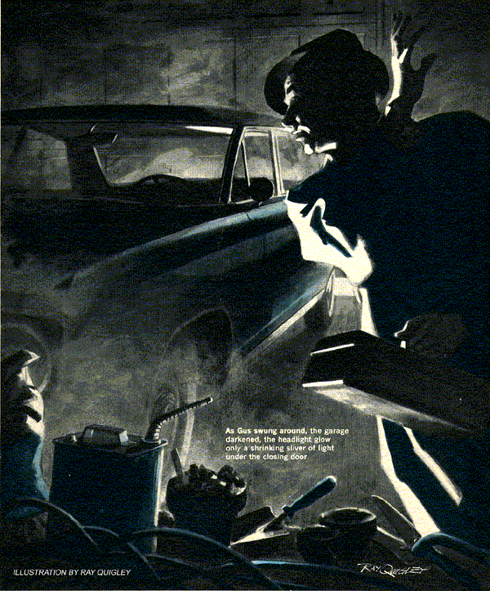
Wind blew the neon motel sign aslant, and drizzle clouded the car's headlight beams. To Gus Wilson, driving since six that morning from an upstate fishing spot, the word 'Vacancy' looked mighty good.
He swung off before the motel office. A bucktoothed man in a striped shirt rose from a chair as Gus walked in.
"Got a single left for me?" asked Gus. "All I ask is a good bed."
"Best in the state." The motel keeper shoved a card before Gus. "In number 10."
Gus laid down a bill. The phone rang.
"Starkey's Motel," the man said, laying the change before Gus. "Gosh, Mrs. Bates, I can't help you…Ryan's away till tomorrow. We got no other mechanic."
From the receiver Gus could hear a thin, pleading, and very distressed voice.
"I'm real sorry, Mrs. Bates. Ain't a thing I can do… No, on a Sunday night no garage'll be open… Okay, I'll call if I think of anything. But don't count on it."
Starkey hung up. "Women drivers! She just drove home from a movie with her kid. Now she wants a mechanic to come shut off the engine! Says she took the key right out but it won't stop runnin'. How about that?"
"It may be dieseling," remarked Gus. "You might call her back, tell her to put in gear and let the clutch out with the brake on.
That'll stall it."
"Dieseling? What's that?"
"Firing on compression, without any spark," explained Gus. "Happens sometimes, especially with a lean mixture or late timing, if the idling speed's too high."
"Well, she says she tried putting it in drive, but it's an automatic transmission and won't stall," Starkey frowned. "She does sound scared to death, but she always has seemed sort of nervous like."
"What kind of garage has she got?"
Starkey cocked his head in concentration. "Mm - attached. Un-huh, it's on one end of that ranch house Ben Gale built just before his wife died. Then he went and got himself killed in that big car of his. Mrs. Bates - she's a widow - inherited."
Eager to get to bed, Gus pondered the danger to the occupants of a house with a car idling all night in an attached garage.
"I'm a mechanic," he told Starkey. "How far away is her place?"
"Bit over a mile. Look, Mr. Wilson, she may be a kook. Twice she called the troopers to look for a prowler. They never found none. And her kid told mine the house is haunted by her Uncle Ben, who died in that accident like I told you."
"Call her back, will you?" asked Gus. "Ask her whether she wants me to come."
Starkey made the call. The voice from the receiver calmed as he spoke.
"That's better," he said, hanging up. "She says she'd be awfully grateful, and pay anything you say, if you'll come right out. Take the right fork half a mile…"
The storm was blowing up heavy gusts now, at times dousing the windshield. Just before he found the house - high on a knoll - Gus saw the lights of a plane flashing through the murk. As he turned into the driveway, his headlights fell on the rear of a car in the open doorway of a garage. If he'd known, thought Gus, he could have gone to bed. There wasn't much danger of carbon monoxide in the house.
As he stopped, a woman ran out to him.
"Thank you for coming! If you can stop it tonight, we'll pack and leave tomorrow."
She was probably in her thirties. Blonde hair blew from under the raincoat she had pulled up over her head.
"I'll see to the car," said Gus, "and let you know when it's okay. Go back in."
The woman nodded jerkily. "I will - I came out to open the garage. It's an electric door. You have to push a button."
Her glance went toward the garage, and her eyes flared in fright. "It was shut..."
She ran back to the house. Faintly echoing from the night sky came the distant roar of a jet.
Gus picked up his tool kit and briskly approached the garage in the glow of his car's lights. Inside, its exhaust burbling smoothly, was a 1964 Olds sedan.
The fumes within were thicker than he had expected, as if the door had indeed been shut and only now opened. Breathing shallowly, Gus sidled past the Olds. The sound of the jet suddenly became louder.
It wasn't a jet he heard, Gus realized, but a much closer, mechanical noise. As Gus swung around, the garage darkened. The headlight glow was a shrinking sliver of light under the closing door. The door clanked down and he was in utter blackness, the only sound the deadly chuckling of the exhaust.
Fumes acrid in his throat, his pulse suddenly pounding, Gus opened his tool kit and fumbled for his flashlight - then remembered leaving it in the glove compartment. He groped along the car to a door handle. As he yanked it open, the courtesy light flashed on and showed the keys on the seat. Gus snapped on the headlights, revealing a door to the house. Gus sprang toward it. The door didn't give; it was bolted on the inside.
Breathing hard now, Gus realized time was running out. Even if he could stop the engine at once, it would be dangerous in the fume-filled garage. He looked about. On the collar beams overhead loomed the bulk of an electric door mechanism, an empty socket where a bulb should have been. He followed a conduit from the unit to the electric panelboard, then traced an armored cable from the mechanism, down a door jamb, to a small box with a button on it.
His chest straining for more air, Gus stumbled forward and pushed the button. The garage door began to rise. He slipped under while it was only waist high, and outside gulped great lungfuls of air.
The soaking downpour had stopped. It was some time before Gus felt up to entering the garage to back the Olds out just ahead of his own car. Then he opened the hood, and took off the positive battery cable.
The engine kept right on running.
With a dry handkerchief, Gus grasped the ignition cable and pulled it out of the coil socket. The engine stopped. It hadn't been dieseling, but firing on ignition that somehow bypassed the switch.
Gus grinned with instant recall of one of the oddest service bulletins he had ever seen. He replaced the ignition and battery cables, then turned the key in the switch. The oil-pressure light glowed; the generator warning light did not. Gus turned the switch off and wriggled under the dash.
Turning the socket of the generator light in the printed circuit panel, Gus released its bayonet catches and pulled it out with the bulb in it. Snapping the bulb out of its clips, he looked at two bare wires emerging from the glass end. Badly kinked, they had been bunched together as the bulb was pushed into the socket.
Straightening both, he folded one over each side of the glass, then pushed the bulb back into the socket and replaced it.
Turning on the ignition brought both warning lights to life. As the engine came on, they winked out. Gus drove into the garage, shut off the engine, and came out.
A loud rumbling swung him about. The door snapped down almost on his toes. Looking up, he saw a jet speeding through the night. He headed for the house.
The instant he rang, Mrs. Bates opened the door, looking as distraught as before.
"Do come in. There's some hot cocoa."
The house smelled of exhaust fumes. A small boy asked sleepily, "Uncle Ben?"
"No, Jimmy. Uncle Ben's gone." She turned to Gus. "Such an imagination!"
"Imagination can play tricks on any of us," remarked Gus, accepting a cup. "Take that engine you couldn't shut off. We're so used to having it stop when we turn the key that it seems supernatural if it doesn't."
Mrs. Bates looked down at her hands.
"Well, there are more things…" She looked full at Gus. "It isn't Jimmy's imagination. It's me, running scared from this house - Uncle Ben's house."
"It seems a very nice one," said Gus.
"He didn't want me to have it. When my husband died, I-I had a nervous breakdown. After I was all right again, Uncle Ben was killed, leaving no will. As next of kin, I got his house and a little money, and we moved in. But I know now we can't stay."
"Because the car acted like that?"
"Don't laugh at me, Mr. Wilson. First there were roof noises. A repairman found some loose shingles he thought were flapping in the wind. Those noises stopped, but then the garage door started to go up and down by itself. Once it hit the top of the car as I was driving out.
"I've tried to convince myself that it was the shingles, that electric gadgets do act up at times. But when that engine refused to stop tonight, I knew somebody - or something - wants me away from here."
"One thing at a time," said Gus. "Your garage door is being triggered by the radio."
"Radio? You push a button to open it."
"You do. But your uncle must have had a transmitter in the car to work it."
She shrugged. "So it's a radio ghost."
"No," said Gus. "It's a jet pilot. A month ago an Air Reserve unit began operating out of the airport near here. I remember reading that. When a plane overhead calls the tower, its radio signal trips the garage receiver. It's probably an old type; the new ones are more selective. I saw it happen twice - and the planes that did it."
Mrs. Bates stared at him.
"But the car. It never did that before - never. It was as if he - like something telling us to stay in the car and go away - to leave this house."
"Didn't you have some trouble with one of the warning lights today?" asked Gus.
She drew a sharp breath. "Yes. I left the car for an oil change while in the movies. The man said the oil light hadn't come on and he checked the bulb. When he started the car again, it did come on and we drove off with no trouble."
Gus grinned. "He pulled out the generator warning light first by mistake, then short-circuited its leads when he pushed it back in.
That short let current flow from the alternator, through the fuel gauge circuit, around Robin Hood's barn, to the ignition coil. The alternator puts out juice even at idle, so it kept the ignition working after you switched off the normal circuit, and you couldn't stop the engine."
The blue eyes blinked. A tremulous smile played over the woman's lips.
"You mean, I've been - been just a fool? There isn't any spooky Uncle Ben?"
Gus set down his cup and stood up.
"That's right. You can have that garage receiver disconnected, and if the car should ever keep running again, just leave it outdoors. But so far as spooks are concerned, there isn't a ghost in a carload."
END

