November 1966

GUS PUTS THE BRAKES

ON A WHEELER DEALER

by Martin Bunn
A Vietnam veteran, just back from the wars
and starting a new job,
wins a battle on the home front when -
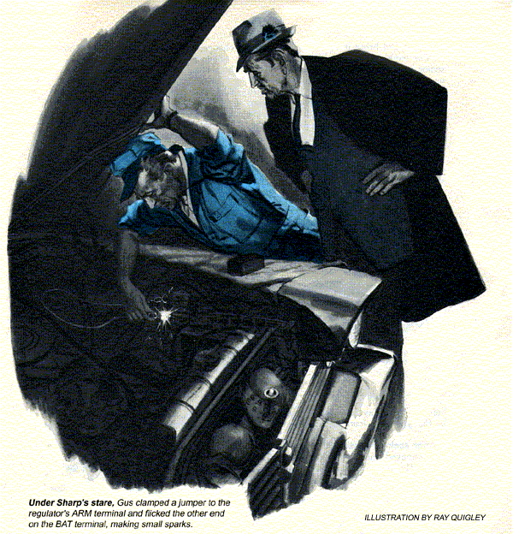
Clanging to the door of the Model Garage, a hubcap rolled a foot or so before Stan could grab it.
"Third thing I've dropped today," he said. "Wonder what that means."
"Greasy fingers," said his boss, Gus Wilson.
"Threes! Got a feeling something'll happen in three today, Bet you a buck,"
"On a long shot," declared Gus, "you get odds. Your buck against a steak."
Stan grunted agreement, and whacked the hubcap on with the heel of his hand.
As he stood up, a '63 Olds, gleaming under a wax job, rolled in. It was driven by a spare, gray-haired man Stan vaguely remembered seeing around town.
"Name's Ben Starr of Four-Star Realty," said the driver. "One of my salesmen recommended your shop when I was beefing about a squeak I have under the hood."
"When does it sound off?" asked Stan.
"Usually when I'm parking."
"I'll take a look at your power steering pump and belt. Will you shut it off?"
Star did so. Stan felt the tension of the thin V belt that ran over the crankshaft, water pump, and hydraulic-pump pulleys. It was a little too tight.
"Shouldn't be the pump," said Starr. "They overhauled it a month ago. When I complained about the noise, the mechanic said the belt hadn't worn in yet."
Stan shook his head, then crouched to sight along the belt.
"It'll wear, alright," he said, "the way they installed it. The belt is over one-eighth inch out of line on the pump pulley. When you load the hydraulic system by making a quick turn, the misaligned belt rubs on one flange and squeaks."
"That bunch of plumbers! They got the pump out of line?"
"No, the pulley. On this model is can be put on backwards. That's what they did."
As Stan got to work removing the belt, Gus greeted Starr, whom he knew slightly.
"Jeff Hornsby was saying he'd bring his car to you," said the real-estate man. "So I thought I'd let you look at mine."
"Glad if we can help," said Gus. "I read that Jeff had been wounded in Vietnam and sent home, and was back with you."
"A good man. What he needs is a better car. A salesman can't afford one that lets him down, the way his did recently."
Soon after, having reinstalled the pulley, Stan got in and cramped the wheel over several times. There was no belt squeak. Starr drove out pleased.
"Power-steering problem number one," said Stan. "Bet we'll have two more."
Returning from a road call about noon, Gus found a '57 Plymouth on the floor. A dark young man, leaning morosely against a fender, straightened and smiled at sight of Gus.
"Morning, Mr. Wilson. It's like old times to be seeing you again."
"You too, Jeff. I'm glad to see you home safe, and busy," said Gus.
"Yeah, I like selling," said Hornsby. "But this crate's letting me down badly. Already cost me a commission I couldn't afford to lose. Some people came back for a second look at a place I'd shown then. When I couldn't start my car, the senior salesman horned in and made the sale."
"Tough. But let's see what we can do to keep that from happening again."
"I dunno if you can. The battery doesn't stand up, though it's fairly new. It's only good for cranking a few seconds-I had to get a push again this morning."
"What happened the first time?"
"Absolutely nothing, I mean nothing at all worked-no lights, no horn, and, of course, no starter. The radio hasn't worked since, but I guess that's something else."
"Maybe. Maybe not," said Gus.
He went for a meter, which he hooked up across the battery. Then he reversed the leads. Finally he started the engine and took some more readings at the regulator.
"Okay, shut it off, Jeff. Your generator polarity is reversed, charging the battery backwards. It made a complete flip through zero to reverse polarity, which is why it went stone-dead."
"That means a new generator and two or three days lost time in the shop? groaned Hornsby.
"For the battery, yes, I'll have to discharge it and bring it up on a slow charge."
"I'm sunk! You see, Mr. Wilson, that senior salesman-Tom Sharp is well named. There's an office record of every salesman's calls, and Sharp has a sixth sense for knowing when a deal's warming up. I have a couple keen on the big Larkin place. They promised to call me this afternoon to have another look at it. If I don't have a car to take 'em or if it doesn't start, Sharp will take over again. I tried to rent a car but there's a small convention in town and every rental car's out."
"Mine isn't, announced Gus. Take my hardtop for today. By tonight your car'll be ready, with a loan battery in it.
After seeing Hornsby drive off in the hardtop, Gus removed the battery from the Plymouth. He connected a resistor across it, to discharge it in preparation for recharging.
Despite its misadventure, the generator showed no traces of thrown solder, high mica, or sticking brushes. Turning to the regulator, Gus found the cut-out contacts somewhat burned. He filed them carefully parallel to the armature, avoiding crossfile marks that might cause sticking. Then he turned to the battery cables and ground connections, removing and cleaning them.
"Hey, how about some service?"
Startled, Gus looked up. A '62 Chevrolet had rolled into the shop. The man, who sported a hairline mustache accentuating two front teeth that gave him the look of an earnest beaver.
"Wondered if I could get a quick oil change," he said. Got an appointment."
Seeing that Stan was finished with his brake job, Gus called him over.
"I think we can do it," Gus told the Chevy's owner. Do you want to wait?"
"Yep. I'm Tom Sharp of Four-Star Realty. Heard about you from young Hornsby, one of our salesmen." "Doesn't this old Plymouth belong to him?"
"Uh-huh. He was in about an hour ago," said Gus as Stan put the Chevy on a lift.
"Going to have it ready soon," asked Sharp casually.
"Tonight," said Gus. Have to check some more and repolarize the generator."
Sharp nodded. Gus saw oil gush from the Chevy's drain. A moment later Stan approached Sharp.
Want the filter changed, too?"
"Did that last time," answered Sharp.
Stan shrugged. The oil's awfully dirty. Thought you might want to take a look."
Sharp did. "Okay change the filter. But sometimes I wonder what good it does."
When he had dropped the old cartridge, Stan wondered too. There wasn't much oil in the case, and the cartridge was, considering the state of the oil, remarkably clean. But one glance where the filter case fastened to the engine block made Stan call Sharp over again.
"You're 100% right. That filter did you no good at all, because no oil ever went through it. See how the gasket pinched in the groove around this plate? You have to put in a new one with each cartridge, but the old ones very tough to get out unless you take out these two bolts and the round plate forming the inside of the groove."
"This third offside hole in the plate," Stan went on, removing the bolts, is the oil inlet. But somebody put the plate back a half a turn around, so this hole didn't register with the block inlet hole. The plate blocked it, and all oil had to go through the bypass instead of the filter."
"Hmmf! I got nothing out of the last filter I paid for, and now I'm paying you for a new one," growled Sharp.
"Yes but if I hadn't opened it, you'd still be driving on unfiltered oil."
Sharp turned away. Stan pulled out the gasket, replaced the plate properly, and installed a new gasket and cartridge.
Under Sharp's stare, Gus put a freshly charged battery in Hornsby's Plymouth. The he clamped a jumper to the regulator ARM terminal and flicked the BAT terminal, making small sparks. He disconnected the jumper and hooked up a meter, then checked the air gaps of the regulator contacts. When he started the engine, the meter showed the generator charging correctly.
Gus put on the regulator cover, closed the hood, and slipped an exhaust hose onto the tailpipe, letting the engine run to raise under-hood temperature and warm up the regulator before he calibrated it.
"Takes a while to repolarize a generator, huh?" asked Sharp with a rabbity grin,
"A tenth of a second. When you saw those sparks, a jolt remagnetized it,
"I though you said Hornsby'd be without wheels until tonight?" muttered Sharp.
"Oh no," said Gus. "He has mine."
An almost comic play of disappointment ran over Sharp's face. "Good!" he boomed heartily, "He has a big deal pending today. Wouldn't want him to muff it. He's showing the right stuff in our office."
"Why not?" asked Gus. "He did that before, the hard way - in Vietnam."
Driving Gus's car in much later, Hornsby blew a triumphant triple toot on the horn.
"I did it, Mr. Wilson! Took that couple out in your car and sold them the place for a big commission. Starr's happy. Even Sharp managed a kind word."
"Fine, Jeff," said Gus. "And your car's ready. In a day or so we'll see how your battery comes along."
"Then you found out what made my generator reverse its polarity like that?"
"Well it can happen from hooking up a booster battery backwards, but only if the regulator contacts stick. In your case I'd say it was excessive resistance between the headlamp or car body, ground, and the battery ground. It sometimes develops on an older car. If it does, the headlight current may find it easier to go to the regulator ground, through the regulator contacts, to the normally negative side of the field winding, out the other side of the armature, and through its windings to ground."
"The trouble is," explained Gus, "that this current is going backwards through the field windings so it magnetizes the field backwards and the output polarity reverses. But that's taken care of."
Reaching into the car, Gus flipped on a switch. Music welled up.
"I don't fix radios," said Gus with a grin. "But your is the kind that won't work unless the car has a negative ground. For a while, it was positive and the radio simply quit. Gave me a clue, in fact. Stick around-we'll celebrate your sale."
"Where do you want to eat that steak, Stan?" asked Gus.
Shaking his head, Stan produced a rumpled bill. "Here's your buck, Gus. We did have three customers from one place but all their jobs were different. I was betting there'd be three alike."
"Uh-huh. We had a reversed pulley, a backward-to filter plate, and a flipped generator and battery. There's three reverses in a row. The steak's on me-for three."
END

