May 1966

GUS TEACHES

AN OLD CAR NEW TRICKS

by Martin Bunn
Eddie just had to sell his Model T
before he went in the service.
Could Gus get it running in time?

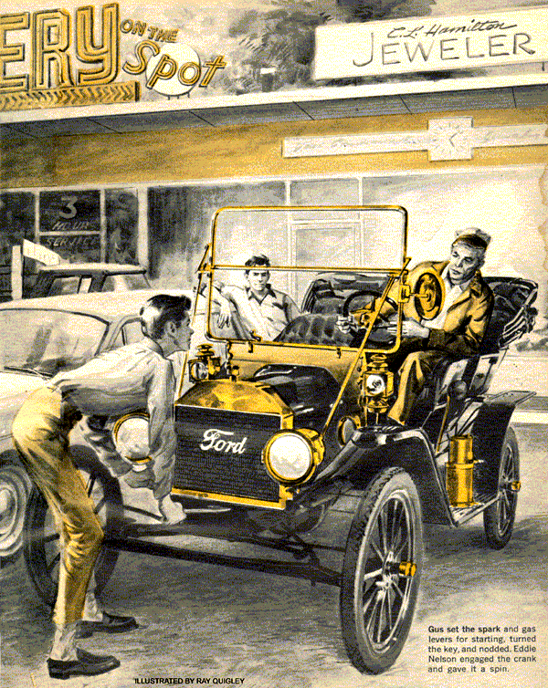
As the panel truck rolled to a stop at the Model Garage, a head emerged from the side window. "Hey, Stan, buddy," called the carrot-topped driver. "Got some time to help me?"
"Business?" queried Stan. "Or is this a bid for free advice on your Model T Ford?"
"No, that's set - now it's this crate," said the young fellow, unfolding a tall, gangling frame and stepping from the truck.
"What's the grief?" asked Stan.
"Every few weeks - trouble. She cuts out at turnpike speeds. New plugs cure it, but don't stand up. I won't be jockeying this bus after today. The boss thought you might teach it better for the new man."
"Quitting for a better job, Eddie?"
"Sort of. Greetings - to Ed Nelson - from Uncle Sam."
Stan got a gunlike instrument with a small blank screen at the muzzle end. "This plug checker will check it out," he said.
Clipping two leads to the truck's battery terminals, Stan fastened one T clamp around the center distributor cable and another to a spark-plug cable. "From this one," he explained, "we take the pulse of all eight. Now watch."
As the engine came to life, the little screen glowed. Eight vertical traces appeared. Two almost reached a horizontal red line part way up the tube face. Six were somewhat shorter. "All plugs okay," pronounced Stan. "In fact, my naked eyeball tells me they're nearly new."
"Sure, but it still misses when I want to roll," griped Eddie.
Humming cheerfully, Stan used a cloth to work free one of the other plug cables. "Now there we get a message," he said, pointing to the oscilloscope face. "The trace for that cable I just yanked goes up past the red line - but it doesn't go far enough. It should hit the top. What you've got, pal, is low secondary voltage."
Stopping the engine, Stan unhooked the distributor clips and inspected the cap and rotor. Both were clean, with no visible cracks or carbon tracks. The points were new; their gap, checked, was on the nose.
"You're cold, buddy," advised Eddie. "She got new points, cap, rotor, and condenser in a tune-up this spring."
Stan nodded. Getting an ohmmeter, he checked each primary lead for continuity, flexing it in the process. He also checked the value of the ballast resistor. "All okay, Ed," he declared. "I'd say your coil has some shorted windings. I'll put in a new one and we'll see."
"Fair enough," agreed Nelson.
Gus, owner of the Model Garage, drifted over. "Get your Model T running?" he asked.
"Last week, Mr. Wilson. Just in time, too - I'm reporting for induction day after tomorrow. That Mr. Hartman who collects antique cars saw mine. Said he'll give me 800 bucks any time I drive it to his place under its own power. He gets it this afternoon."
Stan, who had gone off for a new coil, came back and began removing the old one.
"Spotting that old Ford in Grisholm's barn was a lucky find for you," said Gus.
"Yeah, but I sure made a mistake telling Joe Burke about it. He must have known Hartman wanted a vintage T. When I got to Grisholm's, there was Joe with a phony story that I wasn't coming. Luckily old Grisholm didn't believe him. I got the car, but Joe's been trying to get it away from me ever since."
"A bit older than you, isn't he?" asked Gus. "And just out of the Army?"
"Fire it up, Eddie," interrupted Stan.
Nelson obliged. As Stan picked up the scope, his grin faded. With the new coil, the long trace on the scope still fell short.
"I'd have sworn - " he growled. "Cut it, Eddie. I'll put back the old one."
Gus went off to answer the phone. After reinstalling the original coil, Stan opened the distributor again. The new condenser could be defective, or there might be an internal break in the cable from coil to distributor. But something impelled Stan to pull off the rotor, turn it over, and hold it inside the cap against one contact.
Its shaft hole was off center.
Stan got a second rotor and showed Nelson both. "This one," he said, "is from your truck. And this is the right one."
"So one's shorter." Nelson shrugged. "The high voltage will jump anyway."
"But it won't be so hot when it gets to the plugs. Your rotor is 3/10ths of an inch short. Jumping that extra gap takes several thousand volts the ignition can't spare when the car is going at high speeds."
"Okay. Put in a new rotor," said Nelson as Gus returned. "Then fix whatever's bugging those plugs."
Stan stared at him. "This is it, man!"
"Huh? Slow down, buddy! The voltage was low, so that ruined plugs?"
"Stan's right, Eddie," said Gus. "New plugs fire at lower voltage, so at first they seemed to cure the high-speed miss. But as plugs get older, it takes more voltage to fire them. That's normal. A good ignition system has enough reserve voltage to keep old plugs working. But with under-par voltage you blamed the plugs and overlooked the real cause."
"Who'd expect to get a wrong part?"
"Happens sometimes," said Gus. "More often, somebody files a rotor tip to clean it. It takes 3,000 volts to jump the gap between a new rotor and the distributor contacts. If you file the tip shorter, the gap's bigger and it takes even more voltage to jump it."
When Stan started the engine with the new rotor in it, the telltale trace climbed off the scope face. Nelson drove out.
Late in the afternoon, Gus picked up the phone to hear Eddie's agitated voice.
"Stan through yet?"
"Not for an hour," said Gus.
"An hour! Mr. Wilson, Hartman said he'd wait for me till five; then he's leaving town. I'm at the shopping plaza and the T's all fouled up."
Gus thought briefly. Stan's acquaintance with very old cars was slight.
"I'll be right over myself," he said.
When Gus spotted the gawky little car with its spindly wheels and narrow tires, he also heard Joe Burke's strident voice.
"You're stuck, Eddie. Hartman won't buy that crate until it's fixed, and you haven't got time for that. Give you two-fifty and take my chances - "
Nelson turned a woebegone face toward Gus, and hurried him aside.
"This wrecks my plans, Mr. Wilson. I put a deposit on an engagement ring after Hartman said he'd buy the car. I was going to give it to Mary tonight, and put the rest of the money in our savings account. But Joe's right. Hartman warned me he won't buy the car unless it runs good."
"Did it, on the way here?" asked Gus.
"Sure did. I only stopped to make sure the jeweler had the inscription put on. When I got back to the car, the engine'd packed up. You just try it."
Boyhood memories returned as Gus stepped up on the running board and sat on the thin upholstery. But the fabric was new, body-paint flawless. The little car had been skillfully restored. With easy familiarity, Gus set the spark and gas levers for starting, turned the key, and nodded.
The redhead engaged the crank and spun it. The engine popped. Again he swung the crank. As the engine started, Gus advanced the spark. The engine died.
Once more Nelson spun the crank. As the engine caught, Gus left the spark lever retarded. The motor kept on running with an occasional cough and pop. Holding the clutch pedal part way down, Gus released the hand brake. The engine sputtered as he advanced the gas. Gently he pushed the pedal down to engage low gear.
Immediately the engine died.
"See? It quits every time," said Nelson.
"Know what I think?" put in Joe Burke, a young man with the build of a jockey, a pointed chin, and knowing eyes. "You got some broken valves, kid. You're lucky I'm willing to give you two-fifty."
Plainly desperate, Nelson looked at Gus. "If it can't be fixed right away, Mr. Wilson, I'll have to take that deal."
Gus grinned. "You worked fast, Joe. Did you switch 'em at the coils or timer?"
Burke's sallow face turned white.
"What the devil you talking about?"
"I'll fill Eddie in," said Gus. "Don't wait."
Without a word, Burke took off.
"What did he do?" asked Nelson.
"Switched ignition wires," said Gus, getting out. He raised the right side of the hood. "Plug wires are okay, so it's at the timer. Got any wrenches, Eddie?"
Nelson produced a tool kit. Loosening the single bolt that held it on the front of the engine, Gus drew off the timer.
"Uh-huh. He even left the nuts loose. Must have been in a sweat to finish."
Removing a pair of diametrically opposite wires, Gus interchanged them and retightened the terminal nuts.
"Joe probably learned this in the Army. It works on jeeps, too. To keep anybody from using the car, you switch the cables of cylinders one and four. If you do it at the distributor, it's hard to spot.
"The engine will start and idle. But those two cylinders are firing on the intake stroke, and deliver no power. A four-cylinder engine will quit if you try to load it. Okay. Start it up."
The engine caught at first crank, idling with a familiar and nostalgic rhythm. Nelson jumped in. The car moved.
"Okay; fine," he shouted. "Sure was a dirty trick Joe tried to pull. But how did he know I'd stop here?"
"Probably didn't; just happened to spot you, and grabbed the chance."
"Yeah. Then he came up as if surprised to see me. If it weren't for you, I'd have sold out, Mr. Wilson. Whatever I pay you, I owe more. Anything I can do, ask."
Gus grinned. "No charge, Eddie. But there is something."
"I said just name it."
"You take my car," said Gus. "Let me drive this one to Hartman's. It'll be like old times to see if I can still sort out those three pint-sized pedals."
END

