June 1966

GUS MAKES

THE BEST OF A BAD BARGAIN

by Martin Bunn
When two men decide they'll swap cars
and both cars turn out to be lemons,
the whole deal can go sour pretty fast.

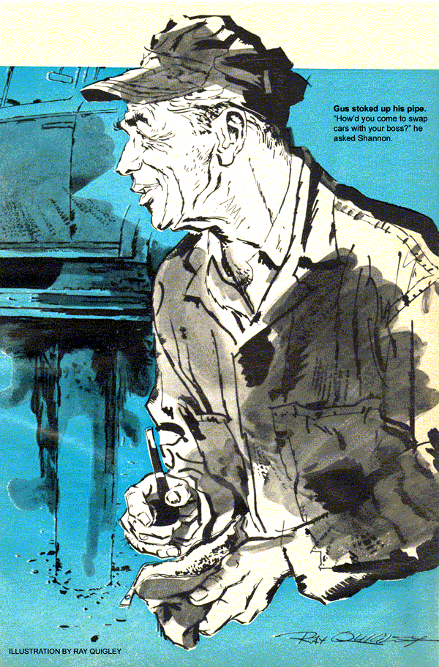
Before an audience of two small boys, Gus was hoisting a compact up behind his tow truck in a parking lot. The ratchet clicked as the car inched higher, the children's eyes following it as if magnetized.
From the corners of his own eyes, Gus saw a taller shadow join theirs. He looked up at a young, bareheaded man wearing dark-rimmed glasses.
"Tim Shannon!" said Gus with real pleasure. "I heard you'd come back to town."
Shannon offered his hand.
"Good to see a friendly face, Gus."
"Oh, I'm still sore about the time you squirted grease all over my new lube rack," returned Gus with a smile. "You weren't a very good grease monkey, but now I hear you're a hot production engineer. Top man at United Plastics, the paper said."
Shannon's long face twisted briefly.
"I'm quitting there. Going to take my family on a trip and look into a job at the same time. These are my kids." Shannon's eyes suddenly lighted. "Say, maybe you could pep up that tired car of mine. Nobody else has been able to."
"Any time," returned Gus cordially.
Two hours later, Shannon drove a '64 two-door with a starred right-rear window up the ramp of the Model Garage.
"I'll leave it and catch a ride with some friends back to the plant, Gus," he said. "Got to tie up some loose ends."
"Tell me about the car first," said Gus.
"It's got no pep. It accelerates okay in traffic, and seems to keep hitting on all eight at higher speeds. Only it won't go over 55, even with the gas to the floor. I've had it to the agency, and in a service station near the plant. Between Brant and me, it's had a new coil, a new carburetor float, new points - even a new muffler, on the theory the old one was creating back pressure.
Nothing's made any difference. No wonder Brant wanted a car with more sass."
"You mean Sam Brant, your boss at United?" asked Gus. "Was this his car?"
"I wish it still were!" snapped the young man. "That lousy car swap we made started the whole trouble." He looked at Gus tensely. "I'm not leaving because I want to, or for a better offer. I just can't stick it any more."
Gus turned away. "Come have a cup of coffee and tell me about it."
Shannon sat down in the office, sipped Gus's dark brew, and smiled crookedly.
"I guess I have to tell somebody. My wife thinks I'm crazy to leave United. But Brant wants me to go. He thinks I cheated, trading him a car I knew was an oil hog."
"Is it?" asked Gus.
"Afraid so. When I came here, I traded my old jalopy on an almost new '65 wagon. It seemed a good buy. The exhaust smoked, but the dealer said that was because some valves were sticking, and they'd run top oil through the carb. He swore the valves were okay, but I should keep using top oil. I did, and the exhaust kept making blue smoke, but the car ran fine. The plugs fouled twice, but I had them cleaned and forgot about it. Anyway, my wife was the one who used the car most. I didn't know she was putting in oil every time she got gas."
Gus stoked his pipe. "How'd you come to swap cars with your boss?" he asked Shannon.
"He had my wife and me for dinner. She mentioned that the kids gave her a hard time in the wagon - they'd open the back doors before she'd stopped. So I said I wished we'd bought a two-door, and Brant admitted he'd like a station wagon to carry samples - he makes sales trips - and that his car was an old lady's crate without enough go for long-distance driving."
"Well, we made the swap, with some money to boot for me - the wagon was a year newer and a more expensive model. The cash came in handy; we bought a dishwasher and paid off what I still owed on the wagon. Brant seemed satisfied, too.
"That was a month ago. After he came back from his first trip, he said, 'you should have told me your car burns oil like a furnace.' I was flabbergasted. When I asked him what he meant, he shrugged me off as if I knew, all right. Since then, nothing I do at the plant seems to suit him."
Gus drew on his pipe. "You think about offering to trade your cars back again?"
Shannon snorted. "Sure have. Yesterday I saw the wagon in the service station. The mechanic told me the plugs had fouled again, and he'd recommended a ring job. So last night I asked Brant to swap back, and give me time to return the extra cash he'd paid.
He snapped back that he wasn't in the installment business. We had some words, and I resigned as of tomorrow."
"Then you're only going back there to empty your desk?" asked Gus.
"We've just set up some new injection presses. I want to check them out."
"Uh-huh. Well, you can come for your car about five," said Gus.
After Shannon left, Gus put the two-door on a body lift. There was no sign of brake drag, tight wheel bearings, a misaligned drive train, or a kinked tailpipe. Gus lowered the car to the floor.
The engine turned freely, without excessive friction. A timing light showed timing right on the nose, centrifugal and vacuum advances working normally. The air cleaner wasn't dirty, and the automatic choke had opened while the engine was running. Gus thought of other possibilities - a clutch that slipped at high speed, or ignition points that bounced because of a weak spring, limiting engine revs.
As if thinking for itself, his hand pulled the throttle rod wide open. With a drop light, Gus looked down the air horn. The throttle plate was not quite vertical, but at a visible angle. It still blocked part of the carburetor throat.
Whistling softly, Gus loosened the throttle linkage and readjusted a clevis. When he was done, the throttle plate stood on end, a thin edge that would pass maximum fuel-air volume to the engine.
He closed the hood, told his assistant, Stan Hicks, that he was leaving, and in five minutes was on the high-speed turnpike, flooring the car's throttle. Speed climbed at once - to 50, 55, 60. At 70, Gus eased off to drive out at an exit. Swinging around, he headed up the opposite ramp back to town.
Just before he merged into the traffic flow, a wagon passed him. Gus stayed behind it briefly at 65, then speeded up. The speedometer was nudging 74, and Gus never saw the amazed double-take of the wagon's driver as the sedan roared past.
Shortly after five, a '65 station wagon trailing blue smoke pulled into the shop. From it stepped Tim Shannon, defiant and embarrassed. Gus promptly guessed the identity of the other man, behind the wheel. Older than Shannon, he had appraising blue eyes in a face like a knobby potato.
"This is Mr. Brant, Gus. He brought me over to get my car and talk about his."
"Only heard about you when Tim told me," put in Brant. "But I thought the man who made that crate of his perform like it does might straighten mine out, too."
"How'd you know about Tim's car?" asked Gus. "I haven't told him yet."
"You passed me on the pike," explained Brant. "I recognized the car by that busted window, so I asked Tim who was driving.
Say, just what was wrong with that car?"
"The throttle linkage," said Gus. "It didn't open all the way. The engine couldn't get enough gas for full power."
Brant grunted in surprise. "The dough I spent on tune-ups - and nobody else spotted that! Would you be willing to see what you can do to stop this car from gulping oil, short of a ring job?"
"Glad to. Bring it in tomorrow."
The first thing Gus looked for on the station wagon's V-8 next morning was some trace of an external oil leak. There was none.
Checking cylinder compression, he found it good enough to rule out worn pistons, cylinders, or rings. Engine oil pressure, checked with a gauge, was within specifications. A punctured vacuum-booster diaphragm, Gus thought, would suck oil into the intake manifold. But this car had electric wipers, and no booster pump.
Gus removed the rocker-arm covers. There was no sludge on the rocker assemblies; the oil-return holes below were open and unclogged. So much for the guess that pressure-trapped oil was being forced past valve stems into the cylinders.
"Still stumped by that oil burner, Gus?" asked Stan, passing by.
"Yeah," grunted Gus. "Not a clue, yet."
"Maybe somebody bored holes in the cylinder heads," quipped Stan.
He strode off, grinning. But his words jogged Gus's memory of a service bulletin seen months ago. Gus got busy removing one of the rocker-arm assemblies. When it was off, he lifted the air cleaner from the carburetor and blocked the choke and throttle open. Then he applied the air hose to one of the holes from which he had unscrewed a rocker-arm support bolt.
Air whistled in the carburetor throat.
The wagon's engine was buttoned up again when Sam Brant came in.
"What's the bad news?" he asked. "Has it got to be a ring job?"
"No ring job," declared Gus. "And you will get much better oil mileage."
"That sure is good news," Brant said. "What was it?"
"A factory blooper. This engine burned oil from the day it was made. The holes for the bolts that hold on the rocker-shaft supports were drilled too far - right through to the intake ports. Those bolts pass through the hollow rocker shafts, which carry oil under full pressure. So oil was forced past the bolt threads into the intake ports, drawn into the cylinders, partly burned there, and partly blown out the exhaust."
Brant shook his head. "Sounds like Detroit needs some good production engineers, too. Did you put on new heads?"
"No. You know that most bolts are a bit undersized. Their threads don't actually bottom in the female threads - 75 percent engagement is usual. So instead of the old bolts, I screwed in some special studs the manufacturer put out for this job, with nuts to hold on the supports. The stud threads are designed for maximum engagement and sealing. They fit the holes so closely oil can't get past them.
"But the dealer who sold Tim Shannon the car," added Gus, "didn't know about this fix - or couldn't be bothered. By recommending top oil, he hid the fact that the car was burning oil. And Tim didn't drive it enough to find it out, as you did."
Brant looked at Gus steadily. "I gather that I've made a blooper myself," he said. "I better get back to the plant and see if I can straighten it out."
"I don't think it'll be too hard."
"You don't?" asked Brant. "Why not?"
"The way I figure," said Gus, "there'll be two of you trying."
END

