November 1965

GUS RESCUES

A DO IT YOURSELF MECHANIC

by Martin Bunn
There wasn't much Mike Kessler
didn't know about cars, he thought.
And then he crossed wrenches with Gus.

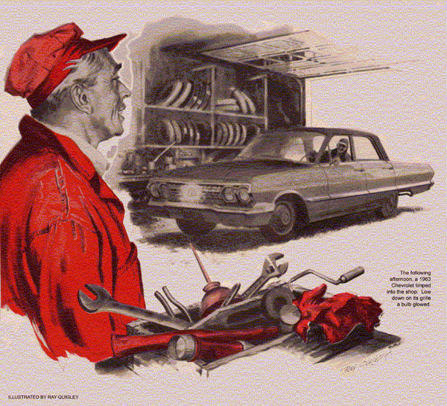
"Looks like Tweedledum and Tweedledee coming, Boss," announced Stan as he looked out of the Model Garage's front window.
"Strangers to me," said Gus Wilson. He opened the door, admitting two men who were remarkably alike - both middle-aged, rotund of face and figure, with pug noses and sandy eyebrows. They wore black windbreakers and hunting caps.
"I'm Mike Kessler," said one. "Got the electric fuel pump I ordered?"
"My name's Robbins," put in the other. "Grabbed a ride to bring you the trade-in on that rebuilt carb I phoned you about."
"Oh, yes," said Gus, "I've got 'em both."
He took a carton from Robbins and lifted out a two-barrel Rochester carburetor, stained and worn, but otherwise identical to a gleaming rebuild on the workbench.
"There's the new one," said Gus. "It's guaranteed. Know how to make the adjustments?"
"My friend doesn't know much about cars," said Kessler. "I'll check it out."
Gus produced another carton. "Here's your fuel pump, Mr. Kessler. You'll probably want to reroute your fuel line and mount the pump on the firewall."
"I know that," snapped Kessler. "Already bought the tubing and fittings."
"We're retired," added Robbins, " and like to do little jobs like this. Keeps us busy until hunting season. Six of us leave day after tomorrow in Mike's car and mine."
"Can't risk breakdowns in the back country," said Kessler. "My old Chrysler's in top shape except that the fuel-pump cam is worn. It doesn't move the pump full stroke, so I don't get enough gas at high speeds. Been getting vapor lock in hot spells, too. Going to an electric pump will kill two birds with one stone."
"Mike was a standards man on a Detroit assembly line," explained Robbins. "Isn't much he doesn't know about cars."
Gus nodded amiably and handed both men their bills. They paid and left.
"What's a standards man, anyway?" asked Stan. "Some kind of inspector?"
"Some kind of," returned Gus with a chuckle. "He's a time-and-motion man who keeps assembly-line workers on their toes."
The following afternoon a '63 Chevrolet V-8 limped into the shop. Low down on its grille a bulb glowed brightly. Gus recognized it as a running light, favored by some drivers on the theory that it makes a car in motion more noticeable. The bulb winked out as the driver cut the engine.
"I put that carb on this morning," said Robbins, climbing out. "Been trying ever since to get the engine to run smooth. It idles rough and hasn't any pep."
Gus opened the hood. "Did your friend help you set the idle-speed adjustment."
"No. He's laid up with something. Hope he'll be in shape for our trip tomorrow."
Gus asked Robbins to start the engine again. It ran at a rocking, uneven idle. Making certain the automatic choke was open and the manifold valve in the "heat-off" position, Gus cautiously turned the two idle-mixture screws. The roughness persisted at every setting.
"Did it idle all right with the old carburetor?" he asked, cutting the engine.
"Yes. Ran okay too, except at high speeds. Then it sometimes missed. Didn't have pep for passing, or on hills. That's why Mike suggested a new carburetor."
Might be a fouled plug, or worn points, Gus mused, but the obvious thing to check first was the installation of the rebuilt carburetor. He got a 1/2" wrench and pulled on two of the mounting nuts, noting that the new gasket was in place. The nuts were tight. He tried a third, leaning lightly on the carburetor with his other hand.
Had it moved?
Gus tugged at the carb. It did seem to give a trifle. When he pushed, it moved a fraction of an inch. Moving up the droplight, he peered at the nuts.
"I tightened those good," said Robbins.
"They are tight," agreed Gus. "But the carb's loose. How about the washers?"
"The ones that were under those nuts? One was split, and they weren't lock washers, so I figured they didn't really do much. I chucked them out."
Gus went to the stockroom, returning with four flat, copper-hued washers.
"You see," he explained as he unscrewed the nuts to place a washer under each, "these stud threads stop a little above the carburetor-mounting flange. When you tightened the nuts, you ran out of threads before they pinched down the flange. That left the carburetor loose enough to draw air in at the joint."
Gus retightened the nuts evenly, then started the engine. With slight adjustments of idling mixture and throttle stop screws, it idled smoothly. Robbins apologized profusely before he drove out.
"You shipped out Tweedledee," called Stan, "and Tweedledum's on the blower."
"Looks like that fuel pump you sold me is no good," said Kessler brusquely on the phone. "Better bring me a good one. I can't come for it - the car won't run."
"I don't often sell those," replied Gus, "so I checked that one myself. It works."
There was a long silence.
"You better come - but not in a tow truck," begged Kessler. "I don't want my wife to think I'm running up a big bill."
On the way - in his own car - it occurred to a mystified Gus that Kessler had made a quick recovery from being "laid up."
Inside the garage at Kessler's stood a big Chrysler. The owner emerged from behind the open hood, perspiring heavily.
"Now watch," he said. He got in the car and turned the key. The electric pump chuckled several times before the engine caught. "Now try to drive it off."
Gus got in, put the car in gear, and let out the clutch. The engine coughed. Gus eased the clutch back, revved up a bit more. With an enormous pop, the engine died.
"I've blown out the filter, checked the ignition, cleaned the line," said Kessler. "It has to be the pump!"
"Does sound like it isn't getting gas," said Gus, noting the gauge read "full."
"I've got to meet the fellows at six a.m. tomorrow," said Kessler desperately.
Under the hood, Gus saw that the fuel-pump opening in the block was neatly blanked off. The firewall where the pump was mounted had been scraped clean for a good ground. New tubing ran from the pump to the carburetor, and to the flexible hose coupling on the tank line.
Maybe an air leak on the suction side? Gus opened the joint at the pump, saw that the brass gland was in place, and retightened the nut.
A wire was securely fastened to the pump terminal. Its other end was attached to one terminal of the ignition coil, which had a secured wire on it as well. Gus disconnected the pump wire there.
"Got another pump in stock, or can you get one in a hurry?" asked Kessler.
"Won't have to," returned Gus. He ran the wire he had disconnected to the ignition resistor, fastening it to the terminal that received current from the switch.
"Now, you try it," he told Kessler.
Again the pump chuckled before the engine fired up. Putting the transmission in gear, Kessler revved the engine. The car rolled halfway out of the garage as he let out the clutch. Hastily he drove back in.
"Well, it runs," he confessed grudgingly. "Why change the wiring? There's plenty of juice at the coil - enough for the whole ignition system."
"But not enough for the pump, too," said Gus. "In a 12-volt system, the coil gets full voltage only at starting. With the key at 'run,' a resistor gets into the act, cutting down voltage to save the points."
"But I hooked up a running light there once. You couldn't see any difference in its brightness," Kessler insisted.
"A fuel pump's more critical," explained Gus. "Getting juice through the resistor, at less than 12 volts, it was so starved for current it could only deliver enough gas for idling. Any time you opened the throttle, the engine simply ran out of gas.
"It's mighty tempting to connect accessories to that coil terminal, especially if you want them switched on automatically whenever the engine is running. But they won't get full power. Besides, there's an even more important reason not to use that coil as a terminal board."
Kessler paid without demur.
"Call me when Tweedledee shows up, Stan," said Gus, back at the Model Garage.
Robbins drove in an hour later. "That miss is still there," he complained.
Gus got out is plug-testing oscilloscope and hooked its four leads to the battery, the center distributor tower, and one spark-plug cable.
With the engine running, he adjusted the instrument until an eight-spiked pattern steadied on the tube.
Then he pulled one cable off its plug and sped up the engine. The corresponding spike lengthened, but didn't reach the top.
"Spark voltage is low," said Gus, cutting the engine. "Be fixed in a jiffy."
He disconnected the extra wire he'd expected to find on the coil terminal and hooked it up to the ignition resistor's switch side. The lagging trace on the scope rose to the top of the tube face.
"You have full ignition voltage now," Gus remarked. "That should end your high speed miss. It was only a bum connection."
"You fixed that car this morning," remarked Stan after Robbins left. "How come you expected friend Tweedledee back?"
"Something Tweedledum told me. He had connected his pal's running light through the ignition resistor, same as he did his own fuel pump, which didn't work. The bulb did, but it draws enough current to drop voltage to the coil to about 15 percent. That reduced spark voltage - say, from 25,000, to about 22,000, volts. At high speed or heavy load, when compression is up, the reduced voltage didn't fire reliably."
"Kessler thinks he's a car expert!"
"He went all out to keep Robbins from knowing about his pump trouble - told him he was sick, asked me to come in my own car. He just couldn't stand losing face."
"I'd like to see his face," snorted Stan, "when his buddy tells him how he goofed."
"He won't," said Gus, grinning. "I never told him. Why spoil a hunting trip?"
END

