March 1965

GUS FINDS A CURE

FOR THE DOCTOR’S CAR

by Martin Bunn
Flat on his back with flu, Gus still couldn't quit wondering why
Doc Barnes' car was smoking like a chimney on four wheels.

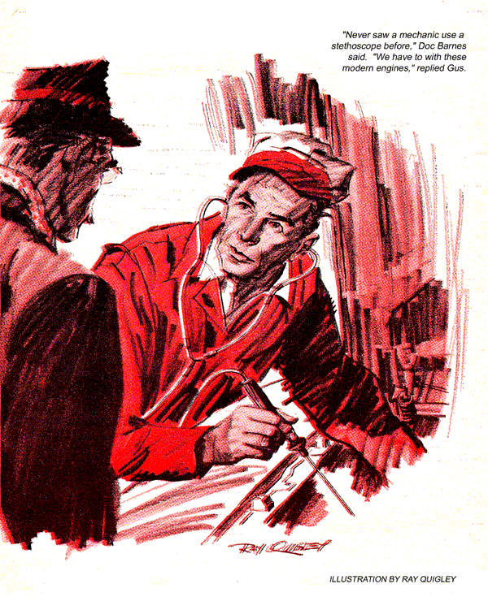
"Dr. Ben Casey, I presume?" Gus Wilson looked up from the engine he was checking with a stethoscope and listening rod.
"Doc Barnes!" he called out as he killed the engine. "What did you say, Doc?"
"I mistook you for that handsome doctor on TV, Gus. Never saw a mechanic use a stethoscope before."
"We have to with these modern engines. They're so complex that we need the 'scope to distinguish one noise from another."
"There's a lot more under the hood now than there was in the days when I drove a Model T," the doctor said with a laugh.
"A lot more to go bad, too." Gus said ruefully. "And when you get a customer like Karl Schmidt.. "
"Thought I recognized the brand new look that Karl manages to keep in his cars. Can't be too much wrong with it, can there?"
"Nothing serious. But somehow I just can't nail it down. Between the buzzing in my head and.. "
The Model Garage owner realized that the physician was watching him closely, with a professional look on his face. "What brings you in today, Doc?" he asked abruptly.
The question was ignored. "Had the bug for a couple of weeks now, haven't you, Gus? Did you get those flu shots I suggested last summer?"
Gus shook his head. "Never got around to it. But I'll be okay in a day or so. Now what's wrong with your car?"
Doc explained that a large cloud of white-blue smoke poured from the exhaust of his Rambler Ambassador when he slowed up and came down the ramp after a fast run on the turnpike. First there would be a "death rattle," then the smoke.
"Probably just burning a little oil," Gus said. "Your engine's never been overhauled, has it?"
Doc Barnes shook his head in disagreement. "Can't be burning oil," he said. "I usually put in a can of oil additive in the crankcase about 1,500 miles after every oil change, and it's been 1,800 miles now since I changed oil and the oil's still on the Full mark on the dipstick. The book says you shouldn't go over the full mark on these Ambassadors."
"Can't always go by the book, Doc."
"I suppose not. But look here, Gus-this new type of Asian flu is almost epidemic in the eastern part of the state. Weren't you hunting around Sutton not long ago?"
Gus readjusted his stethoscope, started the engine, and said, "You take my car, Doc. Stan will run yours over after he's checked it. I promised to finish this job as soon as possible."
When Stan arrived a short time later, Gus put him to work on the Ambassador after repeating the physician's story. Gus finally found that engine noise on Karl Schmidt's car came from excessive valve clearance, which he adjusted. Why had he taken so much time on a job that should have been diagnosed and cured in a few minutes? His head still buzzed, he was a little dizzy. He couldn't shake it off. Maybe Doc Barnes has something. When Stan came back after a road test in the Ambassador, Gus was stretched out in his office, feet on the desk.
"Nothing serious, Boss." Stan reported. "That new kid at Hank Billings' service station probably put a quart of oil in the crankcase when it didn't need it. It's up over the full mark."
Gus grunted.
"The extra oil probably spilled over and was sucked into the valves giving off a puff of smoke. I'll tell Doc about it when I return his car."
Gus grunted again. "When you get back, I'm going home. Feel a little woozy."
For the first time Stan noticed the little beads of perspiration on Gus's brow. "Boss, you're sick. Let me take you home.
"Thanks, Stan, but I'll drive myself home when you get my car back from Doc."
The next morning Gus didn't make it to the Model Garage. Instead he had a visit from Dr. Barnes.
After a brief examination, the doctor asked if he could use the telephone.
"What's the trouble? Gus asked jokingly. "Forget your tools?"
Nope-just want to make sure there's room for you in the hospital."
"Hospital!" Gus roared. "I'm too busy to go to the hospital. Just give me some of those new wonder drugs and leave the hospital for people who are really sick."
"You're really sick, Gus. Let's go."
Stan visited the hospital after work a few days later.
"Doc Barnes is sure stubborn," he told Gus. "His automatic-transmission fluid was a couple of quarts low-probably because he uses the D-1 button instead of Low and races through the gears when he works his way out of snowdrifts, getting the transmission so hot it just burns up the ATF. But he still insists that there is a connection between the transmission fluid being low and his crankcase oil being high. Has he complained to you?"
"I didn't even know that he'd been to the garage, Stan."
"He's been there, all right. Says he still gets a rattle and smoke after he's been driving fast on the turnpike and makes a right turn coming down the ramp."
"Driving fast-that would thin out the fluid.. " Gus mused. Did you check the vacuum line from the transmission solenoid to the manifold to see if there was any sign of ATF in the tube?"
"Sure. Did that the first thing. There's no sign of ATF anywhere under the chassis, either.
Gus then asked if he had checked the automatic transmission cooler lines to the radiator.
Stan had and added that there was no sign of a leak, nor was there any ATF in the radiator.
Gus nodded wearily. "You're probably right then."
Dr. Barnes wouldn't even discuss the Ambassador with his patient, but Stan brought regular reports. He had drained oil out of the crankcase to get it below the Full mark; he had found the number one spark plug on the left bank wet. He knew the car was burning oil because the inside of the exhaust was coated with it. He had therefore deduced that the rings were shot, and that the engine needed a major overhaul.
"That all sounds logical," Gus told him. "But you say the automatic-transmission fluid is still going down. Where's it going to."
Stan was ready to tear his hair out. The marker dye he had put in the transmission had disappeared without a trace. He drained oil from the crankcase and put in an additive and the Ambassador ran like a new car-for a few days. Then poof!- a rattle and a cloud of smoke billowed when it came off the turnpike.
The climax came one night while Stan was visiting his boss, now much improved. The telephone operator asked him to come down to the hospital lobby. Returning a few minutes later, he wore a sickly smile. Have to run along," he told Gus. "A damsel in distress."
"Don't try and kid me," Gus said. "What's the trouble?"
"Just like I said-heck, Gus there's no use your getting excited. Doc Barnes was stopped by a trooper on the turnpike because he was creating a road hazard. The car is throwing a smokescreen like a destroyer. I'm going out with the wrecker and bring him in. I'm sorry, Gus."
"Don't be foolish, Stan. I couldn't have done any more than you have. Give Doc my car and tell him to drive it until we return his car-cured of smoking.
Long after the lights were out that night, Gus Wilson's mind pictured the underside of the Ambassador. It was up on a lift. The front end of the transmission ran into a steel wall at the flywheel. The rear end joining at the torque tube had a drain hole that would disclose any loss of automatic-transmission fluid. The solenoid and its vacuum tube had been thoroughly checked. Only the transmission cooler lines to and from the lower radiator were left as possible suspects, but any leaks in those steel pipes would have been vividly marked by the dye. Where was the stuff going to?
The Ambassador was air-conditioned, but there was no possible connection. Power steering? ATF was used in its system, but again there was no connection to the transmission, and the reservoir level had remained constant. Power brakes? Being the atmospheric-pressure type, there was a vacuum connection to the intake manifold through a check valve and a vacuum reservoir. But there had never been any change in the level of the brake fluid, or evidence of the dye marker being sucked in..
Sucked in! The words lit up like a neon sign in his brain. He mentally raced again along the underside of the Ambassador. He had it! Grinning broadly, he settled back to enjoy his best sleep in a month.
Dr. Barnes found his patient bright-eyed and smiling the next morning. "Gus, you really look good. You should be able to leave any day now."
"I'm ready to leave right now, Doc, and I want my car!"
"You're kidding. You gave me the use of your car until mine was fixed. Don't tell me Stan fixed it last night."
"Not last night. This morning. He couldn't sleep, so he was in the garage at six. Had your car ready to go at seven." Doc stared. "What was wrong?"
"Your transmission cooler lines have been sitting on top of your power steering reservoir for a long time. The two surfaces ground away at each other, until there was a tiny crack common to each. Then, because there's 85 pounds pressure per square inch on the cooler lines, and a vacuum of about 18 inches in the reservoir, the two worked together, transferring the fluid from one to the other without spilling a drop. When you drove fast on the turnpike, the fluid got hot and thin, and gushed into the reservoir, up the brake line and into the manifold. When you left the turnpike, driving down the ramp to the right, centrifugal force carried the fluid to number-one cylinder on the left. It was sucked into the valve. Some went into the combustion chamber and came out as smoke-the rest dripped into the crankcase raising the oil level."
Doc had listened intently. "And last night," he said, the holes got big enough to permit a continuous flow, producing a smoke screen. But what about the rattle?"
"Elementary, my dear Doctor. The fluid that burned in the combustion chamber lowered the octane rating of the gas, causing a bad knock."
Dr. Barnes gave him a quizzical look. I'm sure Stan didn't figure all that out by himself. You must have solved this case right here, flat on your back. You know," he said, turning Gus's head so he could see his profile, "there is a resemblance."
"And Ben Casey solves all his tough cases in a general hospital, too!"
END

