December 1965

GUS HELPS SANTA GET GOING

by Martin Bunn
Neither rain nor snow-not battery failure-
could keep Gus from hurrying
to the aid of Operation Christmas Tree

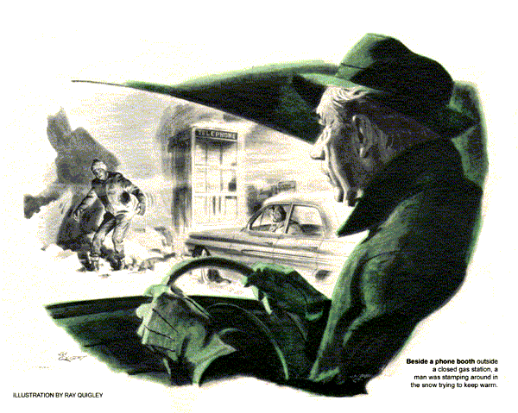
Driving back that December night from his yearly pre-Christmas visit with old friends in the country, Gus Wilson could smell snow on the way. The tires of his coupe hummed on bare pavement, fell silent as they rolled over patches of old snow.
It was nearly midnight, and there hadn't been another car in five miles. The '62 Pontiac standing on the shoulder came as a complete surprise. Instinctively, Gus slowed. Waving wildly, a figure jumped out of the car. Gus stopped behind it.
A tall girl in slacks and a loose coat ran up to him.
"Thank heaven! I thought nobody would ever come. Please help me. It's urgent."
"What's wrong, a flat?" asked Gus.
"Yes-no. I had one, but fixed it. An awful job, but once Tim showed me how, so I managed. Only now the car won't start. Battery's dead. How about a push?"
Something white loomed ahead. Gus got out to look. It was a culvert post, hardly a yard from the Pontiac's front bumper.
"Can't push you," he said. "You'd have to back first to get around that-and I haven't got a tow chain."
She stamped a foot, the coat flapping. I just have to get moving. Do you have those wires to help out a bad battery?"
"Booster cables? No. Sure it's dead? Did it start the engine when you left?"
"It did not," she retorted angrily. A brand-new battery too, only a week old. A neighbor had two thick wires he ran from his own battery to get the engine started. But I stopped it to change that darned tire."
Gus opened the Pontiac's hood. His flashlight beam found the battery, clean and evidently new, its terminals thick with grease. He fingered it.
"Try starting the engine," he said.
The girl jumped behind the wheel. Keys rattled. The starter solenoid clicked, flew back, clicked again.
"That's all it does," called the girl.
Gus twisted one of the spring-clip battery terminals. It snapped off the battery post. He disconnected the other also, then went to his own car for a rag. With it he wiped the grease off the posts and clamps.
"Your battery may not be dead," he told the girl. "These terminals maintain contact only by spring tension, which isn't always reliable. Besides, somebody put on the wrong kind of grease to prevent corrosion. It melts from engine heat and runs between the post and the terminal clamp, making a poor contact worse. A connection like that may pass enough current for the lights, but not heavy juice for the starter."
Replacing the cleaned terminals, Gus worked them back and forth to get a good bite on the posts, then nodded to the girl.
The engine whirred as she turned the key. Three seconds later the engine was running nicely. Gus closed the hood. The whole incident hadn't taken 10 minutes.
It took Gus as many seconds to realize the girl was staring at him.
"Nothing else wrong, is there? Those terminals will hold for now. Later you can get new cables with bolted terminals."
"Oh, who cares? That's the least of it."
It was Gus's turn to stare. Suddenly the girl's tense face broke into a smile.
"I'm sorry. You must think I'm awfully ungrateful. It's not that - I'm worried about something else - Tim and the pickup. You do know about cars, don't you?"
Gus nodded, still puzzled.
"Tim's my boyfriend. He drove north for a load of Christmas trees. He has to deliver them all before midnight tomorrow, the day before Christmas, or he'll lose the money he needs for college. And he's stuck on route 35."
"He did get to a phone, but all the garages or service stations are either closed or won't send help this far. He tried to phone the man he rented the pickup from-a gardener-but couldn't reach him." Her voice rose an octave. Oh no! It's beginning to snow!"
"Where on 35 is he?" asked Gus.
"He phoned from Burnly. He's waiting for me there,"
"Okay, Drive on and I'll follow."
Snow was thickening but the girl drove briskly, just below the threshold of recklessness. At times Gus lost sight of the Pontiac's tail lights in the swirling flakes. In 20 minutes they had reached Burnly, a silent village sleeping under the snow.
Beside a phone booth outside a closed gas station a man was stamping around trying to keep warm. The girl's car swooped down on him. Its door flew open. A minute later the man trudged over to Gus.
"Hello. I'm Tim Collins. Betty told me how you rescued her. Thanks a million for that, and for coming out to help me with the pickup. Okay if I ride with you to show you where it is? Betty will follow us."
"Hop in out of the cold," said Gus.
Collins wasn't much more than 20. Face reddened with the cold, he shivered a bit as the cab's warmth soaked into him. Gus drove around the Pontiac, heading west.
"So, you're hauling Christmas trees?"
"Yes," said Collins. "Though my big idea looks as if it is fizzling out."
"Does seem late in the season to be trucking trees south," remarked Gus.
"But that was the idea! Commercial trees are brought in weeks early. They're already dried out when people buy 'em, lose needles fast, become a fire hazard. My uncle up north wrote me I could cut all the trees I wanted off his land. So I had this brain wave to earn the rest of the dough I needed for the spring term."
"I took orders for fresh trees, to be delivered by Santa Claus, himself, at 12 bucks apiece. They're good trees, but the Santa Claus bit is part of the deal. I have to deliver 30 trees in one day, wearing an overstuffed costume and ho - ho - hoing with the kids. But I figured I could make it - until this happened."
The car slewed on an icy patch. Gus straightened it, an eye on the Pontiac behind.
"There's the pickup," said Collins.
A phantom outline, it was piled high with trees overhanging the tailgate and capped with white. Gus stopped ahead of it. The Pontiac crushed to a stop behind.
Carrying the tool kit he always kept in the car, Gus followed Collins to the pickup - a '61 Chevy with a landscape gardeners sign on its side. The girl joined them.
"It ran fine going north, and most of the way back," the young man said. "This afternoon it coughed a couple of times, but kept going. I was really rolling on this road when I hit a rough spot. A bit later the engine quit as if I'd turned it off."
"I coasted over here. The way it stopped, I thought I'd find a loose ignition wire. But nothing was loose. Then I took off the distributor cap. The points seemed okay and the cap isn't cracked. I didn't know anything else to try, so I walked to that phone in Burnly."
Gus made sure the distributor cap was on right and checked the ignition wiring. The carburetor was cleaner than the rest of the engine, probably a rebuild. After seeing that the automatic choke was closed, Gus pulled off a plug cable and held its end near the engine block.
"Give it a try," he told Collins.
The starter turned sluggishly. There wasn't a pop in response, although a fairly good spark jumped from the disconnected cable. Gus signaled Collins to stop. Selecting a wrench from his kit, he loosened the fuel line at the carburetor end.
Crank it just a second," he called.
As Collins did so, gas spurted from the open line. Gas, air and a spark in the cylinders should add up to at least a pop or two, thought Gus. Even a dirty air cleaner would pass some air. All the plugs couldn't have fouled at the same instant.
With numbed fingers, Gus detached the air cleaner. Shining the flashlight into the carburetor throat, he yanked the throttle open by hand. Not even a smell of gas squirted in from the accelerator pump. Next he removed some of the linkage. After taking out the bolts that held it, he carefully lifted off the air horn that formed the cover of the carburetor.
The float bowl was dry as a temperance meeting.
Gus carried the air horn with its pendant float, to his car and plugged in a trouble light at the dash. The two others followed him.
Wiping snow from his eyes, Gus looked closely at the needle valve-and saw something else.
Whoever rebuilt this carburetor," he said, "forgot to tighten the float-valve seat. It slowly unscrewed, until tonight-maybe on a bumpy stretch - it came right down and on the needle valve. Even with the float down and calling for gas, that cut off all fuel, so the engine quit."
"Can you fix it?" asked Collins tensely. "It's coming down harder, and with fresh snow over the old, no car's going to pull or push this loaded truck."
"Let's see," said Gus. Working over the car seat, he pulled out the pivot pin, dropped out the float and valve, and carefully tightened the valve seat into its proper position. Having worked on this model frequently, he was able to estimate float - level and float - drop adjustments fairly well by eye. He took the air horn back to the pickup and reassembled the carburetor.
"Now try it," he said to Collins.
The starter groaned slowing a little on each turn. When it seemed about to quit, Collins turned the key off.
"I'll kill the battery for sure!"
"You had to fill the carburetor," said Gus. "Next turn may do it."
Again Collins turned the key. Reluctantly the engine churned over-and fired.
A great grin spread over Collins' face.
"You did it! We're going to make it, Betty - and just when I thought those trees were going to stay and take root."
"Snow's getting deep," warned Gus. "Better get moving right away."
Collins got out and pumped Gus's hand. "Nothing will stop us now. Hey, I know you! I've seen you around town. Heard about you too. You're Gus Wilson of the Model Garage."
"That's me."
"Betty, you sure flagged down the right man. That's two rescues we owe you, Mr. Wilson. With these trees practically sold, I can pay up - and gladly.
"No you don't" said Gus. "Who ever heard of charging Santa Claus?"
END

