April 1965

GUS MEETS A TV DEADLINE

by Martin Bunn
The cameras couldn't start shooting
till Gus finished troubleshooting-
and that bus was deader than a TV badman.

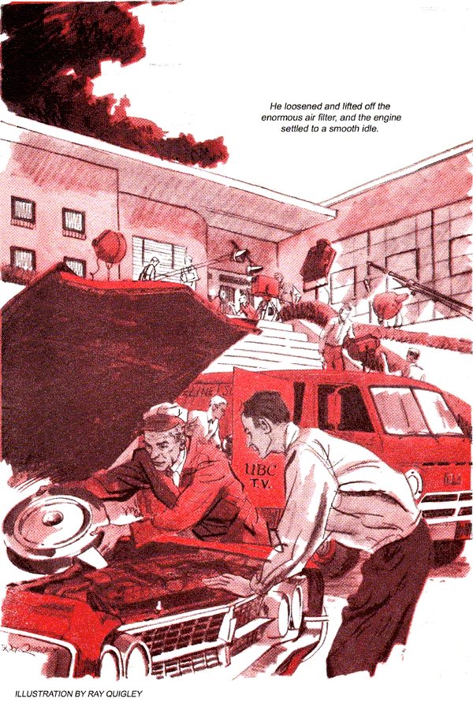
"Emergency call, Boss," announced Stan as Gus Wilson entered the Model Garage one brisk spring morning.
"Okay. You take it," said Gus.
"Uh-uh. It was the principal of the new trade school, calling for a visiting VIP from the city. He said to ask you to come yourself."
Gus grunted, changed to working clothes, and in five minutes was on his way in the wrecker. Turning into the horseshoe driveway of the new Vocational Arts School, he stopped well back of the entrance, before which was a cluster of cars.
One of them was a panel truck, its side lettered: DATELINE SUBURBIA-UBC-TV. Several men were unloading cameras, lights, and booms. Cables littered the pavement. Among five nondescript cars was a 1963 Olds finished in dull gold. Its side panel bore the same legend as the truck, plus the line: J. FIELDING-DIRECTOR.
"Are you the garageman we called?" the reedy young man, who introduced himself as Robbins.
"I'm from the Model Garage," said Gus.
"But are you Gus Wilson? Mr. Fielding insists on having him.
"I'm Gus Wilson. What's the trouble?"
"It's not really trouble," confided the man in a husky whisper. "Mr. Fielding's car doesn't run just right."
"They said it was an emergency."
"Oh, it is. Mr. Fielding's car must always be in top shape. He insists on it. This morning it stalled twice. It must be fixed. He may need it at any moment."
A shadow fell between Gus and Robbins. The slender, middle-aged man who came up wore tweeds, dark sunglasses, and no hat - Mr. Fielding, himself.
"The engine sounds as if it's about to fall apart," he told Robbins. "If you'd have it serviced by somebody besides your brother-in-law, we might get it right."
"This is Mr. Wilson from the Model Garage," said Robbins.
Fielding turned to Gus. "Probably you'd like to work in your shop, but please see what you can do here."
Without waiting for a reply, he left.
"Well, let's hear it," said Gus.
Jumping into the Olds, Robbins fired it up. The engine's idle had a rolling lope. Again and again it seemed about to stall. Its vibration shook the car.
"At higher speeds it's smooth," explained Robbins. "But at every stoplight it runs like this. Mr. Fielding insists..."
"He should insist on a tune-up."
"It had a complete tune-up yesterday," said Robbins. I have the bill right here. Look at what they did."
Gus scanned the yellow sheet, which charged for new points, retiming, new plugs, oil and air filters, an oil change, cleaning the air filter, and a new condenser. The total came to a third more than Gus would have charged, but what interested him most was something not listed.
He loosened and lifted off the enormous air filter, detaching a tube. The engine settled to a smooth idle.
"It's not my brother-in-law," muttered Robbins. "My uncle owns the agency."
"Tell your uncle a tune-up should include servicing the PCV valve," said Gus shutting off the engine.
"PCV? What's that?"
"Positive crankcase ventilation. This is the valve, on the right hand cover. On this car it has two hoses. One dumps blow-by-combustion gases that get by the pistons into the crankcase-into the air cleaner. The other routes them to the intake manifold. The valve shifts from one to the other according to engine load. But if it's clogged it can't, and then blow-by gases will upset the carburetor mixture."
Robbins looked puzzled.
"PCV's been around since 1963," continued Gus. Earlier in California. Some mechanics like to pretend it doesn't exist. It reduces air pollution. Instead of getting into the atmosphere, blow-by is sent back into the cylinders and burned. The engine can handle it, so long as it's metered right."
"But you can't dump blow-by in any time, in any amount, and have a smooth engine. A lot of engines have blow-by colic-or worse-because their PCV systems aren't maintained. A badly clogged one can build up enough crankcase pressure to blow main bearing seals."
Detaching the PCV valve and air-breather cap, Gus soaked both in kerosene.
"It's possible to clean this valve," he told Robbins. "Some others are throwaways."
"How could they let the car go out, running as it did?" asked Robbins.
"Guess they adjusted the carburetor with the air cleaner off," said Gus. "It's so big you can hardly reach the screws when it's on. The idling mixture was right-until they put back the air cleaner and its PCV connection. Then the clogged valve sent blow-by above the carburetor. Since that's largely fuel-air mix that got by the rings, it enriched the normal mixture enough to cause surging and roughness."
"Robbins! called a distant voice, to be echoed immediately by one nearer by: "Mr. Fielding wants Mr. Robbins."
The young man scurried off as if singed. Gus packed his tool kit, and was walking to the wrecker when Robbins stopped him.
"Please wait. Mr. Fielding's coming."
The director strode up importantly. "You may be able to help us further, if you will, Mr. Wilson," he said. "We are filming a documentary about this school and its part in the war on poverty and delinquency. Certain boys with aptitude for training are being sent here from the Mill City School. I wanted to picture their arrival in the Mill City School's bus, and record their reactions to the opportunity offered them here."
"But the bus driver has just phoned that the bus is stalled eight miles away, on route 118. A service-station mechanic he called couldn't get it running. Would you try to get that bus here in time?"
Gus considered. He knew what the Mill City boys were like-volatile, often troublesome, quick to believe nobody cared about them. Even if he failed, they would be better off for seeing somebody try to help.
"I'll go right out," Gus said.
"Good. Put the charges on my bill."
Gus spotted the bus-really a big station wagon with the school name on it-from the top of a long hill. It was near the bottom, as if it had started up and become discouraged. The driver had let it roll back onto the shoulder, where it stood slightly askew, two wheels blocked.
A ragged cheer went up from the boys inside as Gus swung around behind the bus. Young faces peered at him curiously. Two boys lounged against a fender, smoking. The driver, a sandy-haired little man with a drooping mustache, approached Gus. Even when he smiled a welcome, he continued to have a sad-eyed look.
"Sure glad you're here. Might keep them young hyenas quiet for a bit. Not that I blame 'em much-they're crool disappointed. They'd choke admitting it, but they sure want to be on TV."
"Bet he's out of gas, mister," yelled one of the boys, but failed to get a rise out of the bus driver.
"What did the mechanic do before he gave up?" asked Gus.
"Not much. Said it wasn't getting gas and the fuel pump must be shot. But I put in a brand-new one on a couple of weeks ago. Ran okay since, but it hasn't had much pep the last few days."
Gus removed the air filter. On cranking the engine, he could see no gas entering the venture, nor detect the pungent smell of fresh fuel. Detaching the neoprene line from the delivery side of the fuel pump, he cranked again. No gas came out. But the fuel pump indeed looked new. So did the flexible hose leading to its inlet.
"Did they put on this new hose when they changed the pump?" Gus asked. "Yep, I recall that they did. The old one was cracked."
Gus squeezed the foot long piece of tubing, then did the same with the neopreme line between filter and carburetor. Though old and oil stained, it was firm. The hose back of the pump felt flabby by comparison. Gus slipped it off. It dangled from his fingers, limp as overboiled spaghetti-and somehow familiar.
"Why didn't ya bring a horse?" inquired a loud voice from inside the bus.
"Go back to school-with us," urged another boy.
"How about a tow?" called a third.
Ignoring these and sundry catcalls, Gus suddenly realized what was familiar. Going back to the wrecker, he hauled out a coil of bell-alarm hose-the kind laid in gas stations to signal the arrival of cars. The one at the Model Garage was so full of patches Gus had bought new hose to replace it.
He compared the hose to the piece taken from the bus. It was the same kind. Cutting off a length, Gus installed it in the bus and nodded to the driver.
The engine cranked with no result. A concerted groan swelled up inside the bus. Seemingly endless, the whir of the starter slowed ominously.
When the engine fired, the groans quickly turned to cheers.
Gus dropped the hood firmly in place. "Get going," he urged the driver. "But be sure you bring it to the shop today." Early that afternoon the Mill City School bus rolled into the Model Garage empty.
"Came because you told me to," said the driver. "But what for? She goes fine."
"She'd quit again," returned Gus. "I didn't fix it right. All I could do on the road was get you going." He brought out the clogged fuel hose. "See that? It's swollen shut inside. A little gas got through until you needed more to climb that hill. Then pump suction pulled in the walls and pinched it shut."
"Never saw a gas hose go bad so fast."
"This isn't the right kind. The mechanic probably didn't have it in stock, so he used a piece of bell-signal hose. But that's rubber, not neoprene, and gasoline swells and decomposes rubber."
The driver chewed his mustache. "You put on a new one, didn't you?"
"Sure-of the same signal hose, because I had it in the truck. Now I'm going to put on the right hose."
"Hey now, wait," muttered the driver as Gus opened the hood. He kept on talking while Gus removed the temporary hose and installed the new one.
"Sorry, I didn't hear all that," confessed Gus, as he closed the hood.
"Said I can't pay you. But I'll tell the school folk what you done, and you can send 'em a bill."
"It's all been paid," said Gus.
"You mean that?" asked the driver. "Then I won't have to make out a long-winded report to the superintendent. Sure it's okay? Who said so?"
Gus's voice sank to a whisper. "Mr. Fielding. In fact, he insists."
END

