November 1964

GUS GETS CAUGHT IN A CROSSFIRE

by Martin Bunn
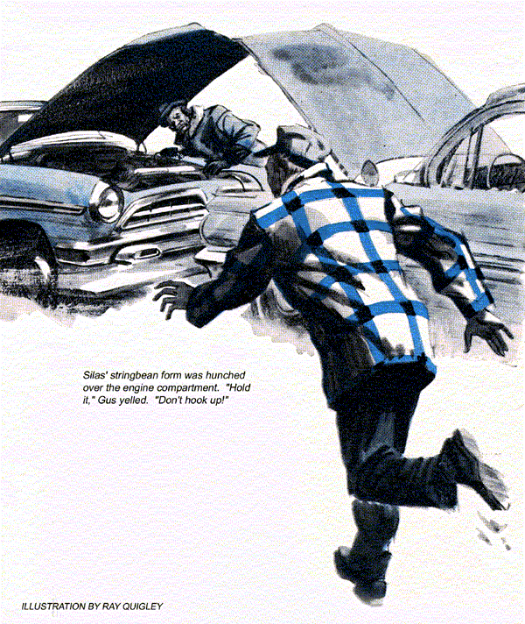
"Better break down and buy a new one, Silas," warned Gus Wilson as he connected the six-volt battery he had just put back. "This one's had it."
Barnstable sniffed. "Just so you boosted it good; I'll be shut of this car by tomorrow. After that, 'taint none of my business what it does."
Gus stared hard at his stingiest customer. "You demonstrated this car with my rental battery in it -- and sold it -- while I was trying to charge this junky one?" "Paid you for the use of it, and for the chargin', didn't I?" snorted Barnstable.
Gus sighed. "Sure, but do the buyer a favor. Tell him he needs a new battery."
"None o' my business, and I allus mind my own business. Which you better do, too."
The cars starter whirred, and with a final snort Barnstable drove out of the Model Garage. Stan Hicks got up from a crawler and looked after him.
"Engine sounded kind of rough, Boss," he said.
Gus shrugged. "You heard him tell me to mind my own business."
"Yeah, and he seems to be switching his, from mortgages to used cars. That's the third jalopy the old penny-pincher has bought and sold since summer."
"It's only a side line. Sometimes he takes an old car for an overdue mortgage payment and sells it at a profit."
An hour later the same 1955 sedan again entered the Model Garage. Barnstable's face was even sourer than before.
"Back for that battery?" asked Gus.
"Nosir! Motor ain't runnin' right. I thought it was just cold when I come here, but it's just as bad now that it's warmed up. Fellow sure won't pay me for the car if it sounds like this."
"Does sound pretty rough. Maybe it needs a tune-up," said Gus.
"Tune-up schmoon-up! hooted Barnstable. Don't look for no big job out of me. It ran fine yesterday, and it ain't been out 'cept to come here. Maybe you charged the battery backwards, or put it in wrong."
Gus looked at him without a word.
"Well, mebbe you didn't," conceded Silas. "But it's almighty funny she'd run good one day and not the next."
"You asking me to check it out?"
"Yeah, but don't run me up a bill."
Gus flung up the hood. The engine was bucketing about as though missing or out of time. Stan sauntered over.
"Plug wire disconnected?" he asked.
"Nope, they're all on," said Gus. "Must be something more serious."
"Maybe the timing gear slipped a tooth or two," offered Stan.
Nodding thoughtfully, Gus opened the throttle by hand. As it snapped back, the engine backfired decisively. Silas jumped.
"Suppose it could be warped or stuck valves?" mused Gus aloud. "Or distributor shaft and gears worn so badly the backlash makes it fire out of time?"
"Whatever it is, it sure sounds expensive," said Stan with relish.
Barnstables homely face was twitching so violently that Gus decided the gag had gone far enough. He killed the engine.
"Nice job of new wiring," he said, running his finger along the neatly aligned and taped spark-plug cables.
"Had to throw it in," said Barnstable. "Fellows who's buyin' it squawked about the old wires being all cracked. Got these at discount and put 'em in myself."
"Sure they're running to the right plugs?" asked Stan.
"Made me a drawing first," snapped Silas.
"They're right, ain't they, Gus?"
"Oh, sure. Your trouble is being too neat," returned Gus, ripping off the tape.
"Hey, quit that!" protested Barnstable.
Gus calmly separated the cables, deliberately crossed two so they no longer ran parallel, separated two others by squeezing a third between them.
"Now try it again," he said.
Sullenly Barnstable did so. The engine immediately settled to a smooth idle, revving up responsively, dropped back with no backfiring or roughness.
A satisfied smirk overspread Silas's face. "Whatever you done, that's fixed it. You can't charge me much, neither."
"It's on the house," chuckled Gus. "Tell him what it was, Stan."
"Crossfiring-all because you tied up the cables in nice, straight bundles. Whenever ignition juice shoots through a wire, it sets up a magnetic field around it. If another cable is close and in line with the first one, the magnetic field will set up a voltage in that other wire, and it's plug will fire too. If that cylinder follows the other in the firing order, it will fire way early, on compression.
"You want to separate cables to cylinders that fire close together. If cables must touch, cross them at an angle. Never run 'em parallel more than an inch or two."
Barnstable sniffed. "Never heard o' such a thing. And if this tomfoolery has run down that there battery, you'll charge it up again free, by gum."
Without a word of thanks he drove out.
"Maybe we ribbed him a bit hard," mused Gus. "But he owed us a laugh."
Snow lay thick on the ground next morning after an all-night storm. Gus was plowing under the pumps when a horn sounded angrily behind him. It was an unshaven and angry Barnstable, this time in the two-year-old V-8 he usually drove.
"That danged battery's deader'n a horseshoe nail!" he barked.
"Told you it has a bum cell, Silas. It won't hold a charge.
"I ain't buyin' no new one, nor investin' good money in them booster cables they got down at the discount store."
"Better not," agreed Gus. "A customer showed me a pair he'd started a neighbor's car with. The insulation was nearly all burned off. The conductors inside are too light to carry starting current, so they overheat fast. If a motor has to be cranked more than a few seconds, you need asbestos gloves to unclamp the jumpers."
"Figured they wasn't much good at that price," remarked Silas.
Gus shrugged. "It's the old story of getting what you pay for. The cables we use cost me three times as much."
"So how about makin' good for that bum battery-chargin' job by lendin' me yours?"
Ruefully Gus realized the cagey old fellow had outmaneuvered him.
"Come on!" wheedled Barnstable. "I'll use the battery in this car to boost the other one. Be back in half an hour."
A Buick slid up to the pump island. Gus remembered he had agreed to drive its owner to the railroad station and bring the car back for a repair job.
"Okay, Silas," he said hastily. "Tell Stan I said to give you the jumpers. Know how to use 'em?
"Sure. Ground post to ground post. Don't need to tell me that," said Silas.
A brief assault on downtown traffic brought Gus to the station. Letting his customer out, he then headed back to the Model Garage. He was halfway there when he suddenly remembered two facts.
One: Barnstable's big car had a 12 volt negative-to-ground system.
Two: the '55 clunker had a six-volt, positive-to-ground system.
With one backward glance, Gus slung the Buick into a U-turn. He nudged the speed limit hard to make the lights on the green. Even so, it seemed an interminable time before he reached Silas' street.
Nose to nose in the driveway stood the old sedan and Silas' V-8. His stringbean form was hunched over the engine compartment of the older car. Jumping out, Gus raced toward him.
"Hold it!" he yelled. "Don't hook up!"
Startled. Barnstable turned his head. The same instant a crackling flash told Gus he was too late. It was followed by a muffled boom as black fragments flew into the air. Silas staggered back.
"Acid!" he screamed. "My eyes..."
One glance told Gus that the side of the battery had blown out. Bits of pitch, splashes of acid, and fragments of separator plates spattered the engine and Silas, who was rubbing his face frantically. Gus forced him to his knees at the edge of the driveway. Scooping up a handful of clean snow, Gus rubbed it over his eyes.
"Wash your hands in the snow," he ordered, "then grab two handfuls and hold them to your eyes."
Barnstable wrung his hands together in the snowbank. Hastily Gus unclamped the booster cables from the V-8's battery. Then, while Silas held his snow-filled hands to his face, Gus guided him to the Buick.
"You're lucky, Silas," declared Dr. Snyder half an hour later. "Your eyes aren't burned by what acid reached them. Might have been if Mr. Wilson hadn't helped you."
"Or if it hadn't snowed," put in Gus.
The doctor nodded. "Washing the eyes immediately was a great help. You say a battery exploded when another was connected to start the car? Isn't that unusual?"
"It was a six-volt battery," explained Gus. "Silas was using a 12-volter to boost it. That's always risky, even if you hook them up right, which he didn't. The 12-volt boosting current immediately starts to charge the six volter, generating oxygen and hydrogen. All it takes to explode that mixture of gases is a spark."
"Why not make your final connection at the 12-volter?" asked the doctor. It's the last connection that sparks."
"That's a bit safer, though that battery produces gases, too. It's also a bit safer to disconnect cables at that end first. But the best dodge is to attach cables at the booster battery first, then hook them up to the starter terminal and ground, making sure polarity is the same as the car. That keeps sparks away from both batteries, with less chance of igniting any gas there might be around."
"Never told me that! Snorted Silas.
"When I asked you, you said you knew all about it," retorted Gus. "Besides, you did the one thing that guarantees a blow-up. One of your cars has a negative ground, the other a positive. You hooked up the 12-volter backwards, in series with the six. That made an 18-volt battery discharging across a dead short.
"Several hundred amps flowed instantly. Maybe a speck of lead or plate paste inside the battery got hot enough to set off the blast, especially if the fluid level was below the plates. Or the spark may have come from the cable clamp."
"But it's okay to boost a 12-volter with another 12-volter, or a six with a six, isn't it?" asked Dr. Snyder.
"If you watch polarity. Even then, so long as batteries generate gases, a spark could set them off, so making final connections to the starter and ground are a good idea. If the car has an alternator, you'd better be sure of polarity before you make contact-reversed connections can ruin the rectifier diodes."
Silas harrumphed loudly.
"If you're through, Gus, lets get in your car and deliver me a new battery before the feller comes for the car."
"I saw you come and get that new battery for Silas," said Stan when Gus returned from installing it. "But what did you use to sell him, Boss? Dynamite?"
"Just about, but I didn't do it. He sort of sold himself-the hard way."
END

