March 1964

GUS GETS TAKEN FOR A RIDE

by Martin Bunn
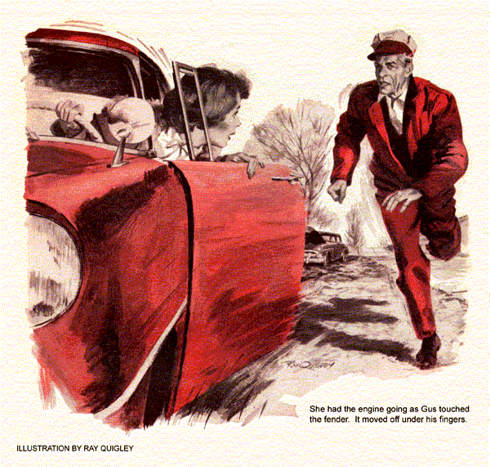
It was shortly after he had turned his car onto an old, concrete-surfaced road that Gus first noticed the sedan. A few hundred feet behind, it kept its distance at Gus's own brisk speed.
At the Jorgensen mailbox, he slowed and swung into the turnabout in front of the farmhouse. As this brought him back facing the road, he saw the other car roll by slowly, as though also stopping.
"It's Gus, Niels!" cried little Mrs. Jorgensen. "Niels will be right along. Come have some coffee while you wait." "Only stopped to leave these ignition points for his tractor," said Gus. "But you've twisted my arm."
Headed back to the Model Garage a few minutes later, Gus had to swing around a sedan stopped partly on the road. It was the one that had tailed him - an elderly Plymouth with patches of rust and sanded steel on its battered body. The driver, a teen-aged girl, glared at Gus as he went by.
A moment later Gus heard the sedan's starter grind and its engine fire up. In the mirror, he saw the Plymouth start off once more behind him. Must have taken the wrong road, thought Gus.
His own car was purring like a steel kitten, and there was a smell of warm earth in the air. Gus relaxed, enjoying the ride and the feel of the road, even the rhythmic bounce of the divider strips in the durable old pavement. At the yellow sign of Billings' service station he pulled off again. Seconds later the Plymouth passed - and drew off the road a hundred feet ahead.
"Hi, Hank," said Gus, as a lanky crane-like figure stepped out of the office. "Here's your regulator valve. Hope it's the right one."
"Sure is," said Hank Billings gratefully. "Now I can get my compressor running again. Come on in and get paid."
Five minutes later Gus drove out, passing the Plymouth, which still stood off to the side. The girl didn't glance at him this time, but he hadn't gone a quarter of a mile when the sedan reappeared in his mirror. Again it kept pace with him.
Surely the girl couldn't be trailing him deliberately, thought Gus.
Now slightly upgrade, the road ran through a desolate wooded area. On impulse, Gus braked and rolled off the highway. The sedan passed then vanished over a short rise ahead. With a chuckle at his suspicions, Gus started off again, well ahead of a heavy trailer toiling up the grade.
He was taken completely by surprise as he crested the hill. Only a wild swerve saved him from hitting the Plymouth, now stopped squarely on the road. The girl stared at Gus, mouth open. Remembering the coming trailer, Gus made a quick stop, jumped out, and ran to the sedan.
"Get off the road - quick!"
"I can't yet," said the girl.
"Yet?" shouted Gus. "There's a truck coming. Take off your hand brake."
The girl grabbed at the brake. Gus hooked his fingers around a door hinge and shoved on a fender. Slowly the car edged onto the comparative safety of the shoulder. Like a storm blast the truck roared by, its horn blaring angrily.
Gus was angry, too. "That was stupid. If you must trail me, use some sense about it. Stopping here could have killed you."
The girl's eyebrows soared. "Trail you? You've got a nerve. Every time I stop, there you are behind me."
The absurdity of it calmed Gus. "But I stopped first, every time. What's going on?"
She flung herself out of the car. "Nothing to do with you. It's just the way this car behaves on concrete roads."
"Try another story. You're talking to a mechanic."
"It's true! When it quit this time, it wouldn't roll far enough to get off the road." To Gus's uneasiness, she now seemed near tears. "If only I hadn't taken this short cut, I'd be there by now. It runs just fine on the blacktop roads. Darn, darn, darn! Are you really a mechanic?"
"Yes. Name's Gus Wilson."
The girl's face brightened. "My father knows you. I'm Barbie Winters. Maybe you can fix this car so it'll run on concrete. It keeps stopping. I have to wait every time before it'll start again and I was in such a hurry I forgot this time. Please! I just have to get to the Little Players' Theater by 10."
Watched by pleading eyes, Gus flung up the hood, exposing a rust-flecked engine. "It's past 10 now," he pointed out.
The girl didn't answer. Gus gave the wiring a quick check. He found no loose connections or obvious breaks. The sound of someone running made him look around. Barbie was racing for his car as fast as perfect legs could carry her.
"Hey!" roared Gus. "You come back."
She got to the car before he could break into a run, was in, and had the engine going just as Gus touched the rear fender. It moved off under his fingers.
Not a pop resulted when Gus tried to start the old sedan. Too chagrined to try any troubleshooting, he waited five minutes and tried again. The engine now caught. He tore after his vanished car.
A mile farther on, the Plymouth quit as if somebody had corked up the gas line. Inwardly fuming, Gus waited a couple of minutes and tried the starter, without result. He stretched the wait to five minutes and tried again. The engine fired.
It happened once more just within sight of the cross-country highway. This time he used the five-minute wait to check the flexible fuel line. It was neither leaking nor collapsed.
When the engine started, he turned onto the blacktop. The sedan hummed along for five miles without a skip.
Scratch that guess about a fuel pump out of wack, thought Gus. Then he reminded himself that it was no business of his and rolled toward the converted barn that was the theater.
When he arrived, Gus found cars as thick as ants around a dropped doughnut. He spotted his own car in the parking area - the girl sitting in it. As he walked toward her, a white convertible roared in and slid to a tire-smoking stop. The tall blond boy who leaped out had the highest crew cut Gus had ever seen.
"You're late!" called the girl, scrambling out of the car. She saw Gus the same instant. "Oh! Come on quick!"
The boy joined her on a dead run. Hand in hand, they scurried into the gloomy depths of the theater. From somewhere came the unmistakable smell of burning rubber.
Gus peered into his car. The smell wasn't from it, and she had left the key. Grumpily, he got in and drove off, headed for the Model Garage.
"Nice day for a ride, Boss?" asked Stan Hicks as the car rolled up the ramp.
Gus's answer to this sally from his assistant was a heartfelt snort. He locked himself into his office and tackled the paper work he detested. By midafternoon he was able to remember his mornings adventure with rueful amusement.
Stan was out getting a replacement part when, with a toot of its horn, a Chevrolet convertible rolled into the shop. Nudging its bumper came the old Plymouth. The girl got out and approached Gus.
"I don't know what you must think of me-" she began.
"I had a few notions, none good," said Gus sternly.
"I'm terribly sorry. It was an emergency- if I hadn't been so desperate-the tryouts were for 10 sharp, and I knew there'd be a huge crowd." Gus let her flounder a long moment.
"Well, you told the truth about going to the theater," he said at last." And now you've come here. So let's just say I lent you my car for a while." "Gosh, thanks. That's wonderful of you. Now if only I can make it up to Bud."
"I guess this is Bud?" asked Gus, looking at the crew-cut youth.
"Oh, no - that's Jerry. Bud's only my brother. It's his car and I took it without asking. If you could fix it, he might forgive me, too. He's tried a new fuel pump, a rebuilt carburetor, a new ignition coil, and - oh, yes - points."
An acrid smell of burning rubber caught Gus's attention. "Got a short in your car?" he asked the tall young man.
Jerry shrugged. "I thought so, but I can't find any. It's been smelling like that all morning. I stopped twice to make sure I wasn't on fire. That's why I was so late."
“We'd better check," said Gus.
But no sizzle of sparks or smoking wire appeared when he raised the hood. Gus felt the brake drums. They were cool. Besides, the smell was rubber, not brake lining. It seemed strongest near the engine.
"When were the new plugs put in?" asked Gus, playing a sudden hunch.
"Yesterday. But how'd you know?"
”I sort of smelled it," returned Gus.
Getting a pair of long-nose pliers, he looked at the plugs until he found what he expected. He detached the terminal clip from the last plug in one bank, withdrew something, and snapped the clip back.
"There's your trouble," he said, displaying a scorched, odoriferous bit of rubber. "A rubber insert from the mechanic's plug wrench. It holds plugs while he starts them. But when they get oil soaked, inserts often pull out of the wrench. This one stuck on the last plug, so close to the manifold that it burned."
"I should've seen that," said Jerry.
"You didn't know what to look for," snapped Barbie. "Mr. Wilson, couldn't you please fix Bud's car, too?"
Gus mentally reviewed the sedan's odd behavior, its possible causes, and what had already been tried to cure it. Playing another hunch, he drove the car outside and rolled under it on a crawler.
With a can ready, he unscrewed the gas tank's drain plug. Rusty fluid and solid matter spewed out. He replaced the plug, rocked the car, and drained out some more until clean gas flowed out.
"Never knew gas could make rust," remarked Jerry, an interested onlooker.
"It doesn't, but there's always some water in a tank," explained Gus. "Luckily it settles to the bottom and isn't picked up. But it does rust the tank in time. What killed the engine was that scale I just drained out.
"On the concrete road Barbie came over divider strips bump the car up pretty regularly. That lifted some flakes off the bottom, up to where fuel-pump suction could pull them against the fuel pickup. When enough flakes clogged it, the gas was cut off. Then it would take five minutes or so for suction to die out of the line and let the scale drift away from the pickup. If you tried to start too soon, pump suction would only pull it back again."
The boy whistled. “’Course, that could only happen to an old crate like this."
"Or one not so old," warned Gus. "The time to prevent it is while a car is much newer. It's smart to drain gas tanks every season. Cuts down rusting and may save you a frozen gas line in winter." While the girl was paying Gus, he asked, "After all the excitement, how did you make out at the theater?"
"Like a bandit," said Barbie. "We got the part."
"The bandit bit I get," said Gus, "but one part? For the two of you?"
She sighed. "Two parts like one. Just dreamy… We're Romeo and Juliet."
END

