July 1964

GUS COOLS OFF A COUPLE

OF OVERHEATED CUSTOMERS

by Martin Bunn
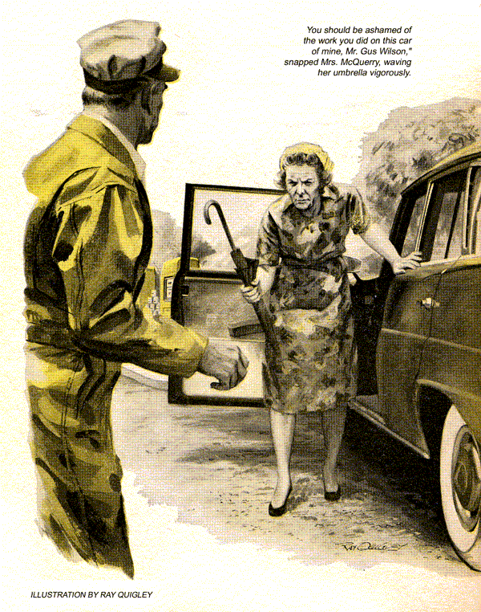
"Got much work lined up for the morning, Stan?" asked Gus Wilson, holding the Model Garage phone.
"No, Boss. I finished the tune-up on Mrs. McQuerry's car while you were out, and she came and got it." Gus spoke into the phone.
"Okay, bring your car in and we'll see what we can do."
He hung up and locked the office. "Joe Stafford's got starting trouble with that old Olds of his," he told Stan. "His new dry-cleaning route's just taking hold, so he needs the car back by noon. "Isn't that the same '55 he used on that tri-state route?" asked Stan "It must have clocked 100,000 miles by now." "Hundred and two, he says.
Looks like a late customer out at the pumps. Take care of him, will you?" It wasn't a him," Gus noticed as he walked past a minute later, but the redoubtable Mrs. McQuerry. She nodded silently at Gus, her face grim under its crown of iron-gray curls. But Stan was already shutting the hood, so whatever had brought her back wasn't serious. Gus headed homeward.
"In this stop-and-go business," explained Joe Stafford next morning, "I can't leave the engine running. Sometimes customers keep me waiting to collect clothing or find loose change to pay me, or just to chew the rag. That wouldn't hurt if only the engine would start again. But lots of times the starter doesn't have enough moxie, and I got to wait 10-12 minutes before it'll turn the engine over."
He reached into the car and turned the key. The starter spun briskly for a moment, and the engine fired. He shut it off.
"Funny. Once in a while the starter seems to run double-quick, like that. But mostly it drags. It's knocked out my delivery and pickup schedule so badly my volume's off and the plant has another fellow bidding for the route.
Again Stafford turned the key. This time the starter groaned reluctantly, only to quit after two or three hopeful, labored chugs.
Stafford looked almost pleased. Gus glanced at the dash. The water-temperature gauge was nudging the hot sector.
"Had much work done on the engine?"
"Not since the 50,000 mark," said Stafford proudly. "She runs fine, once she starts. It ain't the starter, I had that electric man on Grove Street check it."
"The engine may be loaded with carbon," said Gus. "That could be your trouble."
Stafford scowled. "Can't be carbon jamming the pistons, or it wouldn't run."
"Could be carbon so thick it insulates the combustion chambers from the cooling water, so they get too hot. Thick carbon also boosts the compression ratio. Ever hear of compression ignition?"
"You mean compression firing the fuel without a spark, like a diesel?"
"Sure, only too soon. If the charge explodes before top dead center, it kicks the crank backwards, bucking the starter. Happens mostly when the chambers are hot. That's why you have to wait sometimes-to let them cool a bit."
Stafford mused gloomily. "Can't spare the car long enough to let you scrape carbon, or even afford to pay for that just now. Once I build up the route I'll get a panel truck, but right now the starting trouble could put me out of business."
Gus eyed the water-temperature gauge thoughtfully. "Give me a couple of hours and I'll see what I can do."
He was warming up the engine when Stan came out from the rear.
"I heard that about compression ignition," he said. "Happens mostly with old high mileage crates like this, doesn't it?"
"No," returned Gus. "With some kinds of gas and high water-jacket temperatures you get it in newer engines, too." I'm surprised Stafford hasn't got after-running."
"What's that?" asked Stan.
"What they call it if an engine keeps running after you cut the ignition. Can be from compression ignition, or red-hot deposits, or both. Scares some drivers."
The water gauge was again near the hot sector. Cautiously Gus released the radiator cap to its first notch. Steam hissed, billowed up briefly as he removed the cap. Shutting off the engine, he drained off some water and removed the thermostat. It was almost shut, and was slimy with an oil film.
Gus tossed it into a can of boiling water. The thermostat remained closed. He fished it out, threw it away, and asked Stan to bring him a 160-degree unit.
"Here you are, Boss," said his assistant, handing over the new thermostat. "But from what you said I thought Stafford's trouble was carbon?"
"Mostly it is, but it doesn't help to have a thermostat that won't open, or a cooling system with oil in it from head gasket seepage. The oil puts an insulating layer on one side of the cooling jacket, while carbon holds heat on the other. I'm going to clean out the cooling system and put in this fast-opening stat. If we can move heat out faster, that may lower chamber temperature enough to lick the hot-start problem."
Stan nodded in comprehension. "And get the car back on Stafford's route in a jiffy. If it doesn't work, I have a surer cure, Gus."
"What's that?"
"Jack up the radiator cap and drive a new car under it," quipped Stan."
"Uh-huh. While you're in the mood for gags, why was Mrs. McQuerry wearing her battle-axe look last night?"
"Oh, nothing much, Boss. All fixed."
"I know that," returned Gus. "Otherwise she'd have been back this morning. What was it you had to fix after a full engine tune-up?"
Stan reddened slightly. "A goof by me. She complained the car had less pep than before. The cable on number-seven plug had dropped off. Guess I didn't push it on all the way after I put in the new plugs. She couldn't have come back this morning, though. She was on her way to stay overnight with her sister at Blainsville for a birthday party. That's what made her sore - she thought she'd be late there."
"Better hope she wasn't," returned Gus. "I wouldn't care to tackle her if she was really mad."
After installing the thermostat, Gus flushed out the system with a chemical cleaner. Afterwards he drained and refilled the cooling system. The he drove out into a hilly area. The water gauge went to "warm" and stayed there.
At a crest, after a hard uphill pull, Gus shut off the engine. A touch of the key cranked the engine normally, and it came to life. He shut it off again and waited five minutes. Once more the starter took hold.
Driving back to the shop, he stopped the engine at three traffic lights. Each time the starter responded. Satisfied, he drove into the Model Garage.
"I think that'll do it," he told Stan.
"Good. You know that first time Stafford tried the starter here, it seemed to run fast."
"That's right," agreed Gus. "If compression ignition fails to fire the first few cycles, the starter can reach normal cranking speed. Then if compression fires the fuel, momentum swings the cranks over dead center and this maverick ignition actually helps the starter, making it crank two or three times as fast as it could by itself. But you can't count on compression not firing right off, when cranking has barely begun, and catching the cranks the wrong side of dead center."
It was closing time again when a horn sounded imperiously at the gas pumps. Stan had left early to buy a part before the dealer closed, so Gus had to answer the summons. Umbrella in hand, Mrs. McQuerry alighted from her car as he came up.
"You should be ashamed of the work you did on this car of mine, Mr. Gus Wilson," she snapped, waving her umbrella vigorously as though she meant to club Gus.
"My assistant is a good mechanic, Mrs. McQuerry. If he overlooked anything, we'll make it good."
"You'll make up for me being late to my own sister's birthday dinner, will you? And for having to stop twice on the road? You want to fix my husband's dinner, which is going to be late because I'm here now?"
"I'm sorry you were inconvenienced," apologized Gus. "Let me have a look."
Annoyed to think that Stan probably hadn't squeezed the loose terminal cap tighter. Gus expected to find the cable loose again. He raised the hood. To his surprise all cables were firmly in place. He started the engine. Its beat was uneven, suggesting a weak cylinder.
"When I left here last night," went on Mrs. McQuerry, "it didn't feel as good as before the tune-up I paid you for." Halfway to Blainsville it suddenly got worse. I stopped in a gas station and the man did something. Coming home today, it got bad again. Another gas-station man made it a little better for longer than the other. But it isn't right. What are you going to do?"
"I'm going to drive you home so you can get your husband's dinner ready on time," said Gus. "And I'll have your car in top shape by 10 tomorrow."
"Joe Stafford phoned," reported Stan as Gus came in next morning. "Said he worked late, but that the engine started every time after he took it yesterday."
"Good," said Gus. "Did you see the note I left on Mrs. McQuerry's car?"
"Sure. And I've checked it. Timing, points, carburetor all fine. The plugs were new yesterday, and all were gapped right. I've got them out so I can make a compression check."
By the time Gus had changed to overalls, Stan was replacing the plugs.
"Wouldn't you know?" he said bitterly. Compression's right on the button."
"Let's hear the engine again," said Gus.
Stan started it. Once more Gus detected the slight pulse of a limping cylinder. He seized the throttle and gunned it briefly. There was a "plop" as something flew up on the side of the engine.
"Cable blew off number three plug!" reported Stan in amazement.
Gus killed the engine and picked up a wrench. Removing number three plug, he glanced at it and gave it to Stan.
"The metal top is loose!" said Stan.
"That plug was defective," remarked Gus. "The loose top let cylinder gases get inside the rubber cap. On open throttle the pressure blew the cable off."
"But I revved up the engine when I was checking. Why didn't it pop off then?"
"Two mechanics put it back for Mrs. McQuerry," said Gus. "Bet you a hamburger to this bum plug that the second man split cap number seven, probably thinking it was too tight and didn't seat down far enough."
Stan slipped off number-seven cap.
"He sure did. The split bled off pressure, so it didn't blow off the cable. But blow-by made the engine run rough."
"Right," said Gus. "Put in a new plug. And explain things to Mrs. McQuerry."
Stan shook his head. "Not me. You."
"Yeah? Why?"
"Seeing how easily you cooled that overheated car of Stafford's," explained Stan with a straight face, "it'll be a cinch to handle a female with a boiling-point temper."
END

