January 1964

GUS GOES TO WORK

ON A REAL HOT CAR

by Martin Bunn

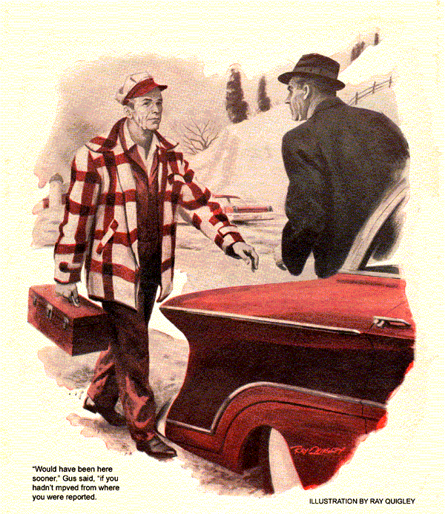
A thaw had set in. Even with the short January day already darkening, the roads were still running with melted snow. Spinning tires whipped up slush that spattered windshields. As Gus Wilson turned the wrecker onto the turnpike, he concluded that mild weather was bringing new problems along with relief from the cold.
Tired from his day at the Model Garage, he wished that the late road call he was answering hadn't come. "Smells like the engine's burning varnish," the state trooper had said on the phone. "You may have to tow this one."
Gus booted the gas to get up to turnpike speed, and settled back for the run. It took him nine minutes to cover the eight miles to the location he'd been given. No disabled car was in sight. He kept on-heading for an exit. And then- three miles from where it should've been, he spotted the car, a 1960 Oldsmobile.
Gus pulled up behind it, made sure that his blinker was working, and walked up. The driver stood beside the car, scowling as if he had a grudge against the world. His face managed to combine Flabby jowls with a hard, square jaw.
"Took you long enough," he remarked.
"Would've been here sooner if you hadn't moved from where you were reported," replied Gus, aware of a nose-wrinkling aroma.
"Wasn't sure anybody'd show." growled the man. "Thought I'd try it again."
"What stopped you this time?"
"Same thing as before. Can't get any speed-it's like something is holding me back. Smells so bad, I figured I'm burning something out, so I pulled off the road."
Grunting noncommittally, Gus opened the hood. The smell was even stronger, much like that of oil on a hot exhaust manifold. With his flashlight to eke out the failing daylight, Gus looked for tell-tale oil stains. There were none. But the engine was so dirty they might not have showed in any case.
Opening the radiator, Gus flashed the beam into it. The water level was normal, too. The hoses looked cleaner than the rest of the engine. Gus guessed they were new.
"Radiators the first thing I checked myself," snorted the driver. "There's plenty of water. Don't waste time. I know how you guys charge-by the minute."
"Okay, anything else you want to tell me to save time?" asked Gus.
"No; I dunno what's wrong. That's your worry. Just get on with it."
Gus got on with it. The engine oil-level was up to the mark. There was no sign of oil leakage from the valve-chamber covers. He got in and started the engine, noting that all dash indicators read normal.
Letting the engine run with the automatic drive in neutral, Gus laid down a tarpaulin and crawled under the car. Fumes from the breather pipe showed that it wasn't clogged. A new odor-not of oil- was now very noticeable. Gus suddenly realized he'd smelled it all along, but the blend of hot oil with the other made it impossible to identify.
Gus wriggled out, revved up the engine and looked for leakage that might occur with increased oil flow and pressure. The smell of hot oil now seemed like something subtly different-transmission fluid. He might have recognized it sooner, Gus felt, if it hadn't been for that other elusively familiar smell.
"Had any trouble with your transmission?" Gus asked the driver.
"Nope. Always been all right. Don't try selling me a big repair bill on that!"
Gus put the transmission in drive and revved the engine to a fast idle. It took several seconds for the car to lurch in response, confirming his suspicion. After a short time he let the engine idle normally and put the transmission in neutral. He got out and reached cautiously for the transmission dipstick. It was too hot to hold.
Using a rag, he pulled it out. The fluid level was low. The filler pipe gave off fumes and an acrid odor. The transmission case was blazing hot. Gus cut the engine.
"It's quicker to ask you than to check," he said. "Did you drive with the hand brake on?"
The man snorted. "I ain't that stupid. And before you ask, I didn't push or tow nobody, either. Or climb any steep hills. I only just came from Wilton Park, and the road's all flat and easy. Ask me another."
Surprised, Gus said, Wilton's only about 12 miles south of here."
"Sure, only got this far because some jerk at the gas station there never finished working on the car till an hour ago."
The smell that wasn't oil once more floated past Gus's nose, annoyingly familiar yet not normal to a car.
"Your transmission's overheating badly," announced Gus. "I'm trying to find out why. If it isn't upshifting-"
Hot paint!
The elusive smell was the kind you got from a freshly painted radiator. Gus put his flashlight on the inside of the car's radiator. Fresh paint gleamed.
"Forget it!" snapped Gus as the man began another spate of grumbling. No more questions. I might have caught on sooner by daylight. Why didn't you tell me you just had the radiator fixed?"
"What for? It's got nothing to do with the oil, or the transmission, either."
"It has plenty to do with your transmission fluid!" retorted Gus.
He slid under the front of the car. The torch showed exactly what he had expected. Setting thing right took Gus scarcely a minute. He got up and went toward the wrecker.
"Hey, wait. You ain't going to leave me here, are you? Asked the grumbler, plaintively.
Gus thrust a cupped hand toward him. "Take a look. These were at the bottom of the trouble. I'll be back."
From the wrecker Gus brought a can of transmission fluid. He added enough to bring the level in the car up to normal, then wrote up his bill.
"Hold on!" protested the man, his heavy chin thrust toward Gus. "You hand me two pencil stubs, tell me that's the trouble, and expect me to pay you for that?"
"Your radiator has a bottom section for cooling the transmission fluid," returned Gus. "When a mechanic takes off the radiator, he plugs the two lines from the transmission so it won't run out. Often he sticks a couple of pencil stubs in them."
"That's what your mechanic did. But I'd bet you were swearing at him when he put the radiator back, beefing so hard he just forgot to take the stubs out and reconnect the lines to the oil cooler. With no cooler, the transmission ran hot. It was sluggish because it was short of fluid, and some of what was left boiled up into froth that couldn't transmit power."
"Chances are no permanent harm's been done, but you can have somebody else check that later. Right now you can drive off to any place or any garage you like-long as it isn't mine."
"Now pay up."
"Sullenly the man paid and got into his car. Automatically looking back, Gus spotted a car approaching in the near lane. The Oldsmobile's driver didn't see, or didn't care. He roared out into the other's path.
Brakes squealed as the oncoming car swerved wildly onto the shoulder, narrowly missing Gus, and came to a stop 50 feet away. Its driver promptly backed up. The small sedan, an impudent little beetle of a car, stood quivering as though frightened by its escape. Emerging from the glare of the wrecker's headlights, the driver proved to be a rather overdressed young man who looked as if he'd enjoyed the close call.
"Lucky I couldn't go fast," he said with a grin. "Since I had to stop anyway, I thought I would ask you to help me. I'll make it worth your while, and being out on another call anyway, you needn't tell your boss you made an extra buck."
"What's your trouble?" asked Gus.
"This little bug's buggin' me. Usually she wheels real good at 70. Today it's so warm I shut off the heater. So right off the engine slows down like I'd shut off half the gas. The more I turn down the heater, the slower it goes, until I can't do more than 50. It won't go any faster unless I turn the heater on again."
"When did you start?" asked Gus.
"Since it turned warm. Of course while it was cold I never turned down the heater. A gas station sold me a set of new plugs this morning. Didn't help. This afternoon I had another guy look at it. He said I needed a new carb, but he didn't have one.
Gus opened the rear hood of the Volkswagen and played his flashlight on the little pancake engine. All the plug wires were tight. The little mill chuckled sweetly, responding at once to the throttle.
From the black fan housing in front of the engine came something Gus had to look twice to believe. A little wisp of steam. Steam? From an air-cooled engine?
Shutting it off, Gus took a closer look. The rapidly dispersing wisp looked like steam, smelled like steam. But there was no other trace of moisture. The distributor was clean and bone-dry. So was the fan housing itself. The whole engine was so well sealed from road moisture the car could ford streams.
But the trouble had appeared only since the thaw-or when the roads got wet-which was the same thing. Gus had run into one forgetful mechanic today. Was he now on the track of another?
With his flashlight he examined the edges of the underpan around the engine. They were tight and dry except at one spot. There had been a forgetful mechanic.
"Here's your trouble," Gus told the driver. "The lips of the pan gasket weren't fitted around the pan edge there, but left under it. When the air stream hits them at 60 or so, it forces the lips down and opens like a scoop. So they act like one, taking in road spray and funneling it onto the fan casing. From there it blows back onto the plugs on this side. They short out-and the car slows down."
"But the heater, man! What's that got to do with the heater?"
"When it's on full, it routes engine-cooling air into the car, and the housing gets hot enough to evaporate that spray, so the plugs don't get wet. When you turn down the heater, you're opening dampers that let the cooling air flow straight out in back. So the fan housing runs cooler, doesn't evaporate the water, and the plugs get wet."
"When you slow down to about 50, the gasket lips flip shut. No more spray gets in. The engine hits on all four-until you try speeding up again."
The young mans eyes gleamed. "That's so far out it just could be."
'It was," said Gus, folding the rubber seal carefully over the edge of the pan. But you'll be okay now."
"Glad you showed," said the young man, handing Gus some folded bills. "This suit you?"
"That's fine," said Gus.
"Remember, you don't have to tell your boss," the young man continued, "so it's all payola."
"The boss?" he said. Never tell him a thing. He's one of those guys who always knows it all."
END

