February 1964

GUS SOLVES A COUPLE

OF CURRENT PROBLEMS

by Martin Bunn
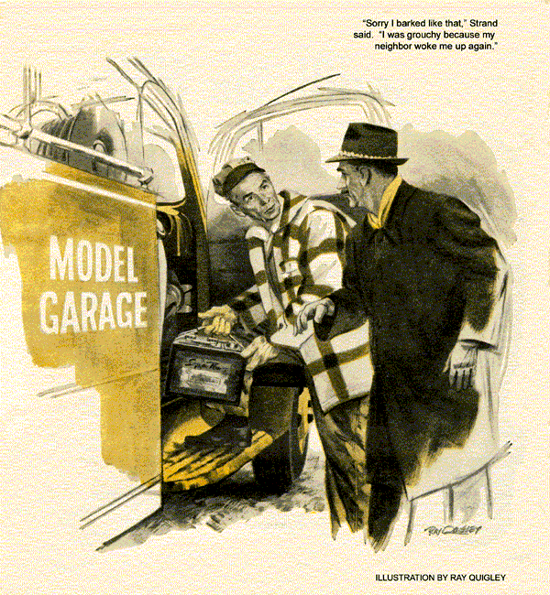
"Man wants a rental battery and recharge," reported Stan, hanging up the Model Garage phone. "Want me to go, Boss? It's out Hathaway Lane."
"I'll take it," said Gus Wilson. "You'd better finish the Dodson car."
"Roger. Just as glad not to have to switch batteries in this cold," confessed Stan. "Beats me why some people try to scrape through winter with a battery that's dead on its feet."
"Sometimes," said Gus, "it's because it's because it's not the battery that's dead."
With that, he hoisted a rental battery into the wrecker and drove out.
Hathaway Lane was just outside the town limits, a moderately new subdivision. Car ports outnumbered garages. At the address given, a two-year-old compact stood under one such wall-less shelter. Gus stopped behind it.
Promptly there was a banging of house doors, and a middle-aged man, dressed for the road, came out to the wrecker.
"Name's Strand," he said. "Thanks for coming. I should be getting on my way."
"If a hot battery will start your car, Mr. Strand, you soon will be."
"Oh, it's the battery, all right. It's the second time this month it's dead."
Taking the rental with him, Gus went to the car and raised the hood. The battery terminals were clean and tight, but plugs and distributor were overlaid with grime that testified to long neglect. Gus turned the key to "start." A click of the solenoid was the only response. He removed the battery and installed the rental.
"Want to try it now?" suggested Gus.
As Strand got in, Gus watched the throttle linkage. The starter churned vigorously, but only after several revolutions did the engine fire.
To Gus's ear it sounded badly in need of a tune-up.
"You know," he said to Strand, "the battery may be okay, but run down because something makes starting tough. For one thing, I noticed you pumped the gas when it didn't take off right away. That floods the manifold, and the battery has to crank longer to clear it."
Strand flushed slightly. "I know better. It's sort of reflex."
"Plugs could be dirty or badly gapped," said Gus. "Want me to check 'em?"
The man's jaw set stubbornly. "It took off fine with a good battery, didn't it? So that's all it needs. If mine's shot, tell me and I'll buy a new one."
Gus nodded, picked up the weak battery, and trudged back to his car. He was surprised, as he hoisted it aboard, to find Strand beside him.
"Sorry I barked like that. I'm short of sleep and grouchy because she woke me up again - my neighbor, I mean."
Gus must have looked as puzzled as he felt, for Strand went on. "This woman next door works an early shift at the telephone exchange.
She leaves around five a.m. Several mornings now she's hopped into her car and sounded off long and loud on the horn before driving away. Once awake, I can't drop off again."
"That's rough," said Gus. "She driving a car pool or something like that?"
"No, she's alone. Some time ago my wife asked her why the horn bit. Know what she said? Unless she does it, the car won't start! Do you buy that?"
Strand was so intense that Gus had to iron out a grin hurriedly. "Never heard that one before, and we have one woman customer who gives us some dandies," he added, thinking of Daisy Allen. "But there's usually a grain of sense in what she says, if you can find it."
Strand snorted. "Not with this one. 'I just have to blow the horn, or the engine won't start,' she says. Wacky dame!"
Gus climbed in. "Want to come for the battery, or shall we bring it out?"
Strand seemed suddenly preoccupied. "Eh? Don't know yet. Better phone."
"Well, how was that battery?" asked Stan as Gus drove in. "D.O.A.?"
"What's that?"
"TV hospital lingo, dead on arrival."
Gus grunted. "Dead enough. It may come around. Put it on the line."
Stan lifted it out and did so.
"Guess you'll have to go out Hathaway Lane next time, Stan," said Gus.
"Sure thing. Any special reason?"
"We may get a woman customer there who's right up your alley. Her engine won't start unless she blows the horn first."
"You're kidding!"
"Honest. And since you do so well fixing way-out troubles for Mrs. Allen… "Stan groaned."…I'd want to send you - our offbeat troubleshooter," finished Gus.
Gus wasn't surprised to find that Strand's battery was taking a charge nicely. Shortly before closing time he asked Stan to phone the customer.
"I told him he could come for it in the morning," reported Stan later. "But he wants you to bring it out by eight-thirty, even though it'll cost him a call."
"Okay. You can take it while I open up," said Gus.
Stan grinned. "If you say so, Boss, but he specially asked you to come yourself."
Light snow was falling as Gus turned into Strand's driveway next morning. He had the battery in place before Strand came out.
"Hello. You're very prompt again."
"Your battery came up fine. Anything you wanted to see me about?"
"Well, you said something about checking the plugs. Guess they are old - they're the ones that came with the car."
Gus got out a wrench and set to work. The first two plugs he removed told all.
"Old's the word. These electrodes are so burned you have almost double the normal gap. One reason for hard starting."
Replacing the plugs, Gus opened the distributor and inspected the points. They were pitted, the rub block was well worn, and the gap a scant few thousandths.
"Here are a couple more reasons your battery has it tough," Gus pointed out. "The points are set so close they don't make a really clean break, so the spark's not as hot as it should be. Also, this small gap makes the spark late.
"It's easy to diagnose a no-start as battery failure, but sometimes that's only the last straw. What you really needed before your battery quit was an engine tune-up.
With good ignition, the battery probably wouldn't have run way down like that."
Strand nodded thoughtfully. "Funny how a fellow's willing to settle for a battery boost to get the car started, and once it's running doesn't care why it let him down. I'll be in for that tune-up today."
"Sleep better this morning?" asked Gus. "Did she quit blowing the horn?"
"Er - yes. I mean no. Look, it's been happening every other day or so. I know, and you know, that blowing that blasted horn can't have a thing to do with starting the engine. But I'm not a mechanic. I thought if you told her…"
"Me? But I thought she left at five."
"Not today. She's off duty, and my wife's made her promise not to use the car until you'd had a look at it."
Gus picked up his tool kit.
In the next carport stood a not-very-new Pontiac. Strand rang the doorbell. A wispy but pretty little blonde came out.
"This is Mr. Wilson, Miss Carr. I'm hoping he can show you that it's not necessary to blow the horn."
Miss Carr's mouth tightened. "Well, it is. Not every morning, but some. I'm sorry it wakes you, Mr. Strand, but it's the only way, and I can prove it - to you and to him, too."
"Right now, Miss Carr?" asked Gus.
"Yes," she said triumphantly. "Because this is one of those mornings it won't start otherwise. I came out earlier and tried it, without blowing the horn. When I do, it will start. You'll see!"
"That's impossible!" blurted Strand. "I know enough about engines to be sure the horn hasn't a thing to do with it. Has it, Mr. Wilson?"
"It's just possible," said Gus, on whom a suspicion was beginning to dawn, "that it may have. How did you find out that blowing the horn helped, Miss Carr?"
"Temper, I guess. I was already late, and the supervisor is fussy about that, so when the engine wouldn't chug over I could have shrieked. Instead I blew the horn hard. That must have calmed me, because then I tried the starter again, and it worked!"
"How does it act evenings?"
"Oh, it always starts right away in the afternoon, when my shift is over. I needn't blow the horn then."
"Let's have a look, Miss Carr," he said.
"She unlocked the car and, as Gus got in, gave him the keys. He turned the ignition switch to "start." There wasn't a sound or a twitch from the engine.
"Battery's dead," pronounced Strand.
"No, it's not," said Miss Carr severely. "Now you blow the horn and…"
Gus got out. "I'd like you to do that, Miss Carr. But let me open the hood first, and don't do it until I signal you."
She nodded and got in. Beckoning to Strand, Gus swung the hood up.
"It's only a hunch," he said to Strand. "But watch both battery terminals."
Strand nodded. Gus waved his arm. A furious blare came from the horn. Between the positive battery post and its spring clamp a small blue arc flared briefly. An instant later the starter ground and the motor roared to life.
Gus cleaned both terminals, reset their clamps, and told Miss Carr she wouldn't need to blow the horn to start.
"But tell me why," said Strand. "I still can't believe it."
"Well, instead of honest bolts, those clamps have only springs to grip the battery posts. In time they weaken. Corrosion forms between the clamps and the posts - often just overnight. It builds up so much resistance that current can't flow."
"But it must have. The horn blew."
"Sure," said Gus. "But the effect of a resistance depends on how much current is trying to squeeze through it. In other words, the voltage drop depends on the current across that resistance. The horn doesn't take much, so that corroded connection caused only a small voltage drop, leaving enough to form an arc that burned away the corrosion."
"But the starter circuit - even the starter solenoid - takes so much more current that there was a big voltage drop the instant she turned on the key. There wasn't enough voltage to jump an arc over, and what little current passed couldn't even kick in the solenoid - until blowing the horn burned away the resistance."
"Well, thanks," said Strand. "Now I've got something to look forward to."
"What's that?"
"Sleeping till eight tomorrow."
Stan looked up as Gus drove into the Model Garage.
"How'd we do, Gus? Did you get that goofy dame for a customer?"
"Uh - you might say she got me."
"She sure sounds spooky. How did you handle her trouble?"
"I'd better not tell you," said Gus. "You'd think I was blowing my horn."
END

