August 1964

GUS TACKLES A HIGH PRESSURE JOB

by Martin Bunn
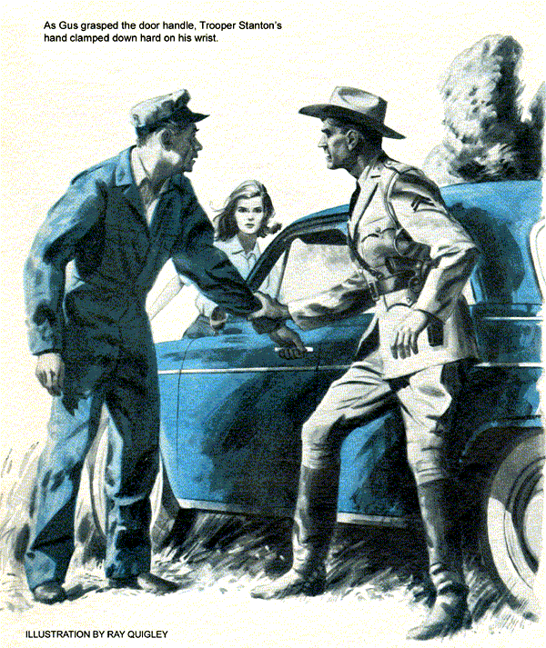
With relief Gus Wilson watched a car drive out of the Model Garage. Stan, just returning from lunch, looked at it curiously.
"Wasn't that Daisy Allen, Boss?"
Gus nodded. "Had a great time with her. Wish you'd been here."
"The usual wacky beefs?"
"One was enough. She thought her right-hand door was squeaking on turns. So I put graphite on all fittings and weatherstrip. Test-drove the car. All quiet. She left."
"In five minutes she was back. Said it still squeaked. I got in and had her drive around the block. She'd hung her heavy pocketbook on the wiper knob. Squeaked like a bucket of mice."
Stan shook his head in commiseration. "Never mind, Boss. It's Friday. We may not get another nut all week."
"All I ask," said Gus fervently, "is ordinary people with ordinary car troubles."
When Gus came back from his own lunch, he found a 1957 Chevrolet on the floor. Stan had the radiator cap off and was pumping up pressure in the cooling system with a rubber-bulb device on the filler neck.
"Got your wish, Gus," he said. "A plain, ordinary Joe on his way south for vacation. His car's been losing water for a couple of years-not enough to bother him around home. But in this hot weather, at throughway speeds, it lost so much he got stuck twice."
"There's no oil in the water, so I figure the head gasket's okay. Bet I'll find the leak around the water pump flange, at a heater hose, or from a hole in the radiator. That ordinary enough for you?"
With a grunt, Gus stalked of to the office to make out weekend bills.
A much soberer Stan poked his head around the door 10 minutes later.
"It's not so ordinary after all," he announced. "The system's tight. What'll I do?"
"Find the leak, in the one thing you haven't checked," suggested Gus.
Stan ducked out. Presently Gus heard the engine start, and noticed that Stan had draped the radiator with an old blanket. Shortly afterwards he was back.
"You were right-it was one thing I hadn't checked. The pressure cap. With the engine hot, the leak showed up as steam from the overflow pipe."
"Pretty ordinary trouble, after all."
"Don't rub it in, Boss. I know bum pressure caps are old stuff. Guess I've got summer slump. All the same, this is one for the book. Have a look."
He laid down the pieces of the old cap, pried apart. Gus held up a coil spring.
"Where's the rivet to hold this?"
"Wasn't any. That spring was just floating around loose in there. The man had two years of nuisance trouble, poured in cans of leak-stopping stuff and lost anti-freeze, all because of one lousy rivet that wasn't there."
"Well, you can tell him," said Gus, looking out to the shop. "He's back."
The Chevy's owner, a stubby little man with a black mustache, was perspiring visibly under a red-and-black striped shirt. He offered a business card to Gus.
"Higgin's my name, diggin's my game," he said loudly. "You the boss?"
"I'm Gus Wilson. It's Stan here who licked your problem, though."
Stan explained, holding up the defunct pressure cap. Higgins shook his head.
"That's Detroit. Make it complicated."
"Pressurized cooling systems are worth it," said Gus. "They make today's engines run warmer and more efficiently."
Higgins waved a hand disdainfully. The gas engine's on its way out. It'll be obsolete when my energy amplifier's sold."
There was a brief, complete silence.
"Come on, I'll show you," said Higgin.
He threw up the trunk lid. Inside reposed an impressive piece of hardware, a spidery wheel of gleaming brass. Ball bearings studded paired, tracklike spokes. Between each pair was a massive block.
"The day will come," pronounced Higgin confidently, "when every car on the road will be driven by one of these."
He reached out and gave the wheel a spin. Smoothly the topmost weight rolled outward and swung down; the next did the same, and the next. At the bottom, a cam and lever pushed the lowest weight back toward the center of the wheel.
"Don't get the idea it's perpetual motion," warned Higgin. It won't keep running by itself. Needs a little energy to overcome rotary inertia. But you drive it with a pea-sized motor, get it spinnin' fast and you can take off lots more power than you put in. I'm on my way to Washington to show it to the Patent Office."
Having made two complete turns the wheel came to rest.
"Well, we both wish you luck," said Gus.
"Thanks, what do I owe you?"
Five minutes later, his bill paid, the confident little man drove out..
"A plain, ordinary Joe, huh?" asked Gus.
"How could I know? Besides maybe he's just way out about this one goofy thing."
Grinning, Gus handed Stan the card.
"Inventor, plumber, and dowser," read Stan with growing disbelief. "Aloysius U. Higgin. Wells dug cheap. Lost items found."
"Any questions?" demanded Gus.
"Yeah. What does the U stand for?"
The day grew hotter. Gus was looking forward to closing when the phone rang.
"Got one for you, Gus," said the dispatcher at state-police barracks. "Renault at milepost 277 South. Stanton thinks it could be vapor lock or fuel pump. Oh, yes-you better take a chair along. You might happen to need it."
"A chair?" asked Gus in amazement.
"Just a gag," said dispatcher Donovan.
Taking an emergency kit that included a few spare parts for the popular imports, Gus rolled out the tow truck. At milepost 277, he saw a saucy little sedan with a girl at the wheel. It was blocked by a police car. The trooper approached as Gus braked to a stop, but froze as the Renault's door opened, his hand moving toward his gun.
"Stay in the car," snapped the officer.
The girl defiantly stepped out and slammed the door. She wore toreador pants and a silk blouse. With an impartial scowl for both of the men, she addressed Gus.
"My car runs perfectly well. Just because it stalled twice, the police made me wait for help I don't need. Please do whatever is necessary to make this Cossack let me go."
Trooper Stanton reddened but said nothing. The hood of the rear-mounted engine was already up. Gus made quick checks of the automatic choke (open), ignition wiring (all tight and dry), and fuel lines (no loose connections or traces of leakage).
"You're wasting time," snapped the girl. "It will start as soon as I turn the switch."
"But I found you stalled out twice," put in Stanton. "And on this road, that's twice too often."
"It's dangerous to stall on a high-speed road," Gus agreed. The trouble may be something that kills the engine after it has run a while-like a clogged gas cap-or when it's very hot, like a vapor lock or water loss from a weak radiator cap."
"It can't be that," the girl said angrily. "I lost the cap two weeks ago and got a new one. The car has run fine ever since, until today."
Gus checked the radiator and heater hoses. All were tight and in good shape, but the water in the radiator was low. He brought a can from the tow truck and added some, saw that the pressure cap was indeed new, and walked around to the driver's side to start the engine.
Trooper Stanton's hand clamped Gus's as he grasped the door handle.
"Let her do whatever you want."
The girl slipped by and was in the car like a flash. Gus heard a rumbling purr like the idling of a straight-pipe V-8. Looking through the rear window, Gus saw the pointed ears and narrowed muzzle of a great catlike head. Its huge feline body was buff colored and spotted.
The girl lowered her window a trifle. "Don't panic," she said. "It's my pet cheetah, Satan. He's quite tame."
She switched on the ignition. The engine started instantly.
"Tame, hey? Confided Trooper Stanton to Gus. Yesterday we had a report from upstate about a big cat chasing a motorcyclist. Want odds it's that one?"
Gus grinned. "Now I know why Donovan said to bring a chair."
Idling smoothly, the engine responded instantly to the throttle. Gus could find no hint of gas or ignition trouble.
"Could still be vapor lock, especially in this weather," he told Stanton. "Was it you who opened the hood?"
Stanton nodded. "I thought I might find a loose wire or something else simple, patch it up, and get her moving with that animal. The quicker it's off the throughway the happier I'll be. But I couldn't spot a thing except a bit of steam."
"Steam?" Gus told the girl to kill the engine, then leaned over to put his ear close to the radiator cap as he slowly loosened it. There was no hiss of escaping pressure. He looked at the valve seat then at the inside of the cap.
Taking a pencil from his pocket, he thrust it down the valve seat in the radiator neck, with his thumb against the rim, then transferred the pencil to the cap. His thumb was a quarter-inch away from the face of the valve.
"That steam was the tipoff," Gus explained. "It was water evaporating off the engine and ignition. Somebody sold her a standard cap. Its valve is too short and won't seat. On town trips it makes no difference, but on hard hauls the water boils because the system isn't pressurized."
"It squirts out under the cap and blows all over the engine, killing the ignition. After the engine heat dries it out, the car runs again."
From the parts kit, Gus brought out a new pressure cap, checked the length of its valve, and tightened it in place.
"As Stan would say, nothing was wrong except one lousy quarter-inch that wasn't there. Soon as she's paid me, you can wave the lady and her overgrown kitten on their way."
Stan was locking up when Gus parked the truck. He came in to change as Gus was taking off his coveralls.
"I been thinking, Boss. Maybe that guy Higgin has something. When those weights are way out, they must have more leverage than when they're close to the hub. It stands to reason they're going to pull down on that side… "
"Not a chance, Stan. That's just one of a lot of tired perpetual-motion schemes, no matter what fancy name Higgin gives it. Systems like that always balance out, at best. You don't get power for nothing."
"Kind of looked good for a minute," remarked Stan. "Your road call easy?"
"Easy enough," said Gus cautiously. "Funny how things sometimes go by twos. This car needed a radiator cap, too. I used the one Jim Stearn ordered for his Renault a couple of months ago and never came back for. Lucky I had it along."
"Yeah. And I'll bet the customer was just a plain, ordinary sort. Right?"
Gus bit his lip thoughtfully but didn't answer. Stan looked up from lacing a shoe.
"Well? Cat got your tongue?"
"You'll never know," said Gus, how close to right you are."
END

