November 1963

GUS WARMS UP A COLD CUSTOMER

by Martin Bunn

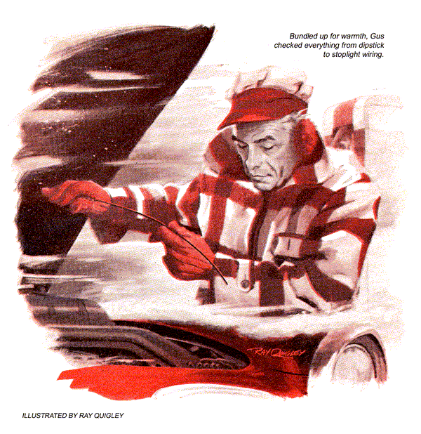
Gratefully Gus swung his wrecker into the alley behind the Model Garage and parked. He stepped from the heated cab, his breath fogging in the chill November air. Snow changing into ice the night before, with temperatures to match, had brought a rash of emergency calls all morning.
The big Chrysler parked near the pumps, could be one more. If so, it could wait until he'd warmed up over coffee and a pipe, Gus thought. But if it had gotten this far, why hadn't Stan put it into the shop?
A swirl of artic air almost blew Gus through the back door when he unlatched it. Forcing it shut, he felt the cozy warmth created by the shop blowers. He saw nobody in the office or out on the shop floor.
"Ov-ve-ver here, G-G-Gus," called Stan.
Gus's helper was huddled under the largest blower in the shop, teeth chattering and ears beet-red with cold.
"What happened to you?" asked Gus.
The eyes Stan turned on him were as woebegone as a scolded spaniel's. "That road locomotive out front, Boss. Oscar Nielsen's car."
Nielsen was an occasional, and usually difficult customer. While admitting that he knew little about cars, he had definite ideas about what he wanted done any time he brought his in.
"I'll start coffee, Stan. Come tell me about it when you're ready," said Gus.
Gus switched on the percolator and a radiant heater. He was glad to find no more road calls on the pad in the office. As he readied two cups, Stan trudged in.
"Get outside this," said Gus, shoving a cup of steaming java in front of his helper. "Where did you manage to get so chilled?"
Stan drank as if inhaling warmth. "Out front, Gus. That's where that stubborn Swede said I'd have to find the same short he didn't have last year."
"Seems it kept well," grunted Gus. "Back last March, I remember, Nielsen wanted you to find out why his circuit breaker kept clicking on cold mornings."
"Only, he thought it was the ammeter! Well, I couldn't hear it click, or find any short. So he forgot it all during the good weather. Today, in the worst cold snap we've had yet, he shows up with the same beef and has to have it fixed. He parked out there and wouldn't drive it in; said I'd have to hunt the short in the cold this time, because that's where it happens every time."
Gus nodded thoughtfully. Nielsen, the best carpenter in town, was a mule once he'd made up his mind. "He just could be right, at that."
"Yeah? I've been all over the wiring, switches, and accessories. Not a thing wrong any place. My fingers got so stiff I had to quit a couple of minutes before you showed up. Maybe he'll forget about it for another year."
Leaning back, Gus slowly packed his pipe. "Something happens, Stan, or Nielsen wouldn't have come here. How did he say the car acted this morning?"
Stan shrugged. "Same as last year. He has no garage and parked in the back yard last night. This morning he came out to start the engine - he always warms it up while he eats breakfast, he says.
"It started okay, but then he noticed the ammeter needle going crazy. From normal charge it would suddenly snap to full discharge with a loud click, go back to charge, then do it all again."
"Did you ask what accessories he had turned on?" inquired Gus.
"Sure, and he asked me what kind of fool I took him for. At night he just switches off the ignition, because he knows that kills the accessory circuits. But mornings, before he even puts the key in, he says, he first switches off the heater, electric wipers, and radio so the battery can put all it's got into cranking."
Gus dragged on his pipe. "Sounds like what Nielsen would do. I'll buy that."
"Un-huh. Well, the windshield was all iced up this morning and he had to get to work, so he switched on the defroster and let the engine run, still clicking. When he came out after breakfast, the ammeter was behaving and the clicking was gone. I let the engine get stone cold again before I checked it, like he told me to. But no clicking, no short - just frostbite."
Gus nodded. "I've got a hunch you just told me why it happens, though I don't see it yet. Make you a deal, Stan - I'll double-check with a meter and take care of Nielsen. You take the next customer or road call, whichever it is."
"Boss, that's no deal - it's a favor."
The next customer drove in with a complaint of hard starting, and Stan sold him a badly needed set of new plugs. Gus bundled himself up again and went out to Nielsen's car. The first thing he did was look at the oil on the dipstick.
Then with the ignition on and a multimeter connected, he checked everything from the stoplight wiring to the radio switch. Every accessory checked with known values. There was no sign of leakage to ground, let alone a short. Almost as chilled as Stan had been, Gus finally went back inside.
Could Nielsen's habit of switching off only the key, instead of individual accessories, be the tip-off? But these did draw power through the ignition switch - Gus had checked that, just in case somebody had rewired things. With the key out, all auxiliary circuits were indeed dead. Besides, it was with the engine running that the discharge occurred.
Two more road calls took Gus out of the shop. One was a tow job that brought him back with a sports car dangling from the hook.
Shortly after, with dusk darkening the sky, the summons of a horn outside made Stan open the main shop door.
A big Pontiac rolled in, its windshield almost opaque with frozen slush. Only through the window could Stan see the driver. He was a stranger. But the passenger who emerged was Oscar Nielsen, his lanky six-feet-two crouching to avoid hitting the door frame. Gus came forward as the carpenter set down an enormous tool case and glanced at Stan.
"Ay got a feeling you didn't find the trouble with my car."
"We didn't find any short," said Gus.
The carpenter snorted, his shrewd blue eyes on Gus. "You are an expert, Gus Wilson, so ay believe you. But some kind of trouble my car has got, for sure."
He turned to indicate the other man.
"My friend Mike Moran drove me - ay be glad not to walk after a long day working. He has trouble, too. Maybe you can fix his better than mine?"
"We'll sure try," said Gus. " And we haven't given up on yours. Maybe Stan can help you, Mr. Moran. What's wrong?"
The stubby little man jerked a thumb at the windshield. "See the muck on that? Think I drive like that because I enjoy it? It's like this: whenever I use the windshield washer, my engine bucks like it's about to give up the ghost. Watch!"
Hopping into the car, Moran started up the engine. Then, as twin jets of water sprayed the dirty windshield, the engine's smooth idle broke into a ragged, bucking gallop.
"You see? Didn't need it this morning, once I cleaned off the ice. But all day the car wheels have been throwin' up dirty slush, and it would sure be a help - "
"Stan can fix that in a jiffy," said Gus, grinning. He'd just been presented with a missing clue. "Mr. Nielsen, you're sure that you always turn off everything before you start the engine in the morning?"
"Sure. Ay want to save the battery in cold weather."
"Let's go to your car," suggested Gus.
Gus started the engine of the Chrysler, turned on the heater, headlights, and wipers, and got out.
"You get in," he said to Nielsen. "Imagine you've just arrived at home. Do exactly what you always do."
Nielsen killed the engine. The hum of the heater died. Wiper blades halted in mid-air. The headlights faded out.
"Now," ordered Gus, "pretend it's morning and you want to warm up the engine."
"But now is not the same," protested Nielsen. "Now it is warmed already."
"I'll allow for that." Gus watched as Nielsen shut off heater and wiper switches. As he turned the ignition key, Gus seized the nearer wiper. It surged in his fingers. He held it firm. Nielsen, intent on the ammeter, didn't notice.
In about 10 seconds there was a loud click, and very soon another. Gus released the blade, and both slid to their off position and stopped.
"You heard it?" asked Nielsen.
"I did. I was causing an overload by holding one wiper," returned Gus. "The motor was trying to move it, and drew so much current your circuit breaker snapped open."
"How could this be?" demanded Nielsen. "You saw me - ay turned off the wipers."
"That's right, but there's a bypass circuit that powers the motor until the blades are back in their off position in a corner of the windshield. Soon as you turned of the ignition, that circuit was closed."
"Ay was not holding any wiper blade this morning!" declared Nielsen.
Gus chuckled. "No - it was frozen tight, where it stopped last night. Once the defroster thawed them, both blades swept back and the motor shut off, ending the overload. But this morning you didn't have to use the wipers at all. The condition Stan was hunting wasn't there."
Nielsen nodded. "It was all my own doing. Ay will turn things off at night."
"If you don't mind some advice," said Gus, "your engine would crank easier and your battery stand up better in this cold if you'd change your oil. Use a multi-viscosity oil instead of the heavy one that's in now. And I'd skip the long warmup. Engineers now agree that a car shouldn't be idled long on cold mornings, but simply driven off at reasonable speed. Just be sure your thermostat opens at the right temperature for the antifreeze you're using."
"Good advice I'm glad to take." Nielsen's blue eyes crinkled. "It will anyway give me five minutes extra for breakfast."
Warm and cozy in front of the heater, Stan winked at Gus as he came in. "Sure outfoxed you when I got that easy job and let you rassle with Nielsen."
"Turned out there was nothing to do on his car." Briefly Gus explained.
"Moran's job wasn't that tricky," insisted Stan. "I couldn't find any vacuum leak, so I twisted around the washer tubing to see if it was okay. When Moran punched the button, the answer hit me smack in the eye - a squirt from near the T-connection middle of the cowl."
"That's using your head," said Gus.
Stan flashed him a suspicious glance. "I let go the tubing to wipe my face, and it aimed that squirt right at the distributor. Soaked the wire to number-six plug, so that cylinder cut out. All I had to do was cut the tubing back to the pinhole."
"You're right then. My job was tougher than that. Much tougher."
"What'd you do that you haven't told me?"
"What sometimes seems the hardest job in the world," replied Gus. "Think."
END

