June 1963

GUS TRACKS DOWN A FOREIGN AGENT

by Martin Bunn

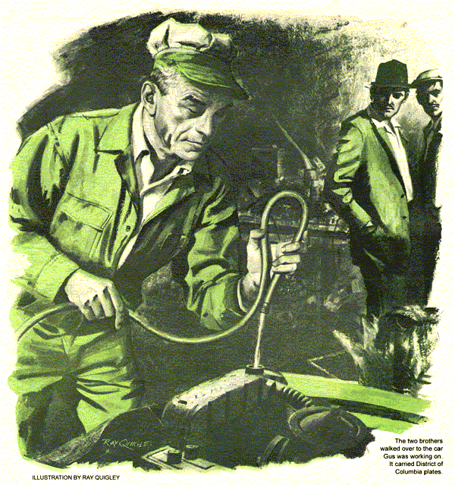
A hiss, louder than its engine heralded the entrance of a 1953 Oldsmobile sedan into Gus Wilson's Model Garage. Steam was pouring from the overflow pipe. As Gus went over, the driver got out and looked ruefully at the cloud of vapor.
"Couldn't happen at a worse time," he said. "Have to be in Springfield tonight."
"When did this begin?" asked Gus.
"Just about noon," said the driver, a broad-shouldered man in a business suit. "Had to stop four times to cool it off. Boils again after 15 minutes. One gas-station mechanic found a collapsed hose, so he replaced both of them. Another put on a new pressure cap."
"I'll check the thermostat," said Gus. "If it's okay, I'll flush the system. There's a restaurant across the street if you want a bite."
"Good, I missed lunch on account of this trouble. Name's Darby, by the way."
Taking a briefcase from the car, Darby walked out. Gus used a drop light to look for leaks around the hoses, radiator core, and water pump, but found no sign of any. With a rag, he turned the radiator cap to its first detent, let the pressure subside, and then removed the cap. No water was visible.
Loosening its housing bolts, Gus found the thermostat open.
But it might have opened late - at too high a temperature - and it was of the old bellows type. From the stockroom Gus got one of the new pellet type. He was retightening the bolts when a horn sounded.
In rolled a hardtop - a 1957 Mercury. The exhaust of its V-8 engine was an authoritative bark. Stan Hicks, Gus's young assistant, hurried over. There were two men in the car, talking briskly in a foreign language. Both were under 30, and had dark hair and complexions. The driver finally turned to Stan. "Excuse us, please. We have far to go and the car does not run well, so we are a little excited. My brother thinks we waste time searching for the trouble."
"Engine sounds good. What's wrong?"
"But it must be the engine. At fast speed, like 60, it goes rough as if missing. But when we go slower, we find nothing is wrong. We see your sign, so we stop."
"A high-speed miss?" said Stan. "I'll check the points and spark plugs."
"But both are already new."
"The plug gaps could be too big," explained Stan.
Both men got out. The driver stared hard at Gus as Stan put the car on the lift. While Stan checked the plugs - which proved okay - the two brothers walked over to the Olds Gus was working on. It carried District of Columbia plates.
Letting the Merc down, Stan checked the ignition points. They were like new, and the gap was correct. As he was hooking up the timing light, Stan saw one of the men - the passenger - walk out and head for the restaurant across the street.
Gus drove off in the Olds. He'd filled the radiator, checked the oil level, fan belt, and radiator core. There'd been no sign of mud on the back of the core. The headlights were free of insect debris, so he was reasonably sure the front of the radiator was, too.
He'd driven only a dozen blocks when the water temperature began to rise - and failed to level off. Gus headed back to the shop; when he drove in, the water was near boiling. The Mercury's dark-eyed driver watched his return with somber interest.
"Say, Gus," called Stan from the stockroom, "will you look at this timing light? I'm not sure it works."
Mystified, Gus entered the partitioned enclosure. Stan shut the door.
"Gus," he whispered, "those two are up to something funny. That one - the driver - hasn't taken his eyes off the Olds you're working on. And that's not all."
"It's not even much," replied Gus.
"Yeah? They say their engine runs rough - but only around 60. I can't test-drive it that fast near here. So it's only their word. Plugs, points, condenser, and timing are all okay. When I wanted to check valve settings, he said that's been done. Fuel pump, ditto. Everything checks fine -"
"What are you getting at, Stan?"
"Gus, there's nothing wrong with that car. They're talking Spanish - and have Florida plates. The fellow who came in just ahead of them has Washington plates. I think he's a government man and these two are tailing him. One went right into the restaurant after him. Those two could be foreign agents."
"My customer's driving a pretty old car for a government man," said Gus.
"Maybe so he won't be noticed. I think we ought to get him back on the road ahead of these other fellows."
"I'm trying," grunted Gus. "Trouble is, something is wrong with his bus."
"Okay," muttered Stan darkly. "But remember I warned you."
Gus returned to the Olds. Considering its age and the heavy scale it might have in its cooling system, he decided chemical flushing was in order. Adding compound and enough water to bring up the level, he drove the car outdoors to let it idle.
A throaty rumble was coming from the exhaust of the Mercury when Gus joined Stan. But as he walked behind the car, he noticed that the hot-rod effect came from the right tailpipe of the dual exhaust.
Stan shut off the engine and turned to Gus. "I rechecked timing and point setting. All okay. Looks like the heat-control valve was frozen once - there's a stain like penetrating oil around it. But it works now."
Gus nodded. "Raise the car, Stan."
Under the car, Gus found the twin mufflers and resonators apparently sound. He tapped each muffler with a wrench. The two blows differed in sound.
Gus came out. "I think a bad muffler is causing your trouble," he told the driver.
"But there are no holes," the man protested.
"Holes aren't all that can go wrong with a muffler. One muffler is roughing up your engine, and I think I can prove it."
The dark-eyed young man shrugged.
"We have tried all else. Okay."
"Change the right-hand one," Gus told Stan. Stan responded with a sly wink.
Gus went back to the Olds, drained the chemical, flushed the system, and refilled it. When he gunned the engine, ripples and suction could be seen in the radiator neck, indicating normal pump action. He got in the car and headed for a hilly region.
Surprisingly, the water temperature climbed as rapidly as before. When Gus drove back into the shop, it was again near the boiling point. Darby, who was waiting, looked glumly at the wisps of steam emerging beneath the radiator.
"Sure wish I'd flown home." "You don't live in Washington?"
"Only go there on sales trips. I'm bringing this heap back for a neighbor."
Gus had removed a small inspection plate in the radiator shield, through which the drain petcock was reached. Now he put in a hand to feel the radiator core, searching for cool areas that would indicate local clogging. He felt no difference until his hand met something soft and fuzzy.
Taking a light, he slid under the grille and peered up at the radiator core. He exhaled slowly, whistling softly. What he saw was a mass of feathers - four dead birds, wings outspread as if in flight. They covered more than half of the core's cooling area. Pulling them free, Gus dropped the birds on the floor.
"Now I remember!" Darby burst out. "Coming around a bend fast, I ran smack into a flock of birds. They flew up - I thought they'd all got away."
"These didn't make it. The grille openings are so big they went clean through till they hit the core. Sorry I didn't spot them sooner."
"I should have tipped you off," returned Darby, getting out his wallet. "You found the trouble the hard way."
Stan was killing time mounting the new muffler. Gus removed the discarded one to a workbench, called the driver over, and proceeded to hacksaw the casing apart. When opened, the two parts proved to be solidly packed with a brownish-black mass, except for a small center passageway.
"There's what was fighting your engine," said Gus. "This sludge, what's left of corroded baffles and wire mesh, choked the exhaust from the right cylinder bank. At high speed, back pressure got bad enough to kill power on that side. The clogged baffles also made the muffler noisy."
His audience now enlarged by Stan and the other stranger, Gus went on. "Why did this one load up? Because with dual pipes the heat-control valve channels exhaust from the right bank though the intake manifold crossover for carburetor warmup, then out the left muffler. That muffler gets hot fast, burning out the water, oil, and raw gas in the exhaust. Some exhaust gets to the right-hand muffler, too - the valve doesn't cut it out altogether. But this muffler doesn't heat up, so sludge, acid, and carbon form in it.
"Once the engine's warm, the valve is supposed to open. Apparently yours was frozen shut once, letting this muffler run cold a long time - and sludge up - until somebody spotted the sticking valve and freed it. You'll see the difference now."
"That will please my brother," said the driver. "he is just coming from Puerto Rico and is anxious to drive on to see his girl here. I myself came years ago as a chauffeur to drive such a car as the one that just left."
"No wonder you were interested in it," said Gus, with a glance at Stan.
"Yes. The owner brought me here, so that kind of car I always remember."
"Your own will be ready in a jiffy now," promised Gus. "Won't it, Stan?"
Red-faced, Stan nodded and fled to finish the job.
"Too many spy thrillers on TV - that's my trouble," grumbled Stan when he and Gus were alone. "Those two Latin types turn out to be innocent American citizens, and the mystery man's a traveling salesman."
"You weren't all wrong. After all, we did find foreign agents, didn't we?"
Stan snorted.
"What else would you call sludge like that, and four dead birds?" asked Gus. "Besides, like the foreign agents you meant, they made a lot of trouble as long as they weren't suspected."
END

