January 1963

GUS FOLLOWS A COLD TRAIL

by Martin Bunn
30,000 Miles Between Grease Jobs -
How Safe is Extended Lubrication?

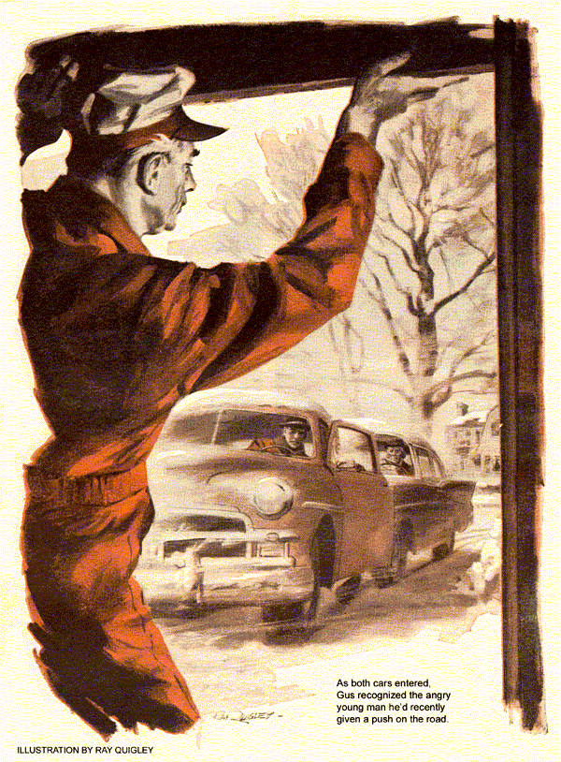
Ice slicks on the road, and snow that thickened on laboring wipers, made Gus Wilson slow prudently for the turn off the dead end of Route 80. It was cruelly cold, and even the full blast of the heater made the car only bearable. With relief he swung into a county road that led to town and the Model Garage.
He had just picked up a little speed when he spotted a stationary car ahead. Checking his mirror, he pulled out to pass. Then he saw that the car wasn't standing, but being pushed by a snow-flecked, plodding figure. Gus stopped behind it, set his turn signals blinking to warn following cars, opened his window, and leaned out.
"Want a push?" he yelled.
The figure straightened up, revealing a young man's face that was a blend of exhaustion, exasperation, and determination in equal amounts.
"Guess I can handle it myself, mister," shouted the young man, as if he were mad at Gus. Then he mellowed. "Well, okay. Let's give it a try."
Gus nodded. The stranger got in and Gus nudged the bumper of his coupe against the other car. At 20 miles an hour he felt the driver engage the clutch. The engine caught made a few revs and died.
Gus reclosed the gap between them and again nudged the car into motion.
This time the engine chugged over longer. It caught at last with a small backfire and kept running. The car pulled away maintaining what speed the icy road permitted. It stayed ahead all the way to town. At the first light, the driver pulled to the curb and rolled down his window.
"Guess it'll run long enough to get me where I'm going," he called out as Gus stopped alongside. "My boss insists I take it to some local genius he swears by. I don't think this joker can fix it even if he is a genius, but I've got to let him try. Anyway, thanks for the push."
"Welcome," said Gus. "Good luck."
Back at the Model Garage, Gus found the day's work nearly done and no new jobs in. He was about to tackle some office chores when from the street came the squeal of hastily applied brakes. An instant later followed the expected crunch of metal on metal.
"Business, Boss," remarked his assistant, Stan Hicks.
"The kind I'd rather do without," said Gus. "Hope nobody's hurt."
Both went to the door. Through the falling snow, two cars could be seen standing askew in the street intersection. A door of each hung open. Two men circled about, looking for damage, and a wordless murmur reached Gus and Stan briefly.
Then both men got into their cars. Starters whirred. One engine fired, the driver of the other car made sweeping gestures as his own engine died. The first backed jerkily, swung behind the other, and lunged forward. Its driver braked barely in time; the bumpers met with an audible smack.
"They're coming here," said Stan. "I think one is Judge Benson's car."
The other car also looked vaguely familiar to Gus, who rolled up the big shop door. As the cars entered, he recognized the angry young man he'd given a push on the road a short time before.
"Hello, Gus," said the retired judge rather sheepishly as he got out, "Did you see what happened back there?"
"Heard it, Ben," returned Gus, looking the cars over. "No glass broken, no dents. Guess only the two bumpers hit."
"The young man nodded. "I was feeding gas to get across when my engine quit again. Fact is, I was headed for this place."
Hey, it's-are you Gus Wilson?"
"Only name I've got," said Gus.
The young man opened his coat and shook the snow off. "It's a small world. You know my boss, Steve Hacket. I'm Jim Dwyer. We're doing a final check of the survey of Route 80. I needed a car to get around fast. Got this one below book value, 'as is."
"It ran fine the first four days. Then it suddenly felt like somebody'd swapped the engine for something out of a lawn mower. No pep. Quit at the lights and on hills. The first mechanic said it was dirt in the carburetor, but as the car was running again it must have cleared itself. He blew out the gas line and it worked okay. Nine days later it conked out when I was rushing to the courthouse for some important data."
"Anybody check for ice in the carburetor throat or gas line?" asked Stan.
"The second mechanic thought of that. He dumped in de-icing fluid. But car trouble made me late on the job twice.
Another mechanic put on a new carb, flexible fuel line, plugs, coil, and distributor. No good."
"No fuel pump?" asked Gus
"Checked that three times," said Dwyer sadly. "Everybody thought it was okay, but finally I did put on a new one.
"Then my troubles really began. I got stuck out in the field hunting up some survey markers. Took me hours to get back. Our schedule's all shot. We're supposed to have the whole survey checked out and approved by next week, and it's mostly my fault we're late. This morning Hacket told me to bring you the car and get it fixed, or get off the job."
Taking a droplight, Gus rolled under the car. Muffler and tailpipe showed no sign of exhaust leaks to account for a vapor lock. He wriggled out and raised the hood, then pulled the gas line off the carburetor. Cranking the engine brought a steady flow of gas from the fuel pump. Gus replaced the line and pulled the fuel line off the pump at the gas-tank side as Stan brought over an air hose.
Gus held the hose to the line and touched the valve. A bubbling of air in the tank could be heard plainly.
"Everybody tried that," said Dwyer. "We know the gas line's clear."
"Do we," asked Gus. "Let's check it another way, Stan, plug the filler."
Stan removed the filler cap and held a sponge-rubber ball firmly on the neck. Again Gus cautiously applied air to the line. Metal twanged and creaked as pressure built up in the tank. Gus removed the air hose.
With air pressure behind it, gas should have gushed from line. Instead there was only a dribble. Gus applied the air hose again, even more briefly. As he removed it, gas trickled past his fingers. Then, with a sudden spurt, it became a fast stream. Something came through the line and fell into Gus's hand.
"Let go, Stan." The stream ceased as Stan removed the ball. Gus held his hand out to Dwyer. In it lay a small wedge-shaped bit of rubber.
"There's your trouble. Could be a piece of a gasket or door seal. It got sucked into the line, then jammed at a bend or flattened spot."
"Then how come air got by it?" asked Dwyer.
"See how soft it is? With the sharp end toward the tank, air going that way just pushed this flap away. But gas going the other way jammed the thin lip back, blocking the line. The more gas flowed, the lighter the squeeze. That's why the engine would idle, but quit when it pulled more gas. A new pump with more suction only made things worse.
"Just in case there's more junk in the tank, you'd better drain it, Stan," added Gus as he replaced the fuel line. "Most people never do. Then some cold morning they wonder how ice got into their gas line. First thing you get out of any tank you drain is water. It condenses out of humid air all summer, sinks to the bottom, and finally gets into the line."
"I'll be back for my car," said Dwyer taking out a bill. "Here-maybe this will cover turning a lemon sweet-and thanks."
Judge Benson, who had been contentedly warming himself at a radiator, thoughtfully watched Dwyer leave, then turned his grizzled, heavily jowled face to Gus.
"Know what, Gus? I'm an old fraud."
"Anybody who's seen you bluff at poker knows that. What else is new?"
"I mean about that accident. He did stall, but I stopped too late. Why? Because my fast idle's stuck. Every time I've gone out lately, the engine races for two, three miles. With an automatic transmission, that gives me mighty poor control."
"It sure would," agreed Gus. He started the judge's six-year-old car. It settled at once to a sedate idle. Gus opened the hood. The fast-idle cam was swung out of the way, as it should have been with a warm engine. When he opened the throttle by hand, it promptly returned against the slow-idle stop.
The frown on Benson's high forehead took on new wrinkles. "Can't understand it, Gus. Why, it was still racing when I shoved that other car in, and I had trouble doing that gently. In this cold weather it usually runs fast much longer than in warmer weather."
"In cold weather?"
"Ever since this zero spell set in."
Cutting the engine, Gus removed the air cleaner and nudged the wide-open choke with a finger. It swung right back proving that the thermostatic spring was intact, choke shaft and vacuum piston free. The fast-idle cam moved with it; its stepping quadrant was clean, the fast-idle screw in the throttle arm correctly set, throttle linkage free.
Gus thoughtfully took his droplight into the driver's compartment. Twin puddles gleamed on the floor mat as he worked the throttle pedal. It was also quite free, but he fingered the hinge on which it worked. It was moist.
"Your garage is unheated, isn't it, Ben?" asked Gus, leaning out the open door.
"Sure. But what difference . . ."
"We've had a lot of snow underfoot right through this nippy spell."
Benson's heavy jowls worked impatiently.
"Don't need a weather report, Gus. I want my car fixed."
Gus had brought two oil cans over from the bench. He bent over the floorboard.
"It is fixed, Ben. You've been getting in the car with snow on your feet. It gets into the hinge of the gas pedal, then refreezes overnight. By morning that ice binds the pedal, holding it part way open once you've pushed it down, until the heater warms up and melts it. Here in the warm shop it melted while we fixed Dwyer's car."
"Okay, okay. So fix it," retorted the judge testily.
"Done all I can," returned Gus. "I shot some alcohol into the hinge to melt any ice left, and oiled it. The rest is up to you."
"Me? I don't know a thing about cars, Gus Wilson," spluttered the judge, "and you know it. What d' you expect me to do?"
"One little thing before you get in the car, Ben. Wipe your feet!"
END

