April 1963

GUS MATCHES WITS WITH A MISER
by Martin Bunn

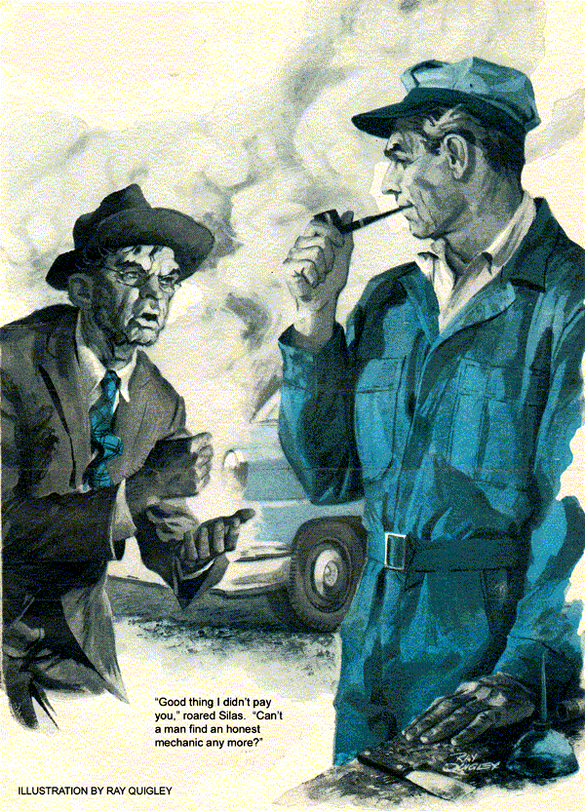
"Gus Wilson," Silas Barnstable called as he walked through the doorway of the Model Garage. "I want to ask you a question."
Gus tightened the last of the plugs he was installing and turned to greet the town's most notorious skinflint.
"Good morning, Silas," he called cheerfully. "Be with you as soon as I wipe my hands."
"Won't do you no good to clean those slippery fingers of yours," Barnstable snapped. "You'll not dip them into my pocketbook."
"Wouldn't risk getting them caught in that mousetrap you keep in there," Gus countered good-naturedly. "What's on your mind?"
"I read in a book about how some feller stopped a leak in his radiator by putting in oatmeal. Now, you give me a straight answer. Will it work?"
"As a matter of fact, it has worked," Gus replied. "But just as often, the oatmeal clogged the whole system. You ought to let me take a look at the radiator now. It'll cost you five times as much to get the radiator cleared after you feed it mush."
"Didn't say I was going to feed it mush," said Barnstable, glaring. "I just wanted to hear what you had to say about oatmeal before I spent good money to get the leak fixed over at the Discount Repair Shop. The prices they advertise are half what you charge, Wilson. Besides, I don't need a fancy mechanic to fix a little leak." He turned to leave and bumped into Gus's assistant, Stan Hicks, almost knocking two containers of coffee out of Stan's hands.
"Hmmph!" Barnstable sniffed. "No wonder your prices are so high. The customers have to pay for your coffee breaks." He walked to his car and drove off, leaving a trail of water on the road.
"What's the old miser been trying to get for nothing?" Stan asked.
Gus told him, and Stan laughed heartily.
"Wait till those sharpshooters at the Discount Shop finish with him. He'll be back begging us to take his money."
"I wouldn't say that," said Gus. "But I'll bet we haven't seen the last of him. Let's have our coffee and get to work on this brake job."
Several days passed before Gus's prediction came true. The sound of a horn honking impatiently outside the shop announced Silas' return. Great clouds of steam billowed from beneath his car.
Stan was alone in the shop. "So, you did it anyway," he called as Silas drove in.
"You went ahead and put oatmeal in your radiator after Gus warned you not to."
"Didn't do any such thing," Silas shouted over the hissing steam. "She started boiling on the way over here and there wasn't any place I could stop to get water."
"Thought you were going to get it fixed at the Discount Shop," Stan shouted back.
"No sirree!" Silas exclaimed. "Those robbers over there wanted to put in a new radiator for $59. Told me there wasn't much sense in trying to fix up a sieve like this."
"So now you've brought your troubles back here."
"No such thing!" Silas answered. "I went home and did a little detective work myself and" -he beamed proudly - "I've found the trouble. Bring a light and I'll show you what to do." He raised the hood. The steam had subsided, leaving a pool of water beneath the car.
Stan hung a trouble light on the upraised hood and Silas pointed to a thin line of rust originating at a point about halfway up the radiator. "There she is. Now, you fix that and nothing else," he ordered.
Stan inspected the area. "Looks like a leak, all right, Silas," he said. "But I don't see how you could lose so much water from a pinhole like that."
"Stop trying to make a big job out of a little one," Silas grumbled. "What's the cheapest way to fix it?"
"Well," Stan said thoughtfully, "the right way would be to remove the radiator and solder it, but maybe I can save you some money with an old boilermaker's trick."
He went to the bench and, after a few minutes, returned with a long, slender bolt, a nut, several washers, and two pieces of rubber cut from an inner tube.
He slipped a washer and a rubber disk on the bolt, passed the bolt through the radiator core where the leak appeared to originate, and put the second rubber disk and washer on the end of the bolt protruding through the opposite side of the radiator. Then he tightened the nut, squeezing the rubber firmly against both surfaces of the radiator.
"There, that ought to do it." Stan straightened
"The pinhole's still there, but the rubber has sealed both ends of the core so the water can't escape."
He dragged a hose to the car and filled the cooling system.
Silas inspected the repair carefully. "See, I told you," he cried jubilantly.
"There's no leak now."
Stan wrote out a bill.
"That'll cost you just 75 cents," he said.
"Seventy-five cents for 10 minutes' work!" Silas complained. "Bet you could've done it in five if you'd wanted to.
Anyway, I'm not paying till I'm sure you've done a good job." He started the engine and drove out.
When Gus returned a short time later, Stan was still outraged. He blurted out a full report, waving the bill.
Gus cautioned his assistant, "Careful Stan, or you'll boil over. I thought you knew Silas well enough not to let yourself get all worked up."
"Can't help it, Gus. I hope his hood blows off next time." He had hardly finished the sentence when a loud hissing and clouds of steam filled the garage entrance. Silas drove into the shop, killed the engine, and stepped out of the car, shaking a knobby fist at Stan.
"Good thing I didn't pay you," he roared. He turned to Gus. "Can't a man find an honest mechanic any more? Don't know what this town's coming to, what with thieves charging 75 cents for a 10-cent bolt that didn't even do the job."
Stan jumped forward, jaw thrust out. "Isn't my time, the tools, and this shop worth anything?"
"Here, hold on, you two," Gus intervened. "There's a misunderstanding here or my name isn't Gus Wilson."
"Your name'll be mud if you don't tear up the bill this amateur mechanic made out for me," Barnstable bawled. "Him and his boilermaker's tricks!"
"I fixed his radiator just like he asked me to-the cheapest way possible." Stan glared at Silas. "Can't blame me if he wouldn't let me check the entire cooling system."
Gus raised the hood and inspected the repair Stan had made. "Silas," he said, "you still owe 75cents. Stan did a fine job on that repair. There's no wetness around it and the radiator seems perfectly sound otherwise. Let's call a truce while we try to find the real cause of your trouble." He turned to his assistant. "Start the engine while I fill the radiator."
Gus twisted the pressure cap on tightly after bringing the water level even with the filler neck. He called to Stan. "Keep her idling until she reaches normal operating temperature."
Making conversation while the engine warmed up, Gus said to Silas, "I hear they wanted to replace your radiator for $59 over at the Discount Repair Shop, instead of repairing it."
Except for a few random drops of condensed steam still dripping from the radiator frame and front-end linkage, there was no sign of a leak from under the front of the car.
Gus walked around to one side, and then suddenly turned to Silas. "Are you still saving your antifreeze in gallon jugs from year to year?"
Silas smiled disdainfully. "Yes, but that has nothing to do with it. Charlie Grimm down at the gas station tests it free after I pour it in each fall. It always checks out for about 10 below zero. Been using the same stuff for four years."
"Still saving the pennies to spread the dollars," Gus remarked dryly.
"Me?" Silas snorted. "Keeps its strength because I drain it back into the jugs at first sign of spring. Good thing I drained it a couple of weeks ago, or I would've lost it all with this leak."
"I thought so," Gus said as he rolled beneath the car on a creeper. "Here's the trouble, Silas, and you've caused it yourself." He called to Stan, "Cut the engine and toss me a hammer, a punch, and a freeze plug to fit this model."
Stan handed Gus the tools and a thin metal disk about the size of a silver dollar as Silas leaped to protest.
"Goldang it, Gus Wilson, are you trying to tell me I let my engine freeze? I told you before that it was definitely protected all winter."
Gus ignored him. The sound of light hammer blows against metal came from beneath the car, followed immediately by the gurgle of water running onto the shop floor.
Gus appeared, holding a metal disk impaled on the punch. The disk was rusted through; it was obvious that the punch had pierced it with little effort. Silas looked at the water rushing across the floor to the storm drain then scrutinized the rusted disk. "What have you done to my car?" he demanded? "And what in tarnation is that thing?"
Gus handed the disk to Silas. "It's a freeze plug," he explained. "There are six of them pressed into core holes cast in the lower part of the engine block. For your sake, I hope the other five are in better shape than this one. Some of them are hard to reach and, believe me, they can take hours to replace."
"But I told you," Silas argued. "The engine never froze."
"Didn't say it did." Gus held up the new disk. "See how thin this metal is - about a sixteenth of an inch. Your foolish economy protected the engine against freezing, but stopped there. You tell him Stan," said Gus, grinning. "I haven't got the heart."
"That old antifreeze gave no protection against rust. After the first winter's use the rust inhibitor inside the antifreeze exhausted itself." Stan spread his hands wide.
"From then on, corrosion ran wild with nothing to check it. It's fortunate that these disks rust through before the block is badly damaged. They give a word of warning to the wise," finished Gus.
"But why did you call them freeze plugs?" Silas persisted.
"Because they've been called freeze plugs for years," Gus answered. "When those early thick-walled engines froze solid in winter, mechanics noticed that the ice often pushed these plugs right out of their seats the same way frozen milk sometimes pushes the cap an inch or two above the bottle.
As a result, they were misnamed freeze plugs and the name stayed with them.
Technically, they're called core-hole plugs, since they're used to close the holes that result from casting the water passages inside the block. In today's light engines, they have little if any value as protection against damage caused by freezing."
Gus got back on the creeper. "I'll drive this new plug in place; then we can refill the cooling system. But this time I suggest you add a can of rust inhibitor to the water. It'll arrest corrosion in the other disks before they develop leaks."
"I think I'll take a little walk," Stan whispered to Gus. "I don't want to be around here when you hand Silas the bill for this little job."
"Just for that, you can give him the bill. Add $3.50 for installing the freeze plug and a dollar for the inhibitor to the 75 cents he owes for the radiator repair." Gus hastily retreated to safety under the car.
Stan hadn't finished tallying the tab when Silas handed him a five-dollar bill and shiny new quarter. The old gent was smiling.
"What - what's got into you?" Stan asked. "You almost look happy."
Gus finished installing the freeze plug and reappeared just as Barnstable, a picture of gracious dignity, replied, "Of course I'm happy. The other day I nearly had to buy a radiator for $59. Today, I had my car expertly repaired for less than one-tenth that amount, and got an education to boot. Any day that I can save better than 90 percent is a very good day."
Gus and Stan exchanged glances, sighed, and threw up their hands.
Barnstable had scored again.
END

