October 1962

GUS PUTS THE SQUEEZE

ON A PENNY PINCHER

by Martin Bunn

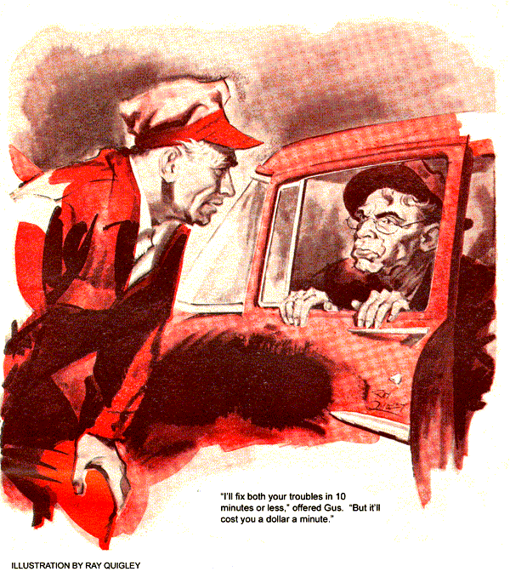
"Duck, Boss - here comes trouble," warned Stan from the door of the Model Garage. A familiar 1956 V-8 crept painfully up the apron.
Gus Wilson looked up just as the engine, evidently starved for gas, expired. From the driver's window glared the lantern-jawed face of Silas Barnstable - a man who never spent a nickel without making sure another wasn't stuck to it.
"You comin' out, Gus, or want I should bring a law summons?" he bawled.
"Keep your shirt flap in," advised Gus, striding out. "What's up?"
Barnstable's bony Adam's apple bounced indignantly. "First off, you cheated me on them plugs I got a month ago. I got to the coast but only halfway back when she started to miss, the man showed me them plugs was burned. You told me they was colder than my old ones."
"They were and you needed 'em," retorted Gus. "You saw the blistered insulators and eroded electrodes on your old ones. If those cold plugs burned, you were scorching the road - or, something else was wrong. You wouldn't let me tune the engine, remember?"
"Waste of money!" snarled Silas. "I ain't paying that bill I owe for them no-good plugs neither. Had to buy new ones to get back."
Gus turned and walked off. "Come back when you're ready to settle up."
"Hey, wait!" Alarm squeaked through Silas' raucous voice. “Tain't plugs I come to see you about."
Gus paused. "Sure sounded like it."
"Fixin' to trade up, get a '58 car - two years newer'n mine," Silas went on. "Got me a buyer for this one. Sell private, buy private. Don't pay no dealer profit that way."
"Then how come I saw you drive into the car dealer's an hour ago?" asked Gus.
"Had a leetle trouble," confided Silas. “Didn't aim to bother you."
"Didn't want to show up on account of that unpaid bill," retorted Gus. "And your trouble's not a little one - you just squeaked in here with a dying engine. No buyer would touch that car with a six-foot pole, the way it is now."
"Those smart Alecs asked 20 bucks for a fuel pump!" whined Silas. "Why should I buy a new pump if I'm sellin'?"
"So you can sell the car."
"Aw, come on, Gus. Jest patch it up so it runs. I ain't guaranteein' it." Gus sighed. "For the sake of your buyer, I'll try. Crank it over."
Silas turned the key. The engine cranked but made no effort to start.
"Sure you have gas?" asked Gus, aware that Silas would drain most of it from a car he was expecting to sell.
"Left in two gallons when I drove out," snapped Silas. "But once she quits, she won't start for about 15 minutes."
Facts clicked into place. To Gus's ear the engine had sounded gas-starved. The agency's diagnosis was fuel-pump trouble. New cold plugs had burned badly in a few thousand miles. And once dead, the engine would restart only after a wait.
"I'll fix both your troubles - the stalling out and your plugs burning - in ten minutes or less," offered Gus. "But it'll cost you a dollar for each minute or fraction of one. Agreed?"
Silas' eyes narrowed. "You're on - but if you take more than 10 minutes I don't pay you anything."
Gus looked at his watch, hoping he hadn't outguessed himself. Then he disconnected the gas line at the carburetor and had Silas crank the engine. No gas pumped out. Gus reconnected the line, then reached down under the fuel pump, and backed off the big thumb-screw that held on the glass sediment bowl. Removing the fiber-glass element, he dumped the bowl and wiped it out, then sauntered into the shop.
Five minutes were gone when he returned with a new filter and gasket. He carefully put the gasket and new filter in position, slid up the bowl, and tightened the big knurled nut. His watch showed two minutes to go when he straightened up. Silas was watching with explosive tenseness.
"Ain't you done yet?" he burst out.
"Got to recheck the gas line," said Gus, leisurely going about it as his watch crept past the nine-minute mark.
"Okay. That's 10 bucks, Silas."
Barnstable snorted and turned on the starter. It cranked over, but the engine stayed dead. Silas shut it off.
"Guess you lose, Gus," he cackled. "Now finish fixin' it - for free!"
"Not just yet." Gus knew he might be wrong, but felt that the odds were still with him. "Try again."
Scowling, Silas resumed cranking. It would take some time, Gus knew, to refill the fuel bowl. Only then would the gas reach the empty carburetor.
With a roar, the engine took off. Gus held his hand out for payment.
"Not just yet," snapped Barnstable. "I'm giving it a good test run. Then I'll deliver it to the buyer. If it cuts out again, I don't owe you nothin'."
That afternoon, on a road call, Gus spotted Silas driving into the dealer's service shop again but the car was a 1958 model this time.
Gus was only mildly surprised when it rolled into the Model Garage some time later.
"See you sold yours," Gus remarked, looking up from a brake job.
"Yup, ain't payin' you 10 bucks, though," said Silas with sly triumph.
"That so? Got a good reason?"
"A bet's a bet, Gus. The car ran okay, but you promised to fix whatever burned them plugs, and you never touched a thing but the fuel system. I watched!"
Gus got up, walked into his office, and brought out a sheet of paper.
"Here's a service bulletin from the spark-plug manufacturer. Read it yourself. It says that low fuel pressure leans out the mixture at high speed. That lean mix causes overheating, which can burn plugs and even valves.
"Low fuel pressure can be caused by a punctured diaphragm, weak diaphragm spring, worn cam or pump rocker arm - or a clogged filter. That last was your trouble. I put in a new filter and fuel pressure went back to normal. Pay!"
Grudgingly Silas handed Gus a $10 bill. "It's robbery for 10 minutes' work, but beats payin' 20 for a pump I didn't need."
Gus chuckled. "Wish I had a buck for every new pump that's sold because its fiber-glass filter is clogged. You can't blow that kind clean - the fine weave accumulates fine particles until it's so loaded gas can't squeeze through.
"When the engine's off, some outside dirt sinks down, gas seeps through, and you can start again. But as soon as pump pressure picks up the same dirt, it clogs the filter again."
"How much is a new filter?"
"Bit over a buck," said Gus. "Your tenspot pays for that, my time, and the new plugs you got a month ago - which you'd still be using if you'd let me check and tune the engine then."
Silas grunted. "Guess I'd have paid you for them plugs some day anyhow."
Gus glanced at the trade-in. "What's wrong with your new car?" he asked.
Silas flashed him an amazed look. "How'd you - who said anything is?"
"I'd still be waiting for my $10 if there weren't."
A scowl overspread Silas' features. "The cheapskate I got it from only left a quarter tankful of gas in it. I used most of that trying out the car before I paid for it. So right after, I went to a gas station.
"That guy there knew me. Soon as he heard I'd bought the car, he laughed fit to bust a hyena. He says it's a gas hog. The owner swore he'd sell it cheap because even the dealer couldn't stop it from guzzling gas."
"What'd they say at the dealer's shop?"
"Tried to sell me a tune-up but I give a mechanic four bits and asked him private. They tried new points, plugs, and carburetor jets but none of it did not good, he said. Gus, you gotta fix it - I been cheated!"
With a droplight, Gus inspected the gas lines, carburetor, and automatic choke. The choke was open and working freely. Cranking resulted in no sign of a sticking float valve or improper float level. The flexible fuel link was sound and the fuel-pump housing was dry.
Gus pulled out the oil dipstick and sniffed it. Mixed with the odor of oil was the reek of gasoline. He opened the fuel filter and drew out the cartridge. It was surprisingly clean - and also smelled of gas. Gus replaced it.
"I know the trouble, Silas. If I fix it, you'll have to pay spot cash."
"Go ahead," growled Barnstable.
Gus backed out the bolts holding on the fuel pump and pulled it off.
"See that rocker arm? Most are oily and dirty. This one's washed clean - by gas leaking into the crankshaft."
"Going to stick me for a new pump?"
Gus didn't answer. Silas watched suspiciously as Gus opened up the fuel pump at a bench and inspected the diaphragm. To Gus's surprise he found no sign of the pinholes he had expected. Then he noticed that the flange of one washer on the actuating rod wasn't turned up all around. He pulled the diaphragm gently away. Where the flange lay flat against it was a short open slit.
"There's your lost gas mileage. Faulty stamping left this washer flange flat at one spot. In time, the flexing of the diaphragm against that sharp edge cut it through. The pump still delivered gas to the carburetor - and a squirt into the crankcase each time."
Silas nodded glumly. Whistling, Gus took apart the diaphragm assembly, put on a new diaphragm and a properly flanged washer. Then he buttoned up the pump and installed it on the engine.
"That tames your gas hog," he said. "Costs you much less than a new pump. Want to change that gas-thinned oil?"
"Yup, but not here. Station out my way gives a free lube job with each oil change. How much are you askin', Gus?"
Stan shook his head as the car drove out of the shop. "Boss, you're too good to that skinflint. I'd have sold him two new fuel pumps."
Gus shook his head. "No, you wouldn't . There's just one fellow Silas has to watch out for."
"Who's that?"
"The one who's just as sharp as he is - and a little more crooked."
END

