November 1962

GUS TACKLES A NOISY PROBLEM

by Martin Bunn

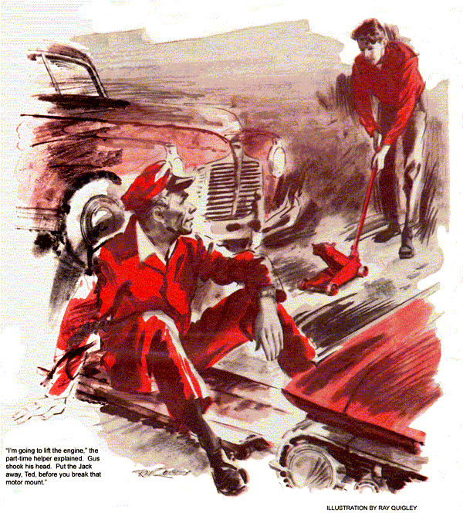
"This the fan belt you wanted, Boss?" asked gangling Ted Beamish, the Model Garage's teen-age helper. "The parts man said he doesn't get much call for these wide ones any more."
"Aren't many '41 cars like Mrs. Flanders' around," returned Gus.
"Got any real work for me? Like on a car, maybe?" pleaded the young helper.
"Well, the Flanders car is over there," said Gus. "Think you can put on that fan belt?"
"Oh, sure," returned the boy loftily. "That's just basic training in high-school auto shop."
"Go ahead then. But remember to--" Gus found himself talking to empty air. Ted had grabbed the new belt and scurried off. Then the phone rang, making Gus forget what he'd meant to say.
A horn sounded outside and Gus opened the big doors. A '59 hardtop rolled in to the accompaniment of a jackhammer racket from a street-repair job outside. Gus lowered the door to restore comparative quiet. The driver of the car, a burly, black-browed man in a checked shirt, sat scowling until Gus came over.
"I've got a noise in this car that's driving me nuts," he said. "Listen!"
Gus put his head inside on the driver's side. Over the engine's tick came a sound midway between a squeak and a rattle. Nearby, Ted raised his head to listen.
"Seems to be coming from the steering column," muttered Gus. "But it could be telegraphed from farther down."
The driver jerked up a chin like a cliff. "The last garage I went to said the same thing. They thought it might be the directional-signal plate. I had to wait three days for them to get one. They put it in, but when I drove out, the noise was just the same. Now they tell me to drive it a few days more and see if it stops. I'll go crazy first!"
The man put a cigarette in his mouth and lit it with shaking hands.
"Give us a couple of hours," said Gus. "All we can promise is to try."
The customer got out of the car. "My name's Meeker. I'll be back in a while."
Gus stretched out on a crawler and rolled under the car, letting the engine run. The noise was still audible below. He held the edge of the splash pan and grasped each end of the tie rods in turn. The sound persisted. Gus rolled out just in time to see Ted jockeying a floor jack under Mrs. Flanders' car.
"What're you doing?" he asked.
"Putting on that fan belt," answered Ted, a defensive quaver in his voice.
Gus spied the old belt on the floor. It had been cut apart.
"Tough getting that off?" he asked.
"Boy!" retorted Ted feelingly. "I never saw one so tight. Even with the generator slacked off. I had to saw the old belt apart to get it out.
That new one's worse yet. Course, I could pry it on if I had to -"
"Not in this shop," said Gus sternly. "That goes for any belt, on any car, new or old. The cords in a belt have not stretch to 'em - they're designed not to have any. Pry one on, or use that trick of some all-thumbs mechanics - forcing it over by cranking the engine - and you know what happens?"
Ted swiped oil-streaked red hair out of his eyes. "No, I guess I don't."
"That belt looks good as ever. But after a few days the strained cords tear. Then it's unbalanced. The belt turns over in the sheave groove and just rips itself apart. When you put on a new belt in my shop, Ted, take the time to yank the generator or do whatever's necessary to install it without straining its guts!"
"Well, gosh, that's what I'm doing," returned Ted plaintively. "I wasn't going to pry it. On this crate the front motor mount's conked out and lets the engine down so far I can't push the belt in between the pulley-damper and the splash pan. So I'm going to lift the engine."
Gus shook his head. "Put the jack away, Ted, before you break that motor mount."
Crestfallen, the boy did so.
"What I tried to tell you before you took off," Gus went on, "is that the vibration damper has two flats on it. Its rim is so near the splash pan you can't slip the belt between. But turn either flat down and it's a cinch."
"So that's it!" sighed Ted. "Okay, I'll give it the old try."
Gus watched as he pulled out the ignition-coil cable and twitched the motor around with short starter bursts until it stopped in the right position. The boy slid the belt into place.
"Never had one like this in school," he said with great relief.
"No," agreed Gus soberly. "They just don't make 'em like they used to."
Driving Meeker's car around the block, Gus heard the annoying squeak-chirp turn into a buzzing rattle on acceleration. He began to understand how it could get on Meeker's nerves.
"I have to go downtown on an errand, Stan," Gus told his senior helper on returning to the shop. "Track down this noise. Some other shop already did work on the wheel; but you might check inside the steering column. It's a fair bet it's in the linkage."
Going out to where his car stood at the curb, Gus was surprised to find Meeker standing near it, apparently absorbed in the street-repair job and untroubled by the racket. He exchanged a few words with him and went downtown.
Stan removed the horn ring, the steering wheel, and a directional signal plate that was plainly new. He found the rubber steering-shaft bushes intact. The noise persisted even when he pinched the shaft tight, eliminating any possible vibration. The shift-linkage shafts were not touching anywhere inside the column.
Stan replaced the signal plate, wheel, and horn ring, and left to answer the phone. He was still on the phone when Meeker walked through the office door.
Ted spotted him. "No, sir, he hasn't found the noise yet," Ted told the big man. "Say, maybe if somebody rode with you he could listen other places than up front."
"I never tried that. It might help," agreed Meeker, cracking long, calloused fingers nervously. "I'll wait."
"What for?" asked Ted, seeing Stan still at the phone. "Come on, I'll go along."
Meeker got behind the wheel. The sound of air hammers, as the shop door opened, alerted Stan Hicks in time to see the car pull out.
Ted sat up front, head cocked and rigidly attentive. The noise still seemed to come from near the steering column.
"Hold it," said the boy. "It could be telegraphed from any place. Let me ride in the trunk. If it's from a rear spring or shock, I'll hear it there."
Meeker stopped. He seemed dubious when Ted jumped into the trunk and told him to close the lid.
"Sure that's a good idea?"
"Got to, or the lid will clatter and the hinges squeak," the boy insisted. "I'll be okay."
Meeker shut the trunk. In pitch darkness scented with rubber and gasoline, Ted curled his gangling frame into a comfortable position.
The car moved off.
To his disappointment the noise was inaudible. Soon the sound of jackhammers signaled their return to the Model Garage. Meeker stopped near the pumps, where Stan was putting gas into a car.
"Just leave it," yelled Stan over the racket. "I'll move it in later."
Meeker nodded, got out with the keys, and, reaching for the door, accidentally banged his hand against the edge instead. The keys flew out of his hand and slid along the apron. Stan picked them up.
Meeker pointed toward the trunk, said something Stan didn't catch, and trudged off. Another car pulled in for a tire change. Stan was just finishing this when Gus returned.
"Seen Ted?" Gus asked as Stan got out of Meeker's car after driving it into the shop.
"He drove off with the man who owns the car and didn't come back."
"Strange. Okay, Stan, you finish it."
Stan raised the hood over the running engine. He disconnected one shift link from its arm on the column shaft. The squeak - and an echo of jackhammer pounding - persisted. He replaced the link rod and disconnected the other one.
The rattling ceased.
Stan inspected the arm. The metal ring or grommet, that the rod rested in was loose in the arm. With a punch and hammer, Stan collapsed it and drove it out, the sound of his blows echoing strangely. He set in a new rubber grommet and replaced the rod. There was no more squeak.
"That was it," Stan said as Gus came up. "Guess the other shop had a car where the noise was in the column, and thought it was here, too. Hey! Is this bus haunted?"
Gus shut off the engine. A dull pounding remained. The thuds evidently came from the trunk. Stan unlocked it and Ted sat up, blinking.
"So that's what the man meant!" murmured Stan.
The boy clambered out. "I thought maybe that noise was telegraphed from in back so I rode in the trunk but it wasn't. Am I fired, Boss?"
"No, but I think you're cured of riding in trunks," answered Gus. "Finding car noises takes common sense, patience, and luck. If you can hear it with the car standing still, as in this case, you ought to know it probably isn't in the shocks, springs, or drive train.
"Engine vibration can kick up a racket, though, from a loose splash pan, clip, tubing, or even sloppy steering joints. You check by looking for such things, holding them tight, or disconnecting them. When the noise quits or even just changes pitch, chances are you've closed in on it."
"I get it, I think," said Ted. "But how come Meeker was so jumpy from a little noise? Bet he has a really quiet job."
"Not exactly," returned Gus. "Mr. Meeker's job is running a jackhammer."
END

