May 1962

GUS TUNES IN ON TROUBLE

by Martin Bunn

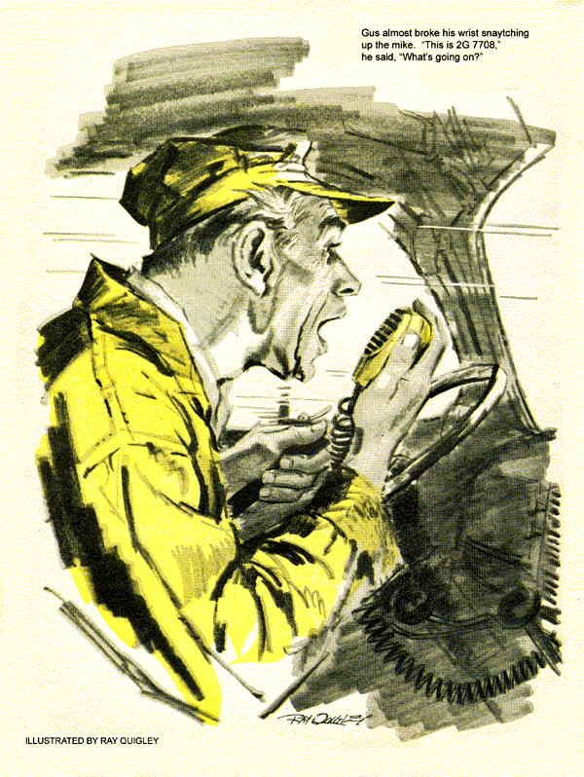
As Stan Hick's flipped the channel switch, the speaker to the cab of the Model Garage wrecker came boisterously to life."
Some fog down here, but bridge traffic's light ...relay to 2C 6399. . .called you earlier but ..."
Gus Wilson reached in and snapped it off.
"Sounds like a doggone party line," he said to his assistant. "Expect me to listen to this tripe all the time I'm on the road?"
Stan looked pained. "Gosh no, just five minutes every hour on the hour. If a road call comes in while you're out, I route you by radio. Saves all kinds of time."
Gus snorted. "How far'll it reach?"
"About 20 miles. This Citizens Band VHF is line-of-sight transmission."
"Might as well send smoke signals," grunted Gus as he stalked off. Stan grinned, wriggled out of the wrecker, and switched on the shop transceiver, on which he listened to an appeal for AB blood, a reminder to bring home a pint of cream, and an urgent call for a plumber.
"No Good trying to sell me a new battery, Gus," warned Silas Barnstable. "I got four months left on the guarantee."
Gus smiled at the town's tightest character.
"Your old one took a full charge, Silas. Cost you only six bits, 'cause I count on repeat business."
Barnstable's skinny fingers shuddered and froze on the latch of his old coin purse. "What repeat business?"
Recharging. About every two weeks."
"You just said my battery's good!"
Gus nodded. "That's why I checked your voltage regulator. It cuts out too soon. Points are pitted, and it looks as if you've monkeyed with the springs."
The Adam's apple in Barnstable's scrawny neck bounced. "All right fix it. But don't try to slick me for a new one."
Gus turned to grin at the town's veteran veterinarian, Doc Hockenjoss.
"For that covered wagon you drive, Doc, I'd be lucky to find a new part."
"Start tryin'. My speedometer's got the fidgets - jumps like crazy."
"I'll look at it," promised Gus. "And for you, Silas. I'll install new points and springs and adjust your regulator. Here's a list of what it may need and the time costs.
Barnstable glared at the figures. "How much is a new one?"
Gus told him.
"Huh! Beats gamblin' on what might or mightn't have to be done, at your rates," grumbled Silas. "Put a new one in."
He shambled out, dropping the slip Gus had given him. Doc picked it up.
"Hey! You sure outbluffed him."
"Outbluffed nothing," said Gus indignantly. "Those are honest figures. On a time basis, fussing with a complicated unit costs more than I like to charge.
Same time, I can't afford to guarantee it unless I do a complete overhaul."
Doc lit his pipe. "You used to rebuild generators, starters, and fuel pumps."
"There were fewer cars around," said Gus. "I had more time, and could charge less. New parts took longer to get. Today, rebuild shops make 'em like new. I can guarantee a new or rebuilt unit. If it's defective I get another."
A vacant spot on the shop floor drew Gus's eyes as he came back into the garage after lunch.
"Hey, where's Mrs. Maybell's car?"
Stan slid out from under a truck. "She got it early to go to the city and then visit her sister across the river. Anyway, it was all ready to go."
"But not road-tested. I like to check out a complete brake overhaul."
"I did, Boss. Four times around the block, and looked over all the line connections afterwards. The pedal felt pretty hard, but I think it'll loosen up.
Besides, she was in an awful hurry."
"Hmm . . . Well, thanks," Gus said.
"I'm going across the bridge myself to get that engine for Benson's sports car. Find a speedometer-cable housing for Doc yet?"
Stan shook his head. "Two shops told me to try the Smithsonian. Uh, Boss - you won 't forget, will you?"
"Forget what?" asked Gus, climbing aboard the wrecker.
"To tune in channel 3 on the hour."
The engine drowned out Gus's reply.
Starting the 60-mile trip back to the Model Garage with the sports-car engine, spotted a billboard clock that reminded him it was almost four.
He switched the two-way to CB channel 3. ". . . new rig you put on comes in fine . . .heard any of the new ... priority call for 2G 7705 . . .priority for 2G 7708 . . . come in, 2G 7708 . . ."
Somebody, Gus reflected wanted that 2G whatever pretty badly - maybe to tell him his mother-in-law was coming for a visit. Gus flicked his eyes to the windshield sticker bearing his call letters.
He was 2G 7708!
He almost broke his wrist snatching up the mike. "This is 3G 7708. What's going on?"
"This is 3R 3711, relaying to 2G 7708. Police ask you to go to west end of the vehicular tunnel, urgent. Please go at once to west end of vehicular tunnel."
"But I'm headed for the bridge!"
"I'm relaying an urgent police message at the request of your home transmitter. You're needed at the tunnel."
"Okay," said a puzzled Gus.
He turned around, headed south. A mile from the tunnel a siren screamed up behind. The police car passed with an urgent wave-on. Gus followed, through the tollgates and down the left lane of the tunnel, past a long line of cars stopped bumper-to-bumper. The tile walls flicked by at 50 m.p.h. until a red flasher winked ahead.
It was on a tow truck, backed up to a behemoth trailer rig that squatted lopsidedly on a broken axle. But what drew Gus's eyes was the eight-year-old sedan alongside the truck, corking up the second lane.
The sedan was Mrs. Maybell's.
The trooper came over as Gus got down. "That car has locked brakes. The driver says they'd been dragging and she had stopped five times to cool them and the engine. Then she had to brake hard for this tie-up. When she tried to get by, the brakes wouldn't let go.
The car behind couldn't budge her. Our tow truck can't yank her out, even with the front wheels up. She got hysterical, hollered that you'd done something to the brakes. So we called your shop."
"I'll go see," muttered Gus.
"The sickening reek of burned brake lining filled the tunnel. Mrs. Maybell sobbing on another woman's shoulder. Gus stooped by one wheel. Heat from the brake drum hit him as if from a hot stove.
He climbed inside the car and, wrenching and straining freed the stuck brake pedal. The wheels remained locked. The pedal stayed very high and hard.
One by one Gus considered and rejected the possible causes. Loose or torn linings? Hardly likely even on a single wheel, right after a brake job, but certainly not on all four wheels at once.
Ditto on loose anchor bolts and on obstructed brake line. Weak brake-shoe return springs would drag rather then back; and as for the chances of bad springs on all four wheels... Remote. Brake lining too thick? That would have shown up right away, and Stan had given the car a short road test.
Only one component, Gus decided, could be causing the trouble.
He got into the wrecker, tussled it around, backed up to the car and winched up the front end.
Sliding under, he cautiously opened a bleeder valve. With a roar, vapor and boiling fluid spurted out. He let the fury spend itself and tried the wheel. It turned.
On the way back, with the car dangling from the wrecker's hook and Mrs. Maybell sitting still and red-eyed beside him, Gus left the CB switch off.
Next morning, he led a factory inspector to the Maybell car, up on blocks.
"The new lining we put in is all charred, wheel-cylinder rubbers cooked all four drums warped so badly they can't be trued," said Gus. "Either we set the master-cylinder push rod too long or that cylinder you sent was defective."
"We know your reputation," said the inspector. "Hardly seems you'd slip up on leaving free travel in the push rod."
Gus nodded. "We always double check that. You'll find the new master cylinder there on the bench. I drained it, but thought you'd want to open it."
Doc Hoekenjoss walked in as the factory man deftly disassembled the unit. He poked in various gauges, shook his head, and began to fill out a form.
"It's one of those foul-ups nobody can explain," he said. "The bypass port was drilled a thirty-second inch too far back, so the piston cup didn't uncover it on the return stroke and fluid could never get back to the reservoir. Every time the brakes were applied, a little more fluid was forced into the system. Eventually there was so much it locked the brakes completely."
He tore off a carbon of the form. "We'll pay for everything - the tow, your charge for the repair job, and replacement parts."
"What was that?" asked Doc when the factory man had gone.
"The exception that proves what you said about rebuilds?"
"That was no rebuild," returned Gus. "I install new master cylinders. Old ones may have pitted walls. This was a thousand-to-one shot, a defective new one."
"Uh-huh. And my speedometer?"
"Your cable housing had a kink that finally broke through and snagged the cable, making it turn unsteadily. Couldn't get a new one any place, Doc."
Doc's face fell. "Thanks for trying. Sure hate to be without a speedometer."
"You aren't. I soldered a sleeve over the break. It'll run another 20 years."
Doc smiled. "I take it back about you never fixing anything. Say, it's all over town how you popped up in the tunnel to rescue Bessie Maybell."
Gus felt his neck grow warm. "It only happened because of that fool two-way radio Stan talked me into. Like it or not, it sure got me a road job!"
END

