January 1962

GUS GIVES THE DOCTOR A CHECK-UP

by Martin Bunn

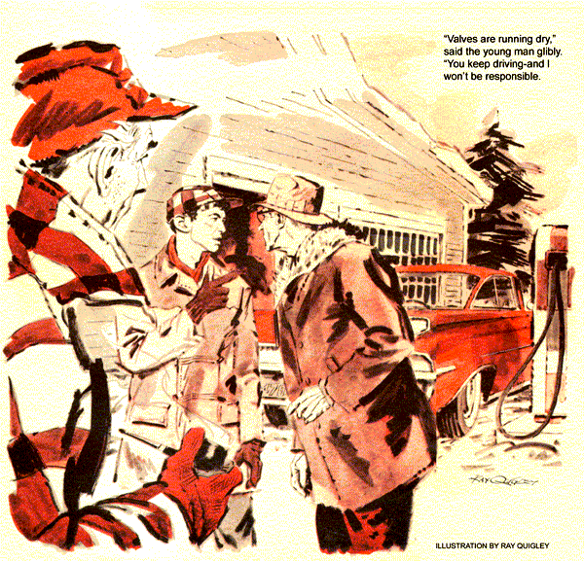
As the big sedan rolled to a stop inside the doors, the Model Garage owner rushed to it.
"Back for a poker lesson, Doc? Or did they catch onto you in Florida?" asked Gus Wilson.
Doc Wilder emerged from the car. "Huh! I can pull the wool over their eyes just as long as you can keep folks thinking you know about cars."
The two appraised each other. "You're skinnier, but mean as ever," said Gus.
"Don't look too bad, yourself. But I didn't drive all this way just to see your homely face." The Adam's apple bounced on Wilder's throat. "Got fed up with that steam laundry climate. Wanted to feel the zing of an honest winter again. So when old Betsy Hopkins yelled for me, and paid the freight - which she can afford - back I came."
"I heard the old lady was very sick," said Gus.
Wilder nodded. "She was my patient for 20 years, so she wanted me around. Why not? I'm retired, got no practice to tie me down. She's so much better I'm taking off for the weekend. Thought you might check the bus."
"Nice-looking car," said Gus.
"It has too many automatic doodads. A choke you can't work, power windows, overdrive, lights instead of gauges."
Gus grinned. "I know where you can trade it on a dandy Maxwell - "
He dodged Wilder's feint and got busy on the car.
Timing was right, the points in good shape, spark plugs fairly new. Gus cleaned them, checked the automatic choke, and replaced a carburetor jet.
Wilder, back from the diner, listened to Gus's report without enthusiasm. "Always has been a gas hog," he said.
"Sixteen miles per gallon on the road. It's those durned gadgets -"
"You should get more now," Gus reassured him. "Don't forget to cut in your overdrive."
Doc snorted, "I'll use it, but it won't help. Say, Gus, I'm borrowing Ken Smith's cottage at Storm Lake. Why not come along for some ice fishing?"
"That streak you just saw," returned Gus, "was me going for my duffel."
Crisply clear, the weather was a joy to drive in. The big car ate up the miles, though at throughway speeds its motor revved so hard Gus was on the point of reminding Wilder to use the overdrive. But the doctor seemed as keyed-up as the engine. Several times he fiddled at the dash.
Once, Gus noticed the radio aerial rise on his side of the car. Five minutes later, Wilder lowered it without having turned on the radio.
"Had this car long?" asked Gus.
"Three years. It was a year old when I got it, loaded with useless gadgets like that overdrive, but a good buy."
A suspicion gnawed at Gus.
"Use the radio much?"
"What for? Nothing on it but rock and roll, commercials, and world crises," Wilder said wryly as he turned in at a restaurant.
"Betsy's doing fine," he said coming back to the table from the phone booth. "Any real emergency, that young fellow who's been doctoring her could handle better'n I could."
As they left the restaurant, Gus casually asked if he might drive. Wilder agreed. Getting behind the wheel, Gus noted that the overdrive control was locked out.
He pushed it in.
The car slipped into overdrive the moment Gus released the throttle. It skimmed along now with the engine merely humming.
"You sure got the touch, Gus. She never felt this smooth to me before."
"Nothing wrong with the overdrive in this car," Gus assured him.
"Oh, I know that," was the astonishing reply. "Had it checked three times because I couldn't feel the difference with it in or out. But it sure feels different when you drive."
Only when they left the throughway and headed into mountainous country did Gus lock out the overdrive again.
It was Sunday afternoon when they left the cottage, Wilder driving. On the crest of a ridge, he suddenly braked to a stop and pointed. "Doggone oil pressure light's on!"
"Better shut off the engine, Doc."
Wilder did so, then turned to Gus. "On this trip you're my guest. We'll coast down and find us a mechanic."
This seemed unlikely to Gus, on a Sunday. The car gathered speed on a long downgrade, Doc skillfully braking to hold it to a safe limit. A gas station came into sight. He triumphantly rolled alongside the pump.
A woman, bundled against the cold, shook her head when Wilder asked for a mechanic.
"My husband's away for the day. A phone? Sure , In there."
Wilder scurried off. While the woman put in gas, Gus checked the oil. It was up to level. The connection at the oil pressure sender on the engine was tight. From his tackle box Gus took one of the wrenches he always carried on car trips and removed a valve cover, taking care not to damage the gasket.
"I couldn't get through," called Wilder as he came out. "Cold snapped some phone wires. What're you doing?"
"Just checking," said Gus. "Start the engine and let it idle a moment."
As Wilder did, oil promptly gushed into the valve chamber at ample pressure, Gus replaced the cover.
"Oil's pumping," he told Wilder. "Trouble's in the indicator circuit."
They went on, Wilder driving fast, the red light aglow all the way. Near the throughway, he turned into a station showing a "Mechanic on Duty" sign.
"Can't stand that danged light any longer," he muttered. "And I want to try the phone again. Don't go to work now, Gus. I'll get a man to tend to it."
A lean young mechanic came out, checked the oil and sender terminal, and peered under the dash, eyes squinting.
"The phone's still out," reported Wilder. "How about that oil warning?"
"Valves are running dry," said the young man glibly. "You keep driving this car, mister, and I won't be responsible. We can run you over to a motel and have your car fixed by tomorrow noon."
Dismayed, Wilder turned to Gus, who shook his head.
"I shouldn't have left Betsy," the doctor said. "You drive Gus."
Sliding into the driver's seat. Gus again engaged the overdrive. Soon they were clipping off throughway miles, the red warning signal still glaring at them.
"Never did like these idiot lights," grumbled Doc. "Gauges are way better."
"They cost more," Gus pointed out.
"Besides, Detroit says drivers might miss a low gauge reading, but can't help notice when a red light flashes on. Sure, a light won't show that oil pressure is falling - it waits till it's under 10 pounds or so. And the charge indicator won't squawk so long as the generator's putting out, even if most of the juice is drained off by lights and other accessories. But I guess idiot lights are here to stay."
"I still don't like them," muttered Wilder. "Stop at this station, will you?
I'll try the phone again."
He was out and talking to a mechanic before Gus could stop him. The mechanic put his head under the dash, started and shut off the engine, and peered furtively under the hood.
Wilder was visibly upset when he turned. "Bets 'n the hospital. I've got to get back . Let's go."
"In this car?" asked the frowning mechanic. "With a clogged oil pump?"
"How fast can you fix it?"
"Six, seven hours. If you drive on, it's at your own risk."
"We'll risk it," said Gus.
Again he took the wheel. At throughway speeds, the big engine poured heat around Gus's legs. He snapped open the cowl ventilator on his side for a few moments of cool air. He was about to close it again when he saw that the oil-pressure light was out.
He closed the vent. The light came on. Satisfied, Gus concentrated on closing the miles to the hospital.
"Betsy pulled out of it as soon as she saw my face," Wilder told Gus next day. "She's getting better. Now, what'd you do to my car? The idiot light's behaving, and the car drives like silk over 30."
"The idiot," said Gus, was an assembly worker who looped the indicator wire - it must have been too long around the vent lever.
When it wore through, it grounded the circuit and lit the bulb, same way the sender unit would. All I did was tape the wire."
"So that's it. And the other thing?"
"Even easier. Lock out you overdrive, Doc - and watch the radio aerial."
Puzzled, Wilder pulled the same knob he'd reached for on the trip - and in amazement watched the antenna slide up.
He punched the button in. The antenna sank. A slow grin overspread his face.
"For three years I've cranked that fool thing up and down, and thought I was locking the overdrive in and out. No wonder I didn't feel any difference."
"Pretty fancy car," said Gus. "Even the aerial's powered. It could happen to anybody not used to overdrive. Think of the gas mileage you'll get now."
"I'm thinking how come a fool thing like this had me buffaloed so long."
Gus grinned. "Only one reason," he said, pointing to the overdrive control.
"This part wasn't automatic."
END

