April 1962

GUS WINS AN EASY WAGER

by Martin Bunn

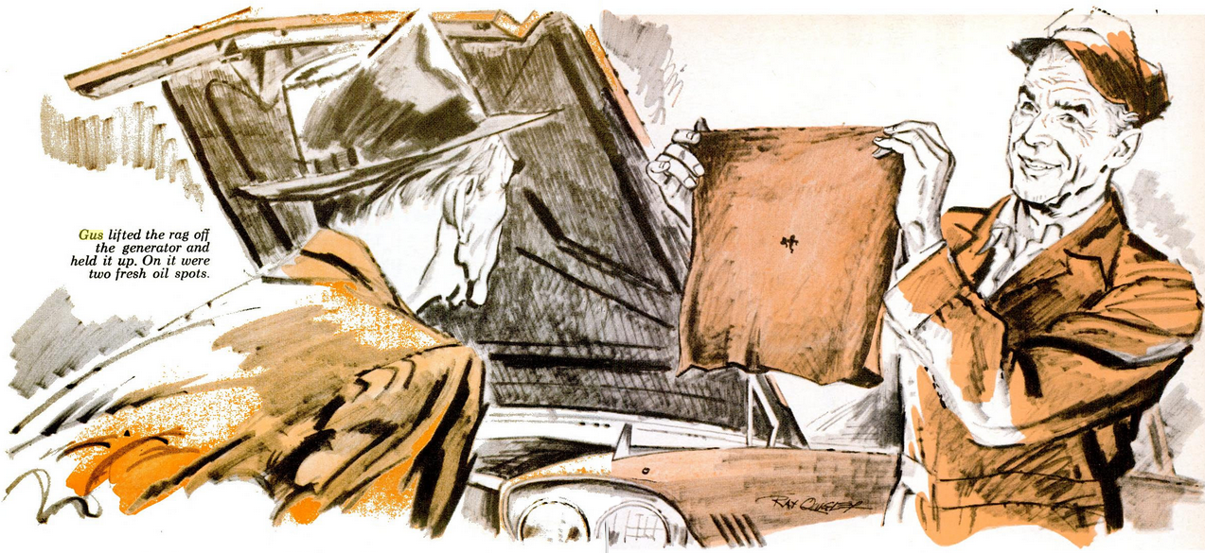
"They just don't make cars like they used to," asserted Dave Rankin, reaching along the Okay Diner's counter for the salt.
Gus slowly buttered a roll. "That doesn't mean they aren't better."
"I'll say," put in Doc Hockenjoss. "That '59 six I bought from my brother-in-law is more automobile than any you ever went courting in, Dave."
Rankin grunted, his sallow cheeks working. "Don't mean that far back. Take that '55 V-8 I've got. It has 60,000 miles on it and it guzzles oil. But I'll bet you have trouble with your car on this trip 'fore I do."
"Twenty bucks," said Doc promptly. "Gus can hold the stakes."
"You're man enough to pay off your own bets," protested Gus. "Going far?"
"The boondocks," responded Rankin. "Doc knows a fishing spot in Cortway County where they bite on bare hooks."
The veterinarian nodded, eyes watering as he downed scalding coffee. "So far out you almost can't get there from here. I'm taking my car so we won't be stranded when his breaks down."
"Waste of gas," grunted Rankin. "It won't be my car that conks out."
Both men got off their stools.
"In case I don't see you before you leave Friday," said Gus, "and in case you both get there - good fishing!"
Gus had hardly opened the shop on Thursday morning when a car rolled up at the Model Garage. Rankin stuck his glossy bald pate out.
"Got a small job, Gus, can I park it in a corner some place?" "Back of that pickup," said Gus.
The retired grocer parked his battered hardtop and hitched his plump figure out of the car. "It ain't much, just the ammeter bouncing. Could you fix it fast?" "Maybe it's only a loose connection." Gus quickly checked the battery terminals and connections at the ammeter and voltage regulator. All were sound, but with the engine running the ammeter needle flicked back and forth.
"Sorry, Dave. It could be anything from the voltage regulator to an out-of-round commutator or bad brush." "Try a new regulator, will you?" asked Rankin, his eyes on the door. "Expecting somebody?" asked Gus. "Eh? Oh, no. Could you hurry it up?"
Finding the regulator points oxidized, poorly aligned, and filed thin, Gus installed a new unit. When it was connected, he started the engine again. The ammeter fluttered off the pin to full charge, fell back, flickered as before. "No good. Have to check some more."
Rankin nodded glumly. "Okay. Don't want to be stuck with a dead battery out in the sticks. Er, Gus - could we keep this just between us?"
Gus smiled. "Your car's sort of hidden behind the pickup. Want me to see why you're losing oil?"
Rankin shook his head. "That don't bother me. I use cheap oil, and I'll take plenty along. Fix my chargin'."
Gus grinned as the paunchy little man peered up and down the street before stepping outside.
As Gus was about to take the generator off the car, a horn blared out in the shop. He walked over to confront Doc Hockenjoss in his '59 sedan.
"Got a little job for you, Gus."
"Didn't think you'd stopped to talk about the weather," retorted Gus.
"This here's a mighty good car," Doc went on. "But two weeks after I got it, it quit charging. My brother-in-law swore that it never did that before, but I had to have the generator overhauled."
"Mean to say you've got charging trouble, too?" asked Gus, taken aback.
"What d'you mean, 'too'? Haven't got any other - isn't one enough?"
"Sure, sure. Go on," urged Gus.
"Three weeks after, it quit charging again. Mechanic out west said the commutator was oil-fouled. Rubbish - the car doesn't lose any oil. But he got it working - till it quit yesterday."
"I'll check it out," promised Gus.
"Not a word to Dave, huh?"
"Drive the car around back," returned Gus, "and he'll never know."
Leaving Stan, his helper, to remove Rankin's generator, Gus checked the fan belt, battery terminals, and charging circuit on Doc's car. All were sound. The battery was low enough to take a hefty charging rate, but a test meter showed nothing coming through, even with the regulator's field terminal grounded.
Disconnecting the generator lead, Gus scratched it on the block. There was no spark. With the engine off, he felt the commutator through an opening in the generator housing. It was oily. Gus removed the generator and opened it on the bench. Commutator and brushes were oil-fouled - a strange thing since this generator had no oil cup. He cleaned the parts with carbon tet and found brushes and springs in good condition. Reassembled and run on the test block, the generator charged normally.
Leaving Stan to re-install it on Doc's car, Gus turned to Rankin's generator. Outside it was thick with oily dirt but, to his amazement, the internal parts were clean and in good order. When belted to the bench rig, Rankin's generator charged steadily.
Gus rubbed his nose with a knuckle.
One generator, from a clean engine, had an oil-soaked commutator. Another from an engine covered with greasy dirt worked fine - when not in the car.
Putting Rankin's generator back on, Gus made an instrument check; the test meter flickered like the ammeter. As he disconnected it, something splashed against his cheek.
It was oil, perhaps flung up by the swirling fan stream. Gus frowned thoughtfully. The oil leak Rankin chose to ignore annoyed him. But what could it have to do with the charging circuit?
He got down on a crawler with a drop light and slid under the car. The bottom of the engine was encrusted with oily muck. It looked cleanest under the front main bearing, where oil was probably leaking past a bad seal. The crankcase seemed oddly atilt, low in front. Flashing the light on the engine mounts showed fragments of oil-rotted rubber clinging to one. The others lacked even that much of the pads meant to cushion the engine.
Gus rolled out and stood up, staring down at the forward-slanted engine. Then he leaned far over the back of the engine block. Between the canted engine and the fire-wall, the braided bonding cable was stretched tautly, all but a few strands torn free.
Stan spoke suddenly at Gus's elbow: "That generator I put on charges fine."
"Thought it would," grunted Gus. He pointed to the almost severed strap. "There's the intermittent ground in this one. Vibration probably grounded the block now and then through the metal parts of the engine mounts, so it charged part time. Put on a new bonding cable, Stan."
Just as Gus had his pipe going nicely, Doc Hockenjoss returned. The lanky veterinarian raised skeptical eyebrows over Gus's account of the trouble.
"It can't be oil on the commutator. Nobody's put oil in this engine since the generator was last cleaned."
"You sure of that?" asked Gus.
"You bet. Nobody checks the oil but me. I like to do it with the engine cold, to get the true level."
"You try to oil the generator?" "Quit kidding, Gus. You know that there's a sealed bearing in that one."
"Okay," said Gus. He hung a rag over the open generator slots. "Now show me just how you checked the oil."
"What's to show?" grumbled Doc. He grasped the dipstick, which stuck up a few inches behind the generator. "I pull this up, slant it forward to get it past this whopping air filter that's in the way, and take it out."
He held up the oily dipstick, then shoved it back in with a snort. Gus lifted the rag off the generator and spread it out. On it were two oil spots.
"That's it," nodded Gus. "Under that big air cleaner, you never saw it happen. But every time you checked the oil the dipstick dripped on or near the commutator. A good service-station man holds a rag under the dipstick."
Doc stared. "Gus, you won't . . ."
"When you doctor one horse, do you tell another?" asked Gus.
A week later, as Gus was finishing a big dinner, Rankin and Doc walked into the Okay Diner.
"Have a good trip?" asked Gus.
"Swell fishing," said Rankin. "But our bet turned out a draw."
Hockenjoss nodded. "Neither of us had any car trouble, thanks to you."
Rankin's plump face split in a grin. "Yeah, we told each other, Gus. I'd like those engine mounts fixed now."
"Any time," said Gus. He stood up, stretched, and walked to the door. "Hey, Tom," boomed Doc. "Doesn't Gus have to pay any more?"
The counter man shook his head. "We bet, too. He won a week's free meals."
"A bet? On what?" asked Rankin.
Gus grinned from beside the door. "A sure thing. After you made your bet, I gave Tom two to one you'd both bring your cars in before you left."
END

