September 1961

GUS MAKES A FAST GETAWAY

by Martin Bunn

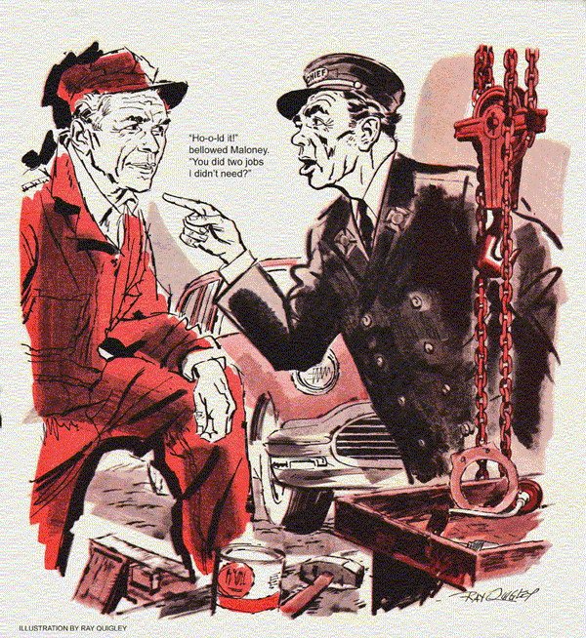
Open in late-summer warmth, the doorway of Gus Wilson's Model Garage suddenly darkened with the bulk of an entering car.
"Come on out, Gus!" bellowed the driver. "No use sneaking under a car."
Gus came out of the office, grinning. "Our big-mouthed fire chief! Haven't been eating much smoke lately, have you Mal?"
Chief Maloney's seamed face puckered into a frown. "It has been kind of quiet. How'd you know?"
"Couldn't yell like that if you'd been earning your pay," cracked Gus.
"At least I don't diagnose auto jobs wrong and make people pay for my bum guesses!" roared Maloney.
"So what can I soak you for?"
"Got a noise. Boys at the firehouse say it's a bad water pump. Listen!"
Gus cocked an ear over Maloney's five year-old sedan. It filled with a regular, metallic twang.
Stan, Gus's young helper ambled over. "Pump bearing's shot," he said.
Maloney cut the engine. "Good thing you've got a real mechanic, Gus," he roared. "Or you'd be charging me for something else. Have it tomorrow, huh?" He started out, but swung back. "Give my best to Nora Blythe, Gus."
Gus started. "Nora Bly - you mean Mrs. Simpson?"
"She's a rich widow now, back from Florida to settle her husband's estate," said Mahoney with a wolfish grin. "I've sort of fixed it for her to see you."
"Now hold on - "began Gus.
"Didn't take much fixing," was the Chief's parting shot. "She's willing."
An hour later, Gus got his hat. "I'm going upstate to see Tom Powers about overhauling his truck."
"But he said there's no rush," protested Stan. "I've got that brake job, and you promised to put that new radiator in Bronson's car today."
"You handle 'em" said Gus with uncharacteristic brusqueness, "I'll be - "
A horn blast interrupted him. From a shiny convertible, a mature, youthfully dressed woman with red hair called, "Gus! Gus Wilson!"
Hastily Gus walked over to the car.
"It's wonderful see you again," said Nora Simpson warmly. "I've thought of you so often. I really have."
"Been a long time," said Gus.
"And you've never married! Naughty you," she cooed. "Look what Chief Maloney left on my car yesterday."
A slip headed "Fire Department" stated that the car had been found leaking gasoline in the street, and that excess gas had been drained from the tank as a safety measure. A suggestion that any necessary gas-tank repairs be made immediately was underlined. The slip was signed by Malcolm Maloney.
Equally annoyed and amused, Gus told Stan to put the car on a lift.
"Mal's very conscientious," Gus said to Mrs. Simpson.
"But I think we can have you out of here very quickly."
The handsome red-haired woman pursed her lips prettily, "Are you in a hurry to get rid of little me?"
"No, no, of course not," fumbled Gus.
"But I thought you might be - "
"I have oodles of time until I have to sign things at my lawyer's."
"Yes, ma'am," said Gus miserably, and took refuge under the raised car. "There's not a thing wrong with your gas tank," he reported presently.
"But it was leaking gas!"
"Somebody overfilled it with cool gasoline from an underground tank.
It was a hot day. With the car in the sun, that thankful expanded. Some had to get out, so it spilled over."
"That's all that was wrong?" asked Nora Simpson.
"That's all," said Gus firmly. Motioning Stan away, he escaped further talk by lowering and turning the car around to get Mrs. Simpson on her way.
Surprising Stan, Gus now forgot all about going to the Powers farm. Instead, he tackled the radiator job. And the convertible rolled back in.
"I forgot," said Nora Simpson triumphantly. "My no-charge light is on."
Silently Gus peered at the dash. The charging indicator stayed lit even when she revved up the engine.
"Tiresome," she pouted. "I had a new generator put in on the way up here because that light stayed on."
"Could be your voltage regulator," said Gus. "Or something even simpler."
"Well, do put in a new voltage thing, Gus."
"Could be just a loose wire."
"No, the other man said it might be that voltage thing, too. I want a new one. Then it's sure to be all right."
"Yes, ma'am," said Gus dubiously as, with a flick of a braceleted wrist, Nora Simpson tripped out of the shop. With some misgivings, Gus ordered Stan to install a new voltage regulator.
"That car has a printed instrument circuit," Stan reported later, "with a fuse in it. I checked that, too. Everything works, so she shouldn't be coming back again."
Gus looked at him narrowly. "Okay.
You finish the radiator job, because now I am going up to Tom Powers' place."
Relieved to see the convertible gone when he entered the Model Garage next morning, Gus set to work on the Maloney sedan. He removed the belt that drove the water pump. Then, just to check the diagnosis, he started the engine.
The tinny clank was still there.
"Sure sounded like a pump bearing" said Stan, a little crestfallen.
"Sure did," agreed Gus, leaning close to the left-hand cylinder bank. "It also sounds like a broken valve spring in number one cylinder. Let's -"
A familiar horn interrupted him.
"I hate to bother you," called a smiling Nora, "but it's lighting up again.
The charge indicator was mockingly alight. In grim silence, Gus put a meter on the generator. It was charging. The regulator, too, worked perfectly. Alongside him, Nora chattered on amiably.
"You look so well, despite the awful winters you have here. You should move to Florida - such good fishing and -"
Gus ducked under the instrument panel. If the fuse were blown, the indicator would "fail safe" by lighting. He shorted the fuse clips with the engine running. The light went out.
He removed the fuse. It wasn't blown, but the light he turned on the clips showed green corrosion. By handling the fuse. Stan had restored contact until, overnight, creeping corrosion had again interrupted it. Gus stopped the engine, cleaned the clips, put back the fuse.
"Do you keep this car near the shore much?" Gus asked as he got out.
"A great deal. We have a seashore cottage, I'd just love to show you."
"That's your trouble, Nora."
The curved lips set angrily.
"I mean that sea air at the shore," Gus explained hastily. "Salt water corrosion caused a bad contact. You didn't need a new generator or regulator."
"Oh, well," she said mollified. "But I do wish you'd visit Florida."
"My sinuses can't stand sea air," lied Gus. "Now Mal, he just loves it. Always wanted to fish for tarpon, too."
Almost absently mindedly Nora Simpson started the engine. The indicator winked out. Thoughtfully she drove away.
"Where's the ham-handed boss?"
"Over here," retorted Gus. "Trying to figure how to get even with you."
Maloney guffawed. "It wasn't all a gag. Her car was spilling gas, Gus."
Gus grunted. "Keep laughing - I've got bad news. We put a new pump in your car, but the noise stayed.
Thought it was a busted valve spring then. But after we pulled the head, we found them all okay - "
"Ho-o-ld it!" bellowed Maloney. "You did two jobs I didn't need?"
"Tough break," said Gus, starting the engine.
Under its smooth idle was the metallic twang. Maloney turned brick red.
"Notice how awkward it is to pull the dipstick out? It's under the generator. The double pulley makes it harder."
Grasping the dipstick, Gus yanked. It came out - and the noise stopped.
"You almost have to bend the stick to put it back," explained Gus. "And some serviceman did.
See how shiny the bent part is? It's been hitting the first crank throw. Easy enough to straighten.
I won't even charge you - for that."
"But you'll soak me for a new pump and for pulling the head!" sputtered Mal.
"Why didn't you find this first?"
"Relax, I did," admitted Gus with a wicked grin. "The dipstick's in front of number-one cylinder, where the noise came from. So I checked. Are we even?"
"Cagey, aren't you?" rumbled the chief. "That how you stayed single with a gal like Nora Blythe chasing you?"
"No," said Gus. "It was by running a bit faster than Ed Simpson."
END

