May 1961

GUS KEEPS A LADY IN LINE

by Martin Bunn

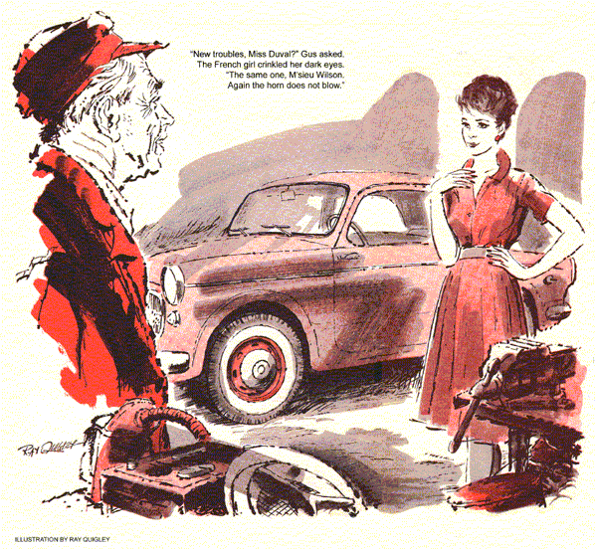
As Gus Wilson waited in line at the state-operated inspection station, a horn beep behind made him look around. From the wheel of a small imported sedan a girl waved a greeting.
The owner of the Model Garage waved back. Madeline Duval, a French exchange teacher, boarded at the house next door to him. He'd met her several times.
It was late afternoon of a warm spring day. The line was long but moved often enough to make waiting drivers keep their engines running. Car after car crept through the station, and Gus's own coupe soon won its inspection sticker, days ahead of the deadline.
Gus drove back to the garage and had just started a finicky ring job when Stan, his young mechanic, interrupted him.
"Lady to see you, Boss."
"Can't you take care of it, Stan?"
Stan grinned. "I wouldn't mind. But she asked for you specially, Gus."
Gus walked to the front, his mild annoyance gone as he saw who it was.
"Make out okay at inspection, Miss?"
The young French teacher's pert features twisted in a grimace. "No, M'sieu.
It is the horn that does not blow."
"Can't be serious," remarked Gus. "Didn't I hear you blow it back there?"
"Yes, and even now it works." She demonstrated with a brief, lady-like toot. "But when I come to the end of the so long line, and the man says to blow it, it will not sound."
"Stan check the fuse holder," ordered Gus. "Look for chafed wiring; clean the bottom contacts. That should do it."
Gus returned to his ring job and an occasional blast testified that Stan was checking. Soon the little car rolled out.
"Tightened one terminal, Gus," reported Stan. "Oh-oh! Look who's here!"
Gus looked up to see Daisy Allen alighting from her '54 sedan.
"Nothing doing!" said Gus firmly to Stan's mute glance of appeal. "Today Mrs. Allen is your customer." Stan slunk away. Gus ignored the chirpings of the volatile Mrs. Allen and the mutterings of his harassed helper.
At closing, Gus turned to Stan. "Not a bad day for me," he remarked. "How'd you do with the Daisy?"
"First she asked whether her hand brake held all four wheels, Gus. I told her only the back two. She said that was just what she thought, and would I please make it looser."
Shrugging out of his coveralls, Gus grinned. "Did you ask her why?"
"Sure. She's commuting to the city for a course or something. When she got home Monday the car had a flat. Today it had two. She was parked on a hill and set the brake hard, so she figures it pinched the tires and squeezed all the air out."
Gus frowned thoughtfully. "Three flats in three days? What did you do?"
Stan reddened. "Slid under with a wrench, then told her the brake would never cause a flat again. Aw, Gus - what else could I do?" "Not a thing, Stan.
A horn that blows except when an inspector's listening, and tires that go flat in pairs! Must be what the papers call the silly season. Let's just hope it's over."
The next day promised at first to be free of odd complaints. But about four o'clock a plaintive beep sounded in the shop.
Gus himself responded.
"New troubles, Miss Duval?"
The French girl crinkled her dark eyes. "The same one, M'sieu Wilson. I arrive at the last moment in the line, and again the horn does not blow."
"We'll double-check and you can still get back before they close for the day."
"It is the final day. I put it off too long. Now - poof! - time is out." Well aware that state law was rigid on this point, Gus traced every visible inch of the horn wiring, cleaned the button contacts again, and replaced the fuse on the off chance that it had an intermittent break inside. The horn gave a pert, clear warning every time.
"I'll send Stan with you, Miss Duval," he told the young teacher. "If you have trouble, he can fix it on the spot."
Once the little car had scurried out, Gus began closing. Then the phone rang.
"Oh, no!" he murmured. "It can't be - "But it was Daisy Allen, her flutterings really in high gear this time.
"..told your young man the brake was too tight, and now I have four flat tires at once and I'm simply desperate because yesterday I had a spare and an extra snow tire in the trunk but now - "
Gus did some quick thinking. The odds against four tires going flat at the same time were monumental.
"Relax, Mrs. Allen," he said. "It may take me some time. Where are you parked?"
After she had told him, Gus inflated a couple of big spare tires somewhat above normal. He was loading them into his car when the phone rang again.
"Gus," said Stan desperately, "it worked fine all the way here. I even tested it while we waited in the line.
When we got to the inspector, not a peep. If we don't get it fixed in 20 minutes, her registration will be void and she can't use the car tomorrow."
"Does it work now?" asked Gus.
"Hold it!" The phone was silent. Then a soft beep traveled over the wire. "It works now! That car's spooked." "By a pretty spook," mused Gus, recalling the slow progress of the inspection line, the idling engines waiting each advance, the day's warmth stretching into the afternoon.
"Got an idea, Stan. No time for anything else. Now do this.. "
Gus drove to the spot Mrs. Allen had described - a steep dead-end with a small factory on one side and a warehouse on the other. Both were closed.
The only car in sight was Daisy Allen's.
In midstreet, far from the curb, it squatted forlornly on four very flat tires.
She emerged from it in mid-sentence. ".. So glad you came, Mr. Wilson, because it's harrowing to be so utterly helpless, as you see, and.. "
Switching off his ears, Gus found without surprise that all four valve stems were loose. He tightened them, and briefly coupled a short hose from each flat tire to one of his well-inflated spares. Soon the car was on its feet.
"Now, Mrs. Allen," he said grimly, "you drive to the nearest gas station and get your tires properly inflated."
"Is that all? Thank you ever so much.
Tomorrow I'll leave the car for you to adjust that horrid hand brake - "
"It isn't the hand brake, Mrs. Allen," said Gus firmly. "It's you."
"I? Whatever do you mean?"
"Is this where you left the car?"
"Of course. I couldn't park near the curb, because of all those others."
"So you parked with cars on three sides - and of course locked yours?" "Certainly, I always lock it.. "
"Mrs. Allen, when the fellows who work here got through, probably at four, your car blocked several of theirs. On Monday they left you a hint - one flat tire. Yesterday they made the hint broader - two. This time, to make sure you got the message - four."
"But that's - that's sabotage?" "Yes, ma'am," said Gus mildly. "And parking the way you did was downright thoughtless. But for all the backing and filling they had to do to get out, they didn't put a scratch on your car."
Daisy Allen meditated briefly. "It is wonderful how you men can maneuver cars. And you're so right - I will never park so carelessly again."
"Keep that promise," said Gus, his fingers crossed, "and I won't charge for adjusting your hand brake yesterday."
Returning to leave his car at the shop, Gus found Stan ready to go.
"You figured that spook right, Boss. Idling in line hotted up the engine, and, running slow, the fan spread hot air around the horn.
Guess the contact mount or diaphragm expanded enough to spoil the vibrator point adjustment."
"And Miss Duval got her sticker?"
"Sure. Soon as we got into line I had her cut the engine, and I pushed her car along as the line moved. The horn stayed cool and blew fine. Afterwards I adjusted it to blow hot or cold."
At the door, Stan turned back. "Uh, Boss - I didn't know what to charge. You know where she lives? I could take the bill around tonight."
"Don't bother, Stan. I'll send it to Washington myself."
"Washington? I thought she lived around here," said Stan glumly. "She does," returned Gus, his eyes twinkling. "But who else should pay for such a good job of foreign aid?"
END

