March 1961

GUS MEETS WITH RESISTANCE

by Martin Bunn

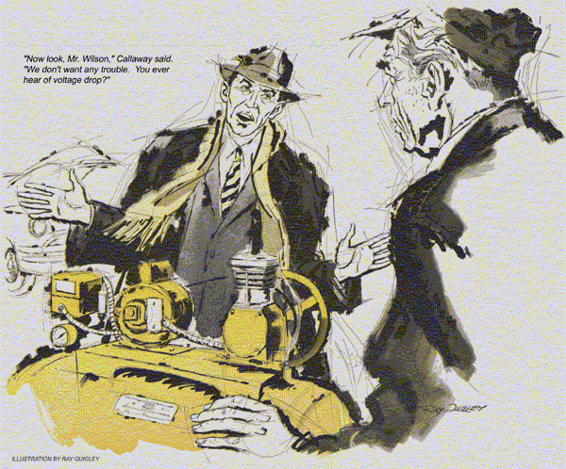
"Gus Wilson?" asked the short, sunburned man who walked into the Model Garage.
"You've found him," said Gus.
The man unbuttoned his topcoat and whipped out a card.
"Nat Calladay, service manager of Plymouth Pumps."
"Oh, sure," said Gus. "You're here about that defective compressor."
"I'm here to investigate your complaint," said Calladay quickly.
The implication that it was unjustified made Gus bristle a bit. "I bought that new compressor from Ed Swain.
Thought he'd come around about it."
"Swain's been transferred to a warmer climate for his health."
"I see," said Gus, recalling Swain's struggle with arthritis. "Well, this machine keeps opening the circuit breaker."
He led the way to one side of the shop, and a shiny new compressor.
"Only way we can get air now is to hold in the breaker. Listen to it."
He threw up the switch handle. The big motor groaned into action, but died as a loud snap sounded across the shop.
"There goes the breaker," said Gus.
"That motor's badly overloaded. Could be a tight bearing or a broken ring."
"Or could be," replied Calladay, "old-fashioned, inadequate wiring."
Gus shook his head. "Swain checked it, said it was okay for this model."
"Maybe he was a bit old-fashioned himself," suggested Calladay. "I'll send you a good electrician."
"Don't need one," said Gus flatly.
"Either send your mechanics to check this machine or get it out of here."
"Now look, Mr. Wilson,, we don't want any trouble. You ever hear of voltage drop?"
"Seems to me I have," said Gus.
"Well, now, this rig is about 60 feet from your service panel. You've got 120 volts there, but you deduct 60 and what've you got left?"
"Sixty?" asked Gus innocently.
"Sure. And what does the nameplate on that machine say?
A hundred twenty. How'd you expect to run it on 60?"
Amused by this distortion of logic, Gus said nothing.
"So what's to be done?" went on Calladay glibly. "You get heavier wiring installed, and I'll guarantee... "
"Your company's guarantee is what I count on," said Gus. "If you won't back it up, I'll go to them."
"I'll have to report your wiring's at fault. No hard feelings, I hope."
A late chill fell with dusk. Stan Hicks, Gus's assistant, had locked the pumps and shut the shop, but Gus remained for some paper work. He was surprised by a hammering on the shop door. It was Calladay.
"Say, am I glad you're in! Seems every other garage in this hick town is buttoned up for the night."
"We're closed too."
"My car's stuck in the municipal parking lot. The battery won't turn the engine."
"Plenty of service stations open."
"Yeah, but they say they have nobody to send out. Fact is, I had some arguments around here."
"Don't think I can help," said Gus.
"This cold snap's kept our charger so tied up on customers' cars that both our booster batteries are down."
"Couldn't you give me a push start?
That lot closes at midnight. And if I don't get my car out tonight, the cops will give me a ticket."
A flicker of sympathy stirred in Gus.
Guess I've worked late enough. Wait a minute and we'll drive over."
Bitter cold assailed Gus as they left the garage.
The city parking lot was almost empty. Under its stark flood-lights stood a modest seven-year-old sedan.
Gus checked the battery terminals first. Both were tight. But the starter gave up the instant its pinion meshed.
"Let it roll back. I'll push with my truck."
The sedan slid back out of the slightly upgrade parking lot, Gus shoved it less than a hundred feet before the engine caught. Calladay scrambled out.
"How about leaving it in your shop?" the little man asked.
"And could you install a new starter tomorrow?"
"Are you sure you need one?"
"I'm sure now. Besides, it won't start if I leave it out all night."
"Okay," agreed Gus. "Follow me."
It was midday when Calladay reappeared.
"On thinking it over," he told Gus, "I guess we better tear down that compressor. Our mechanics are on the way."
"Fine," returned Gus. "I've been boosting your battery. What makes you think your starter's bad?"
"It began on my way up from Florida," said Calladay. "Fellow in North Carolina heard me start the engine and said it was out of time. Sort of galloped like the spark was early. Cost me a tune-up."
"How did it sound then?"
"Just the same the starter dragged, kind of hitching itself around. So I stopped in Delaware. Fellow there put a meter on the starter. It showed a big voltage drop."
"Let's check," said Gus.
Disconnecting the charger, he hooked a voltmeter across the starter while Calladay turned it on. Despite a fresh boost in the apparently sound six-volt battery, the starter ground sluggishly.
"Voltage trouble?" asked Calladay.
"Looks that way," Gus admitted. "It shows a three-volt drop. Should be less than two. Commutator may he shorting... "
Through Gus's coverall sleeve, which lay across the battery as he leaned against the car, seeped an unmistakable warmth.
"How old is this battery cable?"
"Only a week," said Calladay. "Just after I started north, a fellow in a service station showed me the old one was in bad shape. He put on that one."
Gus flashed a light on it.
"That's your trouble, not the starter," he said. "Ever hear of voltage drop?"
Calladay grinned sheepishly. "Not before that fellow mentioned it. But it sounded hep, and I've heard of inadequate wiring, so I thought I'd try it on you."
Gus said nothing.
"I wasn't doing so good down in Florida. Swain is an old friend, he got me his job up here. I'm short of cash and had to make good, so I hated to start by okaying complaints."
There was a brief awkward silence.
"Now here," said Gus, "your trouble really is voltage drop."
"But you boosted the battery."
"Sure. The voltage is there. But this cable's for 12 volt systems."
"Yeah, I noticed. So it sure ought to carry six in my car."
"When," laughed Gus. "It's the amount of current that must flow through a cable that determines how big it must be.
The starter in your six-volt system needs twice the current a 12 volt one would and a bigger cable to carry it.
That's where voltage drop comes in. Try to push current through a cable that's too small and the extra resistance causes excessive voltage drop. And remember, it's the voltage at the end of the line that counts - battery voltage minus voltage dropped on the way."
"I see," said Calladay.
"Did the cold have anything to do with it?"
"This cold snap was just the last straw," said Gus, removing the offending cable. "A cold battery puts out less juice; and to make matters worse, thick oil makes cranking harder."
"Okay," said Calladay. "Now let's go back. Why did you say my starter needed twice as much current as a 12-volt car?"
"Simple multiplication," said Gus. "Electric power, which is what does the work, is voltage times current. With 12 volts a car needs only half the current to get the same power." Gus grinned.
"But don't try to switch your car over piece by piece. It's got to be designed for 12 volts from the beginning."
A brake squeal sounded outside.
"There's your company service truck," Gus said. "Hope they fix the compressor.
But I'll still charge you for a new cable."
"Fair enough," said Calladay. "I'll just consider it tuition for a course on voltage drop."
END

