June 1961

GUS SEPARATES THE MEN

FROM THE BOYS

by Martin Bunn

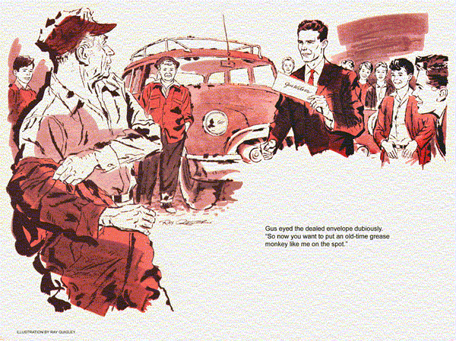
It was Stan Hicks who was responsible for putting his boss, Gus Wilson, and the Model Garage on a spot. One Saturday he attended an open-house demonstration put on by the auto-mechanics class at the high school. As the boys worked on several cars, Herb Findley, the instructor, proudly explained that they were using the latest test equipment to locate troubles.
"Guess they'd be lost without all those fancy gadgets to tell them what's wrong." Stan said.
Findley rubbed his chin. "You may be right. I know Gus Wilson has all these trouble-shooting devices, but in an emergency he can do without them."
Stan nodded. "He sure can, Mr. Findley. If these kids could see..."
"You've read my mind," broke in the instructor. "If my boys could watch an old-time mechanic like Gus..."
That was when Stan's pride in his boss got the best of him. As he went into an excited huddle with Findley, the Model Garage owner at the other side of town was whistling as he worked blissfully unaware of what was in store for him.
As Stan opened the Model Garage on Monday he dreaded the arrival of his boss when he'd have to break the news.
"Beautiful day," Gus greeted him when he strode in. "What's the matter, Stan? You look sort of down in the mouth."
Stan grinned weakly. "Well, Boss, I might as well get it off my chest." And he told about the plan he'd cooked up.
"Let me get this straight," Gus said as he filled a pipe. "Over the weekend Herb Findley and his auto-mechanics class diagnosed the school's balky old station wagon, using all their testing equipment. And then you committed me to compete with them."
"That's right, Gus - but using no modern testing gadgets to help. Just old-time troubleshooting know how."
Gus groaned. "Those are smart kids."
"I know," Stan said, "and here they come. We can't back out now..."
"We!" Gus spluttered.
"I've a good mind to let you..."
"Ah, there you are, Gus," said Herb Findley, climbing out from behind the wheel of the station wagon, followed by eight eager youngsters.
"Has Stan told you about our little proposition?"
"Yes, Herb, he sure has," Gus said. "Great little helper, Stan is."
"It was his idea, all right," said Findley, not catching the sarcasm in Gus's voice. He pulled an envelope from a coat pocket.
"Here are the individual conclusions of these eight students. Each boy checked the car out unaided except by the school's test equipment."
Gus eyed the sealed envelope dubiously. "So now you want to put an old-time grease monkey like me on the spot."
"Oh, no, Mr. Wilson," protested a carrot-topped boy. "Stan says you can just sniff the exhaust, look into a carburetor, and tell what's wrong."
"Yeah," chimed in a tubby youngster. "We want to see how you do it."
"All right," said Gus. "Start her up."
One of the boys slid behind the wheel and started the engine. Gus lifted the hood and listened.
"Be right back," he said, and disappeared. When he came back he was chewing gum and carrying a strip of newspaper. He attached the paper to the end of the exhaust pipe with his wad of gum.
As he watched the paper flutter in the exhaust of the idling engine, Stan caught a twinkle in his boss's eyes. Gus was beginning to enjoy himself.
"Aw, quit giving us the business," said one of the teen-agers, "and start making like a mechanic."
"Don't rush me, boys," Gus said, walking to the front of the car. "We old-time mechanics are sort of slowpokes."
As he spoke, he shorted each spark plug of the in-line engine with a screwdriver. He did a repeat, and stopped the engine.
Then he moved to the bench, pulled out a drawer, and dug around in it.
"Probably looking for his divining rod," suggested one of the students.
"Now, how did you guess," Gus said, coming up with a spark-plug body.
The porcelain had been removed and an inner-tube valve was brazed in its place.
As the boys nudged each other, whispering, Gus put the stick-shift car in gear.
Next he removed the Number 2 spark plug, rocked the piston on top dead center, and screwed the tire-valve spark plug into the cylinder head.
"Bring over the air hose," he called to Stan. "Now, hold it on the valve stem of this plug and turn on the air."
As Stan fed air into the cylinder, Gus moved to the back of the car, leaned over, and listened.
Back at the engine he took off the oil filler breather cap. After a brief look he removed the radiator cap and peered inside, using his pencil flash.
"Okay, Stan, turn off the air," Gus said, removing his trick plug and putting back the original and the ignition wire.
"That's it," he said, as he wrote on a piece of paper and put it face down on the bench. "Now let's see what's in that envelope of yours, Herb."
Findley was shuffling slips of paper.
"Let's see," he said. "Four say the car has a weak compression reading in Number 2 cylinder due to a sticking intake-valve stem.
The others agree on the condition of the Number 2 cylinder, but two give the cause as faulty rings, and two blame a burned exhaust valve."
"No question about the cylinder compression," Gus said, "but I don't go along with any of those causes."
Carrot Top picked up Gus's paper and read aloud what Gus had written. "Low compression, Number 2 cylinder, caused probably by a leaking head gasket."
Loud protests broke out. "Hold it," Gus said. "I could be wrong, but let me explain how I worked it out."
"First clue us in on that strip of paper over the exhaust," said one boy.
"That was just a gag," jeered another.
"No, it wasn't," Gus said. "If a cylinder had been missing entirely, the paper would have been sucked against the pipe with every miss.
But here there was only a break in the flutter, indicating a weak cylinder."
"Makes sense," said the tubby student.
"But how did you spot which was the weak cylinder?"
"With my screwdriver. When you short out a spark plug the engine slows abruptly.
Remove the short and it picks up power. The changes are stronger in a good cylinder than in a weak one.
With practice it is fairly easy to detect a weak cylinder if the others are good."
Several of the students were taking notes. "Now for the payoff," said one.
"How did you rule out valves and rings as the cause of trouble?"
"You all saw what I did," Gus said.
"With Number 2 piston on top dead center, I had Stan apply air pressure to locate the leak causing low compression.
With a faulty exhaust valve I would have heard it leaking into the crankcase when I removed the breather pipe cap."
"Two out and one to go," said a youngster as Gus paused to fill his pipe.
The Model Garage owner continued.
"When I looked into the radiator and saw air bubbles coming up through the water, I knew I had it.
And oil scum on top of the water was a clincher, proving that oil and gas fumes were leaking from the cylinder under compression into the radiator."
Herb Findley looked at his watch.
"I guess we've taken enough time..."
"Just a minute," broke in a student. He pointed to the array of testing instruments on a shelf. "Why all that stuff?"
"Couldn't do without it on lots of jobs," Gus said, "specially on today's cars."
The student nodded. "Sure, on testing a coil or condenser, I guess."
Gus smiled. "A man can tell a lot about coils and condensers by how far a spark will jump, its color, and the snapping noise it makes.
You just remove the high-tension wire from the distributor, pull the distributor cap, switch on, hold the wire a quarter-inch from the engine block, snap the ignition points with your thumb..."
"Whoa," said Findley. "That's enough for today. And thanks, Gus."
When the visitors had gone, Gus opened the hood of a car. "What seems to be wrong, Stan?"
"Low compression, I think."
"Okay. Hand me the compression tester. Doing it the old-time way is quite a strain on a mechanic."
END

