July 1961

GUS LANDS A BIG CATCH

by Martin Bunn

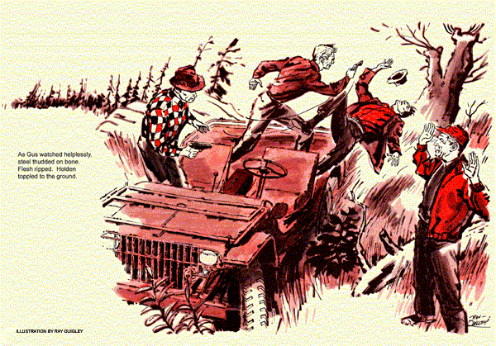
"Great fishing spot," said Gus Wilson between mouthfuls of grilled trout. "How did you happen to find it, Don?"
"A client of mine had a cottage up here," replied Don Holden, a slim man of 40 with sharp blue eyes and a dapper mustache. He lit a cigarette. "Say, Gus, would you mind if we called the trip off now?"
"Right now?" asked Gus, surprised at the suggestion.
Holden nodded. "It's been good to get away these three days. But I'm restless - got things on my mind."
"Okay," Gus agreed reluctantly. "I'll start packing."
The fishing jaunt had come as a surprise. Holden, once a fishing companion, had pulled up at the Model Garage in a jeep for a minor repair job - the first time since leaving his law practice to take a job in Washington. He'd invited Gus to come along "like old times."
Never had Gus known a better spot. The country was ruggedly beautiful, the trout hungry, the frothing waters apparently reserved just for the two of them. But Holden wasn't the avid fisherman Gus remembered. Several times, while Gus was pulling them in, he'd driven off in the jeep without explanation. Sundown was a scant hour away when they started the jolting cross country trek, Holden at the wheel. The terrain was unfamiliar to Gus.
"This isn't the way we came, is it?"
"No. Shorter, though," said Holden.
They were in a sparsely settled upstate area, remote from main roads. Gus estimated it was at least 20 miles to the highway. Suddenly he sat up. "Look over there," he said, pointing. The jeep stopped abruptly, almost turning him against the windshield.
"What is it?" asked Holden.
"Thought I saw a road over there," explained Gus. "But you say we're miles from any road."
"We are," said Holden.
"Must be seeing things. I'd have sworn I saw a road."
The jeep hurled on with Holden silently intent on avoiding the worst hazards. A scant mile farther on they came upon a man standing beside a weather-beaten, black sedan, waving at them frantically to stop. "Glad you showed up," he said as Holden braked. "Thought there was nobody around for miles." "What are you doing here?" asked Holden, rather ungraciously, Gus thought.
"Same as you, I guess," said the man, pointing to the gear in the back of the jeep - "fishing." He was short and dark, his nose peeling with sunburn. Black eyes flicked from Holden to Gus. "My friend got sick this morning. Now our car's quit."
"Where's your friend?" asked Holden. "In the back of the car. Now, if you'll give us a lift…"
Without waiting for an answer, he opened the sedan's door and helped out his hunched up companion. Bent over, evidently in pain, the man, his white hair hatless, stumbled to the jeep.
"Get your friend in back," Holden said. "I'll sit with him. You drive, Gus."
Surprised - for Holden had done all the driving - Gus slid behind the wheel. "Sure that car of yours can't be fixed?" he asked the short man.
"Maybe, mister, but it'll he dark soon and we'd better get out of here." He slid in next to Gus, stowing a big tackle box, between them.
Unfamiliar with the country, Gus followed Holden's curt directions.
As he swerved sharply to avoid a deep pothole, the stranger in back ordered him to stop. Thinking the man might be in acute pain, Gus braked, turned around to see what was wrong.
The sick man was sitting up tall and straight, holding an ugly 38 in one steady hand. With the other he reached inside Holden's open jacket and pulled out a shoulder holstered gun.
"Thanks for the jostling," he said, pocketing Holden's gun. "It threw me against that gun your pal was carrying. Nice tip-off for us that you're not just fishermen. Now, get out - with your hands up!" "That means you," said the short man, nudging Gus and emphasizing his command with a steel blue automatic.
As Gus backed out, he saw Holden and the "sick" man standing up in the back of the jeep.
"What's this all about?" asked Holden. "I think we both know that," said the white haired man. "Just get down there with your pal - and no tricks."
Holden backed, then ducked and made a lunge for his opponent's gun. He wasn't fast enough, but his attack threw the man off balance, and the bullet went wild as he fired. Gus, standing by helplessly, saw him swivel the gun in his hand swing it up, and slash down. Steel thudded on bone. Flesh ripped. Holden toppled to the ground. With lightning speed the tall man had his gun's business end forward again, pointing at the fallen Holden's belly.
Gus was getting ready to leap, do anything, when he heard the short man's voice. "No more shouting. Might be a security patrol around," he said, getting into the jeep and stepping on the starter. "Just make sure the other guy's clean and let's get out of here fast."
White Hair frisked Gus expertly. Satisfied that Gus had no gun, he jumped his companion in the jeep, "Let's go!"
The jeep roared off. As Gus shed his jacket to make a pillow for his unconscious friend, a flashlight dropped out of a pocket. That gave him an idea. Maybe he could make his way back to the sedan they had left abandoned less than two miles back and make it run. But it was getting dark. He had to hurry.
Walking fast, Gus flicked his light on and off, following back the unmistakable prints of jeep tires. The trail led him to his quarry - the drab, disabled sedan.
The key was in the ignition. Gus turned it and stepped on the starter. Nothing happened. He got out, raised the hood, and aimed his flash at the engine. The distributor cap dangled from its cables. But the rotor was in place. A closer look showed him that the spring on the movable breaker arm had snapped off, perhaps at an old kink or a rust spot. The copper bonding strip remained intact, but without the spring; the arm lay limp, the ignition points wide open.
Given pliers and a bit of spring steel, or even a bobby pin, Gus could have rigged a fix. The trunk held only a rusty jack and lug wrench. The glove compartment was empty. Gus's only tool was and old pocketknife, handy for camp chores but useless on steel.
He opened a door, felt the rubber seal strips. It was cracked and brittle with age.
Turning to the engine, he yanked the windshield wiper hose off the vacuum booster pump.
The rubber was lively.
He sliced off a short ring. In the last glimmer of his failing torch, he squeezed the bit of rubber between the breaker arm and the wall of the distributor case, wedging it behind the terminal. The arm now resisted finger pressure, snapped back against the cam.
Replacing rotor and cap, Gus got in and turned the key. The engine started. Awake and rational, Holden slumped beside Gus in silence for a time. "You have an explanation coming, Gus," he said. "It'll wait 'til you're feeling better." "I'm okay. Just get me to a phone." Holden held his wallet in the glow of the dash light, letting Gus see the credentials of a government security agency.
"This really is an old fishing spot of mine, but now it's a top secret defense setup. The road you spotted back there is part of it."
"So this vacation of yours is strictly business," Gus said. Holden nodded. "There have been some leaks and I had a hunch that enemy agents were getting in here.
The Defense Department agreed to let the two of us in. Any other 'fishermen' around this area would have to be phonies."
"But why did you decide to leave all of a sudden today?"
"My hunch soured on me. I figured the leak must be at some other place." "Right now," Gus said, "I'm trying to figure how long a chunk of rubber will bounce if pinched 8,000 times a minute."
It was still bouncing when Gus pulled into a highway gas station. Holden took over the phone. Ten minutes later a patrol car swept in, and soon after, Gus was sipping coffee in a hospital room.
"They got 'em Gus," said Holden, hanging up a bedside telephone. "That tackle box was loaded with telephoto cameras - and the film should send those two away for many years."
"Seems your kind of fishing landed a pretty good catch," said Gus.
"With your help, Gus. Without it, the big ones would have gotten away."
END

