February 1961

GUS LOOKS INTO

A TRUNKFUL OF TROUBLE

by Martin Bunn

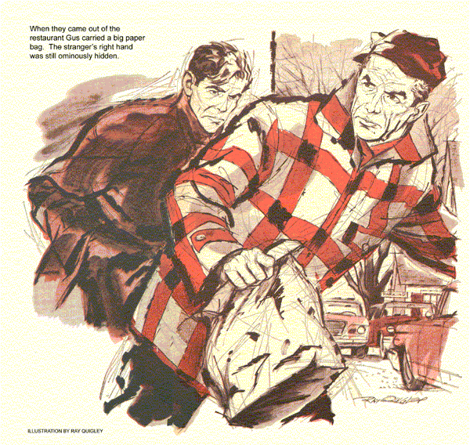
Barreling along on his way back to the Model Garage that Saturday morning, Stan Hicks, Gus Wilson's right-hand man, yawned contentedly as the wrecker's big engine hummed under his feet. Ahead a car was stopped, and Stan's throttle foot lifted instinctively as he approached.
Four men milled about the car's open trunk. At the sound of the wrecker, they turned almost as one. When Stan was still 50 yards away, they dropped the trunk lid.
It was an old gray sedan, with scabrous paint and battered fenders. All four men were unshaven. A party of hunters, Stan figured from upstate.
"Hi!" he called. "Need any help?"
Four pairs of eyes studied him coldly. "Not a thing, son," said one man..
Annoyed by the "son," Stan nevertheless added: "if you're out of gas, I've got a can with me."
A man with a bald head and hard blue eyes leaned on a fender, one hand in his pocket.
He shook his head. "Got gas."
"Okay," said Stan. "Okay!"
He let in the clutch. Steady stares followed him as he moved off.
"Friendly guys!" muttered Stan, and turned on the radio the wrecker carried for highway and weather reports.
Music soon revived Stan's good spirits. But 10 minutes later it was interrupted by a breathless announcer.
"... The Bank of Evansville was broken into during the night, police disclosed early today, and robbed of a sizable sum in cash and negotiable securities. The exact loss was not revealed.
Prime suspects are four men who fled a diner when a bulletin announcing the robbery came over the radio. Driving an old car with a hopped-up engine, they escaped police in a 90-m.p.h. chase. More news... "
"Holy smoke!" breathed Stan and bore down on the throttle until he eased the wrecker slowly into the Model Garage.
"How did it go?" asked Gus.
"Okay," muttered Stan. But as he went out to lock the gas pumps for one o'clock closing, his mind mulled over the highway incident.
Should he tell the state police about it? What did he have, after all? Four men in a rattletrap car - there'd be plenty like them on the road this weekend. But few so downright unfriendly!
"Something on your mind, Stan?" asked Gus as he came back inside.
"Sort of," said Stan. "But it's like a miss in an engine - you can't be sure it's what you first think."
Stan left on foot, headed for the barber shop. He was waiting for the corner light when a bus stopped across the street. With a start Stan recognized the passenger getting off as the blue-eyed man from the stalled car.
The stranger entered the Model Garage, his right hand in his pocket.
Plagued by doubts, Stan stepped between two buildings and waited. Five minutes later, Gus and the stranger came out together - and entered the small restaurant down the street.
When they came out, Gus carried a big paper bag. The man was empty handed, his right hand still ominously hidden.
They walked back to the garage and a minute later Gus drove off in his well-tuned coupe, the stranger beside him.
As they turned the corner, Stan made a dive for his elderly convertible. Retracing his road-call route, he caught up to Gus in 10 minutes - just as the gray jalopy fell in behind the coupe.
But stood a mile farther on, the gray car's speed fell off, dropping to 40, 30, and finally 20 miles per hour. Stan fell back. When the two cars came to a full stop, he hastily swung off where a shoulder of rock hid his car, got out, and looked ahead.
Five men, counting Gus, were huddled around the trunk of the old car. It was too far to see what they were doing. Then the trunk lid slammed, engines started up, and the cars were off. Soon, both turned in at a stone gateway.
"The old Marlow house," mused Stan, driving past. A hundred yards away he parked off the road, and cautiously approached the house.
In the yard, hidden from the road, were both cars.
"This," thought Stan, "is where anybody with sense calls the cops."
Instead, he crouched behind a high hedge and peered through. The car's trunk was open again. Four men were bustling about it. Fascinated, Stan tried to ignore a small nagging worry. But suddenly it hit him hard: four men, and one was Gus!
"Hold it, "a voice behind Stan barked. Stan turned - to see the missing fifth man. "Now stand up and walk over to those cars."
The trunk was slammed shut as Stan walked over. Four men glared at him, only Gus's eyes crinkling above a grin.
"Did you go to the police, Stan?"
"No, I - gosh, Gus, do you know these guys? You helping them?"
"Told you a car was tailing us," put in a tall tow haired man.
"It's okay," said Gus. "He won't talk."
Dismayed, Stan looked at the grim men and the old car.
"It's not what you think, Stan," Gus said. "I heard that news flash, too. But these fellows are no bank robbers. Meet Tim Hendricks. He went to school with me
The bald, blue-eyed man extended his left hand. "Bunged up my other pushing a wrench this morning," he said, taking a bandaged fist from his pocket.
"Tim's a crackerjack machinist and a good practical engineer. He runs a shop in East Hardwick. Does a lot of experimental work," explained Gus. "Okay to show Stan?" he asked the men.
They nodded. Gus opened the trunk inside gleamed the finned silvery bulk of an air-cooled engine.
"These fellows are test-driving a new aluminum engine they designed and Tim put together, Stan. It's secret - still not covered by patents."
"Makes us edgy," put in the man behind Stan, holding nothing more lethal than a meerschaum pipe.
"Anyway, maybe we haven't anything to be secret about. Engine's got a weird bug that has us stymied."
"It loses power," put in Tim. "Quits, then cures itself after standing a bit. We didn't dare risk stalling in town. But seeing the name on your wrecker reminded me how Gus could lick hidden bugs so I brought him out."
"Along with cats," added Gus. "They worked half the night tearing down the engine in a barn. Pitch in!" he ended, lifting a stuffed paper bag onto the fender of the car.
While four tired men wolfed hamburgers and coffee, Gus and Stan studied the strange V-six engine.
"Offset carburetor," muttered Gus.
"Could starve the end cylinders."
"It's set rich," explained Tow-Head around a hamburger. "Maybe that's why we burn so much gas on starts."
Gus looked up sharply, "What sort of weather does it conk out in?"
"Just like now, cold, wet days, not in that zero spell last week."
"That was dry cold," said Gus. He loosened the air-scoop clamp and started the engine. It galloped into life, ran steadily, and gradually grew rough. Gus fingered the automatic choke.
"Nothing stuck there," he said, and motioned to Stan to cut the engine. At once he lifted the scoop to peer into the carburetor throat. Stan saw a glint of white deep in the venturi.
"Your new engine," announced Gus gravely, "has a very old complaint - icing."
As Stan looked puzzled his boss explained. "Air rushing through there expands on the other side.
Expansion cools it. If it's cold and wet to begin with, the water freezes out and chokes the venturi."
"Carburetor icing!" cried one of the men. "Gas-gulping starts, symptoms of over-choking, a mill that quits but runs again after block heat melts the ice."
The tow-headed man nodded. "We muffed all the clues! Got so wrapped up in new problems we forgot to check out old ones."
"It's easy to fix, now we know," said Tim. "A warm-air duct should help. Gus, you did it again."
"We're mighty grateful," added the fourth man. "We'd begun to think this new engine was a lemon and we'd have to start all over."
"After a year's sweat and tears, too," groaned Tow-Head.
"Luckily," said Gus, "things aren't always what we think. And that reminds me, Stan, we heard a spot bulletin while driving out."
"They caught the bank robbers in the hopped up car?"
"Flat-footed. Their car was hopped up all right, but after that cop chase they got panicky. They forgot that it wouldn't run without gas."
END

