December 1961

GUS PLAYS A DIPLOMATIC ROLE

by Martin Bunn

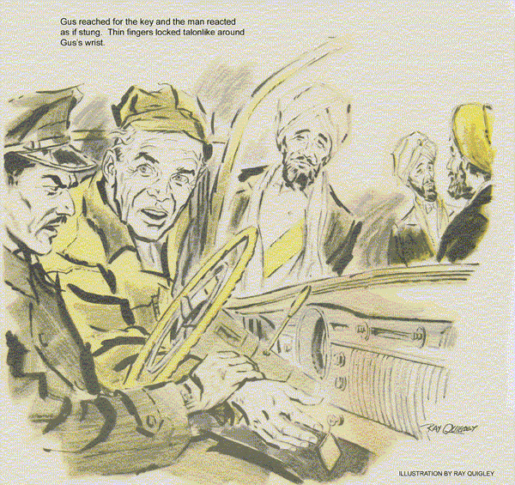
Late on a frosty Christmas Eve, the proprietor of the Model Garage ran his car up the ramp to the shop door. His lights sparkled on snow banks and glowed on the big door as he got out to open it.
Sleepy, after dinner with out-of-town friends, Gus wanted only to put the car inside and get to bed two blocks away. But as he turned on the garage lights, the Model Garage sign lit up, too.
He drove his car in and sauntered to the door, stretching. As he reached for the light switch, the sound of an engine came through the snow-hushed night, its beat so odd that Gus paused and listened.
The sound grew louder and he looked out to behold a curious cavalcade.
In the lead was a small imported car. Pushing it was an American luxury sedan about six years old. An arm waved wildly from the little car's window and the horn buzzed frantically. The car swung in and stopped near the pumps. The big car stood behind it, its engine idling roughly.
"Are you open?" inquired an anxious feminine voice. "We're in a jam."
Gus walked to the small car. "Shop's closed. What's wrong?"
A woman's face, framed in a fur collar, a cloche hat, and stray wisps of red hair, peeped out. "That big car skidded - not their fault really, something's wrong with it, too. But it made me hit a snow pile. My engine stalled and wouldn't start again, even when they pushed me in high gear. It's cold - and I've got a baby."
Gus could see a car cradle in back, a tiny red face screwed up in sleep. "Better get you inside," he said, and walked back to the big sedan. Its uniformed driver stared woodenly ahead, shoulders jerking with the rocking of the car.
A soft voice spoke at Gus's side: "He knows no English. Allow me."
For an instant Gus wondered if he was dreaming. By the pump island stood three bearded, turbaned men who must have alighted from the big car. The shortest, who had addressed Gus, spoke to the chauffeur in a strange tongue. Gently the big car nudged the little one into the Model Garage and backed out again. Gus noticed that it had diplomatic plates.
"We are members of a delegation to the United Nations," explained the turbaned stranger. "We are on our way to attend a reception at our embassy tomorrow. But an hour back, the car developed an impairment. Now it has disabled that of this lady. We are unable to help her or ourselves. Can you assist us?"
"I'll try," said Gus. "When did your car first act this way?"
Teeth glowed whitely in the black beard. "Pray speed the lady on her way first. Her plight is worse than ours - and of our making."
One of the other men was visibly shivering with the cold.
"I'll take care of her," promised Gus. "But as you're on official business, I'll check your car first if you like."
"Thank you, no. It is to help her that we left the main road. Our car can travel, though it shakes so that we like best not to wait in it, as you see."
"Okay," said Gus. "Come on inside."
Hastily Gus donned coveralls, and with three pairs of dark eyes on him, lifted the deck of the little rear-engine car.
A quick check showed Gus that the spark was good and gas not only reaching the carburetor, but flooding it. He removed, cleaned and regapped the gas-fouled plugs. Then he detached the air-filter assembly from an intake pipe.
The automatic choke was closed. Gus held it open while the young woman tried the starter. After a pop or two the engine caught, ran rough briefly, and settled to a fast idle. Gus put an exhaust hose on the tailpipe to let it warm up. The choke opened in due course, and the engine responded to the throttle with no more flooding.
Had the shock of ramming the snow jammed the carburetor float valve? If so, it was working now. Gus shut off the engine. The young woman came up while he replaced the air filter and took off the exhaust hose.
"I'm so glad you fixed it," she said.
"We're on our way to the air base. My husband's a reserve officer there - he couldn't get leave. He'd be awfully worried if we were delayed longer."
"Drive down the block and back," suggested Gus, to let me know it's okay.
Otherwise I'll come after you." He shook his head as she opened a pocketbook.
"No charge to service people on Christmas."
She smiled gratefully, got in, and started the engine. As if on cue the turbaned strangers rose and bowed. But the little car moved hardly a foot before the engine gasped and died. The baby in the back of the car began to wail. Its mother was out of the car in a flash.
She cradled the child in her arms, blowing wisps of hair away from her eyes. Gus flung up the engine deck. He found the carburetor flooded, and again removed the air filter. But the choke was open.
"Have any trouble before you hit that snow?" he asked the young woman.
She shook her head. Gus cranked the engine. It fired after a few turns, and took gas nicely. He set on the air filter, again gunned the throttle. The engine died.
Sliding under the car, Gus traced the air-filter pipe forward, along the chassis, to an air scoop in front. He wasn't surprised to find this so clogged with a snow that it could pass just enough air for idling. Given gas to run faster, the engine strangled itself.
Removing the packed snow took only a minute. Gus explained to the officer's wife what to do it she plowed into any more. She resettled the baby and, after another bow from the three strangers, drove off, headed out of town.
With immense dignity the slim, olive-skinned chauffeur drove the big sedan into the shop. He sat in the seat rocking while Gus checked for missing by shorting two plugs at a time. Despite the vibration the V-8 engine was hitting on all cylinders.
"Shut it off now!" cried Gus.
The driver ignored him. Gus reached in for the key and the man reacted as if stung. Thin fingers locked like talons around Gus's wrist.
"Please excuse," murmured the turbaned spokesman. "Once stopped, the engine will not start again."
"Just how did this trouble begin?"
"An hour ago, as we rode, there was a loud noise as of a blow. The machine began to shake. Twice we stopped at patrol depots. When our driver stopped the engine, it was necessary to push with another car to start it. The attendants said that it is probably a broken val - val - "
"Valve or valve stem?" supplied Gus.
"Yes , thank you. Because of the holiday, they could not repair it."
"Nor can I, if that's it," said Gus. "Now please shut off the engine."
After an exchange of liquid syllables, the chauffeur reluctantly turned the key.
Gus examined the engine mounts. None was broken or loose. The spark plug leads were properly spaced - no chance of cross firing by induction. Besides, there had been a noise....
What besides a broken valve could, in a split second, make a smooth-running engine begin to vibrate?" A fan blade bent by a flying rock? Gus's light showed three good blades. He pulled the fan around to see the fourth. There was no fourth.
The missing blade had snapped off near the hub, leaving an unbalanced fan to rock the engine at every turn. But why should that make starting impossible?
Gus traced the hot battery cable, then the ground strap. This ran from the engine block to a clip on the battery cradle far up front, then to the battery post. Light glinted on newly cut metal.
Where the strap lay against the battery, all but a few strands were severed. The few that remained couldn't carry the heavy starting current. Embedded in the battery case was the fourth fan blade.
Gus wriggled it free. Slowed by cutting the ground strap, it hadn't penetrated enough to cause leakage.
"I haven't got a new fan," said Gus.
"Best I can do is cut off the odd blade to leave the other two balanced."
Removing the blade assembly, Gus sawed off the blade opposite the broken stub, hung the fan on a sharp edge, and filed the stubs until it was in balance. He installed a new ground strap, melted pitch from an old battery into the gash left by the flying blade.
When he tried the starter, the engine fired up and idled like a Rolls.
"Providence was gracious to bring us to your door," intoned the spokesman.
The chauffeur leaped into his seat and deftly turned the car. Ceremoniously the three men bowed. One thrust an envelope into Gus's hands as they got into the car.
As the tail lights vanished, Gus peered into the envelope. It held a bill worth 10 times what he would have charged.
"Caught with the goods," called a dark figure nearby. "How come you're open on a Sunday - and a Holy Day, at that?"
"Officer Mulrooney, is it?" asked Gus.
"And what would you do if travelers in distress hammered on your door?"
"Just what you've done," answered Mulrooney. "But what brought those three whiskered guys here on Christmas Eve?"
"Kindness," said Gus, "consideration for somebody else. Good reasons for all of us to act on. Maybe if we did, it might be Christmas all year long."
END

