April 1961

GUS REPAIRS A FRIENDSHIP

by Martin Bunn

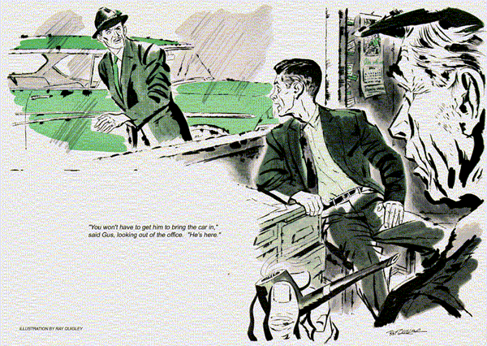
Swinging into the busiest intersection in town, the owner of the Model Garage braked to a stop behind a 15 car pile-up. Soon the flow in the opposite lane halted and Gus Wilson's lane of cars began a detour. But not Gus, the patrolman waved him to a stop behind the car causing the bottleneck.
"See if you can help him, Gus," the officer said. "He keeps starting his engine but can't seem to move."
Gus walked to the stalled car, a vaguely familiar V-8 of a popular make. Jim Hollister, red-faced, turned harassed eyes on him. "Gus! Can you bail me out of this mess?"
"Try the engine when I signal."
All seemed normal under the hood, and Gus waved. The engine roared spiritedly. Grasping the throttle rod near the carburetor, Gus gunned it several times. It took gas well. He lowered the hood. Apparently afraid it would stall, Hollister raced the engine in short bursts. "I'll be in tomorrow," he yelled. "Had all I can take from this crate!"
Gus nodded, turned back to his car, and suddenly remembered why the sedan seemed familiar. It wasn't Hollister's, but Alf Brandon's.
Next morning, it was Brandon who awaited Gus at the Model Garage. The slim, red-headed insurance agent seemed embarrassed. "Something about my policy, Alf?" "Wish it were, Gus. No, it's Jim Hollister - or rather, his car." "Wasn't he head of your local office, before you took over?" asked Gus. Brandon nodded glumly. "He's still my boss, only more so. That makes it rougher. I sold him that car seven weeks ago, when he moved to the city as supervisor. His wife drives his other one." "He's not blaming you for his car trouble, is he?" asked Gus. "After all this time?"
"That's just it!" groaned Brandon. "It began right after he left. At the worst times in traffic or on hills, the engine gives out. Hollister thinks I deliberately unloaded a lemon on him."
"But you and he were friends!"
"Were is the word," muttered Brandon. "He's sent me some nasty letters. Now he's making trouble about my accounts - drove up last night to investigate my office. I've offered to buy the car back, but he only snarls at me."
"I serviced that car," mused Gus. "Don't recall any such trouble."
"There wasn't any, Gus, I'm going to ask him to bring the car to you so you can check it."
"Won't have to," remarked Gus, looking out of the office. "He's here."
"It happened twice on the way over," roared Hollister as he got out of the car. "Just what does happen?" asked Gus. "Ask him!" bellowed Hollister, with a savage head jerk in Brandon's direction. "He knows - he got rid of it!" "Almost two months ago," Gus pointed out. "A lot can happen to a car in that time. Tell me how it acts." "It stalls!" snarled the big man. "It quits. You tromp on the gas and it only squats. I've been hung up in traffic, had my ears chewed by cops, had to roll back against the curb on hills."
"What's been done?" asked Gus.
"Plenty! The agency said the timing was too far advanced and set it back. That didn't help. When I went back, they found the points burned, put in new ones. Still no go. Next it was a fuel pump, then high voltage wiring. Nothing helped."
"I'll check it," promised Gus.
Brandon stepped forward. "Jim - can I drive you to the office?" Ignoring him, Hollister stamped out.
A road call had forced Gus to turn the car over to Stan Hicks, his assistant. On his way back he was flagged by another distressed motorist. It was after two when he returned to the shop.
"Did you get to test drive Hollister's car?" he asked Stan. "Sure, Gus and it quit like he said. Looked like the fuel pump to me, but the oscilloscope tester paid off."
"What did it turn up?"
"A burnt coil. I put in a new one, left it for you to check out."
As Gus looked at the clock, figuring on lunch, a glowering Hollister walked in.
"Find the trouble?" he asked.
"Found a weak coil," said Gus. "But it may not be that. Let's try it."
Gus drove the car out and headed away from town. The engine was quiet and responsive, the automatic drive faultless. Hollister thawed slightly. "Seems you licked it. Bum coil, hey? Could that go bad in just a few weeks?"
"It could," answered Gus, halting at a stop street. "I'll say this, Jim - I don't think Alf ever had that trouble."
"Hmmph! Maybe not."
With the lever still in Drive, Gus nudged down the throttle. Nothing happened. Watching closely, Hollister exploded. "New coil! There's a lot worse wrong with this bus. I'll bet the transmission needs a big job done on it - and Brandon knew it. That's why he dumped it - "
Trying to restart the engine, Gus didn't answer. The starter refused to engage, and the angry man's outburst drowned out something Gus sensed rather than hear. Again he tried the throttle. The engine bellowed in response.
With an idea dawning, Gus made numerous stops and starts - until once more the engine failed to answer. Deaf to the big man's grumbling. Gus did nothing but use his eyes. They told him that the oil-pressure and generator warning lights hadn't lit, as they should have if the engine had stalled. Now, senses alert, Gus felt the faint vibration of a well-balanced engine just ticking over. He tapped the throttle again and again - until, suddenly, the engine roared.
"It's going to be okay," said Gus.
Stan ran up as they drove in. "That coil was bad, Stan," called Gus, "but it never stalled the engine."
"Something did!" snapped Hollister.
"Nope," repeated Gus, lifting the hood.
"It never did stall. You thought it did, because the car wouldn't move." He lifted off the doughnut-shaped air cleaner, pointed to throttle linkage some inches from the carburetor.
"On automatic drive cars of this make," Gus explained, "the pedal swings this pivoted link. The carburetor throttle is hooked to this second link, on the same pivot but connected to the first one only by a spring. As you step down, the spring pulls the second link, opening the throttle."
"Why all that?" asked Hollister.
"Your kickdown, when you want extra power or pickup, is by a mechanical link from the pedal to the transmission. But sometimes you want full throttle without downshifting. Then the pedal has to give it without working the kickdown. For that extra push when you do want it, the pedal has to travel a bit farther, with the throttle already wide. Then the spring stretches to allow it."
"So what's wrong?" asked Stan.
"The spring. Maybe it wasn't tempered right, or somebody working on the car caught and stretched it. It's weak, doesn't pull the second link reliably."
"Then why does it usually work?" asked Hollister skeptically.
"Sometimes gummed dirt between links acts as a drag, helping out the spring," explained Gus. "When you're in a hurry or excited, and jam the pedal down, the dirt breaks free, the spring stretches, and the throttle stays at idle." "That doesn't prove Alf didn't have the same grief," said Hollister.
"No, but I can," returned Gus. "He had his car serviced here for two years before you got it. I can show you his bills - and not one's for any complaint like this one. We'll clean the linkage and put in the right spring and your car will purr like a kitten."
Hollister clapped him on the shoulder. "Go ahead, Gus. I've got a job of my own to do." He walked out, setting his hat firmly.
Gus grinned at Stan. "Hear that, Stan? Better get that new spring in fast. What he has to do won't take long."
"What d'you mean, Gus?"
"He's going to patch up a friendship - and there'll be two of them working at that job."
END

