September 1960

GUS MAKES A CONFESSION
by Martin Bunn

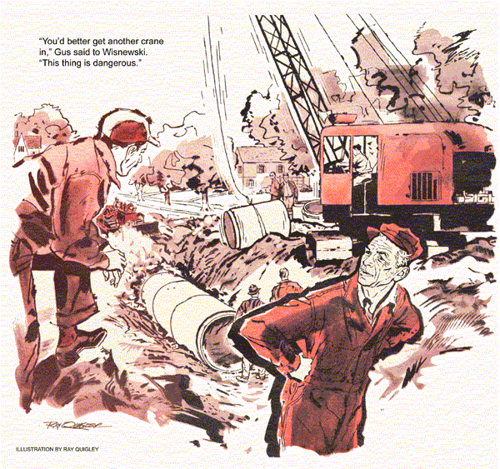
Gus Wilson crossed the torn-up street in front of the Model Garage and walked down to where a construction gang was laying a new storm sewer. The racket from a big crane, an air compressor, jack hammers, and a backhoe rooting ahead of the pipe crew was deafening.
Through the din, the sound of a missing engine caught his ear. As a musician can pinpoint a single sour note in a symphony orchestra, Gus identified the offender as the crane. He was surprised, because it looked new.
A young man climbed down from the cab and greeted him. It was Bill Wiggins, trouble-shooter for Wisnewski's Construction Equipment.
"You don't look very happy," Gus said.
"I'm not," Wiggins said. "We sold that crane to the contractor a few weeks ago.
Every since, it's been acting up and he threatens to turn it back and sue for damages. If he does, I lose my job."
Gus made sympathetic sounds. He knew the job was important to Wiggins.
He'd been in trouble on and off during his teens, and the Model Garage owner had straightened him out and interested him in auto mechanics. Joe Wisnewski had hired Wiggins on Gus's recommendation. Now, if he lost the job, Gus feared his old irresponsibility might turn up again.
"Look at that," Wiggins said as the crane went into action. It was giving the operator a hard time. He was trying to swing a giant section of concrete culvert pipe into position over a ditch. Each time he started to lift and swing the engine missed and sputtered, the cable twitched, the boom teetered, and he had to set his hand brake and wait for the machine to calm down.
Gus noted that the exhaust bark was too mild to indicate that the engine was pulling hard. And when it was hitting, the sound was smooth enough to suggest that the trouble was not poor compression.
"Checked the spark plugs?" he asked.
"Changed them four times yesterday. They keep getting fouled. I just put in a brand new set... "
He was interrupted by the noon siren.
Activity stopped. The crane operator, lunch box in hand, came over to have a word with young Wiggins.
"The way that crane is behaving, Bill, I'm afraid we may have an accident."
"We'll just have to take it easy, Mac," Wiggins said. "I've been over that engine half a dozen times.
Valves, rings, compression, timing are perfect. It doesn't use enough oil to measure. The magneto is as hot as a firecracker. I've done the best I can."
"I know you have Bill," said the crane operator. "It's not your fault."
"Yeah, but try and tell my boss that," Wiggins turned to Gus. "Will you take a look at it, Mr. Wilson? If you can't spot the trouble - well, I'll quit before Joe Wisnewski has a chance to fire me."
"Sure," Gus said, climbing into the cab. "No need to check the spark plugs since you just changed them."
Half an hour later Gus had inspected the magneto for cracks in the distributor housing, flashover, bad condenser, intermittent ground, crossfire, and impulse-coupling performance. He could find nothing wrong.
"Here comes your boss," said the crane operator, biting into an apple as he climbed the cab. "He looks mad."
"I wouldn't work that crane," Gus warned.
"You keep out of this Gus Wilson."
It was Joe Wisnewski, and he was mad. He turned on Bill Wiggins. "If this rig lets us down, you're through - and I'll see that you don't get another job with any construction outfit in this state."
"That's not fair, Joe," Gus said.
"Fair?" Wisnewski roared. "I'm not interested in being fair. There's a cloud-burst headed this way. If the contractor doesn't get the pipe in down to the diversion point in the next two hours, half the town will be flooded."
The crane operator hit the starter button. The engine kicked in and he gave a few tentative tugs at the controls. Slowly he lifted a section of pipe and lowered it into the ditch, where a crew guided it into position. A panting bulldozer followed up, shoving in dirt.
Three sections were in place. As the fourth one was being lifted, it happened.
The crane engine missed, backfired, missed again. The operator dropped his load on the soft earth bank.
"You better get another crane in," Gus said to Wisnewski. "This thing is dangerous."
"Can't," said Wisnewski, looking worriedly at black clouds scudding in from the north. "This one's specially rigged.
It'd take hours just to change over," He pointed at Bill Wiggins. "You're fired!"
"I quit," Wiggins said angrily.
"Take it easy, you two," Gus said.
"It's got to be the spark plugs - only thing I didn't check. Got another set?"
"Sure," Wiggins pulled a box from a pocket. "I've been buying the darn things wholesale."
"Put 'em in."
"And make it snappy," said Wisnewski, forgetting he'd just fired Wiggins.
Wiggins clambered up on the crane. He jerked out the plug cables without bothering to cut the mag. Gus was behind him, checking and spacing gaps as the young man's fingers spun out old spark plugs and put in new ones. When they were all in place, Wiggins started to unscrew brass extension terminals from the old plugs.
"No time for that," Gus said. "Just connect them up."
The crane operator started to protest. Wiggins ignored him, finished the job.
"Okay, hit the button," he said, jumping down.
With a roar the engine came to life.
The crane lifted a section of pipe, positioned it smoothly in the ditch.
"Sounds good," Joe Wisnewski said.
Gus nodded. He was unscrewing the brass extension terminal from one of the spark plugs Wiggins had removed. Its purpose was to hold the wires farther away from the engine block to prevent heat from damaging the insulation. Examining it closely, he knew what had been the trouble and that a fluke had fixed it. The first drops of rain began to fall.
A few hours later, Joe Wisnewski and Bill Wiggins, both soaked to the skin, came into the Model Garage.
"We just made it," Wisnewski said.
"If we hadn't, that contractor would have sued me for my shirt."
"Maybe," Gus said. "Why did you put those brass extensions on, Bill?" he asked, holding up one of the spark plugs that had been removed.
"The operator insisted on it," Wiggins said. "Told me he always used them on his old crane."
"Yes, but not with this type of plug," Gus said. "It's vented and needs a vented terminal."
"A vented spark plug?" Wiggins said, a puzzled look on his face. "Guess I haven't been doing my homework."
Wisnewski burst in. "The crane operator? Then it's the contractor's fault. I'll sue him for - for - "He calmed down.
"What's a vented spark plug?"
Gus explained. Spark plugs on engines that idle a lot - as in a crane, police car, taxicab - often foul up because they don't get hot enough to burn away carbon that forms on the electrodes. A special plug, with an auxiliary spark gap inside, keeps the electrodes from losing heat.
But the interior spark creates ozone, so the upper shank is hollow - vented - to let the ozone escape.
"If the ozone is trapped," Gus pointed out, "pressure builds up, making it hard for the spark to jump the gap. The result is misfire."
"Then this extension terminal trapped the ozone," Wiggins said. "It isn't bored through."
"That's right," Gus said. "A vented spark plug needs a vented terminal."
"Well, that's how we learn," Wisnewski said smiling now. "Thanks, Gus. You saved our lives. Come on, Bill."
When they had gone, Stan Hicks eyed his boss suspiciously, "You were awfully smart about vented spark plugs."
Gus grinned, "I'll confess - but only to you, Stan. I didn't really spot the trouble till after we'd changed the plugs - without time to screw on the extensions. After I got back here, I confirmed it with this technical bulletin from the spark plug people." He pulled some folded papers from his pocket. "While our friends were out in the rain, I was boning up."
Stan winked in mock conspiracy. "The secret's safe with me, Boss. Now what were you saying about a raise?"
END

