October 1960

GUS STRAIGHTENS OUT

AN AVERAGE DRIVER
by Martin Bunn

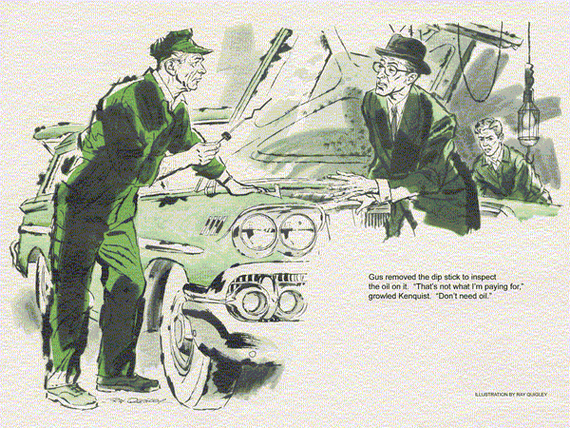
A lean, lantern-jawed, somberly dressed man got out of the station wagon at the Model Garage.
"Name is Kenquist," he told Stan Hicks. "I want the engine tuned up. It's sluggish. And lubricate the car, too."
"Yes, sir. Shall I change the oil?" asked Stan.
The lantern jaw set. "No! I want no oil drained, changed, or added."
"Sorry - lots of customers want an oil change with a lube job -"
"I don't!" snapped Kenquist. "And I'm tired of people who try to sell me high priced oil I don't need!"
"But I only -" faltered Stan.
"Have the car ready by five," said the customer, and stalked out of the station.
Returning from lunch, Gus found Stan moodily busy. He'd lubricated the car, now he cleaned and re-gapped the plugs set the points with a dwell meter, checked compression, and serviced the air cleaner.
Only when he dropped the hood did Gus go over.
Gus listened to the smoothly idling engine. "Nice and quiet. Got us a new customer, have you?"
Stan's face clouded, "Sort of a creep, Boss. Bit my head off when I asked should I change the oil, although it's black as tar on the dip stick."
"What's the last oil-change, mileage on the service sticker?"
Stan shook his head. "So help me, Gus, he's got lube stickers for 10,000 miles back - but not one for an oil change. Maybe he pulls 'em off."
"It takes all kinds, Stan. Better do exactly what he asked for."
Stan nodded. "I did, but I wonder if it's what he needs? Maybe a road test - "
"Not necessary if you've done the work right," ramped a strange voice, as Kenquist appeared at Stan's elbow.
About to speak, Stan thought better of it. Gus turned away, uneasy but reluctant to interfere. He watched Stan make out a bill and take Kenquist's money. At first touch of the starter, the engine swung into a smooth idle.
"Hope I've seen the last of him," muttered Stan as the wagon slid into traffic.
"But I've got a hunch I haven't."
Hunch or not, Stan was dismayed when the car rolled back in the next day, and Gus was again out.
"It's still sluggish," rasped the lantern-jawed driver. "I like to get what I pay for."
"Sorry, Mr. Kenquist. If only you'd let me road-test it yesterday - "
"Do it today. And this time see that you find the trouble."
The somber figure stalked out. Stan proceeded to double-check point setting, timing, and carburetor-float level; made sure that the fuel pump and automatic choke were working right; installed a new condenser. As soon as Gus returned, Stan took the wagon out.
When he returned, his expression was so unhappy that Gus could hardly keep a straight face. "Same car, Stan?"
"Worse - same owner," said Stan, flinging the hood up. "I've checked, tuned, and fine-tuned it. It idles fine, but at road speeds has a 1908 Maxwell's pep."
"How about valve clearances?"
"Gosh, no, this is the quietest engine - but I guess I better, Oh-oh!"
The cranelike figure of Kenquist shadowed the shop door. As he approached Gus took the drop light and peered hard at the engine. Then he removed the dip-stick to inspect the oil on it.
"That's not what I'm paying for," growled Kenquist. "I tell you I don't need any oil."
"Seems not," said Gus. "That's only a small leak as yet."
"An oil leak? Where?"
"Around this valve cover," said Gus casually.
"Shall we check the gasket and install a new one if necessary?"
Kenquist nodded. With four eyes on him, Stan loosened the two valve cover bolts. He grunted softly in astonishment as the cover seemed to rise under his hands. Gingerly he lifted it off.
"Wow! No wonder these valves were quiet!" marveled Stan.
Thick black sludge merged push rods, valve springs, and rocker arms into one gooey mass. Kenquist stared.
"What's that stuff?" he asked.
"Sludge," answered Gus, "You do much hard driving, Mr. Kenquist?"
"None now. Used to, when I was a salesman. Now I only drive between home and office. Say, is this as bad as it looks?"
"Maybe not," said Gus. "But you can see why the valves couldn't work freely at high speed. We'll have to take down the engine, soak and clean parts, blow out oil passages, see if there are stuck rings or worn bearings. Come sit down while Stan checks a bit further."
"I don't understand it," said Kenquist as he sat down in the office. "For a year I've driven only around town. My trips average three or four miles each."
"When do you change oil?" asked Gus. Kenquist colored, some of his aggressiveness returning. "The manual recommends every 4,000 miles of average driving. I did that when I was making long trips. Now I wait longer."
Gus's eyes widened. "Because you make only short runs?"
"Sure. Servicemen want me to change oftener, but that's oil company propaganda. Oil doesn't wear out
"Not while it's oil," admitted Gus. "But what's that stuff in your car?"
Startled, Kenquist said nothing.
"Car makers," said Gus, "stretch the oil change interval as long as they dare.
The joker is that 'average driving' the manual mentions."
"Mine is even less than average."
"Funny thing," remarked Gus. "Everybody thinks he's an average driver. But your kind of driving - the kind most people do nowadays - isn't average. It's worse."
Kenquist's eyes narrowed for an argument. "You can't tell me easy trips are harder on a car than long ones."
"I do," returned Gus. "Today's big engine is powered - and cooled - for turnpike travel. On short trips it hardly warms up. The engine loafs, but the oil is overworked."
"I don't see it," said Kenquist. "How do you figure that?"
"For every gallon of gas it burns, your engine forms about a gallon of water," Gus explained.
"Some combines with combustion gases to make acid. A hot engine vaporizes most of these wastes through the breather and muffler. A cold one lets more get into the oil.
"Automatic choking at every cold start shoots in raw gas. Some washes down the cylinder walls, dilutes the oil. Besides that, an engine running cool and rich forms more soot and other sludge makers."
Kenquist grunted. "If that's so," he said grumpily, "it's a wonder a car keeps running at all."
"Modern oils help," explained Gus.
"They have additives that neutralize acids, disperse sludge, keep dirt in suspension. But they can't work forever.
When those chemicals are neutralized, you have to dump old oil like dirty dish-water - and for the same reason."
Stan came in fastidiously wiping a wrench. "The lifters are all sludged up, too.
Half the valve clearances are way out - they'd have been plenty noisy except for the gunk."
"I think we can promise you a livelier engine when it's cleaned up and readjusted, Mr. Kenquist," said Gus.
"Okay, I'm convinced. Go ahead."
"But you'll get sludge again," waned Gus, "unless you change oil much oftener for stop-and-go driving.
In cold weather, I'd leave the heater off for short trips, to warm the engine faster."
"Guess I'll have to. No use paying you for a lesson if I don't learn anything by it."
Much relieved, Stan watched his difficult customer march out.
"With that personality, what could he sell? Dynamite?"
Gus chuckled. "Could be."
"He got more good advice than he deserved. Boss if you keep telling people how to duck repair bills, what'll happen to our business?"
"Nothing. The law's on our side."
"Huh? How's that?"
"There are so many 'average' drivers," explained Gus, grinning, "that we can depend on the law of averages."
END

