November 1960

GUS CHASES A SPOOK
by Martin Bunn

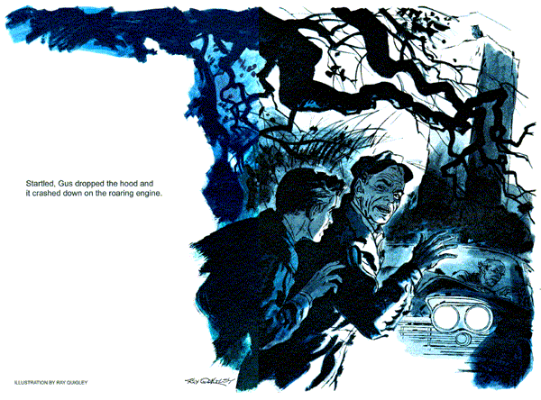
Coasting soundlessly through the open door, the black '50 sedan was inside the Model Garage before Gus Wilson, the proprietor, and Stan Hicks, his assistant, were aware of it. Equally surprising was the stranger who got out.
A small man in a somber black suit, he had a big nose, a bald head, and a standing slouch. He looked like a human caricature of a tame vulture.
"What can we do for you?" asked Gus.
"My left-turn signal does not work," said the stranger, his voice too big for his size.
"Let's see," said Gus. He switched on the key and flipped down the signal lever. The dash indicator stayed dark. So did the front signal lamp. The right-hand signal and indicator worked normally.
Gus found both front and rear bulbs burned out. He replaced them and checked the wiring for frayed spots. There were none.
"Had this trouble before?" he asked.
"Not in the two months I've had this car," boomed the little man. "But this is the first time I have taken it out on a case."
"Just wondered whether it could be a short," remarked Gus, "because both bulbs went at once. Probably not."
"I doubt it, too," remarked the stranger. "But I expect to be back."
He paid the small bill, hopped into the black car, and backed out.
"Now why," asked Gus of nobody in particular, "does he think he'll be back if there's no short?"
Precisely the same time next afternoon the black car rolled in once more.
"It happened again, as I foresaw," said the round-shouldered little driver. "Will you please make repairs? It is most important."
This time neither signal worked. Gus traced current up to the flasher, but it wasn't getting through.
"Your flasher unit is defective," he reported. "I can install a new one, but your real trouble may be a short."
"No, no," boomed the little man. "You will find none. But do check; it is vital to me to know whether you can find a reason for this difficulty."
Stan shook his head as the customer walked out, "I don't dig him, Boss. He's sure you won't find anything, but wants you to try."
"Looks that way," Gus admitted Stan helping, he checked the whole lighting system. With the new flasher in, the signals worked perfectly. Wires were as good as new. The junction block on the radiator yoke was a bit askew, but all its terminals were tight. Battery straps and clamps which, if loose, might be causing voltage surges, were secure. A meter showed the charging voltage to be correct.
"So he's right," shrugged Stan. "We can't find a thing wrong and I bet he'll be glad of it!"
Stan proved a prophet. The little man smiled knowingly when Gus reported that all checked okay.
"Very good indeed!"
The bald, birdlike head bobbed delightedly. "Of course I shall see you again."
A balky automatic transmission made Gus forget his odd customer until just 24 hours later, the black car reappeared, its driver strangely excited.
"A headlight burned out this time. Remarkable! I shall do a paper on this with your confirmation, of course. Please check most carefully."
"We did last time," said Gus. "You seem to know something about this trouble that you haven't told us."
The bald head cocked sidewise. "Yes, I will tell you, although you may not believe."
The little man's chest swelled. "I am Jonathan Rowen, an amateur psychic investigator, student of the mysteries of life and death. The past two nights I have spent - alone - on Eagle Crest."
"In the old Tulliver house, the one people say is haunted?" asked Stan.
"Precisely, the influence of its psychic phenomenon extends to the foot of the mountain. It is there, when I enter the private road, that my lights always fail!"
For a moment Gus was speechless.
"You don't mean," he said at last, "that you think they're doused by - spooks?"
"Unless you can prove otherwise, Mr. Wilson, I shall so report to the Society for Psychic Research. And,"concluded Rowen jubilantly, "I am certain you will not be able to."
Challenged by the little man's cocksure attitude, Gus rechecked everything he had done before. The socket wiring and ground strap of the burned-out headlamp were in good order. Even a high-voltage meter test showed no trace of a short circuit.
"Couldn't find a thing," Gus admitted when Rowen retuned.
"But I still think there may be a fluctuating short we just haven't traced."
"No, no, Mr. Wilson," protested Rowen delightedly. "This is your interpretation. But I know that the spirits may resent my intrusion, can be mischievous and even malevolent. Why should an electrical defect appear always and only on Eagle Crest road?"
"Let's find out," suggested Gus. "Suppose we go along and see what happens?"
"Excellent, I shall be delighted. Shall we start from here at eight?"
"Ghost hunters!" chuckled Stan as he and Gus awaited Rowen that night. "That's a new job for us to be tackling, Gus."
"I'm not hunting ghosts," growled Gus.
"Just some tricky wiring grief. You load those parts I told you to?"
Stan nodded as the black sedan rolled up. Gus got in, stowed a tool box under foot. As they moved off he heard his own car follow, with Stan at the wheel.
Rowen's blinker signals worked faultlessly in town and, later, when he signaled a turn off the parkway. A few miles farther on, a great stone pillar loomed up on the left side of the road. Rowen flicked the signal lever down slowed not quite enough, and swung the wheel. The big car lurched over a gravel apron, almost bottomed on the ruts of a neglected dirt road.
"It's right here - " began Rowen, and interrupting himself, he pointed to the dash. The signal lever was still down, but the dash indicator had quit blinking.
He moved the lever to the off position.
"Stop right here," ordered Gus, and got out. Raising the hood, he asked Rowen to try the signal again. It worked! The left lamp worked in time to a red flashing at the rear. The engine revved up as if Rowen were eager to be away.
"What's up, Gus?"
Stan's breathless query - he had come up unnoticed - was so startling that Gus dropped the hood. It crashed down on the roaring engine - and the left head-light died. Rowen hopped out in high excitement.
"You saw! You are witnesses!"
"Change that sealed beam unit," Gus told Stan. While his helper brought a new lamp from the other car, Gus flung the hood up, played his flashlight on the massive engine, traced the headlight wiring to the junction block.
All six terminals, as Gus well knew, were securely tightened. But in the powerful flashlight beam one end terminal showed a spot of discoloration. Gus wondered whether it had been there before - the shop lights weren't as bright as the flash beam.
He swung the light around the junction block. Nothing could have touched the darkened terminal. Nothing ever came near it except the hood.
The hood - always up when he checked! With the flashlight, Gus sought out a small brace at the front corner of the upraised panel. On it was a tiny spot, black as if burned by an electric arc.
Lowering the hood, Gus fingered the spot, felt the terminal below it.
"There's your spook," he told Rowen. "This junction block is high at one end. The hood doesn't touch it, but banged down or bounced by road shock, this brace shorts the terminal that goes to your left turn signal."
"No!" The word was a blast of disappointment. "It would blow a fuse."
"Not this kind," explained Gus. "A come-and-go short like this doesn't last long enough. But it does cause sudden voltage surges that burn out bulbs."
Deflated, the little man turned away. Gus loosened the junction block and retightened it lower down. With the new headlamp in and the left blinker working, he slammed the hood. The lights stayed on.
"Sorry we scared away your ghost," Gus said to Rowen.
"The truth must be faced," said the little man in a sepulchral voice.
As he paid Gus, he slipped a card into his hand. "Perhaps I can do something for you one day, sir."
After the tail lights of the big car vanished up the hill, Stan remarked, "One for Halloween, wasn't it?"
"Almost hated to spoil his ghost for him," Gus admitted.
"Oh, he didn't hold it against you, Boss. Even said he might do something when he's not ghost-hunting?"
Gus turned the card over in the glow of his car's headlamps. He grinned at Stan wryly, "Mr. Jonathan Rowen is an undertaker."
END

