May 1960

GUS LICKS A WEIGHTY PROBLEM
by Martin Bunn

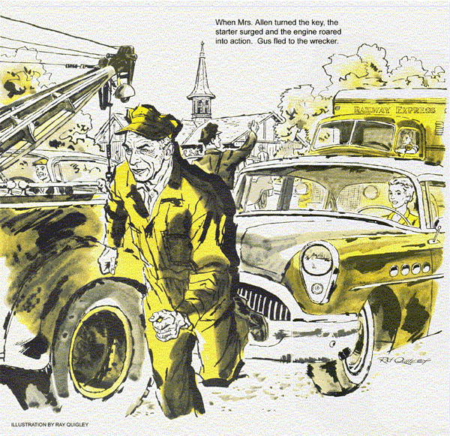
"Isn't that the Allen car?" asked Gus on returning from lunch.
"What's it in for?"
Looking at the well-kept '54 sedan, Stan shook his head. "Wish I knew."
"Oh, she told me," Stan said. "But the more she talks, the less she says. Try figuring this. She wants me to beef up the springs on the left side - because her husband has trouble starting the engine."
Gus sat down on a stool, tamped tobacco into his pipe. "Sure, Stan?"
Stan raised a hand soberly. "So help me. Sometimes the engine won't start for her husband. So because he's been gaining weight, she wants stronger springs on that side, and that will fix everything. Gus, is she related to Gracie Allen?"
Gus grinned. "It only seems that way. What'll you do on the car?"
Stan chewed his lip. "See if any spring leaves are busted, I guess, and check the shock absorbers."
"M-mm. What else?"
Stan turned both hands palms up. "She sure wouldn't like riding on helper springs, or siding boosters."
"No," agreed Gus. "But how about checking the engine?"
A flush spread up from Stan's neck.
"Honest, Gus, I'd have thought of that - just give me time to snap out of what she does to me."
Not without sympathy, Gus grinned at his helper's retreating back. He too had been the victim of Daisy Allen's free-wheeling confusion at times.
Hunched over a finicky automatic, transmission job, Gus was startled by a tense hiss at his elbow.
"Gus! She's back."
"Checked out everything?" asked Gus, inserting a final cotter pin.
"Everything Gus, ignition, starter circuit. That car's got to start."
Nodding, Gus wiped his hands and went to match wits with Mrs. Allen, a small smartly dressed, pretty woman.
Mr. Wilson I'm so glad you've fixed our car. Mr. Allen has had so much trouble - of course it always starts for me. - but we don't want to trade it in until next year, so I'm just delighted that you've fixed it for now."
A bright smile signaled Gus that it was time to speak. "Not exactly, Mrs. Allen. We can't find anything wrong." Resisting an urge to cross his fingers, Gus added: "Suppose you tell me what it seems to be."
"It's James, I mean, he has all the trouble. Yesterday at a gas station the engine just would not start, and he had to leave the car. A friend drove me there and of course I just turned on my key and off it went."
"Has it happened often lately?"
"Seven or eight times. This morning he needed the car in the city. He tried and tried, but it wouldn't start. I'd have been glad to do it for him, but he was so upset he simply ran off. But it started right away for me. It's his weight." She flashed him a bright smile. "Don't you see? It only happens when he's alone in the car. And it only began since he's gained weight. With all his weight on one side - of course I don't know much about engines, but mightn't that unbalance it or twist something?" "That's right, I often go to the station to meet him. Of course I stop the engine, but I leave the radio on. Then when he gets off the train, I slide over and let him drive. He never has any trouble, because I'm on the right and help balance things."
Gus breathed deeply, "Mrs. Allen, I'd like to check your car again, but first I want to talk to your husband. If it should happen again meanwhile, call me and I'll come over."
Daisy Allen wriggled into the driver's seat and switched on the engine. It purred obediently. "I'll do my part too, Mr. Wilson."
"Your part?" asked Gus.
"Of course. I'm putting James on a strict diet, starting tomorrow."
Next morning the phone rang early at the Model Garage. "This is Jim Allen," a grumpy voice announced. "You checked my car yesterday. It's dead in traffic in Station square. Police won't let me catch my train until it's towed off."
"I'm on my way," promised Gus.
The sight of the traffic snarl at the railroad station made Gus wince guiltily. The police helped him jockey the wrecker to the stalled car, where he found an angrily impatient customer. "Chap cut in front of me," explained Allen, a rotund and peppery little man. "Sudden stop killed the engine. Been standing here ever since."
"Think you flooded the engine?"
"Had this car six years. Know better than to flood it. You try."
Silently Gus got in. The ignition key, one of a big bunch, was still in the lock He tried the starter, then floored the throttle while cranking, to clear out any excess gas. There wasn't a pop of response from the engine.
"Tow it away before I get a ticket," ordered Allen. "I've got to go."
Reaching in, he yanked out the ignition key, detached it from the score or more on the chain, gave it to Gus, and stalked off.
Gus pocketed the key and turned to hitching up the wrecker, while rush-hour traffic wove parentheses around him.
"Don't bother, Mr. Wilson," a lifting voice called out. "I'll drive it." The lady alighted from a taxi in mid-street. "My friend Judy Stone was driving by when James got stuck. She phoned me, and I hurried over."
"It's no use," Gus protested. "I just tried it Mr. Allen wants it towed away before he gets ticketed."
Daisy Allen, now in the driver's seat, rummaged in her handbag. As a policeman approached ominously, she pulled out a tiny key-case.
"Stay put, Mrs. Allen," said Gus hastily. "I'll have you in tow in... "
Mrs. Allen's small fingers inserted and turned the key. The starter surged. The engine roared into action.
Gus fled to the wrecker.
Spotting Mrs. Allen as she drove in, Stan deftly vanished, Gus courteously opened the car door for her.
"There, Mr. Wilson. Now you can take care of everything," she said.
"Uh - yes, after I find out why it started for you and not for me."
She peered up at Gus. "You're taller, but you weigh as much as James. That's why. Oh, I'd better leave my ignition key with you."
"Mr. Allen gave me his."
"Not that terrific bunch he carries, I hope. He made all those keys at the plant, but they always put holes in his pockets. If he's forgotten - "
Smiling patiently, Gus held up the ignition key Jim Allen had given him.
Determined to leave no diagnostic alone unturned, Gus himself checked the fuel system from tank to carburetor, inspected the points, tested the plugs, condenser, and under-hood connections.
He squirmed under the dash with a light to see that ignition-switch connections were tight. They were. As Stan had said, this car had to start.
As Gus crawled out, the light fell on a crazy pattern of scratches under the ignition switch, caused no doubt by Allen's heavy bunch of keys. Keys heavy enough to tear holes in pockets! Gus inserted the single key, started the engine. Then he hung the droplight in the eye of the key and swung the light gently. The engine cut out at once.
Late that afternoon, James Allen appeared at the Model Garage. "Got an early train," he explained. "Found the trouble yet?"
"It was a worn ignition switch," said Gus. "We put in a new one."
"A worn switch? How come it always worked for my wife?"
"That's what stumped us at first," said Gus. "Your wife left her keys with the car, and with them the ignition checked out fine. But your heavy bunch dragged on the ignition key so hard that it wore the switch innards, and finally moved them apart enough to break the circuit."
"I'll be darned. Yes, when she meets me at the station she leaves her key in, and I use that. Why, you could have driven my car away instead of towing it!"
Gus cleared his throat. "She did," he said. "There'll be no tow charge."
"Sorry I was gruff at the station," Allen went on. "Besides getting stuck, I'd had two prunes, dry toast, and black coffee for breakfast. Now I'll probably get two lettuce leaves and a peach for dinner. Say, what should I tell my wife about all this?"
"Tell her," suggested Gus, "that we found your overweight on your key chain.
She can take you off that diet."
END

