March 1960

GUS MEETS A SHIFTY CHARACTER
by Martin Bunn

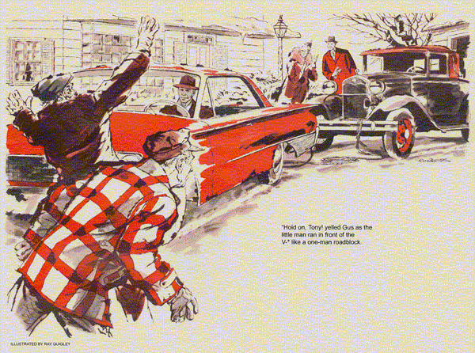
Busy one freezing morning in the Model Garage, Gus and Stan raised their heads as a familiar chugging drew near.
"Mrs. Holden's Model A! But she'd never be driving in this weather."
Gus opened the overhead door and looked out. "It's her car all right."
Prim with black paint and nickel, plated radiator, a snow-capped little Ford cabriolet moved up the concrete apron, only to cough and sigh to a stop half in, half outside the shop. A dark, curly-headed little man scrambled out.
"Sorry, Gus, she just made it." Despite the chill, sweat rolled from the black locks under his cap.
"Okay, Tony," soothed Gus. "Let's just push it in the shop."
Once the Model A was inside, Tony shrugged, "we got a mystery, Gus. She starts fine - right away. But one block, maybe two, and the engine quits... like now."
"I bet Mrs. Holden went visiting yesterday," said Gus. "When it started to sleet and snow, she left the car overnight and sent you for it this morning. Am I right, Tony?"
He knew that Mrs. Holden, an elderly widow still driving the car her husband had bought 30 years before, never turned a wheel on storm-sleek streets.
"That's right," agreed Tony. "I'm glad to do it. She's a good customer for my gardening. Besides, I don't like to see this fine car standing on the street."
"You go in my office and pour yourself a cup of coffee," Gus said. "We'll fix it."
As Gus continued thawing a frozen gas line in another car, Stan sauntered up.
"Want me to check the Ford?"
"No," answered Gus. "Just clean that ice clump off the cowl."
While Tony watched, cup in hand, Stan carefully freed the frozen mass, revealing the gas cap under it.
"Okay, Boss. Blow out the gas line?"
"No. With a frozen line, Tony wouldn't have got this far, even in easy stages.
Blow out the cap vent."
Stan removed the notched gas cap. He found no vent in the top. The under rim was packed with icy snow. Gouging it out, he found a small vent hole there.
"No wonder it kept stalling," he reported.
"This was blocked solid.
Air couldn't get in, gas couldn't flow out."
Gus nodded over his own job. "Until the engine stalled. Then enough air would leak in to let the carburetor fill up."
Stan wiped and replaced the cap. "Okay, Tony. Say, you and Mrs. Holden sure keep this car in fine shape."
Tony stroked the hood lovingly. "When I land here, a boy from Italy, first car I see is a new one like this, just what I want.
Now you can't buy this kind. But I take good care of the car for Mrs. Holden. Some day she'll sell her to me."
"He sure loves that car," said Stan as the little Italian drove off.
"Lots of people loved the Model A," remarked Gus. "I think Tony will get that one soon. Mrs. Holden told me she isn't renewing her license."
Back to the day's quota of jobs, Gus and his helper almost forgot the episode. But late that afternoon they were alerted by a squeal of hasty brakes. The pickup Tony used for gardening jobs slid to a stop, the little man tore open the door to the shop and ran in.
"Please, Gus! You gotta come. This time it's real big trouble that I've got."
"Relax, Tony, Mrs. Holden won't drive the car with snow on the ground."
"You don't understand, Gus. Come on.
I'll tell you while we go," wailed Tony - literally pulling Gus along.
Once out of traffic, the little gardener exploded into speech. "It's the nephew, Grover. He's only come to see her once, twice, before. Right away when he sees the car, he wants her, Mrs. Holden says no, she'll sell her to me.
"Today that Grover, he comes in after I drive the car home and go to another job. When I come back to clean out the cellar, Mrs. Holden is upset. Grover, he looked at the car in the garage and says the transmission is busted, she'll never run again.
"So Mrs. Holden tells him how I just drove the car home and she must be all right. He says he'll show her how I am the guy who busted it, and he shows her. Gus, it's awful. But I didn't do it."
Before Gus could speak, Tony swung into a long curving drive. The Model A stood near the garage.
In front of the old car, and joined to it by a towline, was a modern V-8 hardtop. Randy Smith, a young man Gus knew slightly, sat at the wheel of the modern car.
Tony pulled up hard, jumped out, and ran toward Mrs. Holden and a sleek, too-well-dressed stranger standing with her
"Hold on, Tony!" yelled Gus, fearful that the excited little man would explode into action. But Tony only ran in front of the V-8 taking the stance of a one-man roadblock.
"Tony told me about your trouble," said Gus on approaching Mrs. Holden. "I came to see if I could help."
"I'm afraid not," she said heavily, for the first time looking all of her 75 years.
"Grover is sure the gears are stripped.
Since spare parts cannot be had for so old a car, I may as well let it go. He knows some rich men who collect old automobiles, and could afford to have parts specially made."
Her voice trembled a little. "I know how much Tony wanted the car. But it would be no kindness to give him trouble and expense he cannot afford."
"May I look at it?" asked Gus.
She nodded listlessly, but the young man shook his head. "Haven't time, Dad.
I've got a long tow ahead. Want to start before it gets dark."
He jumped into the Model A and slammed the door, but not before Gus had looked into the car. What he saw wasn't measuring up. The shift lever sprouting from the middle of the floor stood far over to the right and against the dash, as though broken or bent inside the gearbox.
Gus nipped around the car, opened the other door, and got in. "Don't rush off," he said mildly. "I just may be able to fix that."
Before young Grover could protest, he grasped the lever, lifted it straight and let it drop neatly into normal neutral position.
"You can drive it again now, Mrs. Holden," announced Gus.
"She's through with this car," snapped the young man. "I have the registration right here."
He flipped a paper out of his pocket and waved it. But a slender gloved hand snatched it from his hand.
"You hadn't paid for it, Grover," said Mrs. Holden. "And now Mr. Wilson has raised some question in my mind."
"Okay, so I wanted to make a few bucks. I know somebody who wants an old crate like this. Where could you sell it, Auntie?" I'll pay you later."
"Grover, did you fake that damage?"
"Me? Certainly not. I think your gardener did it to get the car cheap."
Gus's tolerance snapped. "That does it! Mrs. Holden, suppose you ask Randy Smith how far he agreed to tow the car."
As the old lady walked to the V-8, Gus took the Model A's ignition key from the lock and stepped out. He had the tow-line unhitched by the time Mrs. Holden came back, fire in her eyes.
"He was hired to tow it only as far as the state highway. So my nephew expected to drive it from there. Grover, you are a fraud."
The sleek young man got into the other car. He seemed to be arguing with the driver as it sped off.
"He'll have to pay for something he never got," chuckled Gus, giving Mrs. Holden the car key, "Guess I'll need a ride to town."
"I am very grateful," said Mrs. Holden. "Tony, take him in your car."
"Sure," Tony said. But as he headed for the pickup, a small hand thrust a key and a paper toward him.
"Your car, not your truck, Tony."
The little man stared at the key. Then his eyes crinkled and a hitherto invisible Adam's apple bobbed in his throat.
"Lucky for me you could fix it so easy," said Tony as he drove off.
"Oh, that spavined shift lever is an old gag," Gus explained. "Young Grover must have heard about it from antique-car collectors. Pull the lever up out of its socket, and you can put it in that crazy position. But it will snap right back. We used to play that nasty little trick on each of our friends when he got his first Model A, then swear him to silence to keep the gag alive."
"Lucky for me that you remember so good, Gus."
"How could I forget?" asked Gus with a grin. "I learned it the hard way - right after I got my first Model A."
END

