June 1960

GUS TEACHES THE TEACHER
by Martin Bunn

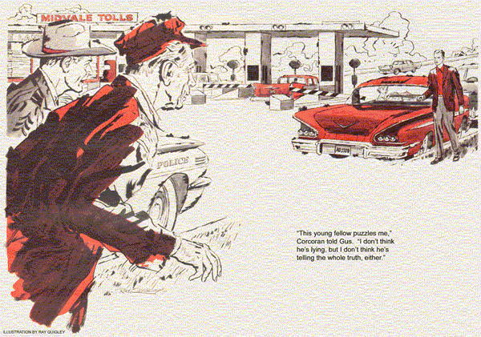
Driving back from a turnpike call, Gus noticed a police car and three others halted at the widened approach to the toll booths. He showed his turnpike pass and drove on. With windows open to a bright early-summer day, he was enjoying the trip when a siren began to wail behind him.
Automatically his foot lifted from the throttle. But a glance at the speedometer showed Gus he was below the limit, and he planted his foot back on the gas.
The siren wavered as a police car shot by. With something of a shock, Gus realized that the trooper was waving him over. He slowed, rolled into the shoulder. As the driver emerged, Gus recognized the smartly uniformed figure of Jerry Corcoran.
"Took a chase to catch you," growled the young trooper.
"I didn't think it was me you were after," Gus said.
"Well, it was. Gus, I've got a situation at the toll stop I want you to look into. I spotted you going by just too late, so I hurried after you. Will you come?"
"Be glad to," Gus agreed. Moments later, following behind Corcoran, he was back at the toll area. Only two cars now stood there, the rear one with a smashed head lamp.
"Fellow in front says he slowed down for the toll," Corcoran told Gus as they walked over. "The woman behind claims he jammed on his brakes so hard she couldn't help hitting him. A third car hit her, did no damage, so I let it go."
"After hours of high-speed driving, their slow-speed judgment may have been off," remarked Gus.
"Maybe. But this young fellow puzzles me. I don't think he's lying, but I don't think he's telling the whole truth either."
A tall, red-headed young man strode toward them from the first car.
"How about it, Officer? I'm the one who was hit. Can't I go on?"
"Pretty soon," said Corcoran. "How fast did you say you were going?"
"I dropped to 30 at the second toll sign, and wasn't doing more than 15 when she hit me."
"She says you stopped. Did you jam on your brakes?"
"No. Why should I?"
"How close was she?"
The young man looked uneasy. "Not too close. It wasn't her fault, nor mine. I had slowed down, and then picked up again, but my transmission downshifted suddenly by itself."
"Why didn't you say that before?" asked the trooper.
"You know you shouldn't be on the turnpike with an unsafe car."
"But it's not unsafe," insisted the young man. "Not at ordinary speeds. It only does this under 20."
"You've just caused a three-car chain accident, luckily in slow-motion," said Corcoran. "Mind if this man checks your car?"
The driver offered no objection as Gus got into the car, a 1954 six-cylinder sedan. Backing slowly, he felt a sudden sharp catch in the power train. It wasn't repeated. He started forward. The car picked up smoothly to 20, then bucked as the transmission suddenly down shifted. Given more gas, it abruptly shifted up again.
On a second run the same thing happened, at lower speed. Gus parked the car.
"It downshifts abruptly at low speed," he told Corcoran. "The effect could be pretty much the same as if he'd slammed on the brakes."
Corcoran nodded and turned to the young driver.
"I won't give you a ticket, but you'll have to be towed off the pike and have this trouble taken care of within 10 days. Here's your warning. Gus Wilson here will tow you off."
The trooper stalked away. Gus looked sympathetically at the disconsolate young man. "Where are you headed?"
"Just into the next town. I have an appointment with the school board at 3:15. Can I make it?"
Gus smiled. "You'd better. I know some of the board members, and they're none too patient. Look, I'll tow you right in at no extra cost."
With the sedan dangling from the wrecker's hook, rear wheels up, Gus and the young man headed toward town.
"Going to teach here?" asked Gus.
"Hope to. My name's Herb Findley.
They're interviewing me for a job to start next fall. But I hear this board has some old codger who's the last word on my subject, and if I don't rate with him, I'm out."
"That so? Who is he?"
"Never got his name. Say, would you look into this transmission trouble?"
"Sure thing," Gus said.
"Usually I do the simpler jobs myself," Findley said. "But I'm not eager to take down an automatic transmission, especially with school over."
"How's that?" asked Gus, turning into the Model Garage.
"Because during school I have equipment, repair manuals and follow-up service bulletins. You see, I teach auto repair in high school."
After making several checks without result, Gus wondered whether he shouldn't go back to school himself.
The car shifted normally into high, downshifted smoothly on grades - and misbehaved staggeringly at low speeds. But the trouble seemed to occur at random. The electrical system and control linkage were faultless.
With the car on a body lift, Gus pondered. What, aside from some defect far inside the guts of the transmission, could make it downshift erratically?
"Stan!" Gus called to his assistant.
"Hold that wheel while I turn this one."
Stan Hicks obediently looked on to one rear wheel while Gus turned the other against transmission drag. The drive shaft slowly spun around nine times. On the tenth it jammed, locking Gus's wheel.
"Let go!" he ordered, and the wheel Stan released turned backward as Gus spun his forward. The drive shaft stayed locked.
"Thanks, Stan. That'll do."
Removing the inspection plate that gave access to the shoes of the emergency brake on the drive shaft, Gus probed inside with two fingers. Both shoes were far from the drum; the hand brake was obviously overdue for adjustment. Seizing the drive shaft, Gus worked it back and forth. There was a clink of metal.
Inside the bottom of the brake drum, he felt something turn under his fingers. With some difficulty he withdrew a steel nut.
"Where there's a nut," muttered Gus, "there's probably a lock washer."
He dredged the washer up after a little fishing. Then he pulled off the brake drum and replaced the wandering nut and lock washer.
More cheerful than he had been on the turnpike, Findley turned up at the Model Garage well before closing.
"Get there in time?" asked Gus.
"Just. And they took me on. Seem as keen on touching auto repair in the high school as I am."
"That old codger make any trouble?"
"No, he wasn't there. But they had a shrewd list of questions. Guess they got it from him. If so, the old coot knows cars."
Gus handed him a bill.
"Yours is ready to roll - even on the pike. And I'm charging only for the tow.
Fixing your downshift trouble is on the house. A nut and washer had fallen off inside the brake drum." Innocently, Gus said, "Wonder why that made the transmission act up?"
The young teacher frowned. "A loose nut inside the drum might jam between it and the shoes, if it happened to turn crosswise. That would put a sudden heavy load on the transmission, which would downshift to carry it, and squeeze the nut through. Soon as that happened, the transmission would upshift again."
"But only at low speed?" asked Gus.
"You're ribbing the teacher now! Is this right? At higher speed centrifugal force flattened the nut against the inside of the spinning drum and held it there, so it skinned by the shoes."
"You can go to the head of the class for that," chuckled Gus.
"I'm mighty grateful to you, Mr. Wilson. And glad that school-board expert didn't try to stump me with that one."
"Oh, didn't he?" asked Gus.
"Course not. How could he..."
Findley paused wide-eyed. "Not you?"
Gus, the old codger, just grinned.
END

