August 1960

GUS TANGLES WITH LIGHTNING
by Martin Bunn

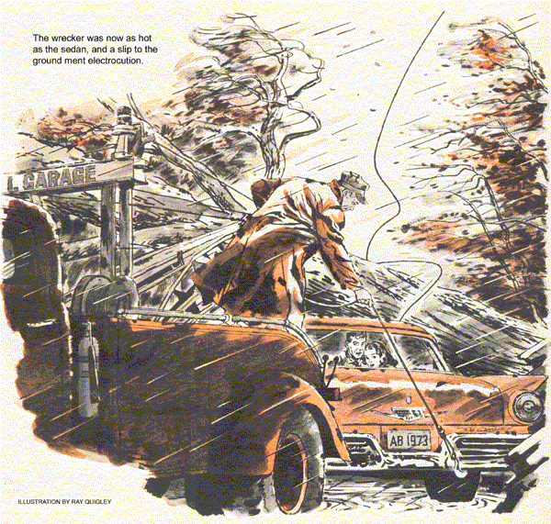
Sultry still with yesterday's heat, the air seemed charged with tension as Gus Wilson unlocked the Model Garage. Remembering storm warnings the night before, he hoped there'd be no road calls.
At once the phone rang. Leaving Stan Hicks to unlock the pumps, Gus answered.
"It's Hal Durward, Gus. We're in a jam - need help right away."
Gus grinned wryly. Durward and his wife had moved to a remote lakeside house. A ride there would be a long one.
"The hospital won't send an ambulance because the baby isn't due, so I was going to bring Bessie in this morning. But the car won't start, and what the radio says has us scared."
"What's that?" asked Gus.
"Hurricane warning. Last big rain we had, this area was flooded. All the neighbors are gone. I had to break into a house to reach this phone."
"Take it easy," counseled Gus. "What's wrong with your car?"
"Lights and horn work, but the starter won't budge. Battery's too far gone. Hurry, Gus. I'm going back..."
The line clicked dead. Gus grunted in exasperation: he could have told Durward what to try, if the excited young husband had waited. Now there was nothing to do but get out there.
Rattling down the dirt road to the lake, the heavy wrecker shuddered under wind gusts. Gus saw that driveways were empty, some houses shuttered.
He braked to a fast stop before Durward's.
"Thank heaven you're here," the young man said. "Bessie's getting awfully anxious about being stranded with the baby near."
"You'll get out," Gus answered, and added a bit tartly. "Might be out by now, if you hadn't run off the phone so fast."
"No, the battery's dead. Look," Durward leaped into the modest sedan, flipped the key over.
A futile clicking of the starter solenoid was the only response.
"Just a second," said Gus, opening the hood. He scowled at the corrosion encrusted terminal clamps on the six volt battery. Then with the hammer he was carrying he tapped both down smartly.
"Try it again," he ordered.
Durward turned the key. The starter growled for a couple of seconds. The engine fired and ran smoothly.
Durward climbed out with a pained look on his face. "What'd you do?"
"What I would have told you," said Gus.
"Hammered the cable clamps down a bit.
Overnight, corrosion worked into the joint, causing a high-resistance contact."
"But the lights worked!"
"Sure. Voltage drop is proportionate to the current. A poor connection may easily pass enough to work the lights. But it will drop the voltage way down when you try to pull a few hundred amps for the starter."
"Gee, Gus - I'm sorry.
Guess I got panicky, trying to calm Bessie."
Gus chuckled. "They say young fathers get some of the wife's symptoms. Get going now. I won't leave 'til you do."
Occasionally the sedan vanished ahead of Gus on the winding forest-lined road.
Even in the solid cab of the tow truck, he could feel the force of gusts that whipped tree tops and hurled branches across the narrow asphalt trip.
Nevertheless he put on enough speed to keep up with the car. The sedan was in plain sight when it happened.
With a crack heard even above the wind's howl, a tree on the right side of the road ahead of the other car began to topple. Gus saw a thin black line lash upward as the free trunk fell toward the road.
Only then did Durward become aware of the danger.
The sedan's tires screeched. For a moment car and tree trunk seemed drawn together. A front wheel struck, the rear of the car slowed and its fender settled against a rocky outcrop on the road shoulder. Simultaneously a black cord, silver tipped dropped down across the car top and trunk.
Briefly the sedan shuddered in reverse. Wedged between tree trunk and rock, it did not move.
The car door opened as Gus pulled alongside, horn blaring, to shout over the storm into Durward's startled face.
"Get back in. There's a wire on your car - maybe a hot one."
"I'm stuck. Pavement's dry - can't I get out and see what's holding me?"
"You'd make a better circuit than dry tires. Touch a foot down and you could be killed!" Gus roared.
"Get back and stay - no matter what."
As if to punctuate his words, the rain began. Water pitch-forked out of the wind-ripped sky turning the road into a shallow river.
Gus backed the wrecker and turned on its blinkers.
Rain water is a poor conductor of electricity, but in sluicing over a dirty car it becomes rich in minerals.
Through the sedan's rear window Gus saw two frightened faces jerk about as miniature lightening flared from the cable's end. With thousands of amperes generating a magnetic field around it, the wire seemed to come alive.
It lashed about like a frantic snake, slid off the roof, again and again struck fire from other parts of the car, until it found a shiny bumper. There it glared fiercely for a moment, then subsided - arc-welded in place.
"The car's charged with juice," Gus shouted. "But you're okay inside."
"We could jump," yelled Durward, "so there'd be no contact."
Gus shook his head. "Your wife's in no condition for it. Besides, the road anywhere near the car is dangerous. Sit tight while I call the linemen."
The woman in the car shrieked. There was a scuffle inside. Then Durward reappeared, one arm tight around his wife. His face was pale.
"She tried to get out. She's hysterical. Don't know if I can hold her."
"You've got to. I can't even touch your car, but the utility company must be aware of this break. They'll soon have men here who can handle it."
Bessie Durward screamed, tore free from her husband. The right hand door flew open. He pulled her back by main force.
"I can't keep fighting her, Gus. Do something!"
"I'll try," promised Gus.
In desperate haste he backed the wrecker, turned it and stopped to clamber back on the deck. There he freed the twin hoist chains. With a coarse file he scraped surface rust off one end of the big steel bumper apron.
Backing cautiously toward the sedan, he angled in toward the left corner, held his breath as the wrecker's apron nudged hard against the car's bumper, and set the brake hard.
Again he climbed from the cab onto the deck, with the difference that the wrecker was now as hot as the sedan, and a slip to the ground meant electrocution.
Hardly aware of the two who peered at him from behind the rain-washed car window. Gus lowered the hooks. Rain blurred his vision. Breathless from wind and tension, he finally engaged them under the edge of the car bumper.
Gingerly he engaged the power take-off, lifting the off-road side of the sedan first. Steel grated on chrome as the hooks settled in their task. The car lifted, rasped free of the rocks.
He was almost through the cab door when one foot slipped on rain slick metal.
For an age-long moment, Gus hung by his hands, feet drawn up to avoid contact with the road. After pulling himself into the cab he was as wet with sweat as with rain.
Putting the wheel hard over toward the center of the road, he eased in the clutch. Slowly the sedan swung on its front wheels.
Over his shoulder Gus watched the black snake draw taut. He fed gas to the engine. With an electric hiss the welded end tore free, struck out angrily. The wrecker groaned, eased the car away from the failing wire.
Gus towed it several hundred feet, then stopped and climbed out, a bit shakily. Durward managed a smile.
"Head back for the turnoff," Gus shouted above the wind. "Take Route 60 to town. I'll wait to warn off other cars."
Utility linemen arrived 15 minutes later, along with a lull in the storm.
Ted Carlson, the crew foreman, soon got the gist of what had happened.
"Twenty four hundred volts on that line," Carlson said. "You were crazy to play around with it. You know the rules about any downed wire - assume it's hot, and leave it alone. All those people had to do was sit in the car and wait. We were on the way."
"Sure," said Gus. "So was something else - a little thing that made all the difference."
"Yeah? What could that be?"
"Biggest little thing in the world," said Gus, "a baby."
END

