April 1960

GUS PLAYS WITH FIRE
by Martin Bunn

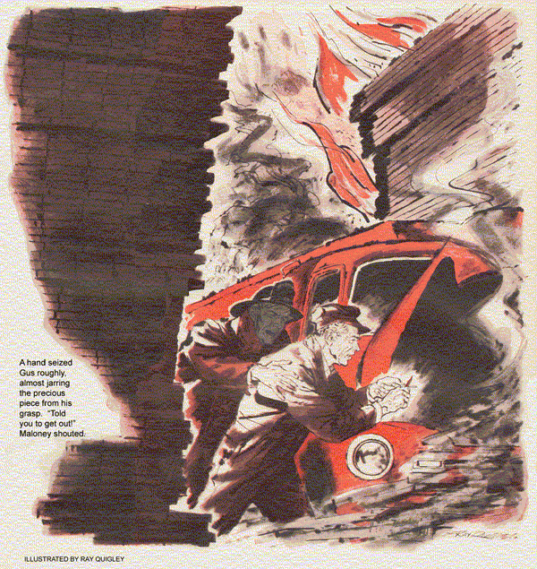
"Where is that thread-stripping, nut-rounding car wrecker you call your boss?" bellowed someone just inside the Model Garage door.
Stan jumped. "Who the - oh, it's you, Chief Maloney."
Gus appeared from around a car, wiping his hands. "Sure enough, it's the loud-mouthed smoke eater. You still on the job, or is it safe to cut down on my fire insurance? How are you, Mal?"
"Fine, till I think what you'll charge the town for a small job I need done on my car," said the Chief.
"We'll take it out of your salary. Don't know when you've last earned it by going to a fire. What job?"
"Tune-up. New points. Gap the plugs. And I want it done now."
Gus's grin faded. "I'd say yes, Mal, but Stan has to finish Joe Stanton's car for an important trip, and I've promised to reline the brakes for Mrs. Munsey while she takes her boy to the doctor this morning."
Maloney frowned. "Can't you put her off? That's no emergency job."
"Nor is yours," said Gus. "That slab-wheeled red crate of yours will haul you any place you need to go today.
Bring it in tomorrow, huh?"
"Okay, tomorrow." But Maloney's good humor was gone.
As the fire chief left, Stan peered up from the crawler he lay on. "You and the Chief sure shout the breeze. Before I saw who it was, when he called you a left handed mechanic - "
"Go on," urged Gus.
"I thought the guy meant it!" finished Stan, and rolled under the car to dodge a wad of waste Gus threw at him.
After sending Mrs. Munsey on her way with better brakes, Gus was phoning a parts order when a banshee whistle penetrated the office. He finished the call and walked out.
"There goes the whistle for the volunteer reserves," he remarked to Stan. "Mal must have a big one."
A car siren screamed a block away. "That's the third one," Stan said. "Two went by while you were inside."
"Then Mal is already there. Kidding aside, he's right on the ball."
"Maybe he'll call you out," suggested Stan, grinning.
It was then that the phone rang.
The very air seemed ablaze over Conwal's Lumber Yard when Gus braked to a quick stop just inside the gate. Under a pall of resinous smoke, stacked lumber burned all along the back fence. Maloney was beside Gus immediately.
"It's a bad one, Gus. I need you,"
He pointed through the smoke hose to a huge wheeled bulk. "Jensen's gas truck jammed in where we can't tow it, and the engine's dead."
The tank truck, its front against a brick wall, stood wedged between enormous piles of lumber. Directly behind it was the yard office, blocking any hope of towing it backward or from the front end of the driveway. The only point from which towing could have been done was inside the blazing yard itself.
"That's where the underground tank its," Maloney explained. "Jensen backed in, delivered gas, and started to drive out. Just then his engine conked out, so he coasted into that slot to leave the driveway clear."
The Chief grinned. "That truck is almost full of gas. The fire won't give us time to move the lumber, and we can't tow the truck out. If it goes up, it could take the whole block along with it."
Gus nodded. Across the street and behind the yard were many modest homes.
"Didn't know till now," Maloney added, "that Jensen left the ignition on.
Now the battery's too far gone to turn it over. Got an extra?"
"It's on charge," snapped Gus. "Got any booster cables? Mine aren't long enough to get in there."
"Couple in the pumper," said Maloney, and went off. But hope sank when Gus saw the Chief's cables. Even with Gus's added, they'd be far too short to connect the truck's battery with the one in the wrecker.
Gus tried to recapture what he knew of the electrical system of this make of truck. Was the negative side grounded, as in his wrecker? An even chance...
"Mal, grab this file and clean a spot my bumper can contact. Get a man to run the wrecker against it and keep the engine at fast idle. Give me a man in the gas truck, too."
Maloney took the file and started roaring orders. Gus clamped the four booster cables end to end, clipped one to the wrecker's ungrounded battery terminal. Holding the other end, he sidled in between the lumber stack and the gas truck.
The truck hood was up, but the corroded battery terminals gave no clue as to which was positive, which negative.
Looking back, Gus saw a fireman drive the wrecker up to nudge the rear of the truck. When it was in firm contact, Gus brushed the cable end against the ungrounded terminal of the truck battery.
Only a modest spark flew.
"Polarity's okay," he muttered, and nodded to Maloney in the truck cab. As Gus clamped on the booster cable firmly, the starter churned over.
There was not even a cough from the engine. Yanking a plug cable off, Gus held it over the block. No spark jumped. He did the same with the high-tension-coil wire. It too was dead, and he signaled the Chief to stop cranking.
As the noise of the starter died, a fireman shouted above the snap and roar of-wind-fed flames. "Wind's shifting, Chief.
Other end of these piles is already afire."
Maloney crawled across the cab, "Gus! What're chances of moving it?"
"Know in a minute. Leave the switch on." Snapping the clips off the distributor, Gus lifted the cap and rotor. With the coil cable again held near the block, he snapped the breaker arm off the point.
A lively spark jumped between cable and block.
"Switch off!" shouted Gus, and choked as smoke engulfed him and the engine.
When it cleared, he spotted a chip of fiber lying in the distributor. He knew what it was at once - a piece broken off the rubbing block that bore on the cam.
Without it, the cam couldn't open the points. A rare happening, but here it was deadly.
Eyes stinging, Gus loosened the nut, pulled the breaker arm off its post. He felt Maloney at his elbow.
"Got another?" asked the Chief.
"Not here - maybe not even in the shop. It's an old truck." Useless to try to substitute an arm from the wrecker or any modern car, Gus knew.
"Fire's blowing this way. I've ordered the houses evacuated. Get out!" Maloney disappeared in a swirl of smoke.
Coughing, Gus took a pencil stub from his pocket, thumbed open his penknife, and sawed a quarter-inch length off the wooden hexagon. But a fit of coughing sent the blade askew. The fragment flew off.
He laid the pencil on the truck fender, sawed off another bit. Half of it splintered away. Prying the lead out of the other half, he set it into the channel of the tiny contact arm.
It fell out. Savagely Gus sawed off a slightly longer bit. Almost unable to use, he wedged it into the channel of the arm, its groove over the stub of broken fiber.
A hand seized him roughly, almost jarring the precious piece from his grasp.
"Told you to get out!" Mal shouted.
"Pile is blazing at the tail end of the tank now."
Gus coughed. "Spray the tank. A minute - I may get it to work."
He set the arm on its post. The pencil-wood block stood clear of the cam. Eyes streaming, Gus estimated the cam lift, backed the stationary point off a bit, slipped on the rotor and cap. He heard Maloney shout an order, and the wrecker's engine roar increased. Coughing uncontrollably, Gus signaled Maloney in the truck cab. The starter ground. The engine fired at once.
Unclamping the booster cable, Gus snaked back out of the narrow side. Maloney backed the truck out almost before he was clear. Its tail clipped a pile of blazing two-by-fours, scattering them like burning matches. Three hoses arched in to wet the sparks.
Yanking free the booster cables, Gus let them fall and jumped into the wrecker.
With split-second timing, the fireman at the wheel backed out in advance of the oncoming gas truck. In its cab, squinting through the smoke, Chief Maloney grinned like a triumphant demon.
When a bright red coupe pulled into the shop next day, Gus shook his head in mock disgust.
"Send him away, Stan. It'll spoil my lunch to work on that gaudy crate."
"Yeah?" Don't know what's got into me - trusting town property to a half-brained mechanic who forgets his booster battery," retorted Maloney.
Stan looked at Gus. "I thought the newspaper called you both heroes."
"Cheap publicity!" snapped the Chief. "Now, about that tune up."
Gus looked thoughtful. "Afraid not today. Got to get Mrs. Smith's car done so she can go to a bridge tournament -"
He broke into a grin. "Only kidding, Mal - after yesterday, I guess you rate top priority at the Model Garage."
END

