September 1959

GUS GETS INTO A SMASH UP

by Martin Bunn
That broiling sun gave Gus an idea.
Could he use the thermometer to take the heat off a friend?

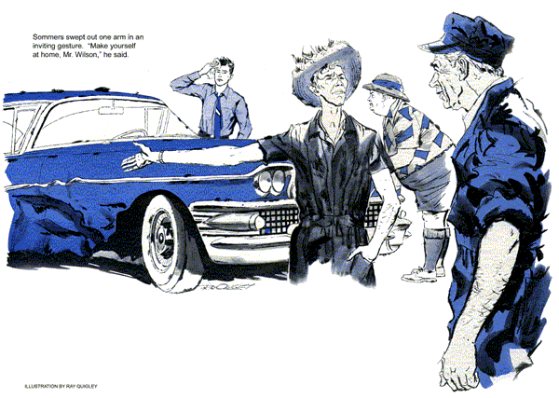
Gus Wilson sat tilted back in a chair against one side of the shaded Model Garage doorway. An oversize fan was aimed at him from the floor.
"Hot enough for you?" he asked.
Stan Hicks looked up in disgust. Naked to the waist, he was hosing down the paving around the garage. Suddenly he swung the hose nozzle around, just missing his boss, bent over and doused himself from waist to head.
Gus grinned. "I get the idea, Stan - no particular need to drown yourself."
"Why don't we close up shop and go swimming? There won't be any business on a scorcher like this."
Gus pointed down the street. "Silas Sommers has got himself a customer for his Continental Garage."
"Got himself a wreck," Stan answered, squinting at a tow truck hauling a heavy sedan with a damaged right-front fender and door. "And that car limping along behind with a bent front bumper had something to do with it."
"Say, that's George Crowley behind the wheel," Gus said. "Thought you told me he was representing a client up at county court?"
"He probably had the case postponed so he could rush back to be with his wife at the hospital," Stan sighed. "Hard times, first his wife has an operation, then he has a smashup."
"Well, at least George can handle his own case in court if it comes to that."
"And I guess any struggling young lawyer can use a new client," quipped Stan.
Whatever retort Gus made was drowned out by the wailing noon siren. He got up and waved to his assistant. "Keep cool," he said, heading down the street. "I'm off to the air-conditioned diner."
When Gus returned he found the lawyer with Stan. Their faces were hidden behind wedges of watermelon.
Crowley dropped his rosy chunk to mop his perspiring face. He had his jacket off and the knot of his tie loosened.
"Hear you saw my car," he said wryly.
"Didn't look too bad from what I saw, George. How's the wife?"
"Fine, Gus. She'll be asleep now, so we've got a couple of hours to look into things."
"We?" Gus asked. "Better brief me."
"Well, you see," Crowley began, "I ran into Tom Walker's car… "
"You mean Butterball, the insurance broker?"
"He's the one. But it was my fault," Crowley went on, "I was tired, worried - not too alert in my driving."
"Stop worrying, George," Gus said.
"Your insurance will cover it."
"Not when it's lapsed. When Mary got sick I forgot to send the check. Now I'll have to pay out of my own pocket."
"Tough - with hospital bills," Gus sympathized. "But from what I saw of the car, they can't charge too much."
Crowley shrugged. "Sommers tells me I put Walker's transmission out of kilter.
Those things run into dough."
"You must have banged into him pretty hard, George."
"No, I didn't, Honest," Crowley said.
"I just can't figure the thing out at all."
"Okay, let's go see what's cooking.
You're entitled to your own estimate - especially if you're footing the bill."
As they approached the Continental Garage, two men peering at the banged up car presented an odd rear view.
One, a lanky six-footer wore a farmer's hat and coveralls cut short at sleeve and trouser ends. The other was five-by-five. Decked in a tropical helmet, a wild shirt, Bermuda shorts, he resembled three balloons stacked on sausage legs.
Slim Sommers and Butterball Walker turned around as Gus and Crowley arrived.
"Well, look who's here," Sommers greeted them. "I kinda expected Mr. Crowley to bring his friend Gus Wilson over."
Gus walked over and examined the sedan's crumpled fender and dented door. "Just dropped over to check on the damage to Mr. Walker's car," he said.
"Tell him about the transmission."
"The frame and front end are okay," Sommers said, "but the transmission took a beating - it'll have to be replaced."
"I'm not doubting your word, Slim,"
Gus said, "but it doesn't look as if this car was hit hard enough to damage the transmission."
"Looks are sometimes deceiving, Gus," Sommers said pompously. "You know how collisions are sometimes - fender hardly dented, but you find a bent frame, hit a man in the rear wheel, bend the front axle."
"It happens," Gus agreed. "Okay if I check on a few things?"
Sommers swept out one arm in an inviting gesture. "Make yourself at home."
Gus started the engine and checked the transmission oil. Then he shifted into reverse. The car backed up, but wouldn't move in any driving range.
"Satisfied?" Sommers asked.
"Not yet, Slim. Let's push the car up on your lift."
With the car raised, Gus took a hydraulic gauge from his kit and connected it to pipe-plug outlets built into the transmission. He checked the drive-pump and accumulator pressures at various engine speeds. Then he removed the bell-housing cover and flashed a light inside. He turned to the car owner.
"Mr. Walker," he said, "I'd say that this transmission has been so hot that the nonmetallic seals and gaskets are seriously damaged."
Butterball, bounced up from a chair he had collapsed in. "Then Crowley did it sure. My car was running smooth as silk before he crashed into me."
Crowley groaned.
"And that means I'm stuck with a big repair bill."
"I'm not so sure, George," Gus said rubbing his chin. "Let me ask Slim here a few questions."
"Look Gus," Sommers said. "It's all cut and dried. I'll give Mr. Crowley a break on the bill."
"That's not the point, Slim. When did you pick up Mr. Walker's car?"
"All right, Mr. D.A. Wilson," Sommers said grudgingly. "It was 11 o'clock sharp.
I looked at my watch because I was in a hurry to get home for lunch by noon so the missus could make a club meeting."
"And you almost made it. The noon siren sounded just after you passed the Model Garage. George tells me the accident took place at Orrville Junction - 47 miles from my place. And you made it in one hour. That's pretty fast towing."
"So what?" Sommers challenged.
"So the transmission damage was caused by your tow, not by collision impact."
"Whoa, there, Gus, them's fighting words. I know enough about this kind of transmission to tow it in neutral."
"Sure you do, Slim," Gus said. "But that's not enough. The book says that even in neutral a dual-turbine drive should not be towed faster then 30 miles an hour on a normal summer day - around 80 degrees." He stopped and pointed at a big thermometer on a shaded post.
"Why," Crowley said, "it made 102 right now."
"And," Gus continued, "it was much hotter at noon out in the sun. Then, too, Mr. Walker's car has a triple-turbine drive - which isn't safe to tow above 25 miles an hour."
"Then I'm not stuck?" Crowley asked.
"No, George. When Slim was towing, the front, motor-driven oil pump of Walker's car wasn't operating. And under that condition, even in neutral, the turbine develops drag, creating excessive heat."
Sommers had been listening thoughtfully. He looked at his wristwatch.
"I have to make a phone call to check on some parts. Be right back."
While Sommers was gone, Gus and Crowley played the soft-drink machine, bringing a bottle of pop over to Walker, who had collapsed into a chair again, his red face streaming.
Sommers came out of his office. "Mr. Walker," he said, "you handle my insurance. Suppose I really did pull a fool boner like Gus says - am I covered?"
"Certainly," Walker said, bristling.
"Then you're getting a brand-new transmission on the insurance company."
"You're agreeing that it was your fault?" Gus asked.
"Well, yes, Gus, now that I've checked in the manual," Sommers grinned. "That was my 'phone call.' But I wasn't going to admit anything till I found out if my insurance covered it."
As Gus and Crowley left, the young lawyer was profuse in his thanks.
"All I did was estimate a wreck," Gus said modestly.
Crowley laughed. "And instead you wrecked an estimate."
END

