October 1959

GUS FIXES A RACE

by Martin Bunn

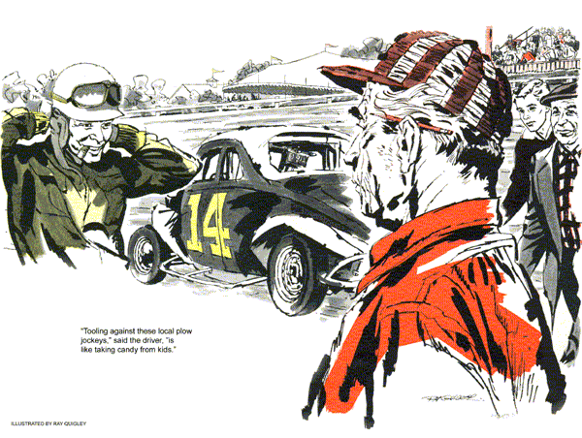
The coupe that pulled up in front of the Model Garage was a beatup, prewar model painted a lemon yellow. Two T-shirt clad youngsters unstrapped the doors, swung them open on loudly protesting hinges, and climbed out.
"Junk yard's out on the edge of town, boys," Gus Wilson greeted them.
"Man, he doesn't know," said Cliff Johnston, his face one big smile.
"That's right," agreed his lanky partner, Jim Gerber. "This mechanical marvel, Mr. Wilson, has a destiny."
The two youngsters looked lovingly at their pride and joy. Cliff sighed. "Isn't she a beaut, Gus?"
The Model Garage proprietor circled the vintage vehicle. The fenders had been trimmed off, the headlight removed, and a strongly bracketed steel-tube arch extended up under the roof.
"What is it?" he asked.
"Quit kidding," said the lanky one. "That's about the keenest stock car you've ever laid eyes on."
"Only one thing missing," put in Cliff. "We need a sponsor. Can't you just see it, Gus?- 'The Model Garage Special' painted in big black letters."
"Now, wait, fellows..."
"Yes, sir," broke in Jim, not giving Gus a chance. "And in exchange for this fabulous advertising all we want is your technical assistance a week from Saturday at the County Fair stock-car race."
Gus held up one hand like a traffic cop. "What you two fast-talkers don't know," he said, "is that this year I'm heading up the technical-inspection committee for the race."
"What's this technical committee?"
Gus explained that the Fair Board was increasing the purses. With bigger prizes, unscrupulous entrants might be tempted to sneak extra, illegal horsepower into their engines. "And," he concluded, "as a race official, I can't sponsor any entry."
They nodded, Cliff spoke: "Well Jim, guess we'll have to take up that offer of the Jones Fruit Market to sponsor us."
Gus saw how disappointed his visitors were. "Tell you what," he said. "Drive around a couple of nights before the race and I'll tune up that heap for you."
On the day of the race, Gus watched the trials from the timer's stand, checking now and then on the time being turned in by the stock cars as they roared around the dirt oval. With him were Stan Hicks, his assistant, and portly Joe Green, the Fair Board representative on the technical committee.
"Looks like Johnston and his yellow menace may barely qualify," Gus said. "But watch Car 14. Bet he'll turn in a time 10 seconds faster than the others."
"Been keeping my eye on him, Stan." Gus turned to Joe Green. "Is 14 local?"
Green checked a list. "Nope," he said. "Fellow named Hawkins, from upstate."
"He's pretty hot," Stan prodded.
"That's what I'm thinking," Gus agreed. "That car 14 is due for some special attention during pit inspection."
In the pits, Gus went over the cars. Peering intently at one engine, he wiped a finger across the carburetor body. Then he moved back, and removed the gas cap, and bent over, sniffing.
"What's he looking for, Stan?" asked a puzzled Joe Green.
"Souped-up fuel - alcohol, ether. Usually you can smell it."
Gus gave an okay sign with his thumb and forefinger and headed down the line. Most of the drivers he knew. At car 14 Gus introduced himself to the driver.
"Name's Wilson," he said. "Technical committee. Congratulations on turning in the fastest trial time on our track, Mr. Hawkins."
"Duck soup," said the driver, chewing on the stub of a dead cigar. "Tooling against these local plow jockeys is like taking candy from kids."
Gus ignored the crack. "You understand we're strictly stock here?"
Hawkins nodded. "Strictly stock. Look her over, Mr. Wilson."
"Let me hear what she sounds like."
Hawkins shrugged, slid behind the wheel. The engine roared to life.
"Now lets drain the water and pull one of the heads," Gus said.
Hawkins jumped out of the car, fighting mad. "Look Mister, I got an honest mill here."
Gus felt a tug on his sleeve. "Better be sure, Gus," Joe Green said timidly. "The Board doesn't want any trouble."
"Yeah!" Hawkins glowered. "You ready to post the $50 challenge money?"
"That's the rule here," Gus said calmly.
"Tear it down."
"When Hawkins and his mechanic had drained the radiator and removed the head bolts, Gus went to work. He looked into the valve ports for sign of enlargement or polishing. A measurement of valve lift ruled out the high lift of a special camshaft. There was no indication of excessively milled heads.
Gus straightened up and turned to Stan. "How about getting my inside micrometers?? I want to check for a stroked crank."
"Here, use mine," said Hawkins, taking a set of mikes from his toolbox.
As Gus slipped the proper mike stem and slipped it into the thimble, Joe Green edged near Stan. "What's he after now?"
"A special crankshaft," Stan told him, "that lets the pistons make a longer stroke. Increases displacement – and horsepower."
"Looks okay," Gus said.
There was a look of smug satisfaction on the driver's face. "Just be sure you have the $50 challenge money ready for me when I've won the race."
Down the line Cliff Johnston and Jim Gerber were working frantically, tools spread around their yellow jalopy. They looked up hopefully.
"Stan, check the fuel tank," Gus said, "while I take a look at the engine."
"Gee thanks," Cliff said. "Maybe you can find out why it almost dies when I tromp it hard coming out of the turns."
"Aren't you two forgetting that I'm an inspector today, not a mechanic?" Gus said as he went over the engine. He paused, took a close look. "Sorry, boys you'll have to remove this fuel filter. It's not stock for this engine.
"Oh no," protested Gerber.
Oh yes," Gus said. "Either put on a stock filter or pipe it up without a filter.
Gus was relaxed in a chair in the timer's stand, puffing on his pipe, when Stan climbed up, balancing two cardboard trays. "Here boss," he said. "Thought you'd like a snack before the feature starts – soda pop and 'foot-long' hot dogs."
"If that thing is a foot long, I'll..." Gus jumped up. "That's it, why didn't I..." The rest of the words were drowned out by the crescendo roar of engines as the pack accelerated to the sweep of the starter's flag.
When the noise had subsided, Gus waved the frankfurter in his assistant's face. "That Hawkins engine is no more stock than this weiner is a foot long."
Stan's face was a blank.
"Think, Stan," Gus went on. "I used his mikes to measure the engine bore. How big a sucker can you be?" He headed for the announcer, whose voice was blaring from the loudspeakers:
"It's Hawkins in car 14, way out in front...Looks like he may add this feature to his string of victories here today...Wait, here's a word from our technical committee. . .Car 14 will be impounded at the completion of the race."
Seconds after the race had ended, a furious Hawkins appeared at the timer's stand. "Now what's the beef, Wilson?" he stormed, yanking off helmet and goggles. "I won that race fair and square."
"Not for my money," Gus said calmly.
"Well, I'm not tearing my engine down for you or anyone else."
"You won't have to, Hawkins. Just let me see that micrometer stem of yours. The one that reads maybe – an eighth-inch under actual size."
"So you finally caught on to that trick."
Joe Green gave the driver a reproving look. "You admit cheating?"
Hawkins gave a laugh. "Sure. And I almost got away with an oversize bore."
"As the disqualified winner drove away, Cliff and Jim stepped up.
"And that put us third," Cliff said, "and in the prize money. But we're still sore at the way you treated us at pit inspection."
"Yeah," Gerber chimed in. "We had some time cobbling up the fuel line."
Gus chuckled. "I figured that might bring you boys into the money."
The two looked at him dumbly. Then Cliff gulped, "how's that?"
Gus explained that paper element fuel filters should be changed often, or they might let small amounts of water seep through, swell, and restrict gas flow.
"And that," he said, "seemed to be the only thing that could be causing the trouble you described. Remember, I overhauled your car only a few nights ago?"
Gerber nodded.
"And just because you billed that yellow monstrosity as 'Jones Fruit Salad', I couldn't let you drive a lemon."
END

