November 1959

GUS PULLS A SWITCH

by Martin Bunn

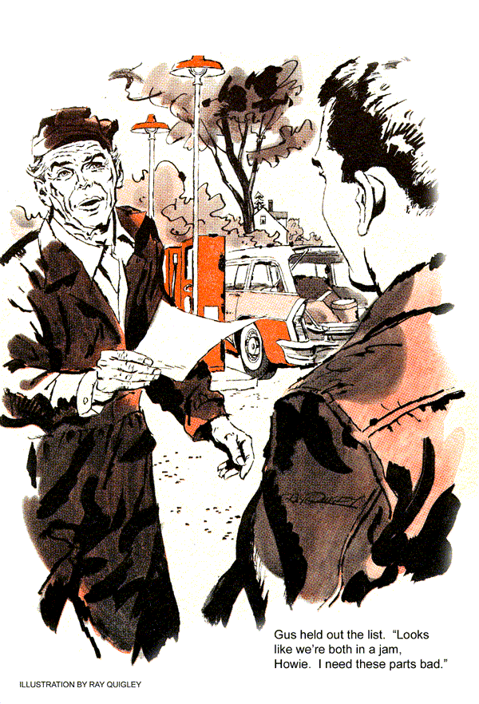
With a bowl of beef stew, apple pie a la mode, and two cups of coffee under his belt, Gus Wilson walked leisurely back to the Model Garage. His young assistant, Stan Hicks, was sitting at the workbench dropping banana peels into his empty lunch box.
"You got a one-track mind, Gus?" Stan asked, taking half a banana in one bite.
"On that, Stan, I plead the Fifth Amendment. But why?"
"Howie Stone He stopped by to cry on my shoulder about all auto mechanics having one-track minds."
Gus leaned over and adjusted a wrench hanging askew on the tool board. "So that used station wagon of his is still acting up. Were you able to fix it?"
"I didn't even get a chance to look at it," Stan said. "When I told him that the symptoms he described sounded like a faulty fuel pump he blew his top and drove off. And the way his car sputtered and balked, it sure sounded as if it was starved for gas."
"Howie's a nice boy," Gus said, "but stubborn, like all the Stones. Guess he just made up his mind it's not the fuel pump, and that's that."
"Wish we could help him," Stan said. "He spent all is money on that wagon, got his package-delivery service started - and now he can't deliver."
Gus nodded. "I know. P. J. Basset told me about it over at the diner."
"You mean Howie's going to lose the job of hauling Pete Bassett's express shipments to the railroad station?"
"Looks like he's lost it," Gus said. "He missed two trains last week. And Pete's maple-sugar candy got off to the customers a day late."
The telephone rang in the Model Garage office. Gus answered it, did more listening than talking, and came back into the shop. "That was Pete Bassett. He's staying late making up a big order that must make the evening train."
"Gosh, Gus, and Howie probably won't be able to make it."
"Pete didn't want Howie. He wants me to come over and get his old pickup running. He hopes to use it to start making his own deliveries again until he can get a new truck."
"Maybe we could stall," Stan suggested. "Maybe we can somehow get Howie to bring his wagon in here and let you check it over."
Gus grinned broadly. "Maybe we can, Stan, maybe we can - if you're willing to aid and abet."
Stan looked at his boss eagerly. "Skullduggery?"
"Not quite that bad, but maybe a few white lies."
"Count me in," Stan said. "What do I do first?"
"Check the bins and make out a list of stock parts we need while I make a phone call."
Stan looked puzzled, shrugged his shoulders and went back to work.
Half an hour later Stan walked back into the office and handed Gus an order list and carbon.
"Want me to run over to Milltown for these? Nice day for a drive."
"Sorry to disappoint you, Stan, but I've just put in a call for your pal Howie Stone."
"Oh, no, Gus. With his wagon running the way it is, Howie'll never make those hills on the 10 miles to Milltown and back."
An engine sputtered to a stop outside. "Here's Howie now." Gus gave his assistant a shove. "Get back in there and keep out of sight."
Stan pulled his cap lower over his eyes. "The plot thickens," he said, slinking dramatically off toward the rear of the garage.
Outside Gus greeted Howie with an innocent smile. "Glad you got my message about that pickup in Milltown. It's a rush job."
Howie's smile wasn't as cheerful. "Gee, Mr. Wilson, I'm afraid I'll have to turn you down."
"You're in the package-delivery business, aren't you?"
"Well, I thought I was until this station wagon of mine started acting up. I can limp around town okay, but once I get on a hill…"
"What seems to be wrong?" Gus asked.
"I don't know - yet. I've wanted to ask your help, Mr. Wilson, but after I refused your offer to check the bus before I bought it - well, I've been sort of embarrassed."
"But you've seen other mechanics?"
Howie nodded, keeping his eyes down, and shuffling his feet. "That's right - and they all seem to have one-track minds. Fuel pump, fuel pump, fuel pump - that's all I hear. Why, one fellow even wanted to charge me 100 bucks to tear down the engine - just to put in a new fuel pump."
"Maybe it is your fuel pump," Gus said.
"Shucks, no, Mr. Wilson. I put a new one in myself, and it didn't make a bit of difference."
Gus held out the parts list. "Looks like we're both in a jam, Howie. I need these parts bad."
"I'd like to help, but…"
"Let's help each other," Gus broke in. "You take my truck and drive over to Milltown and pick up these parts. I'll phone Ace Supplies so they'll have them ready. And while you're gone I'll have a look at your station wagon."
Howie looked up, a grateful-puppy expression in his eyes. "Swell, Mr. Wilson." He took the list Gus handed him and climbed into the Model Garage truck.
"But you can forget about the fuel pump. Nothing wrong with it." He stepped on the starter and drove off.
When Stan Hicks came out of hiding, he found Gus with his head under the station-wagon hood. "Hi, boss, have you forgotten Pete Bassett is expecting you?"
Gus straightened up. "No, Stan. And if he phones, tell him I'm out on an emergency. Now, start this wagon and we'll see how she sounds."
As the engine started and settled into a smooth idle, the office telephone rang. And from then on it continued to ring every five minutes with Stan running back and forth to answer it.
Working on the engine, Gus moved the throttle linkage. It raced briefly, then began to sputter. Just before stall, he let it settle back to idle and asked Stan to turn the wipers on. Each time Gus gunned the engine, the wipers nearly stopped.
"Cut it," Gus called. Stan did, and ran to answer an insistent telephone ring.
Gus was at work on the engine innards when his assistant reported back.
"That was Bassett again. His help's left for the day. He's alone at the plant with a no-go truck, a big ready-to-go order, and that midget sports car of his that hasn't room for an extra package of chewing gum. And he's mad at you."
"I was hoping for something like that," came the muffled voice of Gus as he backed off the last fuel-pump mounting bolt.
When Howie Stone drove up in the Model Garage truck, Gus had just returned from a test run in the station wagon. He was putting the engine through its paces. It accelerated smoothly, ran like a top.
Bug-eyed, Howie jumped out. "What was wrong?"
"Never mind that now," Gus said. "It's running - and I suggest that you get right over to Pete Bassett's plant."
"Huh? Mr. Basset wants nothing to do with me. He made that plain enough after I missed the train the other day.
"I think he'll be glad to see you now, though," Gus said, sliding out from behind the wheel of the station wagon. "Now get in, boy, and get going - but don't tell Pete you've even seen me."
As Howie pulled away, Stan cocked his head and looked at his boss. "Talk about a mother hen and her chicks. But wait till he hears about that fuel pump." The phone rang. "What'll I tell Pete?"
"Tell him if his shipment misses that train it serves him right…"
Later that evening there were lights on in the Model Garage. Gus was doing some work on his own car when Howie Stone walked in.
There was a broad grin on his face.
"You were right, Mr. Wilson," he said. "Pete Bassett was glad to see me. And you know what?"
"No, what?" said Gus, pulling a pipe from his coveralls pocket and filling it.
"He had an order all ready for me to deliver. Said if I made the train he'd sign a contract with me for all his deliveries. I made the train."
"That's fine, Howie. Now, I've got a pot of coffee brewing in the office. How about joining me?"
"Sure thanks. I did want to ask you what was wrong with my car."
When they had taken their first sips from steaming mugs, Gus broke the news. "The fuel pump wasn't operating."
Howie put his mug down with a jolt that splashed coffee over papers on Gus's littered desk. "But it was a new pump. I put it in myself," he protested.
"I didn't say the pump was bad, but that it wasn't operating. It's like this:
"Combination vacuum-booster fuel pumps have a stronger diaphragm spring than the single-purpose types. Once in a while the extra pressure causes the cam to wear. The more it wears, the rounder it gets. Eventually there's a hardly enough lift to keep the pump supplying fuel for a slow idle."
As Howie nodded in understanding, Gus went on. "When you race the engine, the carburetor bowl empties faster than the feeble pump stroke can fill it."
"But why should a job like that cost $100?" Howie asked.
"Well, to fix it means removing the radiator, cylinder heads and all the valves in order to replace the camshaft."
"And you did all that while I drove to Milltown and back," Howie said in admiration. "Well, with the Bassett business I guess I can afford it."
"Your bill is $14 for an electric fuel pump," Gus said. "My time is free in exchange for picking up those parts for me."
Howie pondered that one for a minute. Then: "I get it. An electric fuel pump doesn't need the camshaft to operate it. It's self-powered.
You switched pumps."
"Right," Gus said. "Mechanics have one-track minds, Howie, but we know a good switch when we see one."
END

