March 1959

GUS PLANTS AN IDEA

by Martin Bunn

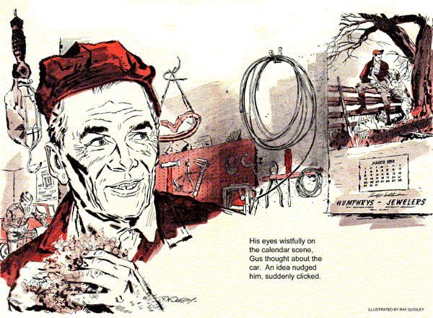
The '57 Lincoln had its oil pan down. Gus Wilson held a rear main-bearing seal in his hand. It was shot. So was his weekend, Gus thought, looking up at a hunting scene on the Model Garage wall calendar. The month read March; the next day's date, Sunday, was circled in red. There was a promise of early spring in the air.
Stan Hicks, his assistant, hung up the telephone, "No luck, boss," he said. "Higgins hasn't got that main seal in stock and he can't get one until Monday."
"There goes my hunting trip," Gus said.
"Why not use your own car?"
"You know the agreement I made with Sam Barton. If I didn't fix his Lincoln in time we'd call off the hunting and put in Sunday fixing up his basement bowling alley." The phone rang. "Maybe Higgins found that part," Stan said hopefully as Gus took the call. It was Ed McBain.
"My garden tractor won't run, Gus. And Hogan's out in his plot making the dirt fly. If you don't come over and fix it he'll beat me on the first mess of green peas and I'll never hear the last of it." "Okay," Gus said, and hung up the phone grinning. "Hogan and McBain are at it again. Hold the fort, Stan, while I'm off to the battle of the green thumbs."
The phone ran again. This time it was Hogan's voice in a conspiratorial whisper. "Slip over here with your tool box, Gus. My tractor's broke down but I don't want old Pig Weed McBain to know it." Gus winked at Stan. "That's strange, McBain just called and said you were making the dirt fly." Hogan cackled over the phone. "He just thinks I am. My motor runs okay and I've got it spitting with the muffler off. But when I throw in the clutch nothing happens."
As he drove out of town Gus mulled over the situation. He was bound to call on McBain first. But with the backyard garden plots of the two crotchety old rivals separated by only a four foot-high hedge, Hogan was sure to see him arrive. And with both tractors out of commission, he knew he was heading for fireworks. He wasn't mistaken. He found McBain a thin, wiry man, blue of eye and reddish of beard, yanking the starter cord of his tractor. As Gus approached he looked up and snorted, "I'd like to get my hands on the guy who built this contraption. Durned motor won't turn over."
"That's one of the best little motors ever built, Ed." Gus took the starter cord and gave it a few futile yanks.
"Best, eh?" McBain cocked an ear toward Hogan's yard. "Listen to that, Old Spinach Beard couldn't run a two-bit screwdriver. But his motor runs and mine don't."
Gus removed the gas-tank cap and stuck a finger into the fuel, "as a matter of fact, your motor and Hogan's are identical." "Maybe so," McBain said. "I'll wager that old reprobate snuck over here last night and put emery dust in my motor. I'll go over there right now and twist his..." "What in time are you doing over there, Gus Wilson?" It was Arch Hogan, his whiskered chin jutting over the top of the dividing hedge. Fixing Ed's tractor," Gus said, a twinkle in his eyes. "Wouldn't be anything wrong with yours, now, would there?"
"Course not," Hogan said hastily. "You can hear it running if you're not deaf. I'd better get back to it. My, how things are growing this spring, got peas three inches high already."
"Hogwash!" McBain said. "Pass up three inches! Why, he's just planting them now. Couldn't work the ground until this morning - too wet." The old man took off around the end of the hedgerow, Gus behind him. They came upon Hogan, a silly grin on his face, leaning on the handles of his racketing but motionless tractor.
"By grabby!" roared McBain. "He isn't going anyplace, either." "Who told you to come peeking around my hedge, Pig Weed?"
"Your hedge? The plants you put down didn't grow. Every last plant in that hedge that grew, I planted." Hogan snorted. "You couldn't grow warm radishes."
"Whoa!" Gus cut in. "Neither of you are going to grow radishes or anything else if you don't stop squabbling and let me look at your tractors. McBain's motor seems to be frozen up, now let me see what the trouble is with this one."
"McBain must have slipped over last night and put metal in my gearbox."
"And who sneaked over last night and put emery dust in my motor?"
"Would have if I'd thought of it," Hogan admitted.
Gus, down on his knees, was removing the differential grease-drain plug from Hogan's gearbox. "Guess it'll take about a week to get parts from the factory. Then, let's see, a couple of days to install them. Say about 10 days to get you boys running again."
McBain's rheumy eyes popped. "Ten days! Why, in 10 days it'll be too late to plant peas, that is, peas that'll grow right. Hot weather'll catch them before they fill, and then...."
"And then," Hogan put in, "they'll sort of peter out. They'll make up small and not sweet."
"That's right. Just like those peas you shipped in from the South last year, Hogan, and made believe you'd grown 'em yourself."
"Shipped in from the South!" Hogan took a threatening step forward. "I'll have you know, Pig Weed, that I beat you fair and square last year. I'm of half a mind to..."
"Stop it!" Gus stepped between them. "If you two will calm down a minute I'll show you both you can get your peas in - and today."
"You will?"
"How?"
"Well," Gus explained, "your tractors are identical. McBain has a good chassis and gears, while you, Hogan, have a good motor. Now, if I mount your motor on McBain's rig..."
"Not on your life," Hogan protested.
"Let Pig Weed rustle up his own motor.
Any time I deal with a character who'll sneak around jimmying folks' gears you'll know it."
"Is that so?" McBain yelled. "And you can get your own gears. Before I'll deal with a snake in the grass who sneaks over putting emery dust..."
"Time out," Gus said, holding up a hand. "I'd say both of you green-thumbed idiots got so excited this morning you forgot something. I'll bet McBain forgot to mix oil with the gas for his two-cycle motor.
And you, Hogan probably drained your gearbox last fall, just like the factory instruction book says, and then forgot to put grease back in. Now...let me make one good tractor out of both of these."
Hogan shook his head. "Nothing doing."
"But," McBain said uncertainly, "it might rain. Hogan, and muddy up the ground again. Ten days is a long time."
Hogan pulled at his whiskers. "Come to think of it. Pig Weed, maybe I did drain my gearbox last fall."
"Admit it, do you?" McBain said.
"Well now, in that case, maybe I did forget to mix oil with my gasoline."
Gus held up two fingers in a V sign.
"Well, we won't get anywhere standing here chewing the fat. Let's shift the motor."
"Let's," said McBain.
"Don't mind if we do," agreed Hogan.
Driving back to the Model Garage, Gus chuckled aloud to himself, wondering what McBain and Hogan would say if they knew he could have gotten the parts and installed them in a couple of hours. But getting the two old gamecocks to work together, he figured, was more important.
Gus still had his own problem - Sam Barton's Lincoln with the oil leak that meant no hunting trip. His eyes strayed wistfully to the hunting scene on the wall calendar as he thought about the car.
An idea kept nudging him. Then, suddenly, it clicked. "Identical parts," he said aloud.
In the garage office, he thumbed through his parts manual, "Ah, here it is, Stan," he said, running a finger across a page. "The crankshaft rear oil seal of the '57 Lincoln also fits '57 Fords. And that means vice versa. Get it, Stan?"
"Sure, boss, but this is Saturday and the Ford dealer..."
"Never mind the dealer. What's your car?"
"Why, a '57 Ford..." Then it dawned on him what Gus meant. "No, not that."
"Yes, that. Get going and switch those identical parts so I can go crow-shooting tomorrow."
Stan was finishing up when Gus came out of the office, a shotgun in each hand.
"Here's a gun for you, Stan," he said.
"Come along with us."
END

