July 1959

GUS MEETS A MEDICINE MAN

by Martin Bunn

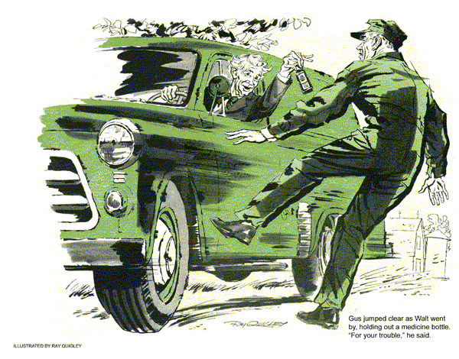
Gus Wilson mopped his forehead with a checkered bandanna as he came out of the Model Garage in response to an insistent horn honking.
"Take it easy, Hank," he said to a man behind the wheel of a delivery truck.
"Got to watch your blood pressure in this heat."
"That's just what I told Walt Morehead. He's fit to be tied. Has trouble starting his car after every stop. People are drinking down to the free line and demanding their money back."
Gus chuckled, "Yeah, I did hear Walt was back in this neck of the woods with a fresh supply of his patent medicine. Maybe if he poured some in his gas tank... "
"He'd blow himself sky high," Hank said with a laugh. "But seriously, Gus, he's desperate and wants you to come to his rescue. Says he'd be somewhere around Pappy Spriggens' place.
As the delivery truck drove away, Gus turned to Stan Hicks, his young assistant.
"I'll take my own car. Just throw a tool box in the back."
"Sure," Stan said. "But what's all this about a free line?"
"An old come-on gimmick, Stan - and looks like it's backfired on old Walt."
Driving out of town, Gus's weathered face crinkled in a smile as he thought of Walt Morehead. Walt was the last of his breed, a peddler who toured the back country selling cooking spices and novelties, and patent medicines for man and beast. A short bustling figure, hatless, his salt-and-pepper hair always in need of cutting, dressed in a sagging out-of-date blue-serge suit, he was as much a part of the farm country as apple butter.
The kids loved him and the adults, though they wouldn't admit it, delighted in bickering with him for his wares.
Gus turned off into the Spriggens farmyard and pulled up behind Walt's 1954 panel truck, which sagged under its load of merchandise. Walt and Spriggens were having a hot argument.
"See!" Spriggens shouted, holding up a flat brown bottle to the sun, squinting at it through thick-lensed spectacles. "I ain't used it a hair below the free line. Give me back my two bucks."
"Hah!" Morehead retorted. He grabbed the bottle and held it at arm's length for the benefit of his near-sighted eyes. "It says right here on the label that the dosage is one tablespoon before meals and at bedtime. You haven't had the bottle more than 20 minutes and you've already taken four doses."
"Makes no difference," Spriggens argued. "It also says that I can use the stuff down to the sample line of the bottle. And if I don't like it, I can return the rest and get my money back. It doesn't say anything about whether I take it in 12 hours or 12 minutes. I don't like the stuff. Cough up my two bucks, Walt."
Walt dug in a pants pocket, pulled out two crumpled dollar bills and turned to Gus. "That gol-derned engine is costing me money. If it had started right off, I'd have been gone before this old coot here could've put it over on me."
"I'd have nailed you next time," Spriggens said, poking a finger at Morehead.
"The peddler poked right back. "Oh, no, you wouldn't. By that time the medicine would've had time to work and straightened you out for fair."
"Maybe you're right," Spriggens said.
"The way that poison of yours tastes, if would straighten out a crooked fence post." He guffawed slapping his thigh.
"Well, got to get on with my chores."
Gus had the hood of Morehead's car up. "What's the trouble, Walt?"
"Starting trouble, that's what. With old frauds like Spriggens here, a man has to get going fast once he prices money out of them. This makes three sales I've turned back in a week 'cause I couldn't get away quiet enough."
"Just what happens?" Gus asked.
"Well, when I drive up to a place I shut off the engine. Can't afford to keep it running the time it takes to sell people on what's good for their arteries. Then, by the time I fiddle five or 10 minutes to get going, chances are my customer comes scramming out for his money back."
"Could be a number of things wrong to cause trouble like that," Gus said "Let's take a look."
He checked the ignition system, cranking the engine by bridging the starter relay with the handles of a pair of pliers. Finding nothing wrong there, he went on to the automatic choke and pulled the air cleaner from the carburetor. The choke seemed to be working properly - but he smelled gas. A close look into the carburetor throat showed signs of flooding. Suspecting a stuck float or dirt holding the float valve open, Gus removed the carburetor top, set it aside and took another close look. The float was riding normally and the float valve was tightly seated.
Puzzled, Gus put the carburetor top back on. "Start the engine," he said.
Morehead lost no time getting behind the wheel and pressing the starter. The engine kicked over and ran smoothly.
"I'm on my way," shouted the peddler.
"Put that hood down, Gus. Got to get going before some of those free-line guzzlers catch up with me."
Gus almost had to jump clear as Walt went by, one hand stuck out the window holding a bottle of patent medicine. "For your trouble," he said, stepping on the gas.
On his way back to the Model Garage, Gus looked at the bottle and smiled. It was probably the one Spriggens had returned, for it was already down to the free line. Walt wasn't taking any chances, but then he hadn't gotten any mechanical service in return for his medicine, either. Somehow Gus felt that the trouble had been staring him right in the face.
It was still bothering him a few hours later when the itinerant peddler drove up in front of the garage.
"You lost me another customer, Gus Wilson," he complained, as he clambered out of the cluttered front seat. "And I just managed to get away from Mrs. Mahoney's as she came screaming out after me."
"Serves you right for running off on me like that, Walt. Auto mechanics don't work like that medicine of yours. We have to diagnose the trouble before we can fix it. You didn't give me a chance."
The old man pulled out one of his bottles, took a swig, and calmed down. "Well, maybe.
But you got the chance now. Guess nobody's going to chase me right into town for their money back."
"I've been thinking about your problem, Walt," Gus said, raising the hood. "If I were a betting man I'd lay odds that there's something wrong with the anti-percolator vent or valve."
"Anti what?"
"Percolator."
"You mean there's a coffee pot in the engine?" asked Morehead.
"Let me explain," Gus continued, again tackling the carburetor but this tie without cranking the engine.
"When you stop an already overheated engine under a hot sun, high-test gas is apt to boil, causing vapor bubbles to rise. In old-model cars they would be trapped in the unvented float bowl of the carburetor.
Vapor pressure would then force gas out of the main jet into the venturi throat - the only exit. This would tend to empty the carburetor and dribble raw gas into the manifold, resulting in flooding and hard starting. This is what happened in older cars."
"Now, wait a minute, Gus. This ain't no Model T I'm driving."
"No, Walt. Your carburetor has an anti-percolator valve to prevent this. It vents the vapors of boiling fuel."
"Then why doesn't it?"
"We'll see," Gus said, removing the carburetor top. When he saw the float at the bottom of a nearly empty bowl, he picked up the top and examined it.
"Here's your trouble," he said, pointing with a pencil. "The anti-percolator vent is clogged with gum and dirt, and the valve is stiff. The gas boiled over into the intake manifold. Smell it? Won't take but a minute to fix that up."
With the vent clear and the valve free, Gus reinstalled the carburetor. Walt had wriggled back behind the wheel.
"You may have to spin it a while to work the gas out of your flooded manifold," Gus continued.
"Can't wait," said Walt, stepping on the gas as he looked in his rear-view mirror. "There comes old Mrs. Mahoney down the road and she's spotted me." He was off with a screech of rubber.
And Gus found himself with another bottle of Morehead's wonder worker in payment.
Mrs. Mahoney drove up and leaned out of a window. "Now why did Walt scoot off like that? I was of a mind to buy a box of liver pills and a bottle of sciatica medicine - nothing like it when a body gets pains in the joints. I'd better get going if I'm to catch him."
Gus took the top off the bottle in his hand and poured out some dark liquid.
Then he handed the recapped bottle of Walt Morehead's medicine to Mrs. Mahoney. "When you do catch him," he said, "give him this and tell him I only drank down to the free line and want my two dollars back.
END

